Chapter 6 Metallic Waveguide and Cavity Resonators

6-1 General Metallic Waveguides
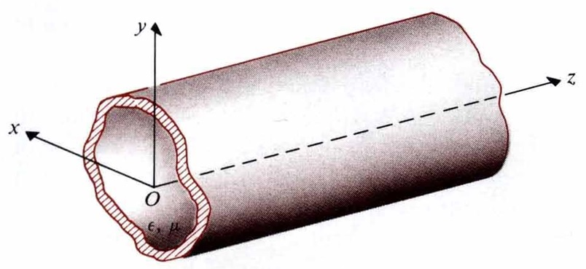

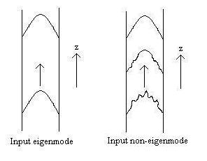
How to study the theory of metallic waveguides (by L. J. Chu, 朱蘭成):
- Specify a proper coordinate system, and derive waveguide’s equations to express the transverse components of the E- and H-fields in terms of the longitudinal components by Maxwell’s equations.
- Caculate the eigenmodes (TM mode, TE mode, TEM mode or other types of modes) of the waveguide, and obtain the eigenvalues and the longitudinal field-components of the corresponding eigenmodes by solving the wave equations. Substituting the longitudinal field-components into the longitudinal components, we can obtain the other components. If the eigenmode is injected into a waveguide, it can propagate along an infinitely-long straight waveguide without any deformation. However, in case the input EM wave is not an eigenmode, some power loss occurs and then it becomes the eigenmode gradually. All the eigenmodal functions in an infinitely-long straight metallic waveguide are orthogonal to each other. Moreover, these eigenmodes form a complete set (a basis in a vector space), such that any electromagnetic fields within the waveguide can be uniquely expressed by the eigenmodal functions.
- Obtain the quantities of the physical characteristics for a given eigenmode, such as the cutoff frequency (f_{c}), the propagation constant (γ=α+jβ), the phase velocity (v_{p}=ω/β), the group velocity ($v_{g}=∂ω/∂β$), the impedance Z, etc.
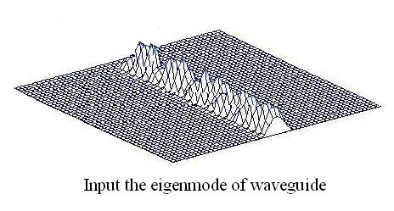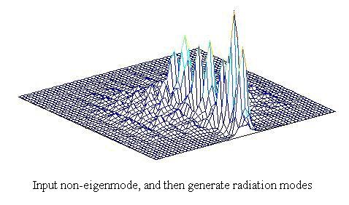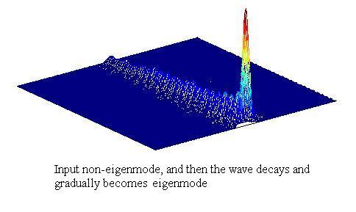
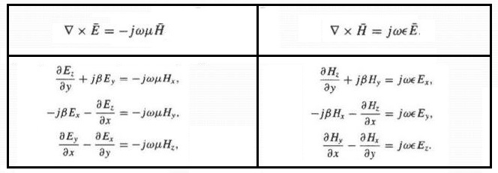
Waveguide’s equations: According to Ampere’s law and Faraday’s law, we obtain
,
, , where h²=γ²+k²,
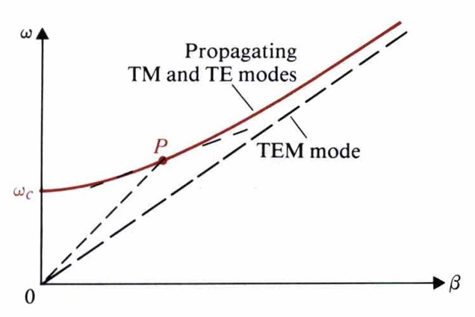
and $\begin{aligned}\left\{∇^{2}E+k^{2}E=0 | \right.\end{aligned}$
Case 1 TEM mode: E_{z}=H_{z}=0
$h^{2}=0=γ_{{\text{TEM}}^{2}}+k^{2}⇒γ_{\text{TEM}}=\text{jk}=jω\sqrt{\text{με}}$, $v_{p}=\frac{1}{\sqrt{\text{με}}}$
and $H=\frac{1}{Z_{\text{TEM}}}\hat{z}×E$
Note: All frequencies make γ_{TEM} is pure imaginary$⇒$TEM wave can propagate at any frequency, no cutoff.

Case 2 TM mode: H_{z}=0, E_{z}≠0 and ▽_{t}²E_{z}+h²E_{z}=0
, , ,
and $H=\frac{1}{Z_{\text{TM}}}(\hat{z}×E)$
$γ=\sqrt{h^{2}−k^{2}}=h\sqrt{1−(\frac{f}{f_{c}})^{2}}$, where $f_{c}=\frac{h}{2π\sqrt{\text{με}}}$
If f>f_{c}, , , and $v_{p}=\frac{1}{\sqrt{\text{με}}\sqrt{1−({f_{c}}/f)^{2}}}$
Case 3 TE mode: E_{z}=0, H_{z}≠0 and ▽_{t}²H_{z}+h²H_{z}=0
, , ,
and $E=−Z_{\text{TE}}(\hat{z}×H)$
If f>f_{c}, $γ=jβ=\text{jk}\sqrt{1−(\frac{f_{c}}{f})^{2}}=jω\sqrt{\text{με}}\sqrt{1−(\frac{f_{c}}{f})^{2}}$,
$⇒$$Z_{\text{TE}}=\frac{η}{\sqrt{1−({f_{c}}/f)^{2}}}$, $v_{p}=\frac{1}{\sqrt{\text{με}}\sqrt{1−({f_{c}}/f)^{2}}}$
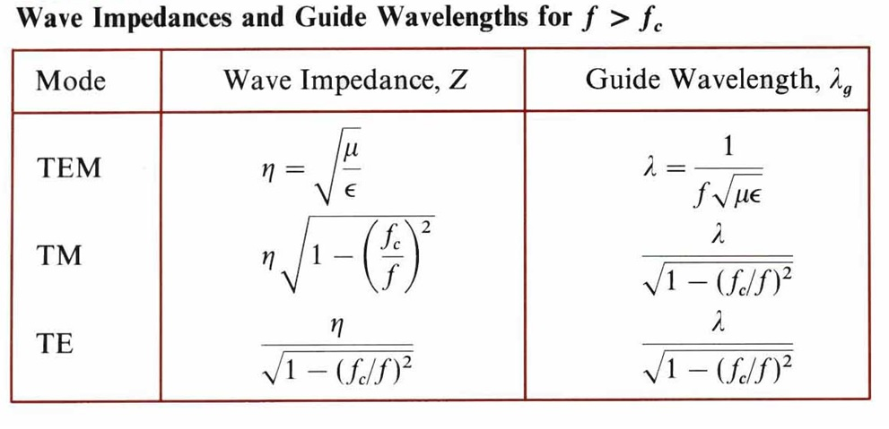
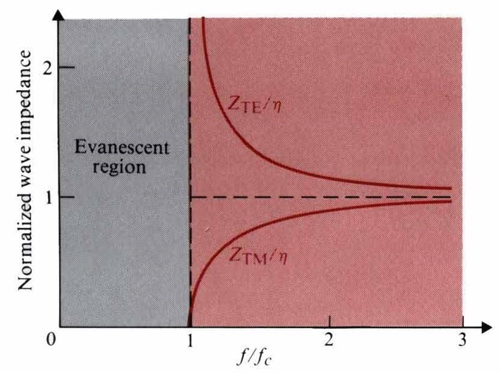
A case of longitudinal v_{p}>0 but longitudinal v_{g}=0 in barber’s pole.

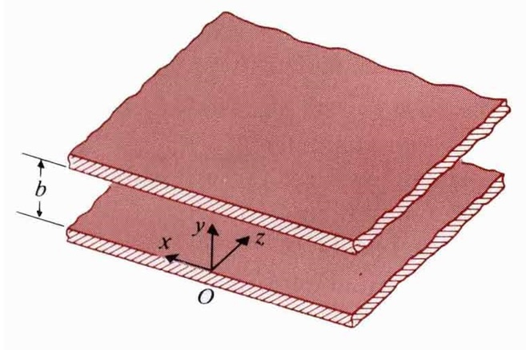
6-2 Parallel–Plate Waveguides
Case 1 TM_{n} mode: H_{z}=0,
, at y=0 and b
$⇒$Eigenvalues: h=$\frac{nπ}{b}$, , n=0, 1, 2, 3, …
and $γ=\sqrt{h^{2}−ω^{2}\text{με}}=\sqrt{(\frac{nπ}{b})^{2}−ω^{2}\text{με}}$
Cutoff frequency: f_{c}=$\frac{n}{2b\sqrt{\text{με}}}$ fulfills γ=0. (Note: n=0 is the TEM mode)
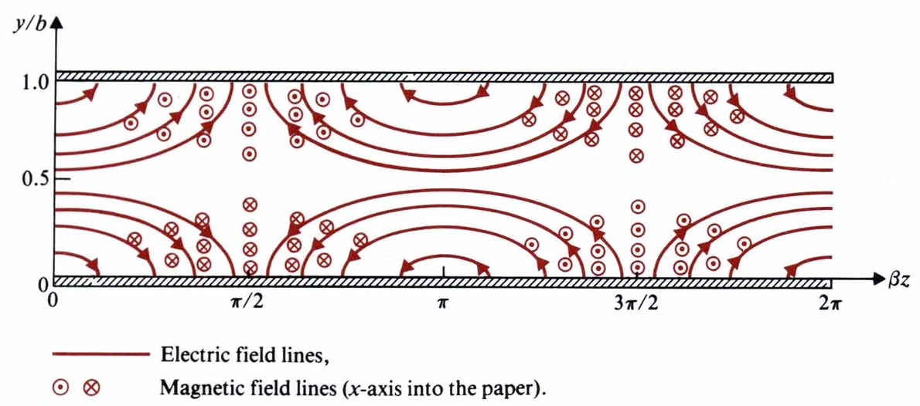
Case 2 TE_{n} modes: E_{z}=0,
, at y=0 and b and f_{c}=$\frac{n}{2b\sqrt{\text{με}}}$
and γ=$\sqrt{(\frac{nπ}{b})^{2}−ω^{2}\text{με}}$, n=1, 2, 3, …
Eg. (a)Write the instantaneous field expression for TM₁ mode in a parallel-plate waveguide. (b) Sketch the E- & H- field lines in the yz-plane.
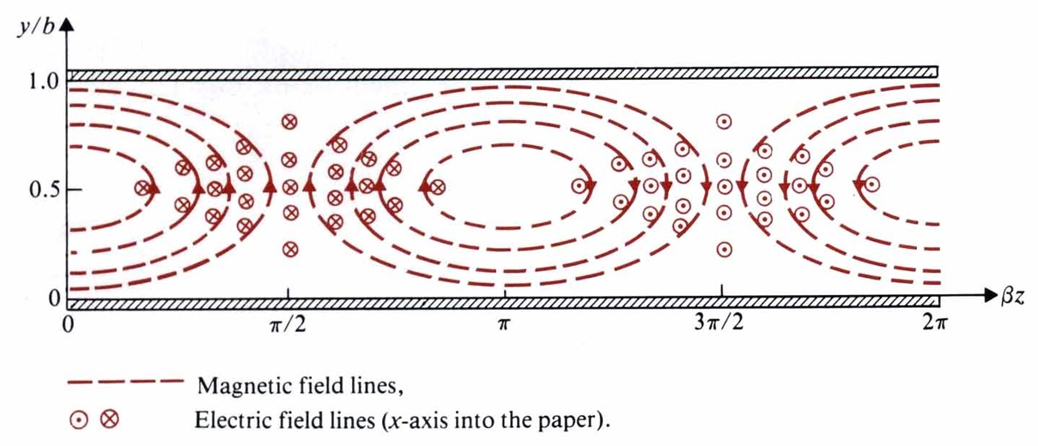
(Sol.) (a) For n=1, $E_{y}(y,z,t)=\frac{βb}{π}A_{1}\text{cos}(\frac{πy}{b})\text{sin}(ωt−βz)$
$H_{z}(y,z,t)=−\frac{\text{ωε}b}{π}A_{1}\text{cos}(\frac{πy}{b})\text{sin}(ωt−βz)$, $β=\sqrt{ω^{2}\text{με}−(\frac{π}{b})^{2}}$
(b) $\frac{\text{dy}}{E_{y}}=\frac{\text{dz}}{E_{z}}⇒\frac{\text{dy}}{\text{dz}}=\frac{E_{y}(y,z,0)}{E_{z}(y,z,0)}=−\frac{βb}{π}\text{cot}(\frac{πy}{b})\text{tan}βz$$⇒\text{cos}(\frac{πy}{b})\text{cos}βz$=constant

Eg. (a) Write the instantaneous field expression for TE₁ mode in a parallel-plate waveguide. (b) Sketch the electric and magnetic field lines in the yz-plane.
(Sol.) (a) For n=1, $H_{z}(y,z;t)=B_{1}\text{cos}(\frac{πy}{b})\text{cos}(ωt−βz)$,
$$H_{y}=(y,z;t)=−\frac{βb}{π}B_{1}\text{sin}(\frac{πy}{b})\text{sin}(ωt−βz)$$
$E_{x}(y,z;t)=−\frac{\text{ωμ}b}{π}B_{1}\text{sin}(\frac{πy}{b})\text{sin}(ωt−βz)$, where β is the same as that of the TM₁ mode.
(b) At t=0,
$E_{x}(y,z;0)=−\frac{\text{ωμ}b}{π}B_{1}\text{sin}(\frac{πy}{b})\text{sin}βz$,
$$\frac{\text{dy}}{\text{dz}}=\frac{H_{y}(y,z;0)}{H_{z}(y,z;0)}=\frac{βb}{π}\text{tan}(\frac{πy}{b})\text{tan}βz$$

Eg. Find the electric and the magnetic fields of the propagating wave in a parallel waveguide b=5cm, filled with a dielectric (4ε₀,μ₀) and excited by $H=\hat{y}\text{cos}\text{40}πx\text{sin}8π{\text{10}}^{9}t$.
(Sol.) f=4×10⁹Hz, cos40πx=$\text{cos}(\frac{2πx}{0\text{.}\text{05}})$: TM₂ mode
$(f_{c})_{{\text{TM}}_{2}}=\frac{2}{2b\sqrt{μ_{0}4ε_{0}}}=3×{\text{10}}^{9}$, $(f_{c})_{{\text{TM}}_{2}}<f$, ∴ TM₂ mode can propagate!
$β=ω\sqrt{μ_{0}4ε_{0}}\sqrt{1−(\frac{(f_{c})_{{\text{TM}}_{2}}}{f})^{2}}=\text{110}\text{.}\text{82}$$⇒$$H=\hat{y}\text{cos}(\text{40}πx)\text{sin}(8π{\text{10}}^{9}t−\text{110}\text{.}\text{82}z)$
$$E=\hat{x}\text{124}\text{.}\text{67}\text{cos}(\text{40}πx)\text{sin}(8π{\text{10}}^{9}t−\text{110}\text{.}\text{82}z)+\hat{z}\text{141}\text{.}\text{37}\text{sin}(\text{40}πx)\text{cos}(8π{\text{10}}^{9}t−\text{110}\text{.}\text{82}z)$$

Eg. Find the electric field of the propagating wave in an air parallel waveguide b=5cm excited by $E=\hat{y}\text{10}(\text{sin}\text{20}πx+0\text{.}5\text{sin}\text{60}πx)\text{sin}{\text{10}}^{\text{10}}πt$.
(Sol.) f=5×10⁹Hz, sin20πx=$\text{sin}(\frac{πx}{0\text{.}\text{05}})$: TE₁ mode, sin60πx=$\text{sin}(\frac{3πx}{0\text{.}\text{05}})$: TE₃ mode $(f_{c})_{{\text{TE}}_{1}}=\frac{1}{2b\sqrt{μ_{0}ε_{0}}}=3×{\text{10}}^{9}$,$(f_{c})_{{\text{TE}}_{3}}=\frac{3}{2b\sqrt{μ_{0}ε_{0}}}=9×{\text{10}}^{9}$, $(f_{c})_{{\text{TE}}_{1}}<f<(f_{c})_{{\text{TE}}_{3}}$
∴ Only TE₁ mode can propagate! $β=ω\sqrt{μ_{0}ε_{0}}\sqrt{1−(\frac{(f_{c})_{{\text{TE}}_{1}}}{f})^{2}}=\frac{\text{80}π}{3}$
$$E=\hat{y}\text{10}\text{sin}(\text{20}πx)\text{sin}({\text{10}}^{\text{10}}πt−\frac{\text{80}πz}{3})$$
Energy-transport velocity and attenuation in parallel-plate waveguides:
Energy velocity: $v_{\text{en}}=\frac{(P_{z})}{W_{\text{av}}^{'}}$ and $(v_{\text{en}})_{\text{TE}}=(v_{\text{en}})_{\text{TM}}$
Energy velocity of TM mode:
$=\frac{\text{ωεβ}b}{4h^{2}}A_{n^{2}}$
$w'_{\text{av}}=\frac{ε}{4}\text{Re}(E⋅E∗)+\frac{μ}{4}\text{Re}(H⋅H∗)$$=\frac{{εA}_{n^{2}}}{4}[{\text{sin}}^{2}(\frac{nπy}{b})+\frac{β^{2}}{h^{2}}{\text{cos}}^{2}(\frac{nπy}{b})]+\frac{μ}{4}(\frac{ω^{2}ε^{2}}{h^{2}})A_{n^{2}}\text{cos}(\frac{nπy}{b})$
$$W'_{\text{av}}=\int{w'_{\text{av}}\text{dy}}=\frac{εb}{4h^{2}}k^{2}A_{n^{2}}⇒v_{\text{en}}=\frac{\text{ωβ}}{k^{2}}=\frac{1}{\sqrt{\text{με}}}\sqrt{1−(\frac{f_{c}}{f})^{2}}$$
Attenuation constant: α=α_{d} +α_{c}
α of TEM mode: $α_{d}=\frac{G}{2}R_{0}=\frac{σ}{2}\sqrt{\frac{μ}{ε}}=\frac{σ}{2}η≈\frac{\text{ωε}\text{''}}{2}η$, $α_{c}=\frac{R}{2R_{0}}=\frac{1}{b}\sqrt{\frac{πfε}{σ_{c}}}$
α of TM mode:
$γ=j[ω^{2}\text{με}(1−\frac{jσ}{\text{ωε}})−(\frac{nπ}{b})^{2}]^{1/2}$$j\sqrt{ω^{2}\text{με}−(\frac{nπ}{b})^{2}}⋅\left\{1−\frac{j\text{ωμσ}}{2}[ω^{2}\text{με}−(\frac{nπ}{b})^{2}]^{−1}\right\}$
$=jω\sqrt{\text{με}}⋅\sqrt{1−(\frac{f_{c}}{f})^{2}}⋅\left\{1−\frac{j\text{ωμσ}}{2}⋅\frac{1}{1+(\frac{f_{c}}{f})^{2}}\right\}=α_{d}+jβ$$⇒α_{d}=\frac{\text{ση}}{2\sqrt{1−(\frac{f_{c}}{f})^{2}}}$,
$$β=ω\sqrt{\text{με}}⋅\sqrt{1−(\frac{f_{c}}{f})^{2}}$$
$α_{c}=\frac{P_{L}(z)}{2P(z)}$, where $P(z)=w\int_{0}^{b}{−\frac{1}{2}(E_{y}^{0})(H_{x}^{0})∗\text{dy}}=w\text{ωεβ}b(\frac{{\text{bA}}_{n}}{2nπ})^{2}$,
$\left|J_{\text{sz}}^{0}\right|=\left|H_{x}^{0}(y=0)\right|=\frac{\text{ωε}{\text{bA}}_{n}}{nπ}$$⇒P_{L}(z)=2w(\frac{1}{2}{\left|J_{\text{sz}}^{0}\right|}^{2}R_{s})=w(\frac{\text{ωε}{\text{bA}}_{n}}{nπ})^{2}R_{s}$,
$$R_{s}=\sqrt{\frac{{πfμ}_{c}}{σ_{c}}}⇒α_{c}=\frac{2}{ηb}⋅\sqrt{\frac{{\text{πμ}}_{c}f_{c}}{σ_{c}}}⋅\frac{1}{\sqrt{({f_{c}}/f)[1−({f_{c}}/f)^{2}]}}$$
α of TE mode: α_{d} is the same as the expression in TM mode
,
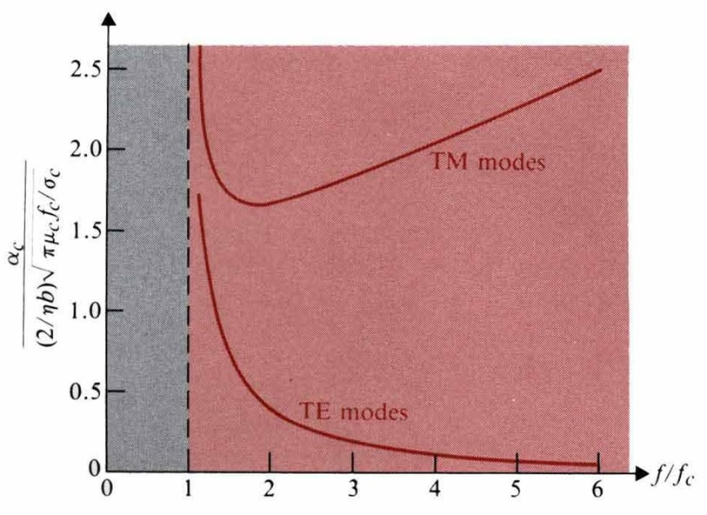
$$β=ω\sqrt{\text{με}}⋅\sqrt{1−(\frac{f_{c}}{f})^{2}}$$
$$α_{c}=\frac{P_{L}(z)}{2P(z)}=\frac{2R_{s}}{\text{ωμβ}b}(\frac{nπ}{b})^{2}=\frac{2R_{s}f_{c}^{2}}{η{\text{bf}}^{2}\sqrt{1−({f_{c}}/f)^{2}}}=\frac{2}{ηb}\sqrt{\frac{{\text{πμ}}_{c}f_{c}}{σ_{c}}}\sqrt{\frac{({f_{c}}/f)}{1−({f_{c}}/f)^{2}}}$$
Note: ∵ $\begin{aligned}\left\{α_{c} | \right\}\end{aligned}\left\{\right\}$ of the higher-order modes >$\begin{aligned}\left\{α_{c} | \right\}\end{aligned}\left\{\right\}$ of the lower-order modes, ∴ the lowest-order mode is often utilized in communication systems. Otherwise, the signal decays very soon.

Eg. A waveguide is formed by two parallel copper sheets, which is separated by a 5cm thick lossy dielectric ε_{r}=2.25, μ_{r}=1, σ=10⁻¹⁰(S/m). For an operating frequency of 10GHz, find α_{d}, α_{c}, β, v_{p}, v_{g} and λ_{g} for (a) the TEM mode, (b) the TM₁ mode.
(Sol.) σ_{c}=5.8×10⁷(S/m)
- TEM: $β=ω\sqrt{\text{με}}=\text{314}\text{.}\text{16}{\text{rad}}/m$, $α_{d}=\frac{\text{ση}}{2}=1\text{.}\text{257}×{\text{10}}^{−8}{N_{p}}/m$,
$α_{c}=\frac{1}{b}\sqrt{\frac{πfε}{σ_{c}}}=2\text{.}\text{078}×{\text{10}}^{−3}{N_{p}}/m$, $v_{p}=\frac{1}{\sqrt{\text{με}}}=2×{\text{10}}^{8}m/s$, $v_{g}=v_{p}$,
$$λ_{g}=\frac{v_{p}}{f}=0\text{.}\text{02}m$$
(b) TM₁: $f_{c}=\frac{1}{2b\sqrt{\text{με}}}=2×{\text{10}}^{9}\text{Hz}$, $β=ω\sqrt{\text{με}}⋅\sqrt{1−(\frac{f_{c}}{f})^{2}}=\text{307}\text{.}\text{88}{\text{rad}}/m$
$α_{d}=\frac{\text{ση}}{2\sqrt{1−({f_{c}}/f)^{2}}}=1\text{.}\text{282}×{\text{10}}^{−8}{N_{p}}/m$, $α_{c}=\frac{1}{ηb}⋅\frac{1}{\sqrt{({f_{c}}/f)[1−({f_{c}}/f)^{2}]}}=4\text{.}\text{237}×{\text{10}}^{−3}{N_{p}}/m$
$v_{p}=\frac{ω}{β}=2\text{.}\text{041}×{\text{10}}^{8}m/s$, $v_{g}=\frac{(3×{\text{10}}^{8})^{2}}{2\text{.}\text{25}v_{p}}=1\text{.}\text{96}×{\text{10}}^{8}m/s$, $λ_{g}=\frac{v_{p}}{f}=0\text{.}\text{0204}m$

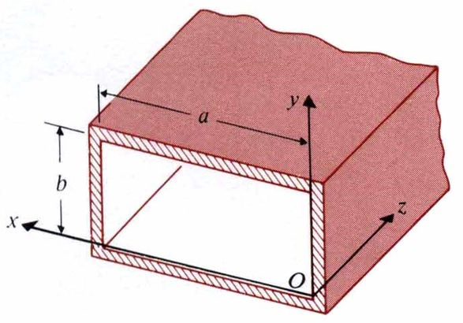
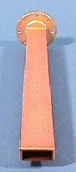
6-3 Rectangular Waveguides

Case 1 TM_{mn} modes: H_{z}=0, $E_{z}(x,y,z)=E_{z}^{0}(x,y)e^{−γz}$
,
at x=0, a, and y=0, b
Eigenvalues: $h^{2}=(\frac{mπ}{a})^{2}+(\frac{nπ}{b})^{2}$,
Waveguide’s equations$⇒$
$γ=jβ=j\sqrt{ω^{2}\text{με}−(\frac{mπ}{a})^{2}−(\frac{nπ}{b})^{2}}$. Note: TM_{mn} mode, neither m nor n can be zero.
Cutoff frequency: $(f_{c})_{{\text{TM}}_{\text{mn}}}=\frac{1}{2\sqrt{\text{με}}}\sqrt{(\frac{m}{a})^{2}+(\frac{n}{b})^{2}}$
In case of f>f_{c}: waves can propagate, else if f<f_{c}: evanescent waves (cutoff).

Case 2 TE_{mn} modes: E_{z}=0,
, at $\begin{aligned}x=0,a \\ y=0,b\end{aligned}$
$⇒$
Waveguide’s equations$⇒$
where and $(f_{c})_{{\text{TE}}_{\text{mn}}}=\frac{1}{2\sqrt{\text{με}}}\sqrt{(\frac{m}{a})^{2}+(\frac{n}{b})^{2}}$
Note: We prefer the single-mode waveguide because the fundamental mode has the lowest attenuation and avoid modal dispersion. The bandwidth of the single-mode waveguide is (f_{c})₁<f<(f_{c})₂.

Eg. Calculate in ascending order the cutoff frequencies of an a×b rectangular waveguide for the following modes: TE₀₁, TE₁₀, TE₁₁, and TE₀₂ if a=2b.
(Sol.) $f_{c}=\frac{1}{2\sqrt{\text{με}}}\sqrt{(\frac{m}{a})^{2}+(\frac{n}{b})^{2}}$, a=2b$⇒(f_{c})_{{\text{TE}}_{\text{10}}}=\frac{1}{4b\sqrt{\text{με}}}$,$(f_{c})_{{\text{TE}}_{\text{01}}}=\frac{1}{2b\sqrt{\text{με}}}$
$(f_{c})_{{\text{TE}}_{\text{11}}}=(f_{c})_{{\text{TM}}_{\text{11}}}=\frac{\sqrt{5}}{4b\sqrt{\text{με}}}$, $(f_{c})_{{\text{TE}}_{\text{02}}}=\frac{1}{b\sqrt{\text{με}}}$
Note: In case of 2b>a>b, the fundamental mode of the rectangular waveguide is TE₁₀ mode. It has the lowest cutoff frequency and the corresponding cutoff wavelength . It means that the TE₁₀ mode will be cut off in case of or

Dispersion: Waves have different velocities
Modal Dispersion: Different modes have distinct phase velocities.

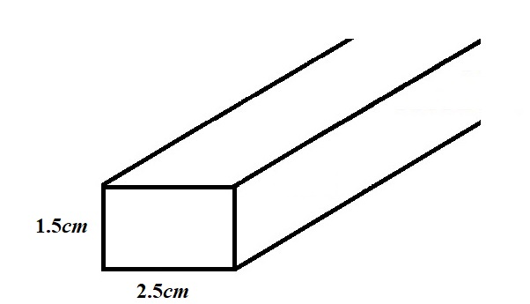
Eg. Calculate and compare the values of β, v_{p}, v_{g}, λ_{g} and $Z_{{\text{TE}}_{\text{10}}}$ for a 2.5cm×1.5cm rectangular waveguide operating at 7.5GHz. if the waveguide is hollow.
(Sol.) μ=μ₀,ε=ε₀, $(f_{c})_{{\text{TE}}_{\text{10}}}=\frac{1}{2a}\frac{1}{\sqrt{\text{με}}}=6×{\text{10}}^{9}\text{Hz}$, $\sqrt{1−(\frac{f_{c}}{f})^{2}}$=0.6
$β=ω\sqrt{\text{με}}⋅\sqrt{1−(\frac{f_{c}}{f})^{2}}$=94.25rad/m, $v_{p}=\frac{1}{\sqrt{\text{με}}}⋅\frac{1}{\sqrt{1−(f_{c}/f)^{2}}}$= 5×10⁸ m/s
λ_{g}=v_{p}/f=0.067m, $Z_{{\text{TE}}_{\text{10}}}=\frac{\text{120}π}{\sqrt{1−(f_{c}/f)^{2}}}$=628.3Ω, $v_{g}=\frac{1}{\sqrt{\text{με}}}⋅\sqrt{1−(\frac{f_{c}}{f})^{2}}$=1.8×10⁸ m/s
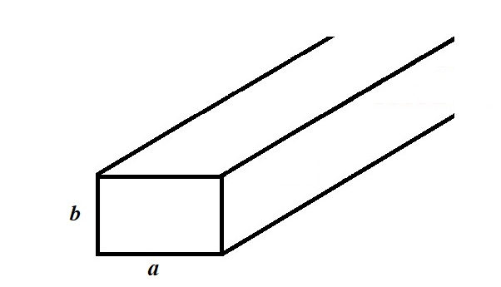
Eg. An air-filled a×b (b<a<2b) rectangular waveguide is to be constructed to operate at 3GHz in the dominant mode. We desire the operating frequency to be at least 20% higher than the cutoff frequency of the dominant mode and also at least 20% below the cutoff frequency of the next higher-order mode. (a) Give a typical design for the dimensions a and b. (b) Calculate for your design β, v_{p}, λ_{g} and the wave impedance at the operating frequency. [台大電研]
(Sol.) (a) $f_{c}=\frac{1}{2\sqrt{\text{με}}}⋅\sqrt{(\frac{m}{a})^{2}+(\frac{n}{b})^{2}}$. b<a<2b, the dominant mode: TE₁₀, the next mode: TE₀₁
$(f_{c})_{{\text{TE}}_{\text{10}}}=\frac{1}{2a\sqrt{\text{με}}}$, $(f_{c})_{{\text{TE}}_{\text{01}}}=\frac{1}{2b\sqrt{\text{με}}}$, $\frac{3×{\text{10}}^{9}−(1/2a\sqrt{\text{με}})}{(1/2a\sqrt{\text{με}})}>\text{20}\text{\%}$,
$\frac{(1/2b\sqrt{\text{με}})−3×{\text{10}}^{9}}{(1/2b\sqrt{\text{με}})}>\text{20}\text{\%}$$⇒a≥0\text{.}\text{06}m$, $b≤0\text{.}\text{04}m$, and a<2b
(b) Choose a=0.065m, b=0.035m, $(f_{c})_{{\text{TE}}_{\text{10}}}=2\text{.}3×{\text{10}}^{9}(\text{Hz})$, $\sqrt{1−(\frac{f_{c}}{f})^{2}}=0\text{.}\text{679}$,
$β=ω\sqrt{\text{με}}⋅\sqrt{1−(\frac{f_{c}}{f})^{2}}=\text{40}\text{.}\text{15}{\text{rad}}/m$, $v_{p}=\frac{1}{\sqrt{\text{με}}}⋅\frac{1}{\sqrt{1−(f_{c}/f)^{2}}}=4\text{.}7×{\text{10}}^{8}m/s$,
$λ_{g}=\frac{v_{p}}{f}=0\text{.}\text{157}m$,
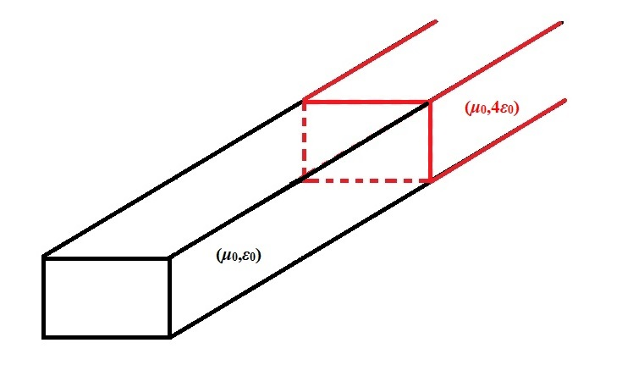
Eg. A 3cm×1.5cm rectangular waveguide operating at 6GHz has a dielectric discontinuity between medium 1 (μ₀,ε₀) and medium 2 (μ₀,4ε₀). (a) Find the SWR in the free-space region. (b) Find the length and the permittivity of a quarter-wave section to achieve a match between two media.
(Sol.) (a) For TE₁₀ mode, ,
$Z_{1}=\sqrt{μ_{0}/ε_{0}}/\sqrt{1−(f_{c1}/f)^{2}}=\text{682}Ω$,
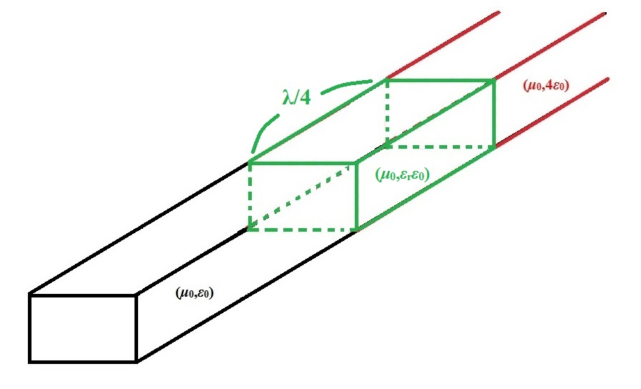
$⇒Γ=\frac{Z_{2}−Z_{1}}{Z_{2}+Z_{1}}=−0\text{.}\text{5337}$$⇒$SWR=$\frac{1+\left|Γ\right|}{1−\left|Γ\right|}$=3.289
(b)$f_{c3}=\frac{1}{2a}\frac{1}{\sqrt{μ_{0}ε_{r}ε_{0}}}$ and $Z_{3}=\sqrt{μ_{0}/ε_{r}ε_{0}}/\sqrt{1−(f_{c3}/f)^{2}}=\sqrt{Z_{1}Z_{2}}$$⇒$ε_{r}=1.6995
d=λ₃/4=v_{p3}/4f=1.24685×10⁻²m

Bending and T-Branches of Waveguides:
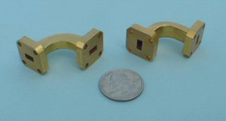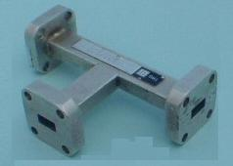

Magic-T-junction: (made of rectangular metallic waveguide)
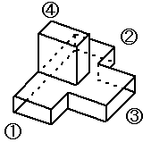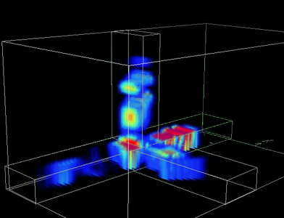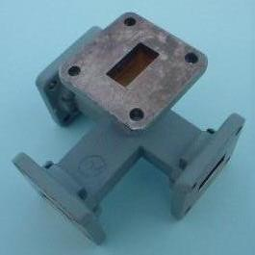

Eg. (a) Write the instantaneous field expression for the TE₁₀ mode in a rectangular waveguide having sides a and b. (b) Sketch the electric and magnetic field lines in typical xy-, yz-, and xz-planes. (c) Sketch the surface currents on the guide walls.
(Sol.) (a) m=1, n=0,
$E_{x}(x,y,z;t)=0$, $E_{z}(x,y,z;t)=0$, $E_{y}(x,y,z;t)=\frac{\text{ωμ}}{h^{2}}(\frac{π}{a})H_{0}\text{sin}(\frac{π}{a}x)\text{sin}(ωt−βz)$,
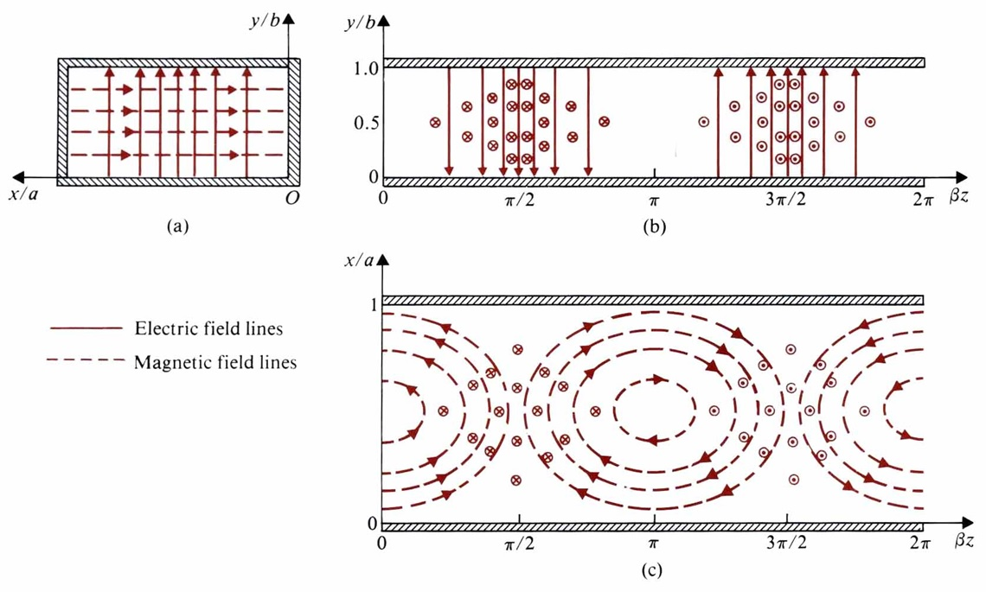
$H_{x}(x,y,z;t)=−\frac{β}{h^{2}}(\frac{π}{a})H_{0}\text{sin}(\frac{π}{a}x)\text{cos}(ωt−βz)$,$H_{y}(x,y,z;t)=0$
where $β=\sqrt{k^{2}−h^{2}}=\sqrt{ω^{2}\text{με}−(\frac{π}{a})^{2}}$
(b) $(\frac{\text{dx}}{\text{dz}})_{H}=\frac{β}{h^{2}}(\frac{π}{a})\text{tan}(\frac{π}{a}x)\text{tan}βz$
(c) $J_{s}={\hat{a}}_{n}×H$. At t=0, $J_{s}(x=0)=−\hat{y}H_{z}(0,y,z;0)=−\hat{y}H_{0}\text{cos}βz$
$$J_{s}(x=a)=\hat{y}H_{z}(a,y,z;0)=J_{s}(x=a)$$
$$J_{s}(y=0)=\hat{x}H_{z}(x,0,z;0)−\hat{z}H_{x}(x,0,z;0)=\hat{x}H_{0}\text{cos}(\frac{π}{a}x)\text{cos}(βz)−\hat{z}\frac{β}{h^{2}}(\frac{π}{a})H_{0}\text{sin}(\frac{π}{a}x)\text{sin}βz$$
$$J_{s}(y=b)=−J_{s}(y=0)$$
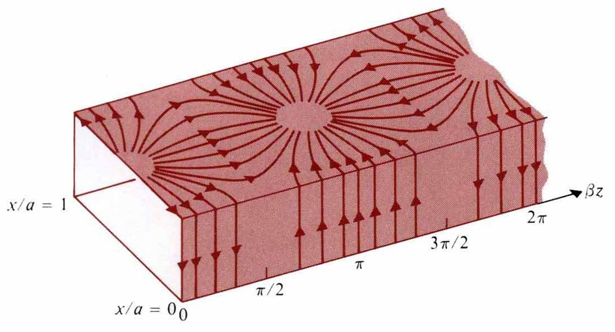
Attenuation in the rectangular waveguide:
α=α_{d} +α_{c}, where $α_{d}=\frac{\text{ση}}{2\sqrt{1−(f_{c}/f)^{2}}}$ and $α_{c}=\frac{P_{L}(z)}{2P(z)}$.
Consider TE₁₀ mode:
and
$P_{L}(z)=2[P_{L}(z)]_{x=0}+2[P_{L}(z)]_{y=0}$,
and
$$⇒P_{L}(z)=\left\{b+\frac{a}{2}[1+(\frac{βa}{π})^{2}]\right\}H_{0}^{2}R_{s}=[b+\frac{a}{2}(\frac{f_{c}}{f})^{2}]H_{0}^{2}R_{s}$$
$(α_{c})_{{\text{TE}}_{\text{10}}}=\frac{R_{s}[1+(2b/a)(f_{c}/f)^{2}]}{ηb\sqrt{1−(f_{c}/f)^{2}}}=\frac{1}{ηb}\sqrt{\frac{{πfμ}_{c}}{σ_{c}[1−(f_{c}/f)^{2}]}}[1+\frac{2b}{a}(\frac{f_{c}}{f})^{2}]$, $R_{s}=\sqrt{\frac{{πfμ}_{c}}{σ_{c}}}$
Similar approach $⇒(α_{c})_{{\text{TM}}_{\text{11}}}=\frac{2R_{s}[(b/a^{2})+(a/b^{2})]}{η\text{ab}\sqrt{1−(f_{c}/f)^{2}[(1/a^{2})+(1/b^{2})]}}$
General Cases: $\begin{aligned}\left\{(α_{c})_{{\text{TE}}_{\text{mn}}}=\frac{2R_{s}}{ηb\sqrt{1−(f_{c}/f)^{2}}}\left\{1+(\frac{b}{a})(\frac{f_{c}}{f})^{2}+[\frac{1}{2}−(\frac{f_{c}}{f})^{2}]⋅\frac{\frac{b}{a}(\frac{b}{a}m^{2}+n^{2})}{\frac{b^{2}}{a^{2}}m^{2}+n^{2}}\right\} | \right.\end{aligned}$
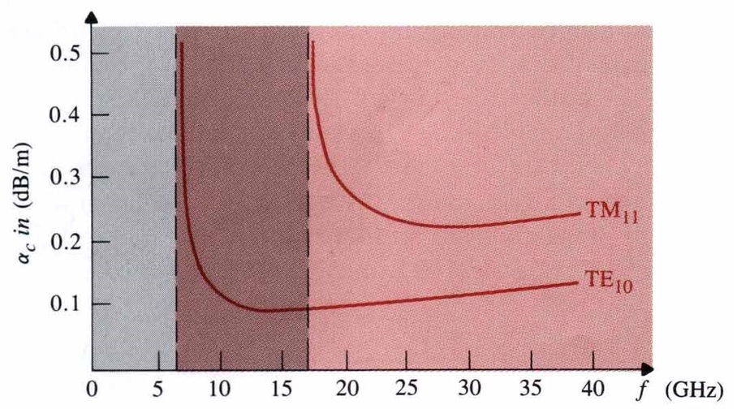
Eg. A TE₁₀ wave at 10GHz propagates in a brass σ_{c}=1.57×10⁷(S/m) rectangular waveguide with inner dimensions a=1.5cm and b=0.6cm, which is filled with ε_{r}=2.25, μ_{r}=1, loss tangent=4×10⁻⁴. Determine (a) the phase constant, (b) the guide wavelength, (c) the phase velocity, (d) the wave impedance, (e) the attenuation constant due to loss in the dielectric, and (f) the attenuation constant due to loss in the guide walls.
(Sol.) f=10¹⁰Hz, (m)
For TE₁₀ mode, $f_{c}=\frac{v}{2a}=\frac{2×{\text{10}}^{8}}{2×(1\text{.}5×{\text{10}}^{−2})}=0\text{.}\text{667}×{\text{10}}^{\text{10}}\text{Hz}$
,.(m)
$v_{p}=\frac{v}{\sqrt{1−(f_{c}/f)^{2}}}=2\text{.}\text{68}×{\text{10}}^{8}m/s$, $Z_{{\text{TE}}_{\text{10}}}=\frac{\sqrt{μ/ε}}{\sqrt{1−(f_{c}/f)^{2}}}=\text{337}\text{.}4(Ω)$
$σ=4×{\text{10}}^{−4}\text{ωε}=5×{\text{10}}^{−4}S/m$, $α_{d}=\frac{σ}{2}Z_{{\text{TE}}_{\text{10}}}=0\text{.}\text{084}{\text{Np}}/m=0\text{.}\text{73}{\text{dB}}/m$
$R_{s}=\sqrt{\frac{{πfμ}_{c}}{σ_{c}}}=0\text{.}\text{05101}(Ω)$,
$α_{c}=\frac{R_{s}[1+(2b/a)(f_{c}/f)^{2}]}{ηb\sqrt{1−(f_{c}/f)^{2}}}=0\text{.}\text{0526}{\text{Np}}/m=0\text{.}\text{457}{\text{dB}}/m$.

Eg. (a) Determine the value of f_{c}/f at which the attenuation constant due to conductor losses in an a×b rectangular waveguide for the TE₁₀ mode is a minimum. What is the minimum obtainable α_{c} in a 2cm1cm guide? At what frequency? (b) Determine the value of $(f/f_{c})_{{\text{TM}}_{\text{11}}}$ at which this attenuation constant is a minimum.
(Sol.) (a) $(α_{c})_{{\text{TE}}_{\text{10}}}=\frac{1}{ηb}⋅\sqrt{\frac{{πfμ}_{c}}{σ_{c}[1−(f_{c}/f)^{2}]}}[1+\frac{2b}{a}(\frac{f_{c}}{f})^{2}]$, $\frac{d(α_{c})_{{\text{TE}}_{\text{10}}}}{\text{df}}=0$
$$⇒f=f_{c}⋅[\frac{(6b+3a)−\sqrt{(6b+3a)^{2}−8\text{ab}}}{2a}]^{{−1}/2}$$
(b) $(α_{c})_{{\text{TM}}_{\text{11}}}=\frac{2R_{s}(b/a^{2}+a/b^{2})}{η\text{ab}\sqrt{1−(f_{c}/f)^{2}}(1/{a^{2}}{+1}/{b^{2}})}$, $\frac{d(α_{c})_{{\text{TM}}_{\text{11}}}}{\text{df}}=0$$⇒f=\sqrt{3}f_{c}$
Eg. An air-filled rectangular waveguide made of copper and having transverse dimensions a=7.20cm and b=3.40cm operates at a frequency 3GHz in the dominant mode. Find (a) f_{c}, (b) λ_{g}, (c) α_{c}, and (d) the distance over which the field intensities of the propagating wave will be attenuated by 50%.
(Sol.) σ_{c}=5.8×10⁷S/m (a) $(f_{c})_{{\text{TE}}_{\text{10}}}=\frac{1}{2a\sqrt{\text{με}}}=2\text{.}\text{083}\text{GHz}<3\text{GHz}$
(b) $λ_{g}=\frac{λ}{\sqrt{1−(f_{c}/f)^{2}}}=0\text{.}\text{109}m$
(c) $(α_{c})_{{\text{TE}}_{\text{10}}}=\frac{1}{ηb}\sqrt{\frac{{πfμ}_{c}}{σ_{c}[1−(f_{c}/f)^{2}}}[1+\frac{2b}{a}(\frac{f_{c}}{f})^{2}]=2\text{.}\text{26}×{\text{10}}^{−3}N_{p}m$
(d) $0\text{.}5=e^{−α_{c}d}⇒d=\text{307}\text{.}\text{25}m$

Eg. An average power of 1kW at 10GHz is to be delivered to an antenna at the TE₁₀ mode by an air-filled rectangular copper waveguide 1m long and having sides a=2.25cm and b=1.00cm. Find (a) the attenuation constant due to conductor losses, (b) the maximum values of the electric and magnetic field intensities within the waveguide, (c) the maximum value of the surface current density on the conducting walls, (d) the total amount of average power dissipated in the waveguide. [台大電研]
(Sol.) (a) $(f_{c})_{{\text{TE}}_{\text{10}}}=\frac{1}{2a\sqrt{\text{με}}}=6×{\text{10}}^{9}(\text{Hz})$, $f=\text{10}×{\text{10}}^{9}\text{Hz}$, $\sqrt{1−(\frac{f_{c}}{f})^{2}}=0\text{.}\text{7454}$
$$(α_{c})_{{\text{TE}}_{\text{10}}}=\frac{1}{ηb}⋅\sqrt{\frac{{πfμ}_{c}}{σ_{c}[1−(f_{c}/f)^{2}]}}[1+\frac{2b}{a}(\frac{f_{c}}{f})^{2}]=0\text{.}\text{13}{\text{Np}}/m$$
(b) $P=\text{ωμβ}\text{ab}(\frac{{\text{aH}}_{0}}{2π})^{2}$, $β=ω\sqrt{\text{με}}⋅\sqrt{1−(f_{c}/f)^{2}}=\text{156}\text{.}1{\text{rad}}/m$, $h^{2}=(\frac{π}{a})^{2}$
$$⇒\text{1000}=3\text{.}\text{56}×{\text{10}}^{−2}H_{0}^{2}⇒H_{0}=\text{167}A/m⇒\left|E_{\text{max}}\right|={\left|E_{y}^{0}(x,y)\right|}_{\text{max}}=\frac{\text{ωμ}}{h^{2}}⋅\frac{π}{a}H_{0}=\text{94800}V/m$$
${\left|H_{x}^{0}(x,y)\right|}_{\text{max}}=\frac{βa}{π}H_{0}=\text{187}\text{.}4A/m$, ${\left|H_{z}^{0}(x,y)\right|}_{\text{max}}=H_{0}=\text{167}A/m$.
If at input end, all factor×e^{0.13} (=1.138)
(c) $J_{s}(x=0)=−\hat{y}H_{0}\text{cos}βz⇒\left|J_{s}(x=0)\right|=H_{0}$, $J_{s}(y=0)=\hat{y}×(\hat{x}H_{x}^{0}+\hat{z}H_{z}^{0})_{y=0}$
$⇒\left|J_{s}(y=0)\right|=\frac{E_{0}}{η_{0}}⋅{\left\{(\frac{f_{c}}{f})^{2}+[1−2(\frac{f_{c}}{f})^{2}⋅\text{sin}(\frac{πx}{σ})]\right\}}^{1/2}$, ∴ Max of $\left|J_{s}(y=0)\right|=\frac{E_{0}}{η_{0}}⋅\sqrt{1−(\frac{f_{c}}{f})^{2}}$
At the input end, this factor×1.138
(d) $ΔP=\text{1000}×[e^{2α_{c}⋅1}−1]=\text{26}\text{.}2W$ (∵ $P$ ${\left|E\right|}^{2}$ $e^{−2α⋅ℓ}$)
6-4 Circular Waveguides
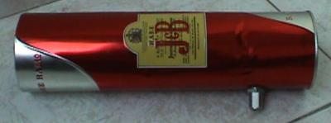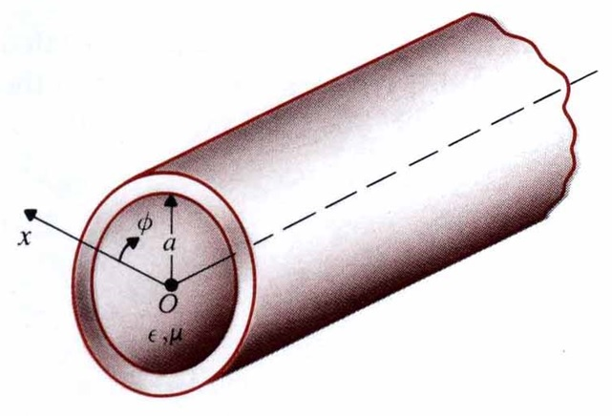
Circular waveguide’s equations:
$\begin{aligned}\left\{E_{r}=−\frac{j}{h^{2}}[β\frac{∂E_{z}}{∂r}+\frac{\text{ωμ}}{r}\frac{∂H_{z}}{∂φ}],H_{r}=\frac{j}{h^{2}}[\frac{\text{ωε}}{r}\frac{∂E_{z}}{∂φ}−β\frac{∂H_{z}}{∂r}] | \right.\end{aligned}$
Case 1 TM_{np} modes: H_{z}=0, and ▽_{t}²E_{z}+h²E_{z}=0
$$⇒\frac{1}{r}\frac{∂}{∂r}(r\frac{∂E_{z}}{∂r})+\frac{1}{r^{2}}\frac{∂^{2}E_{z}}{∂φ^{2}}+h^{2}E_{z}=0$$
and
at r=a and h²=γ²+k²$⇒$ h fulfills J_{n}(ha)=0 (the first root of J₀(x) is 2.405)
Case 2 TE_{np} modes: E_{z}=0, ▽_{t}²H_{z}+h²H_{z}=0$⇒H_{z}^{0}(r,φ)=C'_{n}J_{n}(\text{hr})\text{cos}nφ$
Waveguide’s equations
at r=a$⇒$h fulfills J’_{n}(ha)=0 (the first root of J’₁(x) is 1.841)
Note: The cutoff frequency of TE₁₁ mode: $(f_{c})_{{\text{TE}}_{\text{11}}}=\frac{h_{{\text{TE}}_{\text{11}}}}{2π\sqrt{\text{με}}}=\frac{0\text{.}\text{293}}{a\sqrt{\text{με}}}$ and the corresponding cutoff wavelength is where ($h_{{\text{TE}}_{\text{11}}}=\frac{1\text{.}\text{841}}{a}$).
Note: TE₁₁ mode is the fundament (dominant) mode of a circular waveguide.
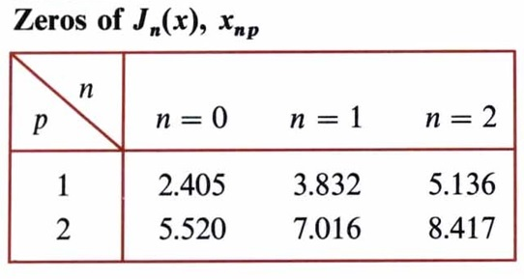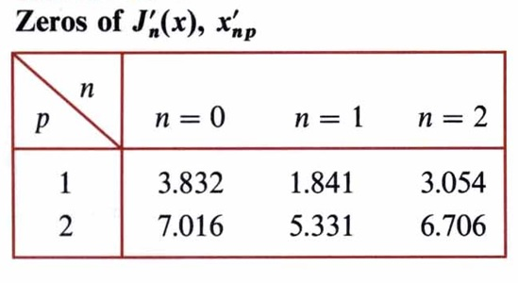
Note: For TM_{np} mode, h fulfills the p^{th} root of J_{n}(ha)=0, but for TE_{np} mode, h fulfills the p^{th} root of J’_{n}(ha)=0.

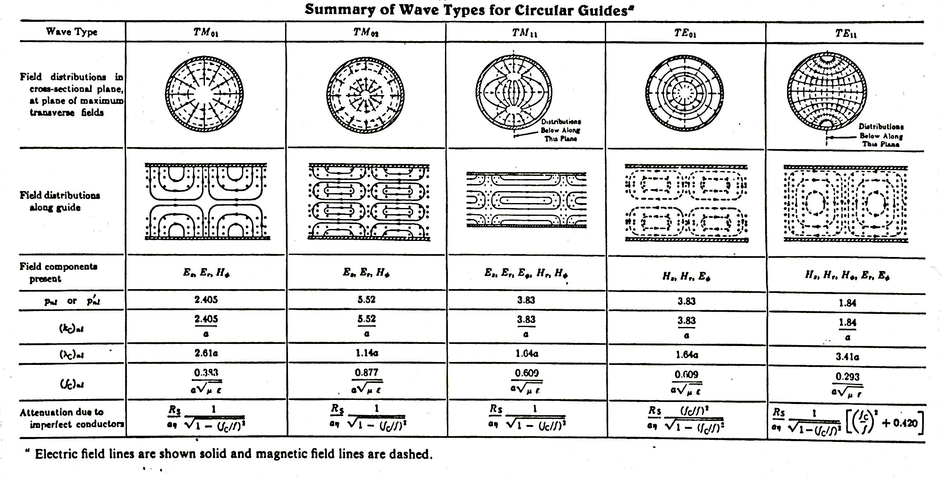
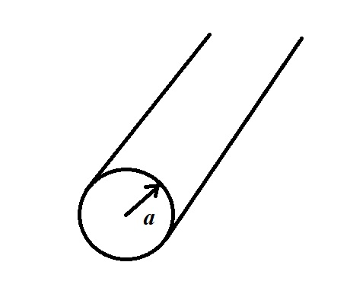
Eg. (a) A 10GHz signal is to be transmitted inside a hollow circular conducting pipe. Determine the inside diameter of the pipe such that its lowest cutoff frequency is 20% below this signal frequency. (b) If the pipe is to operate at 15GHz, what waveguide modes can propagate in the pipe?
(Sol.) (a) =10¹⁰(1-20%)=810⁹, 2a=0.022m.
- f_{c} of waveguide with a=0.011(m) is $(f_{c})_{{\text{TE}}_{\text{11}}}$=8GHz<15GHz.
$(f_{c})_{{\text{TM}}_{\text{01}}}=\frac{2\text{.}\text{405}}{2πa\sqrt{μ_{0}ε_{0}}}=\text{10}\text{.}\text{45}(\text{GHz})$, $(f_{c})_{{\text{TE}}_{\text{21}}}=\frac{3\text{.}\text{054}}{2πa\sqrt{μ_{0}ε_{0}}}=\text{13}\text{.}\text{27}(\text{GHz})$
6-5 Rectangular Cavity Resonators
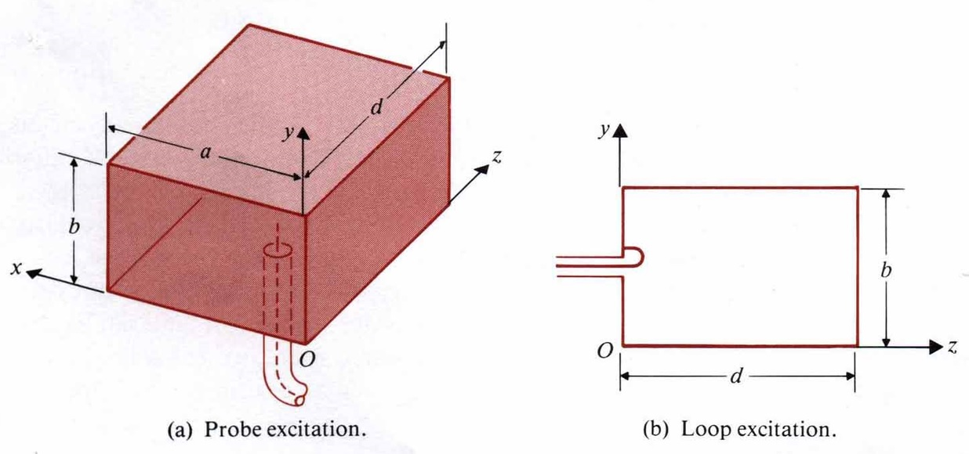
Case 1 TM_{mnp} mode: H_{z}=0, neither m nor n =0, p can be 0.
$\begin{aligned}\left\{E_{z}(x,y,z)=E_{0}\text{sin}(\frac{mπ}{a}x)\text{sin}(\frac{nπ}{b}y)\text{cos}(\frac{pπ}{d}z) | \right.\left\{E_{x}(x,y,z)=−\frac{1}{h^{2}}(\frac{mπ}{a})(\frac{pπ}{d})E_{0}\text{cos}(\frac{mπ}{a}x)\text{sin}(\frac{nπ}{b}y)\text{sin}(\frac{pπ}{d}z) | \right.\left\{E_{y}(x,y,z)=−\frac{1}{h^{2}}(\frac{nπ}{b})(\frac{pπ}{d})E_{0}\text{sin}(\frac{mπ}{a}x)\text{cos}(\frac{nπ}{b}y)\text{sin}(\frac{pπ}{d}z) | \right.\left\{H_{x}(x,y,z)=\frac{j\text{ωε}}{h^{2}}(\frac{nπ}{b})E_{0}\text{sin}(\frac{mπ}{a}x)\text{cos}(\frac{nπ}{b}y)\text{cos}(\frac{pπ}{d}z) | \right.\end{aligned}$,
where $h^{2}=(\frac{mπ}{a})^{2}+(\frac{nπ}{b})^{2}+(\frac{pπ}{d})^{2}$
Case 2 TE_{mnp} mode: E_{z}=0, p≠0. Either m or n =0, but not both.
$$\begin{aligned}\left\{H_{z}(x,y,z)=H_{0}\text{cos}(\frac{mπ}{a}x)\text{cos}(\frac{nπ}{b}y)\text{sin}(\frac{pπ}{d}z) | \right.\left\{E_{x}(x,y,z)=\frac{j\text{ωμ}}{h^{2}}(\frac{nπ}{b})H_{0}\text{cos}(\frac{mπ}{a}x)\text{sin}(\frac{nπ}{b}y)\text{sin}(\frac{pπ}{d}z) | \right.\left\{E_{y}(x,y,z)=−\frac{j\text{ωμ}}{h^{2}}(\frac{mπ}{a})H_{0}\text{sin}(\frac{mπ}{a}x)\text{cos}(\frac{nπ}{b}y)\text{sin}(\frac{pπ}{d}z) | \right.\left\{H_{x}(x,y,z)=−\frac{1}{h^{2}}(\frac{mπ}{a})(\frac{pπ}{d})H_{0}\text{sin}(\frac{mπ}{a}x)\text{cos}(\frac{nπ}{b}y)\text{cos}(\frac{pπ}{d}z) | \right.\end{aligned}$$
Both have the same resonant frequency (degenerate modes): $f_{\text{mnp}}=\frac{1}{2\sqrt{\text{με}}}⋅\sqrt{(\frac{m}{a})^{2}+(\frac{n}{b})^{2}+(\frac{p}{d})^{2}}$
Note: TE₁₀₁ mode is the dominant mode of the rectangular resonator in case of a>b<d.
Eg. Given an air-filled lossless rectangular cavity resonator with dimensions 8cm6cm5cm, find the first twelve lowest-order modes and their resonant frequencies.
(Sol.) $f_{r}=\frac{c}{2}\sqrt{(\frac{m}{0\text{.}\text{08}})^{2}+(\frac{n}{0\text{.}\text{06}})^{2}+(\frac{p}{0\text{.}\text{05}})^{2}}=1\text{.}5×{\text{10}}^{\text{10}}⋅\sqrt{(\frac{m}{8})^{2}+(\frac{n}{6})^{2}+(\frac{p}{5})^{2}}$
${\text{TM}}_{\text{110}}⇒f_{r}=3\text{.}\text{125}\text{GHz}$, ${\text{TE}}_{\text{101}}⇒f_{r}=3\text{.}\text{54}\text{GHz}$,
${\text{TE}}_{\text{111}},{\text{TM}}_{\text{111}}⇒f_{r}=4\text{.}\text{33}\text{GHz}$, ……
Quality Factor of Rectangular Cavity Resonators: Q=$\frac{ωW}{P_{L}}$, W=W_{e}+W_{m}
Q=2π×(Time-average energy stored at a resonant frequency)/(Energy dissipated in one period)
Consider TE₁₀₁ mode:
$$\begin{aligned}W_{e}=\frac{ε_{0}}{4}\int{{\left|E_{y}\right|}^{2}\text{dv}}=\frac{ε_{0}ω^{2}μ_{0}^{2}π^{2}}{4h^{4}a^{2}}H_{0}^{2}\int{}\int{}\int{{\text{sin}}^{2}(\frac{π}{a}x){\text{sin}}^{2}(\frac{π}{d}z)\text{dxdydz}}=\frac{ε_{0}ω_{\text{101}}^{2}μ_{0}^{2}π^{2}}{4π^{2}}H_{0}^{2}(\frac{a}{2})b(\frac{d}{2}) \\ \frac{1}{4}ε_{0}μ_{0}^{2}a^{3}{\text{bdf}}_{\text{101}}^{2}H_{0}^{2}\end{aligned}$$
$$\begin{aligned}W_{m}=\frac{μ_{0}}{4}\int{\left\{{\left|H_{x}\right|}^{2}+{\left|H_{y}\right|}^{2}\right\}\text{dv}}=\frac{μ_{0}}{4}H_{0}^{2}\int{}\int{}\int{\left\{\frac{π^{4}}{h^{4}a^{2}d^{2}}{\text{sin}}^{2}(\frac{π}{a}x){\text{cos}}^{2}(\frac{π}{d}z)+{\text{cos}}^{2}(\frac{π}{a}x){\text{sin}}^{2}(\frac{π}{d}z)\right\}\text{dxdydz}} \\ \frac{μ}{4}H_{0}^{2}\left\{\frac{a^{2}}{d^{2}}(\frac{a}{2})b(\frac{d}{2})+(\frac{a}{2})b(\frac{d}{2})\right\}=\frac{μ_{0}}{\text{16}}\text{abd}(\frac{a^{2}}{d^{2}}+1)H_{0}^{2}\end{aligned}$$
where h²=$(\frac{π}{a})^{2}+(\frac{π}{d})^{2}$ and the resonant frequency: $(f_{r})_{{\text{TE}}_{\text{101}}}=\frac{1}{2\sqrt{μ_{0}ε_{0}}}\sqrt{\frac{1}{a^{2}}+\frac{1}{d^{2}}}$
At resonance, W=2W_{e}=2W_{m}=$\frac{μ_{0}}{8}⋅H_{0}^{2}\text{abd}(\frac{a^{2}}{d^{2}}+1)$
Power loss per unit area: P_{av}=$\frac{1}{2}{\left|J_{s}\right|}^{2}R_{s}=\frac{1}{2}{\left|H\right|}^{2}R_{s}$
$$P_{L}=\oint{P_{\text{av}}\text{ds}}=R_{s}\left\{\int{}\int{{\left|H_{x}(z=0)\right|}^{2}\text{dxdy}+\int{}\int{{\left|H_{z}(x=0)\right|}^{2}\text{dydz}}}+\int{}\int{{\left|H_{x}\right|}^{2}\text{dxdz}}+\int{}\int{{\left|H_{z}\right|}^{2}\text{dxdz}}\right\}$$
$=\frac{R_{s}H_{0}^{2}}{2}\left\{\frac{a^{2}}{d}(\frac{b}{d}+\frac{1}{2})+d(\frac{b}{a}+\frac{1}{2})\right\}$$⇒Q_{{\text{TE}}_{\text{101}}}=\frac{{πf}_{\text{101}}μ_{0}\text{abd}(a^{2}+d^{2})}{R_{s}[2b(a^{3}+d^{3})+\text{ad}(a^{2}+d^{2})]}$
Similarly, the expression for the Q of an air-filled a×b×d rectangular resonator for the TM₁₁₀ mode is $(Q)_{TM_{\text{110}}}=\frac{π(f_{r})_{{\text{TM}}_{\text{110}}}μ_{0}\text{abd}(a^{2}+b^{2})}{R_{s}[2d(a^{3}+d^{3})+\text{ab}(a^{2}+b^{2})]}$.
Eg. An air-filled rectangular cavity with brass walls σ=1.57×10⁷(S/m) has the following dimensions: a=4cm, b=3cm, and d=5cm. (a) Determine the dominant mode and its resonant frequency for this cavity. (b) Find the Q and the time-average stored electric and magnetic energies at the resonant frequency, assuming H₀ to be 0.1A/m.
(Sol.) (a) $f_{r}=\frac{c}{2}\sqrt{(\frac{m}{0\text{.}\text{04}})^{2}+(\frac{n}{0\text{.}\text{03}})^{2}+(\frac{p}{0\text{.}\text{05}})^{2}}$, dominant mode: TE₁₀₁, $(f_{r})_{{\text{TE}}_{\text{101}}}=4\text{.}8\text{GHz}$
(b) $(Q)_{{\text{TE}}_{\text{101}}}=\frac{π(f_{r})_{{\text{TE}}_{\text{101}}}μ_{0}\text{abd}(a^{2}+d^{2})}{R_{s}[2b(a^{3}+b^{3})+\text{ad}(a^{2}+d^{2})]}=\text{6869}$, $R_{s}=\sqrt{\frac{π(f_{r})_{{\text{TE}}_{\text{101}}}μ_{0}}{σ_{c}}}$
At the resonant frequency, $W_{e}=W_{m}=\frac{ε_{0}}{4}μ^{2}a^{3}\text{bd}(f_{r})_{{\text{TE}}_{\text{101}}}^{2}H_{0}^{2}=7\text{.}\text{73}×{\text{10}}^{−\text{14}}(J)$
Eg. For an air-filled rectangular copper cavity resonator, determine how much b should be increased in order to make Q 20% higher.
(Sol.) $\frac{Q_{2}}{Q_{1}}=1\text{.}2=\sqrt{\frac{b_{2}}{b_{1}}}⇒b_{2}=1\text{.}\text{44}b_{1}$
Eg. (a) What should be the size of a hollow cubic cavity made of copper in order for it to have a dominant resonant frequency of 10GHz? (b) Find the Q at that frequency.
(Sol.) (a) For a cubic cavity, a=b=d, TM₁₁₀, TE₀₁₁, and TE₁₀₁ are degenerate dominant modes. $f_{\text{101}}=\frac{3×{\text{10}}^{8}}{\sqrt{2}a}={\text{10}}^{\text{10}}(\text{Hz})$, $a=\frac{3×{\text{10}}^{8}}{\sqrt{2}×{\text{10}}^{\text{10}}}=2\text{.}\text{12}×{\text{10}}^{−2}m$.
(b) $Q_{\text{101}}=\frac{{πf}_{\text{101}}μ_{0}a}{3R_{s}}=\frac{a}{3}\sqrt{{πf}_{\text{101}}μ_{0}σ}$
For copper,$σ=5\text{.}\text{80}×{\text{10}}^{7}(S/m)$, $Q_{\text{101}}=(\frac{2\text{.}\text{12}}{3}×{\text{10}}^{−2})\sqrt{π{\text{10}}^{\text{10}}(4π{\text{10}}^{−7})(5\text{.}\text{80}×{\text{10}}^{7})}=\text{10700}\text{.}$

6-6 Circular Cavity Resonators
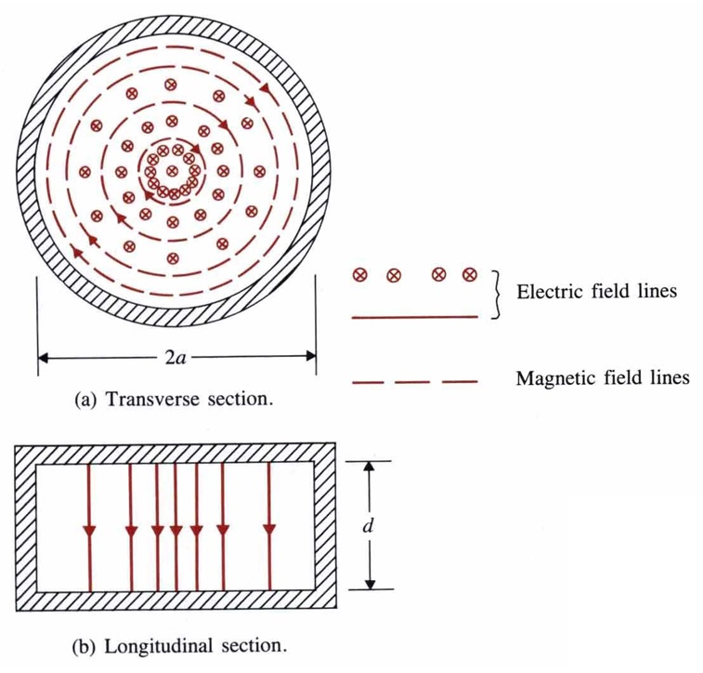
For an air-filled circular cylindrical cavity resonator of radius a and length d. The resonant frequencies are $(f_{r})_{{\text{TM}}_{\text{mnp}}}=\frac{1}{2π\sqrt{\text{με}}}\sqrt{(\frac{X_{\text{mn}}}{a})^{2}+(\frac{pπ}{d})^{2}}$, where J_{m}(X_{mn})=0
$(f_{r})_{{\text{TE}}_{\text{mnp}}}=\frac{1}{2π\sqrt{\text{με}}}\sqrt{(\frac{X'_{\text{mn}}}{a})^{2}+(\frac{pπ}{d})^{2}}$, where J’_{m}(X’_{mn})=0
Note: In case of 2d>2a>d, the dominant mode of the circular cylindrical cavity is TM₀₁₀ mode:
$E_{z}=C_{0}J_{0}(\text{hr})=C_{0}J_{0}(\frac{2\text{.}\text{405}}{a}r)$, $H_{φ}=−\frac{{\text{jC}}_{0}}{η_{0}}J'_{0}(\text{hr})=\frac{{\text{jC}}_{0}}{η_{0}}J_{1}(\frac{2\text{.}\text{405}}{a}r)$
Quality factor of the TM₀₁₀ mode: $Q_{{\text{TM}}_{\text{010}}}=\frac{ωW}{P_{L}}$.
$W=2W_{e}=\frac{ε_{0}}{2}\int_{v}{{\left|E_{z}\right|}^{2}\text{dv}}=\frac{ε_{0}C_{0}}{2}(2πd)\int{J_{0}^{2}(\frac{2\text{.}\text{405}}{a}r)\text{rdr}}$$=({\text{πε}}_{0}d)C_{0}^{2}[\frac{a}{2}J_{1}^{2}(2\text{.}\text{405})]$
$\begin{aligned}P_{L}=\frac{R_{s}}{2}\left\{2\int{{\left|J_{r}\right|}^{2}2π\text{rdr}+(2π\text{ad}){\left|J_{z}\right|}^{2}}\right\}={πR}_{s}\left\{2\int{{\left|H_{φ}\right|}^{2}\text{rdr}}+(\text{ad}){\left|H_{φ}(r=a)\right|}^{2}\right\} \\ \frac{{πR}_{s}C_{0}^{2}}{η_{0}^{2}}\left\{2\int{J_{1}^{2}(\frac{2\text{.}\text{405}}{a}r)\text{dr}}+(\text{ad})J_{1}^{2}(2\text{.}\text{405})\right\}=\frac{π{\text{aR}}_{s}C_{0}^{2}}{η_{0}^{2}}(a+d)J_{1}^{2}(2\text{.}\text{405})\end{aligned}$$⇒Q_{{\text{TM}}_{\text{010}}}=(\frac{η_{0}}{R_{s}})\frac{2\text{.}\text{405}}{2(1+a/d)}$, $(f_{r})_{{\text{TM}}_{\text{010}}}=\frac{2\text{.}\text{405}}{2πa\sqrt{μ_{0}ε_{0}}}=\frac{0\text{.}\text{115}}{a}×{\text{10}}^{9}\text{Hz}$
Eg. A hollow circular cylindrical cavity resonator is to be constructed of copper such that its length d equals its diameter 2a. (a) Determine a and d for a resonant frequency of 10GHz at the TM₀₁₀ mode. (b) Find the Q of the cavity at resonance.
(Sol.) (a) $(f_{r})_{{\text{TM}}_{\text{010}}}=\frac{0\text{.}\text{115}}{a}×{\text{10}}^{9}=\text{10}×{\text{10}}^{9}$, $a=1\text{.}\text{15}×{\text{10}}^{−2}m$, d=2a=2.30cm.
(b) $R_{s}=\sqrt{\frac{{πfμ}_{0}}{σ}}=\sqrt{\frac{π×{\text{10}}^{\text{10}}×(4π{\text{10}}^{−7})}{5\text{.}\text{80}×{\text{10}}^{7}}}=2\text{.}\text{61}×{\text{10}}^{2}(Ω)$, $Q=(\frac{\text{120}π}{2\text{.}\text{61}×{\text{10}}^{−2}})\frac{2\text{.}\text{405}}{2(1+1/2)}=\text{11},\text{580}\text{.}$

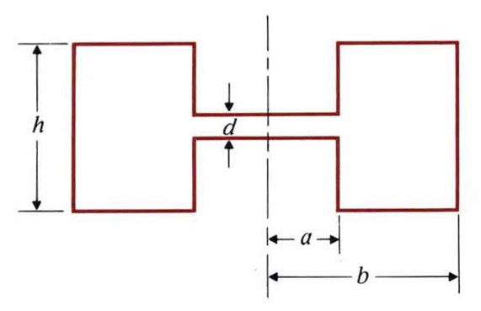
Eg. In some microwave applications, ring-shaped cavity resonators with a very narrow center part are used. A cross section of such a resonator is shown in the figure, in which d is very small in comparison with the resonant wavelength. Assuming that this the narrow center part and the inductance of the rest of the structure, find (a) the approximate resonant frequency. (b) the approximate resonant wavelength.
(Sol.) $C=\frac{\text{επ}a^{2}}{d}$, $L=\frac{μh}{2π}\text{ln}(\frac{b}{a})$
(a) $f_{r}=\frac{1}{2π\sqrt{\text{LC}}}$ (b) $λ_{r}=\frac{1}{f_{r}\sqrt{\text{με}}}$

6-7 Excitations of Waveguides
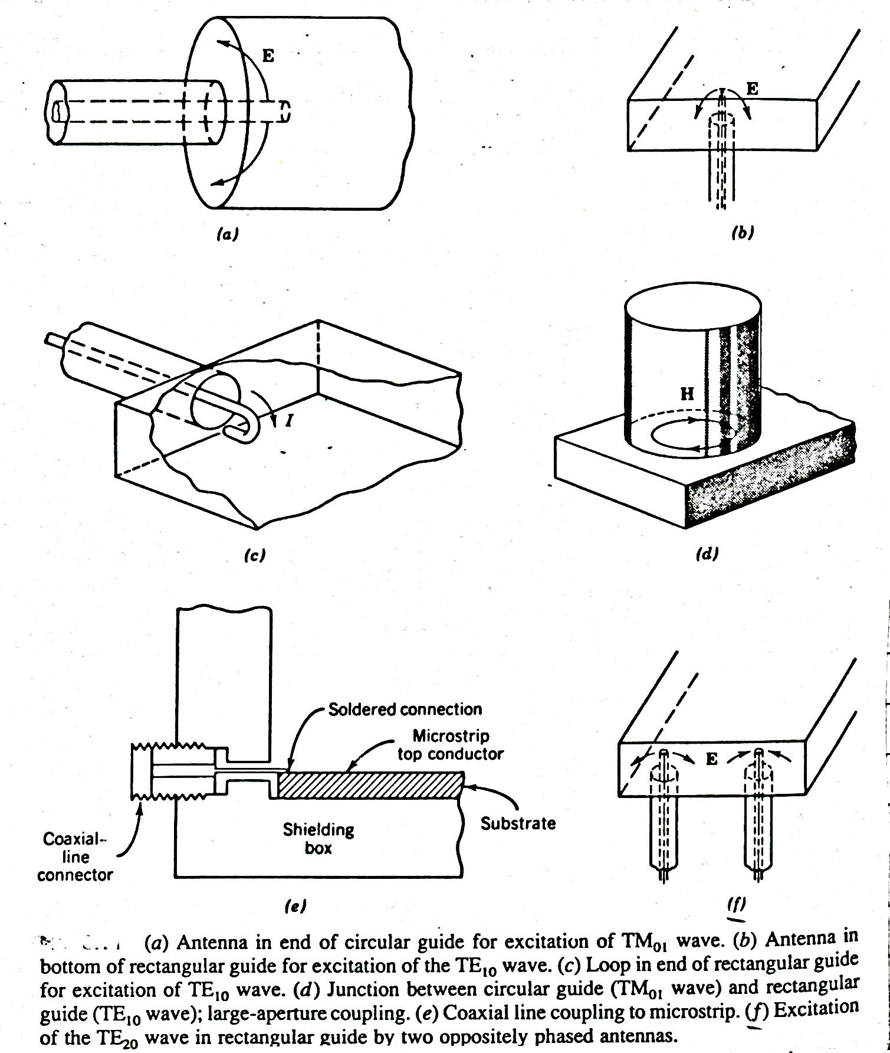

6-8 Directional couplers
