Chapter 4 Selected Topics for Circuits and Systems

4-1 Poisson’s and Laplace’s Equations
Poission’s equation: $∇⋅εE=ρ⇒∇^{2}V=−\frac{ρ}{ε}$
Laplace’s equation: If no charge exists, ρ=0, $∇^{2}V=0$

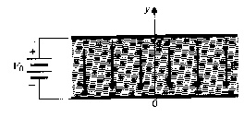
Eg. The two plates of a parallel-plate capacitor are separated by a distance d and maintained at potentials 0 and V₀. Assume negligible fringing effect at the edges, determine (a) the potential at any point between the plates, (b) the surface charge densities on the plates. [清大電研]
(Sol.) $\frac{d^{2}V}{{\text{dy}}^{2}}=0⇒V=c_{1}y+c_{2},V\left(y=0\right)=0,V\left(y=d\right)=V_{0}⇒V=\frac{V_{0}}{d}y$
$$E=−\hat{y}\frac{\text{dV}}{\text{dy}}=−\hat{y}\frac{V_{0}}{d},E_{n}={\hat{a}}_{n}⋅E=\frac{ρ}{ε}$$
At the lower plate: ${\hat{a}}_{n}=\hat{y},ρ_{\text{sl}}=−\frac{{εV}_{0}}{d}$.
At the upper plate: ${\hat{a}}_{n}=−\hat{y},ρ_{\text{ul}}=\frac{{εV}_{0}}{d}$

Eg. The upper and lower conducting plates of a large parallel-plate capacitor are separated by a distance d and maintained at potentials V₀ and 0, respectively. A dielectric slab of dielectric constant ε_{r} and uniform thickness 0.8d is placed over the lower plate. Assuming negligible fringing effect, determine (a) the potential and electric field distribution in the dielectric slab, (b) the potential and electric field distribution in the air space between the dielectric slab and the upper plate. [台大電研]
(Sol.) Set $V_{d}\left(y\right)=c_{1}y+c_{2},E_{d}=−\hat{y}c_{1},D_{d}=−\hat{y}ε_{0}ε_{r}c_{1}$
$$V_{a}\left(y\right)=c_{3}y+c_{4},E_{a}=−\hat{y}c_{3},D_{a}=−\hat{y}ε_{0}c_{3}$$
$V_{d}\left(0\right)=0,V_{a}\left(d\right)=V_{0}$, $V_{d}\left(0\text{.}8d\right)=V_{a}\left(0\text{.}8d\right)$, $D_{d}\left(0\text{.}8d\right)=D_{a}\left(0\text{.}8d\right)$
$$⇒c_{1}=\frac{V_{0}}{\left(0\text{.}8+0\text{.}2ε_{r}\right)d},c_{2}=0,c_{3}=\frac{ε_{r}V_{0}}{\left(0\text{.}8+0\text{.}2ε_{r}\right)}d,c_{4}=\frac{\left(1−ε_{r}\right)V_{0}}{1+0\text{.}\text{25}ε_{r}}$$
$$\left(a\right)V_{d}=\frac{5{\text{yV}}_{0}}{\left(4+ε_{r}\right)d},E_{d}=−\hat{y}\frac{5V_{0}}{\left(4+ε_{r}\right)d}\left(b\right)V_{a}=\frac{5ε_{r}y−4\left(ε_{r}−1\right)d}{\left(4+ε_{r}\right)d}V_{0},E_{a}=−\hat{y}\frac{5ε_{r}V_{0}}{\left(4+ε_{r}\right)d}$$
Eg. Show that uniqueness of electrostatic solutions.
(Proof) Let V₁ and V₂ satisfy $∇^{2}V_{1}=−\frac{ρ}{ε}$ and $∇^{2}V_{2}=−\frac{ρ}{ε}$. Define V_{d}=V₁-V₂, ▽²V_{d}=0
- On the conducting boundaries, V_{d} =0$⇒$V₁= V₂
- Let f= V_{d}, $A$=▽V_{d}
$∇⋅\left(V_{d}∇V_{d}\right)=∇⋅\left(fA\right)=f∇⋅A+A⋅∇f=V_{d}∇^{2}V_{d}+{\left|∇V_{d}\right|}^{2}$$⇒∯_{s}{{\left(V_{d}∇V_{d}\right)⋅{\hat{a}}_{n}\text{ds}=\iiint_{v^{'}}{\left|∇V_{d}\right|}}^{2}}\text{dv}$
$R→∞,V_{d}=V_{1}−V_{2}∝\frac{1}{R},∇V_{d}∝\frac{1}{R^{2}},\text{ds}∝R^{2}$$⇒∯_{s}{\left(V_{d}∇V_{d}\right)⋅{\hat{a}}_{n}\text{ds}→0},∴\iiint_{v}{{\left|∇V_{d}\right|}^{2}}\text{dv}=0⇒$ V_{d} =0$⇒$V₁= V₂

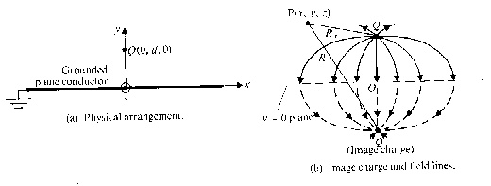
Image Theorem P(x,y,z) in the y>0 region is $V\left(x,y,z\right)=\frac{Q}{4{\text{πε}}_{0}}\left(\frac{1}{R_{+}}−\frac{1}{R_{−}}\right)$, where R₊ and R₋ are the distances from Q and –Q to the point P, respectively.

Eg. A point charge Q exists at a distance d above a large grounded conducting plane. Determine (a) the surface charge density ρ_{s}, (b) the total charge induced on the conducting plane. [交大光電所]
(Sol.) $E_{y=0}=−\hat{y}\frac{Q}{4{\text{πε}}_{0}R^{2}}⋅2\text{sin}θ=−\hat{y}\frac{\text{Qd}}{2{\text{πε}}_{0}{\left(d^{2}+r^{2}\right)}^{3/2}}$
$$\left(a\right)ρ_{s}=\hat{y}⋅εE_{y=0}=−\frac{\text{Qd}}{2π{\left(d^{2}+r^{2}\right)}^{3/2}},\left(b\right)\int{ρ_{s}2π\text{rdr}}=−Q$$

Eg. Two dielectric media with dielectric constants ε₁ and ε₂ are separated by a plane boundary at x=0. A point charge Q exists in medium 1 at distance d from the boundary. Determine Q₁ ＆ Q_{2.} (Q & -Q₁ in medium 1, or Q & Q₂ in medium 2)
(Sol.) $V_{1}(x=0)=\frac{Q}{4{\text{πε}}_{1}\sqrt{s^{2}+d^{2}}}−\frac{Q_{1}}{4{\text{πε}}_{1}\sqrt{s^{2}+d^{2}}},V_{2}(x=0)=\frac{Q+Q_{2}}{4{\text{πε}}_{2}\sqrt{s^{2}+d^{2}}}$
V₁=V₂, $ε_{1}\frac{∂V_{1}}{∂x}=ε_{2}\frac{∂V_{2}}{∂x}\text{at}x=0⇒\frac{Q−Q_{1}}{ε_{1}}=\frac{Q+Q_{2}}{ε_{2}}$, and $Q+Q_{1}=Q+Q_{2}⇒Q_{1}=Q_{2}=\frac{ε_{2}−ε_{1}}{ε_{2}+ε_{1}}Q$
Eg. A line charge density ρ_{l} located at a distance d from the axis of a parallel conducting circular cylinder of radius a. Both are infinitely long. Find the image position of line charge.
(Sol.) Assume $ρ_{i}=−ρ_{l},V=−\int_{r_{0}}^{r}{\text{Edr}}=−\frac{ρ_{l}}{2{\text{πε}}_{0}}\int_{r_{0}}^{r}{\frac{1}{r}\text{dr}}=\frac{ρ_{l}}{2{\text{πε}}_{0}}ℓn\frac{r_{o}}{r}$
$$⇒V_{M}=\frac{ρ_{l}}{2{\text{πε}}_{0}}ℓn\frac{r_{0}}{r}−\frac{ρ_{l}}{2{\text{πε}}_{0}}ℓn\frac{r_{0}}{r_{i}}=\frac{ρ_{l}}{2{\text{πε}}_{0}}ℓn\frac{r_{i}}{r}$$
$\frac{r_{i}}{r}=\frac{d_{i}}{a}=\frac{a}{d}=C⇒$$d_{i}=\frac{a^{2}}{d}$
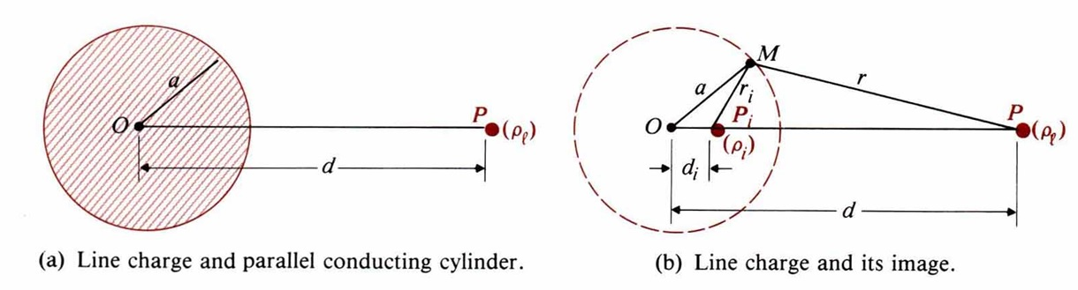

Eg. A point charge Q is placed at a distance d to a conducting sphere. Find its image.
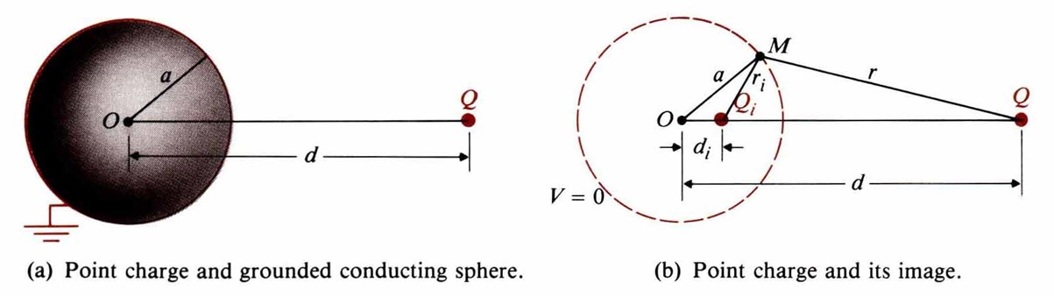
(Sol.) $V_{M}=\frac{1}{4{\text{πε}}_{0}}\left(\frac{Q}{r}+\frac{Q_{i}}{r_{i}}\right)=0$$⇒\frac{r_{i}}{r}=−\frac{Q_{i}}{Q}=\frac{a}{d}⇒Q_{i}=−\frac{a}{d}Q$, $\frac{a−d_{i}}{d−a}=\frac{a}{d}⇒d_{i}=\frac{a^{2}}{d}$
4-2 Boundary-Value Problems in Rectangular Coordinates
$∇^{2}V=\frac{∂^{2}V}{∂x^{2}}+\frac{∂^{2}V}{∂y^{2}}+\frac{∂^{2}V}{∂z^{2}}=0$. Let V(x,y,z)=X(x)Y(y)Z(z), k_{x}²+k_{y}²+k_{z}²=0
→ $\frac{d^{2}X\left(x\right)}{{\text{dx}}^{2}}+k_{x}^{2}X\left(x\right)=0,\frac{d^{2}Y\left(y\right)}{{\text{dy}}^{2}}+k_{y}^{2}Y\left(y\right)=0,\frac{d^{2}Z\left(z\right)}{{\text{dz}}^{2}}+k_{z}^{2}Z\left(z\right)=0$
For X(x), 1. k_{x}²=0, X(x)=A₀x+B₀ is linear.
2. k_{x}²>0, X(x)=A₁sink_{x}x+B₁cosk_{x}x, X(x=a) is finite, X(x=b) is finite
3. k_{x}²<0, X(x)=A₂sinhk_{x}x+B₂coshk_{x}x, X(∞) is finite, X(-∞) is finite
Similar cases exist in Y(y) and Z(z).

Eg. Two grounded, semi-infinite, parallel-plane electrodes are separated by a distance b. A third electrode perpendicular to and insulated from both is maintained at a constant potential V₀. Determine the potential distribution in the region enclosed by the electrodes. [高考]
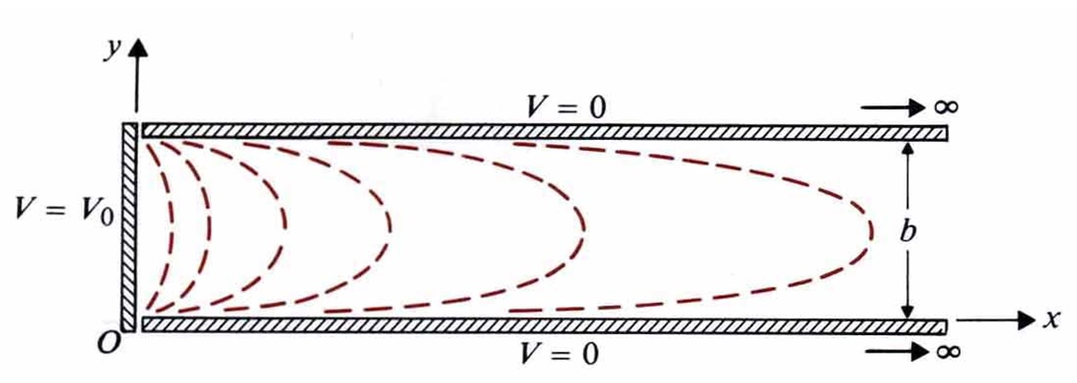
(Sol.)
$$V\left(x,y,z\right)=V\left(x,y\right)=X\left(x\right)Y\left(y\right)$$
B.C.: $\begin{aligned}V\left(0,y\right)=V_{0},V\left(x,0\right)=0 \\ V\left(∞,y\right)=0,V\left(x,b\right)=0\end{aligned}$
$\frac{d^{2}X(x)}{d^{2}x}=k_{x}^{2}X(x)⇒X(x)=D_{1}e^{k_{x}x}+D_{2}e^{−k_{x}x}=D_{2}e^{−k_{x}x}$
$\frac{d^{2}Y\left(y\right)}{{\text{dy}}^{2}}=−k_{y}^{2}Y\left(y\right)⇒Y\left(y\right)=A_{1}\text{sin}k_{y}y$
$\begin{aligned}⇒V_{n}\left(x,y\right)=C_{n}e^{−k_{x}x}\text{sin}k_{y}y⇒k_{x}=k_{y}=\frac{nπ}{b},n=1,2,3 \\ ⇒V_{n}\left(x,y\right)=C_{n}e^{−\frac{nπx}{b}}\text{sin}\frac{nπy}{b} \\ V\left(0,y\right)=V_{0}=\sum_{n=1}^{∞}{}C_{n}\text{sin}\frac{nπy}{b} \\ \int{V_{0}\text{sin}\frac{mπy}{b}}\text{dy}=\sum_{n=1}^{∞}{C_{n}}\int{\text{sin}\frac{nπy}{b}}\text{sin}\frac{mπy}{b}\text{dy} \\ \\ \end{aligned}\begin{aligned}\left\{\frac{2{\text{bV}}_{0}}{mπ},m:\text{odd} | \right.\end{aligned}$
$V\left(x,y\right)=\frac{4V_{0}}{π}\sum_{n:\text{odd}}{\frac{1}{n}e^{−\frac{nπx}{b}}}\text{sin}\frac{nπy}{b},n=1,3,5,⋯$ for x>0, 0<y<b.
4-3 Boundary-Value Problems in Cylindrical Coordinates
$$∇^{2}V=\frac{1}{r}\frac{∂}{∂r}\left(r\frac{∂V}{∂r}\right)+\frac{1}{r^{2}}\frac{∂^{2}V}{∂φ^{2}}+\frac{∂^{2}V}{∂z^{2}}=0$$
- Assume $\frac{∂^{2}V}{∂z^{2}}=0$, then V(r,φ)=R(r)Φ(φ),
→ $r^{2}\frac{d^{2}R\left(r\right)}{{\text{dr}}^{2}}+r\frac{\text{dR}\left(r\right)}{\text{dr}}−n^{2}R\left(r\right)=0,\frac{d^{2}Φ\left(φ\right)}{{dφ}^{2}}+n^{2}Φ\left(φ\right)=0$
→R(r)= A_{r}r^{n}+B_{r}r^{-n}, Φ(φ)=A_{φ}sinnφ+ B_{φ}cosnφ
→V_{n}(r,φ)=r^{n}(Asinnφ+Bcosnφ)+ r^{-n}(A’sinnφ+B’cosnφ), n≠0
→V(r,φ)=$\underset{n=1}{\overset{∞}{\sum{V_{n}}}}\left(r,φ\right)$

- Assume n=0, $\frac{d^{2}Φ\left(φ\right)}{{dφ}^{2}}=0⇒$Φ(φ)=A₀φ+B₀, R(r)=C₀lnr+D₀,
In the φ-independent case, V(r)=C₁lnr+D₁
In the φ-dependent case, Φ(φ)=Aφ+B, V(r,φ)=(Clnr+D)(Aφ+B)

Eg. Consider a very long coaxial cable. The inner conductor has a radius a and is maintained at a potential V₀. The outer conductor has an inner radius b and is grounded. Determine the potential distribution in the space between the conductors. [電信特考]
(Sol.) $V\left(b\right)=0,V\left(a\right)=V_{0}⇒C_{1}ℓn(b)+C_{2}=0,C_{1}ℓn(a)+C_{2}=V_{0}$
$C_{1}=\frac{V_{0}}{\text{ln}\left(b/a\right)},C_{2}=−\frac{V_{0}\text{ln}b}{\text{ln}\left(b/a\right)}$, ∴ $V\left(r\right)=\frac{V_{0}}{\text{ln}\left(b/a\right)}\text{ln}\left(\frac{r}{b}\right)$
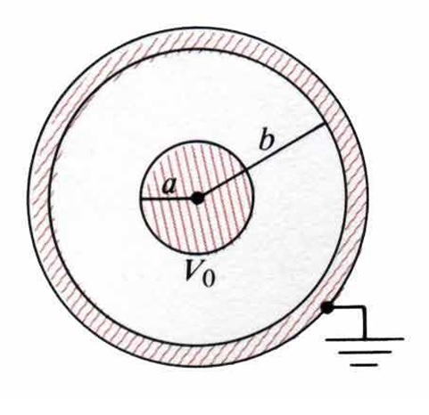
Eg. Two infinite insulated conducting planes maintained at potentials 0 and V₀ form a wedge-shaped configuration. Determine the potential distributions for the regions: $\begin{aligned}\left(a\right)0<φ<α \\ \left(b\right)α<φ<2π\end{aligned}$. [中央光電所、成大電研]
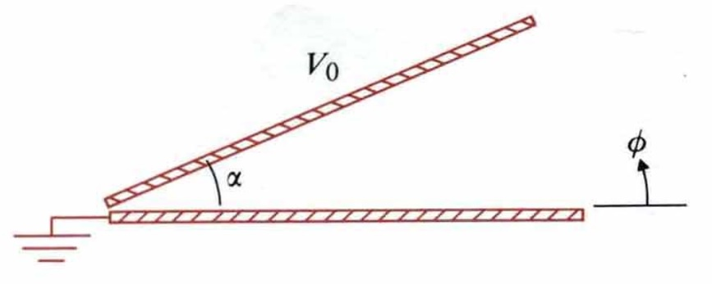
(Sol.)
(a) V(φ)=Aφ+B,
$\begin{aligned}\left\{V\left(0\right)=0⇒B_{0}=0 | \right.\end{aligned}$$⇒V\left(φ\right)=\frac{V_{0}}{α}φ,0≤φ≤α$
(b) $\begin{aligned}\left\{V\left(α\right)=V_{0}=A_{1}α+B_{1} | \right.\end{aligned}$$⇒A_{1}=−\frac{V_{0}}{2π−α},B_{1}=\frac{2{πV}_{0}}{2π−α}⇒V\left(φ\right)=\frac{V_{0}}{2π−α}\left(2π−φ\right)$, $α≤φ≤2π$

Eg. An infinitely long, thin, conducting circular tube of radius b is split in two halves. The upper half is kept at a potential V=Vo and the lower half at V=-Vo. Determine the potential distributions both inside and outside the tube.

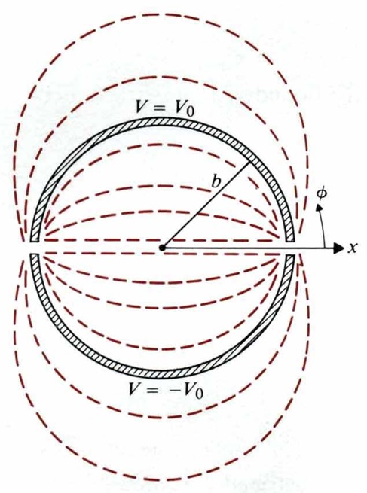
(Sol.) $V\left(b,φ\right)=\begin{aligned}\left\{V_{0},0<φ<π | \right.\end{aligned}$
- Inside the tube: $r<b⇒V_{n}\left(r,φ\right)=A_{n}r^{n}\text{sin}nφ$$⇒V\left(r,φ\right)=\sum_{n=1}^{∞}{}A_{n}r^{n}\text{sin}nφ$
$$r=b⇒\sum_{n=1}^{∞}{}A_{n}b^{n}\text{sin}nφ=\begin{aligned}\left\{V_{0},0<φ<π | \right.\end{aligned}$$
$$\begin{aligned}⇒A_{n}=\begin{aligned}\left\{\frac{4V_{0}}{{nπb}^{n}},n:\text{odd} | \right.\end{aligned} \\ \end{aligned}$$
- Outside the tube: $r>b⇒V_{n}\left(r,φ\right)=B_{n}r^{−n}\text{sin}nφ$$⇒V\left(r,φ\right)=\sum_{n=1}^{∞}{}B_{n}r^{−n}\text{sin}nφ$
$$r=b⇒\sum_{n=1}^{∞}{}B_{n}b^{−n}\text{sin}nφ=\begin{aligned}\left\{V_{0},0<φ<π | \right.\end{aligned}$$
$$\begin{aligned}⇒B_{n}=\begin{aligned}\left\{\frac{4V_{0}b^{n}}{nπ},n:\text{odd} | \right.\end{aligned} \\ \end{aligned}$$
Eg. A long, grounded conducting cylinder of radius b is placed along the z-axis in an initially uniform electric field $E=\overset{}{x}E_{0}$. Determine potential distribution V(r,φ) and electric field intensity $E\left(r,φ\right)$ outside the cylinder. Show that the electric field intensity at the surface of the cylinder may be twice as high as that in the distance, which may cause a local breakdown or corona (St. Elmo’s fire.) [中央光電所、高考]
(Sol.) $V\left(r,φ\right)=−E_{0}r\text{cos}φ+\sum_{n=1}^{∞}{B_{n}r^{−n}\text{cos}nφ\left(\text{At}r\text{>>}b,E=\hat{x}E_{0},V=−E_{0}r\text{cos}φ\right)}$
At $r=b:V\left(r,φ\right)=−E_{0}b\text{cos}φ+\sum_{n=1}^{∞}{B_{n}b^{−n}\text{cos}nφ=0}$$⇒B_{1}=E_{0}b^{2},B_{n}=0\text{for}n≠1\text{.}$
Outside the cylinder, $r≥b:V\left(r,φ\right)=−E_{0}r\left(1−\frac{b^{2}}{r^{2}}\right)\text{cos}φ$

Eg. A long dielectric cylinder of radius b and dielectric constant ε_{r}, is placed along the z-axis in an initially uniform electric field $E=\hat{x}E_{0}$. Determine V(r,φ) and $E\left(r,φ\right)$ both inside and outside the dielectric cylinder.
(Sol.) For $r≥b,$$V_{0}\left(r,φ\right)=−E_{0}r\text{cos}φ+\sum_{n=1}^{∞}{B_{n}r^{−n}\text{cos}nφ}$
$r≤b,$$V_{i}\left(r,φ\right)=\sum_{n=1}^{∞}{A_{n}r^{n}\text{cos}nφ}$
$\begin{aligned}V_{0}\left(b,φ\right)=V_{i}\left(b,ϕ\right) \\ −\frac{∂V_{0}}{∂r_{|r=b}}=−ε_{r}\frac{∂V_{i}}{∂r_{|r=b}}\end{aligned}$$⇒$$\begin{aligned}−E_{0}b+B_{1}b^{−1}=A_{1}b,B_{n}b^{−n}=A_{n}b^{n},n≠1 \\ E_{0}+B_{1}b^{−2}=−ε_{r}A_{1},{\text{nB}}_{n}b^{−\left(n+1\right)}=−ε_{r}{\text{nA}}_{n}b^{n−1},n≠1\end{aligned}$
$⇒$$\begin{aligned}\left\{A_{1}=\frac{−2E_{0}}{ε_{r}+1},B_{1}=\frac{ε_{r}−1}{ε_{r}+1}b^{2}E_{0} | \right.\end{aligned}$$⇒$$\begin{aligned}\left\{V_{0}\left(r,φ\right)=−\left(1−\frac{ε_{r}−1}{ε_{r}+1}⋅\frac{b^{2}}{r^{2}}\right)E_{0}r\text{cos}φ | \right.\end{aligned}$
$E=−∇V=−{\hat{a}}_{r}\frac{∂V}{∂r}−{\hat{a}}_{φ}\frac{∂V}{r∂φ}$$⇒$$\begin{aligned}\left\{E_{0}={\hat{a}}_{r}E_{0}\left(1+\frac{ε_{r}−1}{ε_{r}+1}⋅\frac{b^{2}}{r^{2}}\right)\text{cos}φ−{\hat{a}}_{ι}E_{0}\left(1−\frac{ε_{r}−1}{ε_{r}+1}⋅\frac{b^{2}}{r^{2}}\right)\text{sin}φ | \right.\end{aligned}$
4-4 Boundary-Value Problems in Spherical Coordinates
$$∇^{2}V=\frac{1}{R^{2}}\frac{∂}{∂R}\left(R^{2}\frac{∂V}{∂R}\right)+\frac{1}{R^{2}\text{sin}θ}\frac{∂}{∂θ}\left(\text{sin}θ\frac{∂V}{∂θ}\right)+\frac{1}{R^{2}{\text{sin}}^{2}θ}\frac{∂^{2}V}{∂φ^{2}}=0$$
Assume φ-independent: $\frac{∂^{2}}{∂^{2}φ}=0$, V(r,θ)=R(r)Θ(θ)
$r^{2}\frac{d^{2}R\left(r\right)}{{\text{dr}}^{2}}+2r\frac{\text{dR}\left(R\right)}{\text{dr}}−k^{2}R\left(r\right)=0,\frac{d}{dθ}\left[\text{sin}θ\frac{dΘ\left(θ\right)}{dθ}\right]+n\left(n+1\right)Θ\left(θ\right)\text{sin}\left(θ\right)=0$, and
k²=n(n+1)→ R(r)=A_{n}r^{n}+B_{n}r^{-n-1}, Θ(θ)=P_{n}(cosθ)→V(r,θ)=[A_{n}r^{n}+B_{n}r^{-n-1}]P_{n}(cosθ)

Table of Legendre’s Polynomials
n | $$P_{n}\left(\text{cos}θ\right)$$
0 | 1
1 | $$\text{cos}θ$$
2 | $$\frac{1}{2}\left(3{\text{cos}}^{2}θ−1\right)$$
3

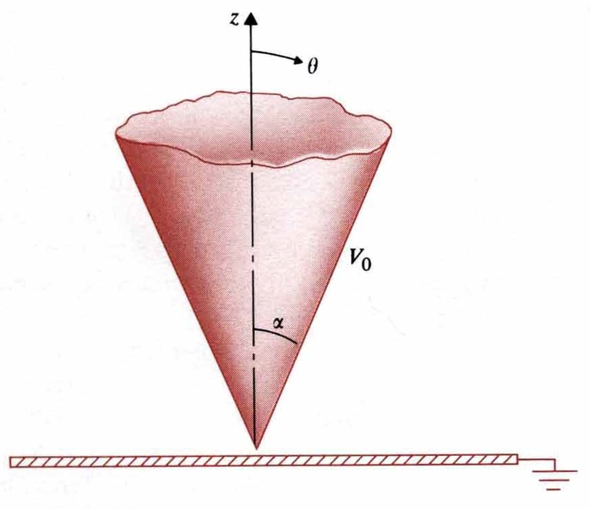
Eg. An infinite conducting cone of half-angle α is maintained at potential V₀ and insulated from a grounded conducting plane. Determine (a) the potential distribution V(θ) in the region α<θ<π/2, (b) the electric field intensity in the region α<θ<π/2, (c) the charge densities on the cone surface and on the grounded plane.
(Sol.)
$$\frac{d}{dθ}\left(\text{sin}θ\frac{\text{dV}}{dθ}\right)=0,\frac{\text{dV}}{dθ}=\frac{C_{1}}{\text{sin}θ}⇒V\left(θ\right)=C_{1}ℓn\left(\text{tan}\frac{θ}{2}\right)+C_{2}$$
（a）$\begin{aligned}V\left(α\right)=C_{1}ℓn\left(\text{tan}\frac{α}{2}\right)+C_{2}=V_{0} \\ V\left(\frac{π}{2}\right)=C_{1}ℓn\left(\text{tan}\frac{π}{4}\right)+C_{2}=0\end{aligned}$$⇒$$\begin{aligned}C_{1}=\frac{V_{0}}{ℓn\left[\text{tan}\left(\frac{α}{2}\right)\right]} \\ C_{2}=0\end{aligned}$$⇒$$V\left(θ\right)=\frac{V_{0}ℓn\left[\text{tan}\left(\frac{θ}{2}\right)\right]}{ℓn\left[\text{tan}\left(\frac{α}{2}\right)\right]}$
（b）$E=−{\hat{a}}_{θ}\frac{\text{dV}}{\text{Rd}θ}=−{\hat{a}}_{θ}\frac{V_{0}}{Rℓn\left[\text{tan}\left(\frac{α}{2}\right)\right]\text{sin}θ}$, （c）$\begin{aligned}θ=α:ρ_{s}=ε_{0}E\left(α\right)=\frac{ε_{0}V_{0}}{Rℓn\left[\text{tan}\left(\frac{α}{2}\right)\right]\text{sin}θ} \\ θ=\frac{π}{2}:ρ_{s}=−ε_{0}E\left(\frac{π}{2}\right)=−\frac{ε_{0}V_{0}}{Rℓn\left[\text{tan}\left(\frac{α}{2}\right)\right]}\end{aligned}$
Eg. An uncharged conducting sphere of radius b is placed in an initially uniform electric field $E=\hat{z}E_{0}$. Determine the potential distribution V(R,θ) and the electric field intensity $E\left(R,θ\right)$ after the introduction of the sphere. [中山電研]
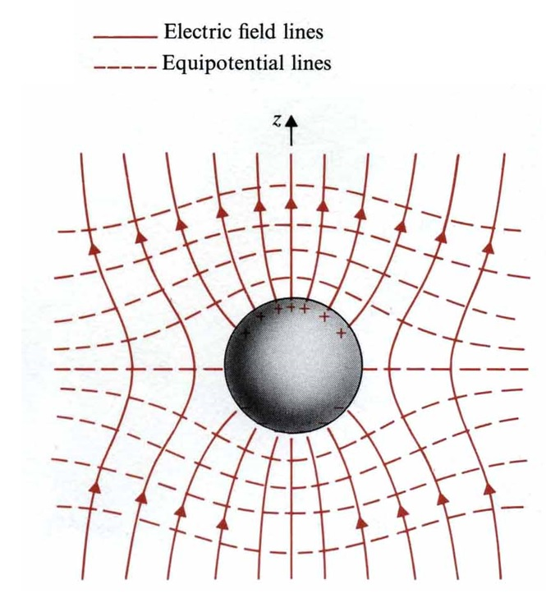
(Sol.) $V\left(b,θ\right)=0$
If R>>b,$V\left(R,θ\right)=−E_{0}z=−E_{0}R\text{cos}θ$
$V\left(R,θ\right)=\sum_{n=0}^{∞}{\left[A_{n}R^{n}+B_{n}R^{−\left(n+1\right)}\right]P_{n}\left(\text{cos}θ\right)}$, $R≥b$
（$\begin{aligned}A_{n}=0,n≠1 \\ A_{1}=−E_{0}\end{aligned}$）
↓
$$=−E_{0}{\text{RP}}_{1}\left(\text{cos}θ\right)+\sum_{n=0}^{∞}{B_{n}R^{−\left(n+1\right)}P_{n}\left(\text{cos}θ\right)},R≥b$$
（sphere is uncharged, $B_{0}=0$）
↓
$=\left(\frac{B_{1}}{R^{2}}−E_{0}R\right)\text{cos}θ+\sum_{n=2}^{∞}{}B_{n}R^{−\left(n+1\right)}P_{n}\left(\text{cos}θ\right),R≥b$
$R=b,0=\left(\frac{B_{1}}{b^{2}}−E_{0}b\right)\text{cos}θ+\sum_{n=2}^{∞}{}B_{n}b^{−\left(n+1\right)}P_{n}\left(\text{cos}θ\right)⇒B_{1}=E_{0}b^{3},B_{n}=0,n≥2$,
∴ $V\left(R,θ\right)=−E_{0}\left[1−{\left(\frac{b}{R}\right)}^{3}\right]R\text{cos}θ,R≥b$
$E\left(R,θ\right)={\hat{a}}_{R}E_{R}+{\hat{a}}_{θ}E_{θ}=−∇V\left(R,θ\right)={\hat{a}}_{R}\left(−\frac{∂V}{∂R}\right)+{\hat{a}}_{θ}\left(−\frac{∂V}{R∂θ}\right)$$={\hat{a}}_{R}E_{0}\left[1+2{\left(\frac{b}{R}\right)}^{3}\right]\text{cos}θ−{\hat{a}}_{θ}E_{0}\left[1−{\left(\frac{b}{R}\right)}^{3}\right]\text{sin}θ,R≥b$
A dipole moment $P=\hat{z}4{\text{πε}}_{0}b^{2}E_{0}$ is at the center of the sphere. Surface charge density is $ρ_{s}\left(θ\right)=ε_{0}E_{R|R=b}=3ε_{0}E_{0}\text{cos}θ$

4-5 Capacitors and Capacitances

Q=CV$⇔$C=Q/V
Eg. A parallel-plane capacitor consists of two parallel conducting plates of area S separate by uniform distance d, the space between the plates is filled with a dielectric of a constant permittivity. Determine the capacitance.
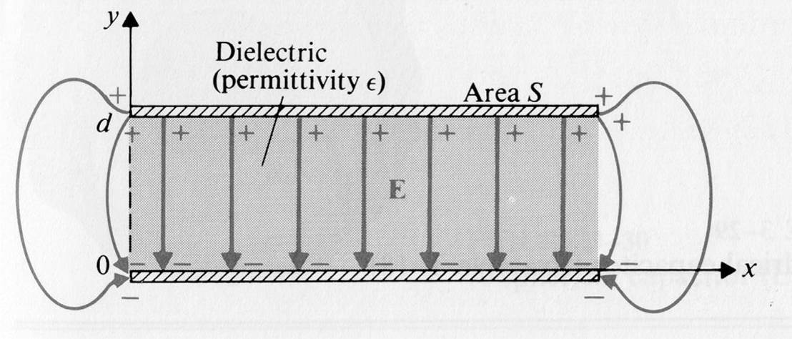
(Sol.) $ρ_{s}=\frac{Q}{S}$, $\overset{→}{E}=−\overset{}{y}\frac{ρ_{s}}{ε}=−\overset{}{y}\frac{Q}{εS}$
$V=−\int{\overset{→}{E}⋅d\overset{→}{l}=\int{\left(−\overset{}{y}\frac{Q}{εS}\right)⋅\left(\overset{}{y}\text{dv}\right)}}=\frac{Q}{ε S}d$
$C=\frac{Q}{V}=ε\frac{S}{d}$. In this problem, $\overset{→}{E}=−\overset{}{y}\frac{V}{d}$
$⇒$Surface charge densities on the upper and conducting planes are ρ_{s} and -ρ_{s}, ρ_{s}=εE_{y}=εV/d.

Eg. The space between a parallel-plate capacitor of area S is filled with dielectric whose permittivity varies linearly from ε₁ at one plate (y=0) to ε₂ at the other plate (y=d). Neglecting all the edge effect, find the capacitance. [台科大電子所]
(Sol.) Assume Q on plate at y=d, $ε=\frac{ε_{2}−ε_{1}}{d}y+ε_{1}$
$\overset{→}{E}=−\overset{}{y}\frac{ρ_{s}}{ε} , ρ_{s}=\frac{Q}{S}$$⇒V=−\int{\overset{→}{E}⋅d\overset{→}{l}=\frac{\text{Qd}\text{ln}\left(ε_{2}/ε_{1}\right)}{S\left(ε_{2}−ε_{1}\right)}}$$⇒C=\frac{Q}{V}=\frac{S(ε_{2}−ε_{1})}{d\text{ln}(\frac{ε_{2}}{ε_{1}})}$

Eg. A cylindrical capacitor consists of an inner conductor of radius a and an outer conductor of radius b is filled with a dielectric of permittivity ε, and the length of the capacitor is L. Determine the capacitance of this capacitor.
(Sol.) $\overset{→}{E}=\overset{}{a_{r}}E_{r}=\frac{Q}{2\text{πε}\text{Lr}}$,
$V_{\text{ab}}=−\int{\overset{→}{E}⋅d\overset{→}{l}}=−\int{\left(\overset{}{a_{r}}\frac{Q}{2\text{πε}\text{Lr}}\right)⋅\left(\overset{}{a}\text{dr}\right)}$$=\frac{Q}{2\text{πε}L}\text{ln}\left(\frac{b}{a}\right)$, $C=\frac{Q}{V_{\text{ab}}}=\frac{2\text{πε}L}{\text{ln}\left(\frac{b}{a}\right)}$
Eg. A spherical capacitor consists of an inner conducting sphere of radius R_{i} and an outer conductor with a spherical wall of radius R_{o}. The space in between them is filled with dielectric of permittivity ε. Determine the capacitance.
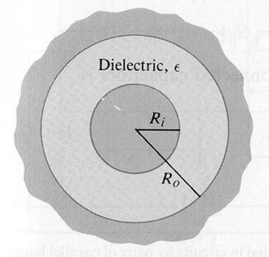
(Sol.) $\overset{→}{E}=\overset{}{a_{r}}E_{r}=\overset{}{a_{r}}\frac{Q}{4\text{πε}R^{2}}$
V=$−\int{\overset{→}{E}⋅\left(\overset{}{a_{r}}\text{dR}\right)}=−\int{\frac{Q}{4\text{πε}R^{2}}\text{dR}}=\frac{Q}{4\text{πε}}\left(\frac{1}{R_{i}}−\frac{1}{R_{o}}\right)$
$C=\frac{Q}{V}=\frac{4\text{πε}}{\frac{1}{R_{i}}−\frac{1}{R_{o}}}$.
For an isolating conductor sphere of a radius: $R_{i} , R_{o}→∞ , C=4\text{πε}R_{i}$
Eg. Assuming the earth to be a large conducting sphere (radius=6.37×10³km) surrounded by air, find (a) the capacitance of the earth, (b) the maximum charge that can exist on the earth before the air breaks down.
(Sol.) (a) $C=4{\text{πε}}_{0}R=4π×\frac{1}{\text{36}π}×{\text{10}}^{−9}×\left(6\text{.}\text{37}×{\text{10}}^{3}×{\text{10}}^{3}\right)=7\text{.}\text{08}×{\text{10}}^{−4} (F)$
(b) $E_{b}=3×{\text{10}}^{6}=\frac{Q_{\text{Max}}}{4{\text{πε}}_{0}R^{2}} ⇒Q_{\text{Max}}=1\text{.}\text{35}×{\text{10}}^{\text{10}} (C)$
Eg. Determine the capacitance of an isolated conducting sphere of radius b that is coated with a dielectric layer of uniform thickness d, the dielectric has an electric susceptibility χ_{e}.
(Sol.) $b<R<b+d, \overset{→}{E}=\overset{}{a_{r}}\frac{Q}{4{\text{πε}}_{0}\left(1+χ_{e}\right)R^{2}}$, $b+d<R, \overset{→}{E}=\frac{Q}{4{\text{πε}}_{0}R^{2}}$
$V=−\int{\overset{→}{E}⋅d\overset{→}{l}}=\frac{Q}{4{\text{πε}}_{0}\left(1+χ_{e}\right)}\left(\frac{χ_{e}}{b+d}+\frac{1}{b}\right)$, $C=\frac{Q}{V}=\frac{4{\text{πε}}_{0}\left(1+χ_{e}\right)}{\frac{χ_{e}}{b+d}+\frac{1}{b}}$
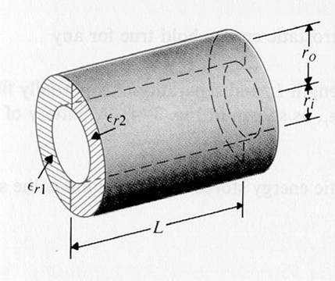
Eg. A cylindrical capacitor of length L consists of coaxial conducting surface of radii r_{i} and r_{o}. Two dielectric media of different dielectric constants ε_{r1} and ε_{r2}, and fill the space between the conducting surface. Determine the capacitance. [台大物理所、高考電機技師]
(Sol.) $π\text{rL}\left(ε_{0}ε_{r1}+ε_{0}ε_{r2}\right)E=ρ_{l}L$$⇒E=\frac{ρ_{l}}{{πrε}_{0}\left(ε_{r1}+ε_{r2}\right)}$
$$V=−\int{\text{Edr}}=\frac{ρ_{l}}{{\text{πε}}_{0}\left(ε_{r1}+ε_{r2}\right)}\text{ln}\left(\frac{r_{o}}{r_{i}}\right)$$
$$C=\frac{ρ_{l}L}{V}=\frac{{\text{πε}}_{0}\left(ε_{r1}+ε_{r2}\right)L}{\text{ln}\left(r_{o}/r_{i}\right)}$$
Eg. The radius of the core and the inner radius of the outer conductor of a very long coaxial transmission line are r_{i} and r_{o} respectively. The space between two conductors is filled with two coaxial layers of dielectrics. The dielectric constants of the dielectrics are ε_{r1} for r_{i}<r<b and ε_{r2} for b<r<r_{o}. Determine its capacitance per unit length.
(Sol.) $\overset{→}{E_{1}}=\overset{}{a_{r}}\frac{ρ_{l}}{2{\text{πε}}_{0}ε_{r1}r} , r_{i}<r<b$, $\overset{→}{E_{2}}=\overset{}{a_{r}}\frac{ρ_{l}}{2{\text{πε}}_{0}ε_{r2}r}, b<r<r_{o}$
$V=−\int{\overset{→}{E}⋅d\overset{→}{r}}=\frac{ρ_{l}}{2{\text{πε}}_{0}}\left[\frac{1}{ε_{r1}}\text{ln}\left(\frac{b}{r_{i}}\right)+\frac{1}{ε_{r2}}\text{ln}\left(\frac{r_{o}}{b}\right)\right]$, $C=\frac{ρ_{l}}{V}=\frac{2{\text{πε}}_{0}}{\frac{1}{ε_{r1}}\text{ln}\left(\frac{b}{r_{i}}\right)+\frac{1}{ε_{r2}}\text{ln}\left(\frac{r_{o}}{b}\right)} (F/m)$

Eg. Determine the capacitance per unit length between two long, parallel, circular conducting wires of radius a. The axes of the wires are separated by a distance D. [台大電研]
(Sol.) $V_{2}=\frac{ρ_{ℓ}}{2\text{πε}}ℓn\frac{a}{d},V_{1}=−\frac{ρ_{ℓ}}{2\text{πε}}ℓn\frac{a}{d}$
$$C=\frac{ρ_{ℓ}}{V_{1}−V_{2}}=\frac{\text{πε}}{ℓn\left(d/a\right)},d=D−d_{i}=D−\frac{a^{2}}{d},d=\frac{1}{2}\left(D+\sqrt{D^{2}−4a^{2}}\right)$$
C=$\frac{\text{πε}}{ℓn\left[\left(D/2a\right)+\sqrt{{\left(D/2a\right)}^{2}−1}\right]}$$=\frac{\text{πε}}{{\text{cosh}}^{−1}\left(D/2a\right)}$ (F/m)
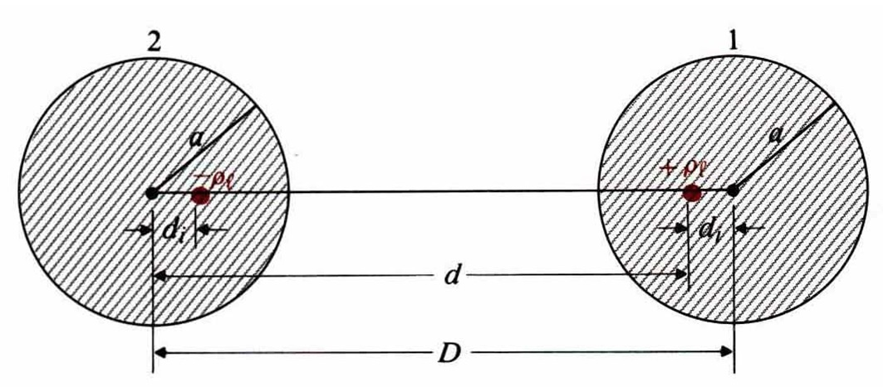

Eg. A straight conducting wire of radius a is parallel to and at height h from the surface of the earth. Assume that the earth is perfectly conducting; determine the capacitance and the force per unit length between the wire and the earth.
(Sol.) D=2h, $C=\frac{{\text{πε}}_{0}}{{\text{cosh}}^{−1}\left(D/2a\right)}=\frac{{\text{πε}}_{0}}{{\text{cosh}}^{−1}\left(h/a\right)}\left(Fm\right)$
Eg. A capacitor consists of two coaxial metallic cylindrical surface a length 30mm and radii 5mm and 7mm. The dielectric between the surfaces has a relative permittivity ε_{r2}=2+(4/r), where r is measured in mm. Determine the capacitance of the capacitor.
(Sol.) $\overset{→}{E}=\overset{}{a_{r}}\frac{ρ_{l}}{2\text{πε}r}=\overset{}{a_{r}}\frac{ρ_{l}}{2{\text{πε}}_{0}\left(2+\frac{4}{r}\right)r}=\overset{}{a_{r}}\frac{ρ_{l}}{4{\text{πε}}_{0}\left(r+2\right)}$
$V=−\int{\overset{→}{E}⋅d\overset{→}{r}}=\frac{ρ_{l}}{4{\text{πε}}_{0}}\text{ln}\left(r+2\right)|\begin{matrix}r=7 \\ r=5\end{matrix}=\frac{ρ_{l}}{4{\text{πε}}_{0}}\text{ln}\left(\frac{9}{7}\right)$, $C=\frac{ρ_{l}L}{V}=\frac{4{\text{πε}}_{0}L}{\text{ln}\left(\frac{9}{7}\right)}≈\text{1500}ε_{0}$
Series or parallel connection of capacitance:
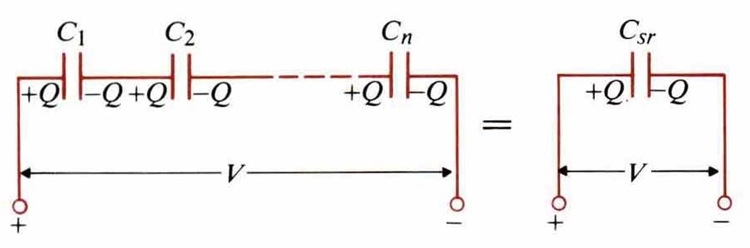
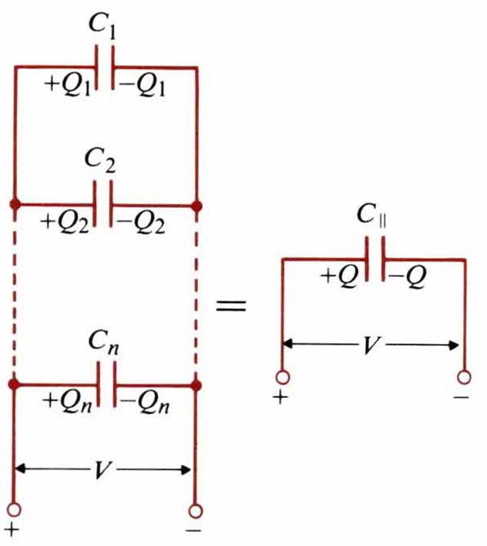
$$V=\frac{Q}{C_{\text{sr}}}=\frac{Q}{C_{1}}+\frac{Q}{C_{2}}+\frac{Q}{C_{3}}+⋯⋯+\frac{Q}{C_{n}}⇒\frac{1}{C_{\text{sr}}}=\frac{1}{C_{1}}+\frac{1}{C_{2}}+\frac{1}{C_{3}}+⋯⋯+\frac{1}{C_{n}}$$

$$Q=Q_{1}+Q_{2}+⋯⋯+Q_{n}$$
$$⇒C_{\text{//}}V=C_{1}V+CV+⋯⋯+C_{n}V$$
$$⇒C_{\text{//}}=C_{1}+C_{2}+⋯⋯+C_{n}$$

4-6 Electrostatic Energy
To remove Q₁ from infinite to a distance R₁₂ from Q₂, the amount of work required is
$$W_{2}=Q_{2}V_{2}=Q_{2}\frac{Q_{1}}{4{\text{πε}}_{0}R_{\text{12}}}=Q_{1}\frac{Q_{2}}{4{\text{πε}}_{0}R_{\text{12}}}=Q_{1}V_{1}=\frac{1}{2}\left(Q_{1}V_{1}+Q_{2}V_{2}\right)$$
$$\begin{aligned}\vec{\text{induction}}\end{aligned}\text{method}→W_{e}=\frac{1}{2}\sum_{k=1}^{N}{Q_{k}V_{k},} \text{where} V_{k}=\frac{1}{4{\text{πε}}_{0}}\sum_{j=1(j≠k)}^{N}{\frac{Q_{j}}{R_{\text{jk}}}}$$

Eg. Determine the work done in carrying a -2μC charge from P₁(2,1,-1) to P₂(8,2,-1) in the field $\overset{→}{E}=\overset{}{x}y+\overset{}{y}x$along (a) the parabola x=2y², (b) the straight line joining P₁ and P₂.
(Sol.) $dl=\hat{x}\text{dx}+\hat{y}\text{dy}$, $W=−q\int{\overset{→}{E}⋅d\overset{→}{l}}=−q⋅(\int{\text{ydx}+\text{xdy}})$
(a) Along $x=2y^{2}, \text{dx}=4\text{ydy}⇒W=−q\int{6y^{2}\text{dy}}=−\text{14}q=\text{28} (μJ)$.
(b) Along $x=6y−4, \text{dx}=6\text{dy}⇒W=−q\int{\left(\text{12}y−4\right)\text{dy}}=−\text{14}q=\text{28} (μJ)$

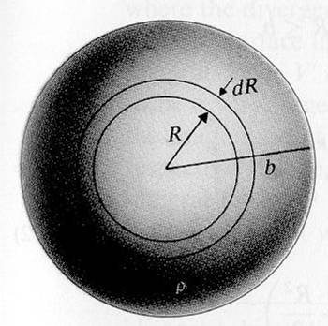
Eg. Find the energy required to assemble a uniform charge of radius b and volume charge density ρ. [清大電研]
(Sol.) $V_{R}=\frac{Q_{R}}{4{\text{πε}}_{0}R}$ $Q_{R}=ρ\frac{4}{3}{πR}^{3}$
${\text{dQ}}_{R}=ρ4{πR}^{2}\text{dR}$, $\text{dW}=V_{R}{\text{dQ}}_{R}=\frac{4π}{3ε_{0}}ρ^{2}R^{4}\text{dR}$
$$W=\int{\text{dW}}=\frac{4π}{3ε_{0}}ρ^{2}\int{R^{4}\text{dR}}=\frac{4{\text{πρ}}^{2}b^{5}}{\text{15}ε_{0}}$$
$Q=ρ\frac{4π}{3}b^{3}$, $W=\frac{3Q^{2}}{\text{20}{\text{πε}}_{0}b} (J)$
Eg. According to W_{e}=$\frac{1}{2}\iiint{ρ\text{Vdv}}=\frac{1}{2}\iiint{\left(∇⋅\overset{→}{D}\right)\text{Vdv}}$, show that the stored electric energy is $W_{e}=\frac{1}{2}\iiint{\overset{→}{D}⋅\overset{→}{E}\text{dv}}$
(Proof) ∵ $∇⋅\left(V\overset{→}{D}\right)=V∇⋅\overset{→}{D}+\overset{→}{D}⋅∇V$, ∴ $V∇⋅\vec{D}=∇⋅\left(V\overset{→}{D}\right)−\vec{D}⋅∇V$
∴ $W_{e}=\frac{1}{2}\iiint{∇⋅\left(V\overset{→}{D}\right)\text{dv}}−\frac{1}{2}\iiint{\overset{→}{D}⋅∇\text{Vdv}}=\frac{1}{2}∯{V\overset{→}{D}⋅\overset{}{a_{n}}\text{ds}}+\frac{1}{2}\iiint{\overset{→}{D}⋅\overset{→}{E}\text{dv}}$
When$R→∞, S∝R^{2}, V∝\frac{1}{R}, \left|\overset{→}{D}\right|∝\frac{1}{R^{2}}$$⇒\frac{1}{2}∯{V\overset{→}{D}⋅\overset{}{a_{n}}\text{ds}}→0$$⇒W_{e}=\frac{1}{2}\iiint{\overset{→}{D}⋅\overset{→}{E}\text{dv}}$
If$\overset{→}{D}=ε\overset{→}{E}$, then$W_{e}=\frac{1}{2}\iiint{ε{\left|\overset{→}{E}\right|}^{2}\text{dv}}=\frac{1}{2}\iiint{\frac{{\left|\overset{→}{D}\right|}^{2}}{ε}\text{dv}}=\iiint{w_{e}\text{dv}}$
Note: 1. SI unit for energy: Joule(J) and 1 eV =1.6×10⁻¹⁹J.
2. Work (or energy) is a scalar, not a vector.
Electrostatic energy density: w_{e}=$\frac{1}{2}\overset{→}{D}⋅\overset{→}{E}=\frac{1}{2}ε{\left|\overset{→}{E}\right|}^{2}=\frac{{\left|\overset{→}{D}\right|}^{2}}{2ε}$
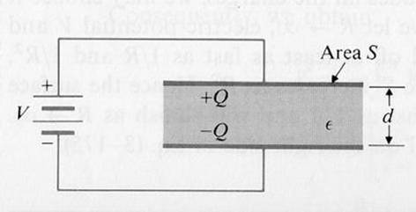
Eg. A parallel-plate capacitor of area S and separation d is charged by a d-c voltage source V. The permittivity of the dielectric is ε. Find the stored electrostatic energy.
(Sol.) $E=\frac{V}{d}$, $W_{e}=\frac{1}{2}\iiint{ε{\left(\frac{V}{d}\right)}^{2}\text{dv}}=\frac{1}{2}ε{\left(\frac{V}{d}\right)}^{2}\left(\text{Sd}\right)=\frac{1}{2}\left(ε\frac{S}{d}\right)V^{2}$
Eg. Use energy formulas to find the capacitance of a cylindrical capacitance having a length L, an inner conductor of radius a, an outer conductor of inner radius b, and dielectric of permittivity$ε$.
(Sol.) $\overset{→}{E}=\overset{}{a_{r}}\frac{Q}{2\text{πε}\text{Lr}}$, $W_{e}=\frac{1}{2}\int{ε{\left(\frac{Q}{2\text{πε}\text{Lr}}\right)}^{2}\left(L2π\text{rdr}\right)}$$=\frac{Q^{2}}{4\text{πε}L}\int{\frac{\text{dr}}{r}}=\frac{Q^{2}}{4\text{πε}L}\text{ln}\left(\frac{b}{a}\right)$, $\frac{Q^{2}}{2C}=\frac{Q^{2}}{4\text{πε}L}\text{ln}\left(\frac{b}{a}\right)⇒C=\frac{2\text{πε}L}{\text{ln}\left(\frac{b}{a}\right)}$
Eg. Find the electrostatic energy stored in the region of space R>b around an electric dipole of moment p.
(Sol.) $E=\frac{p}{4{\text{πε}}_{0}R^{2}}\left({\hat{a}}_{R}2\text{cos}θ+{\hat{a}}_{θ}\text{sin}θ\right)$, $W=\frac{1}{2}ε_{0}\iiint_{v}{{\left|E\right|}^{2}}dv^{'}=\frac{p^{2}}{\text{12}{\text{πε}}_{0}b^{3}}$
4-7 Electrostatic Forces and Torques
Electrostatic force and torque due to the fixed charge:
$\text{dW}=\overset{→}{F_{Q}}⋅d\overset{→}{l}$ is mechanic work done by the system, it costs the stored energy.
∵ ${\text{dW}}_{e}=−\text{dW}=−\overset{→}{F_{Q}}⋅d\overset{→}{l}=\left(∇W_{e}\right)⋅d\overset{→}{l}$, ∴ $\overset{→}{F_{Q}}=−∇W_{e} (N)$
${\left(\overset{→}{F_{Q}}\right)}_{l}=−\frac{∂W_{e}}{∂l}=−\frac{∂}{∂l}\left(\frac{Q^{2}}{2C}\right)=\frac{Q^{2}}{2C^{2}}\frac{∂C}{∂l}$, $\text{dW}={\left(T_{Q}\right)}_{z}dφ⇒{\left(T_{Q}\right)}_{z}=−\frac{∂W_{e}}{∂φ}$
Electrostatic force and torque due to the fixed potential:
${\text{dW}}_{s}=\sum_{k}{V_{k}{\text{dQ}}_{k}}$, $\text{dW}=\overset{→}{F_{v}}⋅d\overset{→}{l}$, ${\text{dW}}_{e}=\frac{1}{2}\sum_{k}{V_{k}{\text{dQ}}_{k}}=\frac{1}{2}{\text{dW}}_{s}$
$$\text{dW}+{\text{dW}}_{e}={\text{dW}}_{s} ⇒\text{dW}=\frac{1}{2}{\text{dW}}_{s}={\text{dW}}_{e}=\overset{→}{F_{v}}⋅d\overset{→}{l}=\left(∇W_{e}\right)⋅d\overset{→}{l}$$
∴ $\overset{→}{F_{v}}=∇W_{e}, {\left(T_{v}\right)}_{z}=\frac{∂W_{e}}{∂φ}$, ${\left(\overset{→}{F_{v}}\right)}_{l}=\frac{∂W_{e}}{∂l}=\frac{∂}{∂l}\left(\frac{1}{2}{\text{CV}}^{2}\right)=\frac{V^{2}}{2}\frac{∂C}{∂l}=\frac{Q^{2}}{2C^{2}}\frac{∂C}{∂l}$
Eg. Determine the force on the conducting plates of a charged parallel-plate capacitor: The plates have an area S and separate in air by a distance x.
(Sol.) (a) Assuming fixed charge, $W_{e}=\frac{1}{2}\text{QV}=\frac{1}{2}{\text{QE}}_{x}x$, ${\left(F_{Q}\right)}_{x}=−\frac{∂}{∂x}\left(\frac{1}{2}{\text{QE}}_{x}x\right)=−\frac{Q^{2}}{2ε_{0}S}$
(b) Assuming the fixed potential,
$${\left(F_{v}\right)}_{x}=\frac{∂W_{e}}{∂x}=\frac{∂}{∂x}\left(\frac{1}{2}{\text{CV}}^{2}\right)=\frac{V^{2}}{2}\frac{∂}{∂x}\left(\frac{ε_{0}S}{x}\right)=−\frac{ε_{0}{\text{SV}}^{2}}{2x^{2}}$$
∵ $Q=\text{CV}=\frac{ε_{0}\text{SV}}{x}$, ∴ ${\left(F_{Q}\right)}_{x}={\left(F_{v}\right)}_{x}$
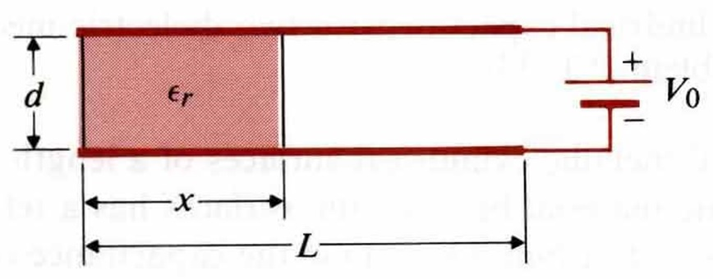
Eg. A parallel-plate capacitor of width w, length L, and separation d is partially filled with a dielectric medium of dielectric constants ε_{r}. A battery of V₀ volts is connected between the plates. (a) Find $D$, $E$, ρ_{s} in each region. (b) Find distance x such that the electrostatic energy stored in each region is the same. [台大電研]
(Sol.)（a）$\begin{aligned}E_{1}=−\hat{y}\frac{V_{0}}{d},D_{1}=−\hat{y}ε_{0}ε_{r}\frac{V_{0}}{d},ρ_{s1}=ε_{0}ε_{r}\frac{V_{0}}{d} \\ \end{aligned}$
$E_{2}=−\hat{y}\frac{V_{0}}{d},D_{2}=−\hat{y}ε_{0}\frac{V_{0}}{d},ρ_{s2}=ε_{0}\frac{V_{0}}{d}$（b）$\frac{W_{e1}}{W_{e2}}=\frac{ε_{r}x}{L−x}=1⇒x=\frac{L}{ε_{r}+1}$

Eg. A parallel-plate capacitor of width w, length L, and separation d has a solid dielectric slab of permittivityεin the space between the plates. The capacitor is charged to a voltage V₀ by a battery. Assuming that the dielectric slab is withdrawn to the position shown, determine the force action on the slab. (a) with the switch closed, (b) after the switch is first opened. [台大電研、清大電研]
(Sol.) (a) $W_{e}=\frac{1}{2}{\text{CV}}_{0}^{2},C=\frac{w}{d}\left[εx+ε_{0}\left(L−x\right)\right]⇒F_{x}=∇W_{e}=\hat{x}\frac{V_{0}^{2}}{2}\frac{∂C}{∂x}=\hat{x}\frac{V_{0}^{2}w}{2d}\left(ε−ε_{0}\right)$
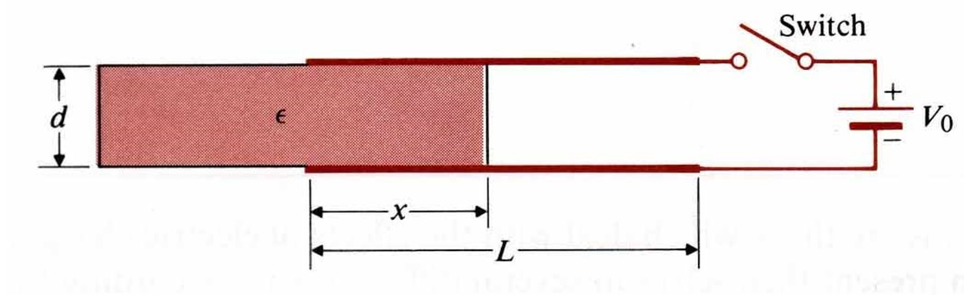
(b)
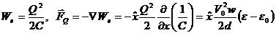

Eg. The conductors of an isolated two-wire transmission line, each of radius b, are spaced at a distance D apart. Assuming D>>b and a voltage V₀ between the lines, find the force per unit length on the lines.
(Sol.)
$$\begin{aligned}E=\hat{x}\left[\frac{ρ_{l}}{2{\text{πε}}_{0}x}+\frac{ρ_{l}}{2{\text{πε}}_{0}\left(D−x\right)}\right],V_{0}=V_{1}−V_{2}=\int{{}_{b}^{D−b}}E⋅d\hat{x}=\frac{ρ_{l}}{{\text{πε}}_{0}}\text{ln}\frac{D−b}{b}≈x\frac{ρ_{l}}{{\text{πε}}_{0}}\text{ln}\frac{D}{b} \\ C^{'}=\frac{ρ_{l}}{V_{0}}=\frac{{\text{πε}}_{0}}{\text{ln}\left(Db\right)}\left(F/m\right),F^{'}=∇W_{e}=\hat{x}\frac{V_{0^{2}}}{2}\frac{∂C^{'}}{∂D}=−\hat{x}\frac{{\text{πε}}_{0}V_{0}^{2}}{2D{\left[\text{ln}\left(Db\right)\right]}^{2}}\end{aligned}$$

4-8 Resistors and Resistances
Ohm’s law: V=RI
$$V=Eℓ⇒E=\frac{V}{ℓ},I=\iint_{s}{J⋅d\vec{S}}=\text{JS}⇒J=\frac{I}{S}=σ\frac{V}{ℓ}⇒V=\left(\frac{ℓ}{σS}\right)I=\text{RI}$$
∴ $R=\frac{ℓ}{σS}$, $G=\frac{1}{R}=σ\frac{S}{ℓ}$
Power dissipation: $P=\iiint_{v^{'}}{E⋅J\text{dv}=\int{E⋅dℓ\iint_{\text{ss}}{J⋅dS}=−\text{VI}=−I^{2}R}}$

Eg. A long round wire of radius a and conductivity σ is coated with a material of conductivity 0.1σ. (a) What must be the thickness of the coating so that the resistance per unit length of the uncoated wire is reduced by 50%? (b) Assuming a total current I in the coated wire, find J and E in both the core and the coating material. [台科大電子所]
(Sol.) $R_{1}=\frac{1}{\text{σπ}a^{2}},R_{2}=\frac{1}{\text{σπ}[(a+b)^{2}−a^{2}]}$
(a) $R_{1}=R_{2}⇒b=\left(\sqrt{\text{11}}−1\right)a$, (b)$I_{1}=I_{2}=\frac{I}{2},J_{1}=\frac{I}{2{πa}^{2}}={σE}_{1},J_{2}=\frac{I}{2π\left[{\left(a+b\right)}^{2}−b^{2}\right]}=0\text{.}1{σE}_{2}$$⇒J_{1}=\text{10}J_{2},E_{1}=E_{2}$

Eg. A d-c voltage of 6V applied to the ends of 1km of a conducting wire of 0.5mm radius results in a current of 1/6A. Find (a) the conductivity of the wire, (b) the electric field intensity of the wire, (c) the power dissipation in the wire, (d) the electron drift velocity, assuming electron mobility in the wire to be $1\text{.}4×{\text{10}}^{−3}\left(m^{2}/V⋅s\right)$.
(Sol.) (a) $R=\frac{ℓ}{σS}=\frac{V}{I}⇒σ=\frac{ℓI}{\text{SV}}=3\text{.}\text{54}×{\text{10}}^{7}\left(S/m\right)$, (b)$E=\frac{V}{ℓ}=6×{\text{10}}^{−3}\left(V/m\right)$, (c) $P=\text{VI}=1$Watt, (d) $v_{e}=μE=8\text{.}4×{\text{10}}^{−6}(m\text{/sec})$
Calculation of resistance:
$$∇^{2}V=0⇒V⇒\vec{E}=−∇V⇒\vec{J}=σ\vec{E}⇒\vec{I}=∯{\vec{J}\text{ds}}⇒R=V/I$$

Eg. A conducting material of uniform thickness h and conductivity σ, has the shape of a quarter of a flat circular washer, with inner radius a and outer radius b. Determine the resistance between the end faces. [清大電研]
(Sol.) $∇^{2}V=0$, V=0 at $φ=0$, V=V₀ at $φ=\frac{π}{2}$
$\frac{d^{2}V}{{dφ}^{2}}=0$, V=c₁φ+c₂, $V=\frac{2V_{0}}{π}φ$, $\vec{J}=σ\vec{E}=−σ∇V=−{\hat{a}}_{φ}σ\frac{∂V}{r∂φ}=−{\hat{a}}_{φ}\frac{2{σV}_{0}}{πr}$
$I=\int{\vec{J}⋅d\vec{s}}=\frac{2{σV}_{0}}{π}h\int{\frac{\text{dr}}{r}}=\frac{2σ{\text{hV}}_{0}}{π}\text{ln}\frac{b}{a}$, $R=\frac{V_{0}}{I}=\frac{π}{2σh\text{ln}\left(\frac{b}{a}\right)}$
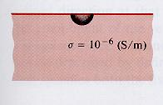
Eg. A ground connection is made by burying a hemispherical conductor of radius 25mm in the earth with its base up. Assuming the earth conductivity to σ=10⁻⁶ S/m, find the resistance of the conductor to far-away points in the ground. [交大電信所]
(Sol.) $\vec{J}={\hat{a}}_{R}\frac{I}{2{πR}^{2}}$, $\vec{E}={\hat{a}}_{R}\frac{I}{2\text{πσ}R^{2}}$=>$V_{0}=−\int{\text{EdR}}=\frac{I}{2\text{πσ}b}$
$R=\frac{V_{0}}{I}=\frac{1}{2\text{πσ}b}=\frac{1}{2π({\text{10}}^{−6})(\text{25}×{\text{10}}^{−3})}=6\text{.}\text{36}×{\text{10}}^{6}$.

Eg. The space between two parallel conducting plates each having an area S is filled with an inhomogeneous ohmic medium whose conductivity varies linearly from σ₁ at one plate (y=0) to σ₂ at the other plate (y=d). And d-c voltage V₀ is applied across the plates. Determine the total resistance between the plates.
(Sol.) $\vec{J}=−\hat{y}Jo$=>$\vec{E}=\frac{\vec{J}}{σ}=−\hat{y}\frac{Jo}{σ(y)}$, $σ(y)=σ1+(σ2−σ1)\frac{y}{d}$, $V_{0}=−\int{\vec{E}⋅\hat{y}}\text{dy}=\frac{J_{0}d}{σ2−σ1}\text{ln}\frac{σ2}{σ1}$, $R=\frac{V_{0}}{I}=\frac{V_{0}}{JoS}=\frac{d}{(σ2−σ1)S}\text{ln}(\frac{σ2}{σ1})$
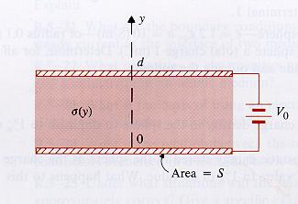
Relation between R and C: $C=\frac{Q}{V}=\frac{∯{\vec{D}⋅d\vec{s}}}{−\int{\vec{E}⋅d\vec{l}}}=\frac{∯{ε\vec{E⋅d}\vec{s}}}{−\int{\vec{E}⋅d\vec{l}}}$, $R=\frac{V}{I}=\frac{−\int{\vec{E}⋅d\vec{l}}}{∯{\vec{J}}⋅d\vec{s}}=\frac{−\int{\vec{E⋅d\vec{l}}}}{∯{σ\vec{E}⋅d\vec{s}}}$, ∴ RC=$\frac{C}{G}=\frac{ε}{σ}$

Eg. Find the leakage resistance per unit length (a) between the inner and outer conductors of a coaxial cable that has an inner conductor of radius a, an outer conductor of inner radius b, and a medium with conductivity σ, and (b) of a parallel-wire transmission line consisting of wires of radius a separated by a distance D in a medium with conductivity σ. [台科大電研]
(Sol.) (a) $C=\frac{2\text{πε}}{\text{ln}(\frac{b}{a})}$, $R=\frac{ε}{σ}\left(\frac{1}{C}\right)=\frac{1}{2\text{πσ}}\text{ln}\left(\frac{b}{a}\right)$
(b) $C=\frac{\text{πε}}{{\text{cosh}}^{−1}(\frac{D}{2a})}$, $R=\frac{ε}{σ}\left(\frac{1}{C}\right)=\frac{1}{\text{πσ}}{\text{cosh}}^{−1}(\frac{D}{2a})$

Eg. Find the resistance between two concentric spherical surfaces of radii R₁ and R₂ (R₁<R₂) if the space between the surfaces is filled with a homogeneous and isotropic material having a conductivity σ.
(Sol.) $C=\frac{4\text{πε}}{\frac{1}{R1}−\frac{1}{R2}}$, $\text{RC}=\frac{ε}{σ}$ => $R=\frac{1}{C}⋅\frac{ε}{σ}$ => $R=\frac{1}{4\text{πσ}}(\frac{1}{R1}−\frac{1}{R2})$

4-9 Inductors and Inductances
Mutual flux: $Φ_{\text{12}}=\iint_{S_{2}}{{\vec{B}}_{1}⋅d{\vec{S}}_{2}}=L_{\text{12}}I_{1}$ (Wb)
General mutual inductance: $L_{\text{12}}=\frac{N_{2}Φ_{\text{12}}}{I_{1}}=\frac{Λ_{\text{12}}}{I_{1}}$ (H)
Self-Inductance: $L_{\text{11}}=\frac{Λ_{\text{11}}}{I_{1}}$
Eg. Assume that N turns of wire are tightly wound on a toroidal frame of a rectangular cross section. Then, assuming the permeability of the medium to be μ₀, find the self-inductance of the toroidal coil. [台大電研]
(Sol.)
$d\vec{l}={\hat{a}}_{φ}\text{rd}φ$, $\oint_{C}{\vec{B}⋅d\vec{l}}=\int{\text{Br}dφ}=2π\text{rB}=μ_{o}\text{NI}⇒B=\frac{μ_{o}\text{NI}}{2πr}$
$⇒Φ=\iint_{S}{\vec{B}⋅d\vec{s}}=\frac{μ_{o}\text{NIh}}{2π}\int{\frac{dr}{r}}=\frac{μ_{o}\text{NIh}}{2π}\text{ln}(\frac{b}{a})$, $L=\frac{NΦ}{I}=\frac{μ_{o}N^{2}h}{2π}\text{ln}(\frac{b}{a})$
Eg. Find the inductance per unit length of a very long solenoid with air core having n turns per unit length. And S is the cross-sectional area.
(Sol.) $B=μ_{o}\text{nI}$, $Φ=\text{BS}=μ_{o}\text{nSI}$ $'=nΦ=μ_{o}n^{2}\text{SI}$, $L'=μ_{o}n^{2}S$

Eg. Two coils of N₁ and N₂ turns are would concentrically on a straight cylindrical core of radius a and permeability μ. The windings have lengths l₁ and l₂, respectively. Find the mutual inductance between the coils.
(Sol.) $Φ_{\text{12}}=μ(\frac{N_{1}}{ℓ_{1}})({πa}^{2})I_{1}$, $Λ_{\text{12}}=N_{2}Φ_{\text{12}}=\frac{μ}{ℓ_{1}}N_{1}N_{2}{πa}^{2}I_{1}$
=>$L_{\text{12}}=\frac{Λ_{\text{12}}}{I_{1}}=\frac{μ}{ℓ_{1}}N_{1}N_{2}{πa}^{2}$

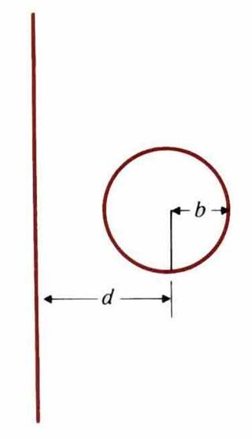
Eg. Determine the mutual inductance between a very long, straight wire and a conducting circular loop. [台大電研、清大物理所]
(Sol.)
B at p is $\frac{μ_{0}I}{2π(d+r\text{cos}θ)}$
$$\begin{aligned}Λ=\frac{μ_{0}I}{2π}\int{\int{\frac{\text{rd}θ\text{dr}}{d+r\text{cos}θ}}}=\frac{μ_{0}I}{2π}\int{\frac{2π\text{rdr}}{\sqrt{d^{2}−r^{2}}}}=μ_{0}I(d−\sqrt{d^{2}−b^{2}}) \\ L=μ_{0}(d−\sqrt{d^{2}−b^{2}})\end{aligned}$$
Eg. Determine the mutual inductance between a conducting triangular loop and a very long straight wire.
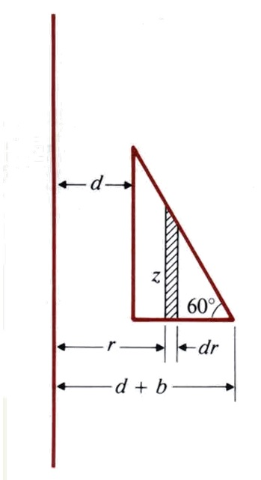
(Sol.)
$B_{2}={\hat{a}}_{φ}\frac{μ_{0}I_{2}}{2πr}$, $Λ=Φ=\int{B⋅ds}$, where $dS={\hat{a}}_{φ}\text{zdr}$
z=$\sqrt{3}(d+b−r)$
$$\begin{aligned}Λ=\frac{\sqrt{3}μ_{0}I}{2π}\int{\frac{1}{r}(d+b−r)\text{dr}}=\frac{\sqrt{3}μ_{0}I}{2π}[(d+b)\text{ln}(1+b/d)−b] \\ L=\frac{Λ}{I}=\frac{\sqrt{3}μ_{0}}{2π}[(d+b)\text{ln}(1+b/d)−b]\end{aligned}$$

Eg. Determine the mutual inductance between a very long, straight wire and a conducting equilateral triangular loop. [高考]
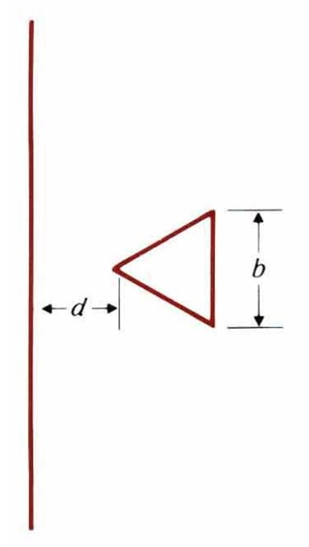
(Sol.)
$$\begin{aligned}B={\hat{a}}_{Φ}\frac{μ_{0}I}{2πr}={\hat{a}}_{Φ}B_{Φ} \\ Λ=\int{B_{Φ}⋅\frac{2}{\sqrt{3}}(r−d)\text{dr}}=\frac{μ_{0}I}{\sqrt{3}π}[\frac{\sqrt{3}}{2}b−d\text{ln}(1+\frac{\sqrt{3}b}{2d})] \\ L=\frac{Λ}{I}=\frac{μ_{0}}{\sqrt{3}π}[\frac{\sqrt{3}}{2}b−d\text{ln}(1+\frac{\sqrt{3}b}{2d})]\end{aligned}$$

Eg. Find the mutual inductance between two coplanar rectangular loops with parallel sides. Assume that h₁ >> h₂ (h₂ > w₂ > d). (台大電研)
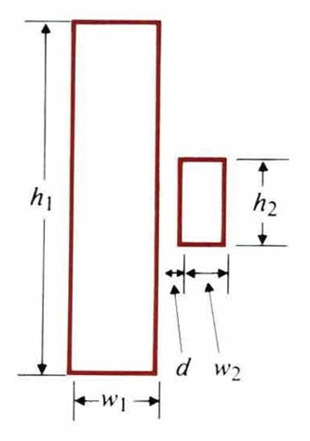
(Sol.)
$$\begin{aligned}Λ_{\text{12}}=\frac{μ_{0}h_{2}I}{2π}\int{(\frac{1}{d+x}−\frac{1}{w_{1}+d+x})\text{dx}}=\frac{μ_{0}h_{2}I}{2π}\text{ln}(\frac{w_{2}+d}{d}⋅\frac{w_{1}+d}{w_{1}+w_{2}+d}) \\ L_{\text{12}}=\frac{Λ_{\text{12}}}{I}=\frac{μ_{0}h_{2}}{2π}\text{ln}[\frac{(w_{1}+d)(w_{2}+d)}{d(w_{1}+w_{2}+d)}]\end{aligned}$$
Neumaun formula: $L_{\text{12}}=\frac{μ_{0}N_{1}N_{2}}{4π}\oint_{C_{1}}{\oint_{C_{2}}{\frac{dℓ_{1}dℓ_{2}}{R}}}$
L₁₂$=\frac{N_{2}Φ_{\text{12}}}{I_{1}}=\frac{N_{2}}{I_{1}}\iint_{S}{B_{1}⋅dS_{2}}=\frac{N_{2}}{I_{1}}\iint_{S_{2}}{(∇×A_{1})⋅dS_{2}}=\frac{N_{2}}{I_{1}}\oint_{C_{2}}{A_{1}dℓ_{2}}$
∵ $A_{1}=\frac{μ_{0}N_{1}I_{1}}{4π}\oint_{C_{1}}{\frac{dℓ_{1}}{R_{1}}}$, ∴ $L_{\text{12}}=\frac{μ_{0}N_{1}N_{2}}{4π}\oint_{C_{1}}{\oint_{C_{2}}{\frac{dℓ_{1}dℓ_{2}}{R}}}$
Eg. A rectangular loop of width w and height h is situated near a very long wire carrying a current i₁. Assume i₁ to be a rectangular pulse. Find the induced current i₂ in the rectangular loop whose self-inductance is L.
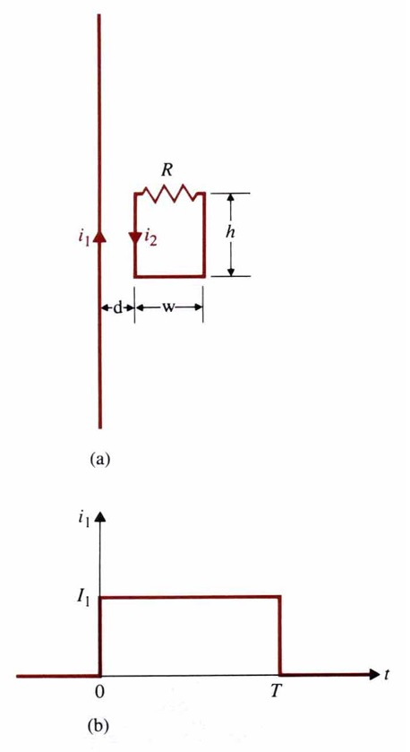
(Sol.)
$L_{\text{12}}\frac{{\text{di}}_{1}}{\text{dt}}=L\frac{{\text{di}}_{2}}{\text{dt}}+{\text{Ri}}_{2}$,
where $L_{\text{12}}=\frac{Φ_{\text{12}}}{i_{1}}=\frac{h}{i_{1}}\int{\frac{μ_{0}i_{1}}{2πr}\text{dr}}=\frac{μ_{0}h}{2π}\text{ln}(1+\frac{w}{d})$
t=0, $L\frac{{\text{di}}_{2}}{\text{dt}}+{\text{Ri}}_{2}=L_{\text{12}}I_{1}δ(t)⇒i_{2}=\frac{L_{\text{12}}}{L}I_{1}e^{−(\frac{R}{L})t}$
t=T, $i_{2}=\frac{L_{\text{12}}}{L}I_{1}e^{−\frac{\text{RT}}{L}}$, when –I₁ is applied
t>T, $i_{2}=−\frac{L_{\text{12}}}{L}I_{1}e^{−(\frac{R}{L})(t−T)}$

4-10 Magnetic Energy
W_{m}=$\frac{1}{2}\sum_{j=1}^{N}{\sum_{k=1}^{N}{L_{\text{jk}}}I_{j}I_{k}}=\frac{1}{2}\sum_{k=1}^{N}{I_{k}Φ_{k}}=\frac{1}{2}\iiint_{V'}{A⋅J\text{dv}'}$
Let $V_{1}=L_{1}\frac{{\text{di}}_{1}}{\text{dt}}⇒W_{1}=\int{V_{1}i_{1}\text{dt}}=L_{1}\int{i_{1}{\text{di}}_{1}}=\frac{1}{2}L_{1}I_{1}^{2}=\frac{1}{2}I_{1}Φ_{1}$: Magnetic energy

Similarly, $V_{\text{21}}=L_{\text{21}}\frac{{\text{di}}_{2}}{\text{dt}}⇒W_{\text{21}}=\int{V_{\text{21}}I_{1}\text{dt}}=L_{\text{21}}I_{1}\int{{\text{di}}_{2}}=L_{\text{21}}I_{1}I_{2}$
And $W_{2}=\frac{1}{2}L_{2}I_{2}^{2}$ $⇒W_{m}=\frac{1}{2}LI_{1}^{2}+L_{\text{21}}I_{1}I_{2}+\frac{1}{2}L_{2}I_{2}^{2}=\frac{1}{2}\sum_{j=1}^{2}{\sum_{k=1}^{2}{L_{\text{jk}}}I_{j}I_{k}}$
Generally, $W_{m}=\frac{1}{2}\sum_{j=1}^{N}{\sum_{k=1}^{N}{L_{\text{jk}}}I_{j}I_{k}}=\frac{1}{2}\sum_{k=1}^{N}{I_{k}Φ_{k}}$ when $Φ_{k}=\sum_{j=1}^{N}{L_{\text{jk}}I_{j}}$

∵ $Φ_{k}=\iint_{S_{k}}{B⋅dS_{n}'=\oint_{C_{k}}{A⋅dℓ_{k}}}$
∴ $W_{m}=\frac{1}{2}\sum_{k=1}^{N}{{ΔI}_{k}\oint_{C_{k}}{A⋅dl_{k}}}=\frac{1}{2}\iiint_{V'}{A⋅J\text{dv}'}$ $({ΔI}_{k}{\text{dl}}_{k}'=J(Δ{\hat{a}}_{k}'){\text{dl}}_{k}'=J⋅v_{k}')$
∵ $∇⋅(A×H)=H⋅(∇×A)−A⋅(∇×H)⇒A⋅(∇×H)=H⋅(∇×A)−∇⋅(A×H)$
And $J=∇×H⇒A⋅J=H⋅B−∇⋅(A×H)$
$⇒W_{m}=\frac{1}{2}\iiint_{V'}{H⋅B\text{dv}'−\frac{1}{2}}∯_{S'}{(A×H)⋅a_{n}\text{dS}'}$ as $R→∞⇒\left|A\right|∝\frac{1}{R},$ $\left|H\right|∝\frac{1}{R^{2}}$, $dS∝R^{2}⇒−\frac{1}{2}∯_{S'}{(A×H)⋅{\hat{a}}_{n}\text{dS}'}→0$
∴ $W_{m}=\frac{1}{2}\iiint_{V'}{H⋅B\text{dv}'}=\iiint_{V'}{w_{m}\text{dv}'}$
Magnetic energy density: $\begin{aligned}w_{m}=\frac{1}{2}H⋅B \\ w_{m}=\frac{|B|^{2}}{2μ} \\ w_{m}=\frac{1}{2}μ|H|^{2}\end{aligned}$ and L=$\frac{2W_{m}}{I^{2}}$.

Eg. Determine the inductance per unit length of an air coaxial transmission line that has a solid inner conductor of radius a and a very thin outer conductor of radius b. [台科大電機所]
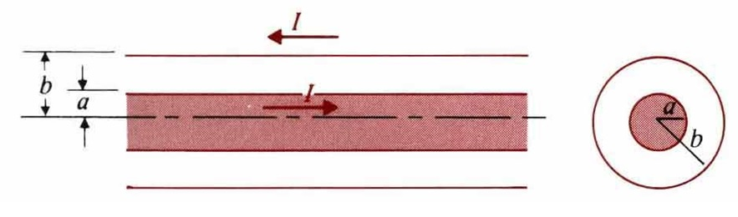
(Sol.)
W_{m1}=$\frac{1}{2μ_{0}}\int{B_{1}^{2}2π\text{rdr}=\frac{μ_{0}I^{2}}{4{πa}^{4}}}\int{r^{3}\text{dr}}=\frac{μ_{0}I^{2}}{\text{16}π}$
W_{m2}=$\frac{1}{2μ_{0}}\int{B_{2}^{2}2π\text{rdr}=\frac{μ_{0}I^{2}}{4π}}\int{\frac{1}{r}\text{dr}}=\frac{μ_{0}I^{2}}{4π}\text{ln}\frac{b}{a}$, $L'=\frac{2}{I^{2}}(W_{m1}+W_{m2})=\frac{μ_{0}}{8π}+\frac{μ_{0}}{2π}\text{ln}\frac{b}{a}$

Eg. Consider two coupled circuits having self-inductance L₁ and L₂, which carry currents I₁ and I₂, respectively. The mutual inductance between the circuits is M.
- Find the ratio I₁/I₂ that makes the stored magnetic energy W_{m} a minimum.
- Show that $M≤\sqrt{L_{1}L_{2}}$. [清大核工所]
(Sol.) $W_{m}=\frac{1}{2}L_{1}I_{1}^{2}+{\text{MI}}_{1}I_{2}+\frac{1}{2}L_{2}I_{2}^{2}$
(a) $W_{m}=\frac{I_{2}^{2}}{2}[L_{1}(\frac{I_{1}}{I_{2}})^{2}+2M(\frac{I_{1}}{I_{2}})+L_{2}]=\frac{I_{2}^{2}}{2}[L_{1}x^{2}+2\text{Mx}+L_{2}],x≡\frac{I_{1}}{I_{2}}$
$\frac{{\text{dW}}_{m}}{\text{dx}}=0=\frac{I_{2}^{2}}{2}(2L_{1}x+2M)⇒x=\frac{I_{1}}{I_{2}}=−\frac{M}{L_{1}}$ for minimum W_{m}
(b) (W_{m})_{min}=$\frac{I_{2}^{2}}{2}(−\frac{M^{2}}{L_{1}}+L_{2})≥0⇒M≤\sqrt{L_{1}L_{2}}$

4-11 Magnetic Forces and Torques

Force due to constant flux linkage:
$F_{φ}⋅dℓ=−{\text{dW}}_{m}=−(∇W_{m})⋅d\vec{ℓ}⇒F_{φ}=−∇W_{m}$ and $(T_{φ})_{z}=−\frac{∂W_{m}}{∂φ}$
Force due to constant current:
$${\text{dW}}_{s}=\sum_{k}{I_{k}'}{dΦ}_{k}=\text{dW}+{\text{dW}}_{m}$$
${\text{dW}}_{m}=\frac{1}{2}\sum_{k}{I_{k}Φ_{k}}=\frac{1}{2}{\text{dW}}_{s}⇒\text{dW}=F_{I}⋅dl={\text{dW}}_{m}=(∇W_{m})⋅dl$$⇒F_{I}=∇W_{m}$
Torque in terms of mutual inductance:
$W_{m}=\frac{1}{2}L_{1}I_{1}^{2}+L_{\text{12}}I_{1}I_{2}+\frac{1}{2}L_{2}I_{2}^{2}$$⇒F_{I}=I_{1}I_{2}(∇L_{\text{12}})$, $T_{I}=I_{1}I_{2}\frac{∂L_{\text{12}}}{∂φ}$
Eg. One end of a long air-core coaxial transmission line having an inner an conductor of radius a and an outer conductor of inner radius b is short-circuited by a thin, tight-fitting conducting washer. Find the magnitude and the direction of the magnetic force on the washer when a current I flows in the line.
(Sol.) $W_{m}=\frac{1}{2}{\text{LI}}^{2}$, $L=\frac{Φ}{I}=\frac{x}{I}\int{B_{φ}\text{dr}}=\frac{x}{I}\int{\frac{μ_{0}I}{2πr}\text{dr}=\frac{μ_{0}x}{2π}\text{ln}\frac{b}{a}}$
$$F_{I}=\hat{x}\frac{∂W_{m}}{∂x}=\hat{x}(\frac{I^{2}}{2})\frac{∂L}{∂x}=\hat{x}\frac{μ_{0}I^{2}}{4π}\text{ln}(\frac{b}{a})$$

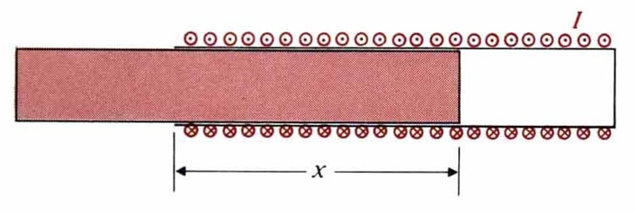
Eg. A current I flows in a long solenoid with n closely wound coil-turns per unit length. The cross-sectional area of its iron core, which has permeability μ, is S. Determine the force acting on the core if it is withdrawn to the position. [高考電機技師]
(Sol.)
$$\begin{aligned}W_{m}=\frac{1}{2}\iiint{{μH}^{2}\text{dv}},W_{m}(x+Δx)−W_{m}(x)=(\frac{1}{2}μ_{0}μ_{r}n^{2}I^{2}−\frac{1}{2}μ_{0}n^{2}I^{2})SΔx=\frac{1}{2}μ_{0}(μ_{r}−1)n^{2}I^{2}SΔx \\ ⇒(F_{I})_{x}=\frac{∂W_{m}}{∂x}=\frac{μ_{0}}{2}(μ_{r}−1)n^{2}I^{2}S\end{aligned}$$

Magnetic torque: $T=m×B$ (B=B⊥+B∥, m∥B⊥=>m×B⊥=0)
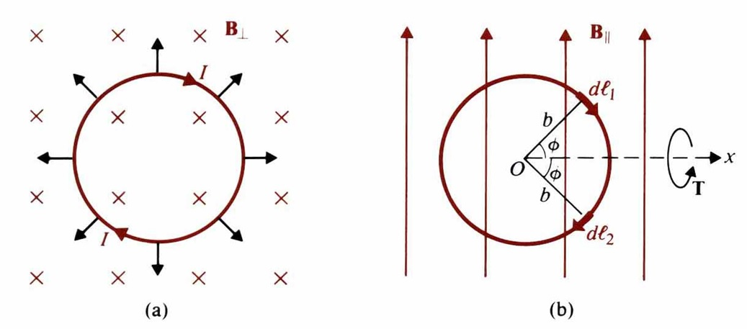
$dT=\hat{x}\text{dF}2b\text{sin}φ=\hat{x}({\text{IdlB}}_{||}\text{sin}φ)2b\text{sin}φ=\hat{x}2{\text{Ib}}^{2}B_{||}{\text{sin}}^{2}φdφ$$\begin{aligned}T=\int{dT=\hat{x}2{\text{Ib}}^{2}B_{\text{//}}}\int{{\text{sin}}^{2}φdφ=\hat{x}I({πb}^{2})B_{\text{//}}}=\hat{x}{\text{mB}}_{\text{//}} \\ ⇒T=m×B\end{aligned}$

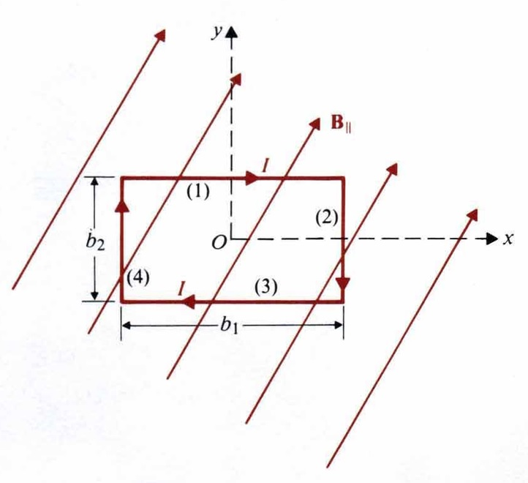
Eg. A rectangular loop in the xy-plane with sides b₁ and b₂ carrying a current I has in a uniform magnetic field $B=\hat{x}B_{x}+\hat{y}B_{y}+\hat{z}B_{z}$. Determine the force and torque on the loop.
(Sol.) $T=m×B={\text{Ib}}_{1}b_{2}(\hat{x}B_{y}−\hat{y}B_{x})$

4-12 Magnetic Circuits
Define $V_{m}=\text{NI}$: mmf, $Φ=\text{BS}$: magnetic flux, $ℜ=\frac{l}{μS}$: reluctance
(1) $\sum{N_{j}I_{j}=\sum_{k}{ℜ_{k}Φ_{k}}}$. (2) ∵ $∇⋅\vec{B}=0$, ∴ $\sum_{j}{Φ_{j}}=0$

Eg. (a) Steady current I₁ and I₂ flow in windings of N₁ and N₂ turns, respectively, on the outside legs of the ferromagnetic core. The core has a cross-sectional area S_{c} and permeability μ. Determine the magnetic flux in the center leg.
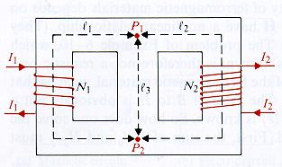
(Sol.)
$ℜ_{1}=\frac{l_{1}}{{μS}_{C}}$, $ℜ_{2}=\frac{l_{2}}{{μS}_{C}}$, $ℜ_{3}=\frac{l_{3}}{{μS}_{C}}$
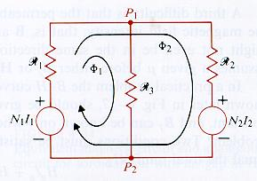
Loop 1: $N_{1}I_{1}=(ℜ_{1}+ℜ_{3})Φ_{1}+ℜ_{1}Φ_{2}$
Loop 2: $N_{1}I_{1}−N_{2}I_{2}=ℜ_{1}Φ_{1}+(ℜ_{1}+ℜ_{2})Φ_{2}$
$$Φ_{1}=\frac{ℜ_{2}N_{1}I_{1}+ℜ_{1}N_{2}I_{2}}{ℜ_{1}ℜ_{2}+ℜ_{1}ℜ_{3}+ℜ_{2}ℜ_{3}}$$

Eg. A toroidal iron core of relative permeability 3000μ₀ has a mean radius R= 80mm and a circular cross section with radius b=25mm. An air gap l_{g}=3mm exists, and a current I flows in a 500-turn winding to produce a magnetic flux of 10⁻⁵Wb. Neglecting flux leakage and using mean path length, find (a) the reluctances of the air gap and of the iron core, (b) B_{g} and H_{g} in the air gap, and B_{c} and H_{c} in the iron core, (c) the required current I.
(Sol.) (a) $ℜ_{g}=\frac{l_{g}}{μ_{o}S}=\frac{3×{\text{10}}^{−3}}{4π×{\text{10}}^{−7}×(π×0\text{.}{\text{025}}^{2})}=1\text{.}\text{21}×{\text{10}}^{6}$ ($H^{−1}$)
$ℜ_{c}=\frac{2π0\text{.}\text{08}−0\text{.}\text{003}}{\text{3000}×(4π×{\text{10}}^{−7})×(π×0\text{.}{\text{025}}^{2})}=6\text{.}\text{75}×{\text{10}}^{4}$ ($H^{−1}$)
(b) $\vec{B_{g}}=\vec{B_{c}}={\hat{a}}_{φ}\frac{{\text{10}}^{−5}}{π×0\text{.}{\text{025}}^{2}}={\hat{a}}_{φ}5\text{.}\text{09}×{\text{10}}^{−3}$(T) $H_{g}=\frac{B_{g}}{μ_{0}}$, $H_{c}=\frac{B_{c}}{\text{3000}μ_{0}}$
(c) $\text{NI}=Φ\left(ℜ_{C}+ℜ_{g}\right)⇒I=0\text{.}\text{0256}$ (A)
Eg. Consider the electromagnet in Figure. In which a current I in an N-turn coil produce a flux Φ in the magnetic circuit. The cross-sectional area of the core is S. Determine the lifting force on the armature.
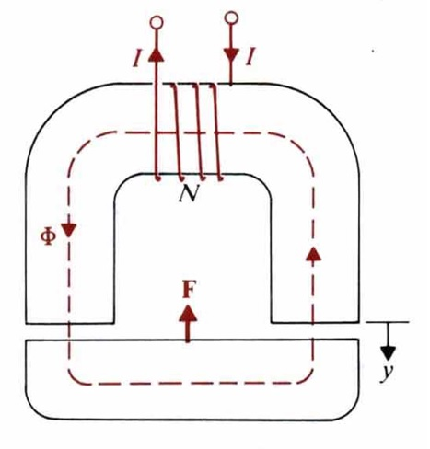
(Sol.)
$$\begin{aligned}{\text{dW}}_{m}=d(W_{m})_{\text{airgap}}=2(\frac{B^{2}}{2μ_{0}}\text{Sdy})=\frac{Φ^{2}}{μ_{0}S}\text{dy} \\ L=\frac{NΦ}{I}=\frac{N⋅\frac{\text{NI}}{R_{c}+2yμ_{0}S}}{I}\end{aligned}$$
$F_{φ}=\hat{y}\frac{−{\text{dW}}_{m}}{\text{dy}}=−\hat{y}\frac{Φ^{2}}{μ_{0}S}$ and $F_{I}=\hat{y}\frac{d}{\text{dy}}(\frac{1}{2}{\text{LI}}^{2})=−\hat{y}\frac{1}{μ_{0}S}(\frac{\text{NI}}{R_{c}+2y/{μ_{0}}S})^{2}=−\hat{y}\frac{Φ^{2}}{μ_{0}S}$

