自 傳
學生吳國榮，生活在一個普通家庭，家中成員有爸爸、媽媽、哥哥和我四人。爸爸是計程車司機，媽媽則是家庭主婦，哥哥已從研究所畢業，目前正在當兵。
我在高中時期，因為已知道自己的興趣是在電子電機方面，於是大學便選擇文化電機系就讀。而在大學時期，我曾在班上擔任過總務股長，也在學校的布袋戲社團中擔任副社長。在專題研究方面，我在指導教授的帶領下，擔任過兩個研究小組的組長，分別是「光電小組」與「Zigbee智慧型生活應用小組」，除了從事自己的研究工作之外，也要負責督導其他組員完成研究任務。而「光電小組」的主要研究內容，包括從事光子晶體波導與複合式波導之特性研究與其相關的元件設計等。至於「Zigbee智慧型生活應用」小組的研究內容，主要是以Zigbee技術結合太陽能電池作為電源，來進行室內環境的監控，如室內燈具與照度的控制，以及電力負載的監測等。
而在大學時期，除了在課堂上課之外，我也跟隨指導教授參訪過聯陽半導體股份有限公司(圖1)，並參加「2010年國科會光電學門與台灣地區光電研討會(OPT2010)」(圖2)以及「2011年民生電子論壇」(圖3)。
由於在大學時期從事專題研究與企業參訪的經驗，使我發覺程式的撰寫是非常重要，而在專題研究中更讓我學習到許多程式的技巧。同時我也對光子晶體波導的特性，以及Zigbee相關的應用有所了解，這使得我對於光電、計算機、控制等領域都非常有興趣，因此希望未來能夠從事這些領域相關的研究工作。
活動照片
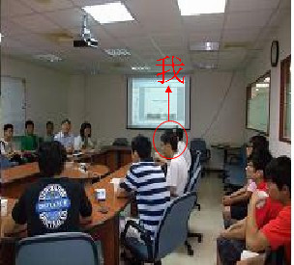 | 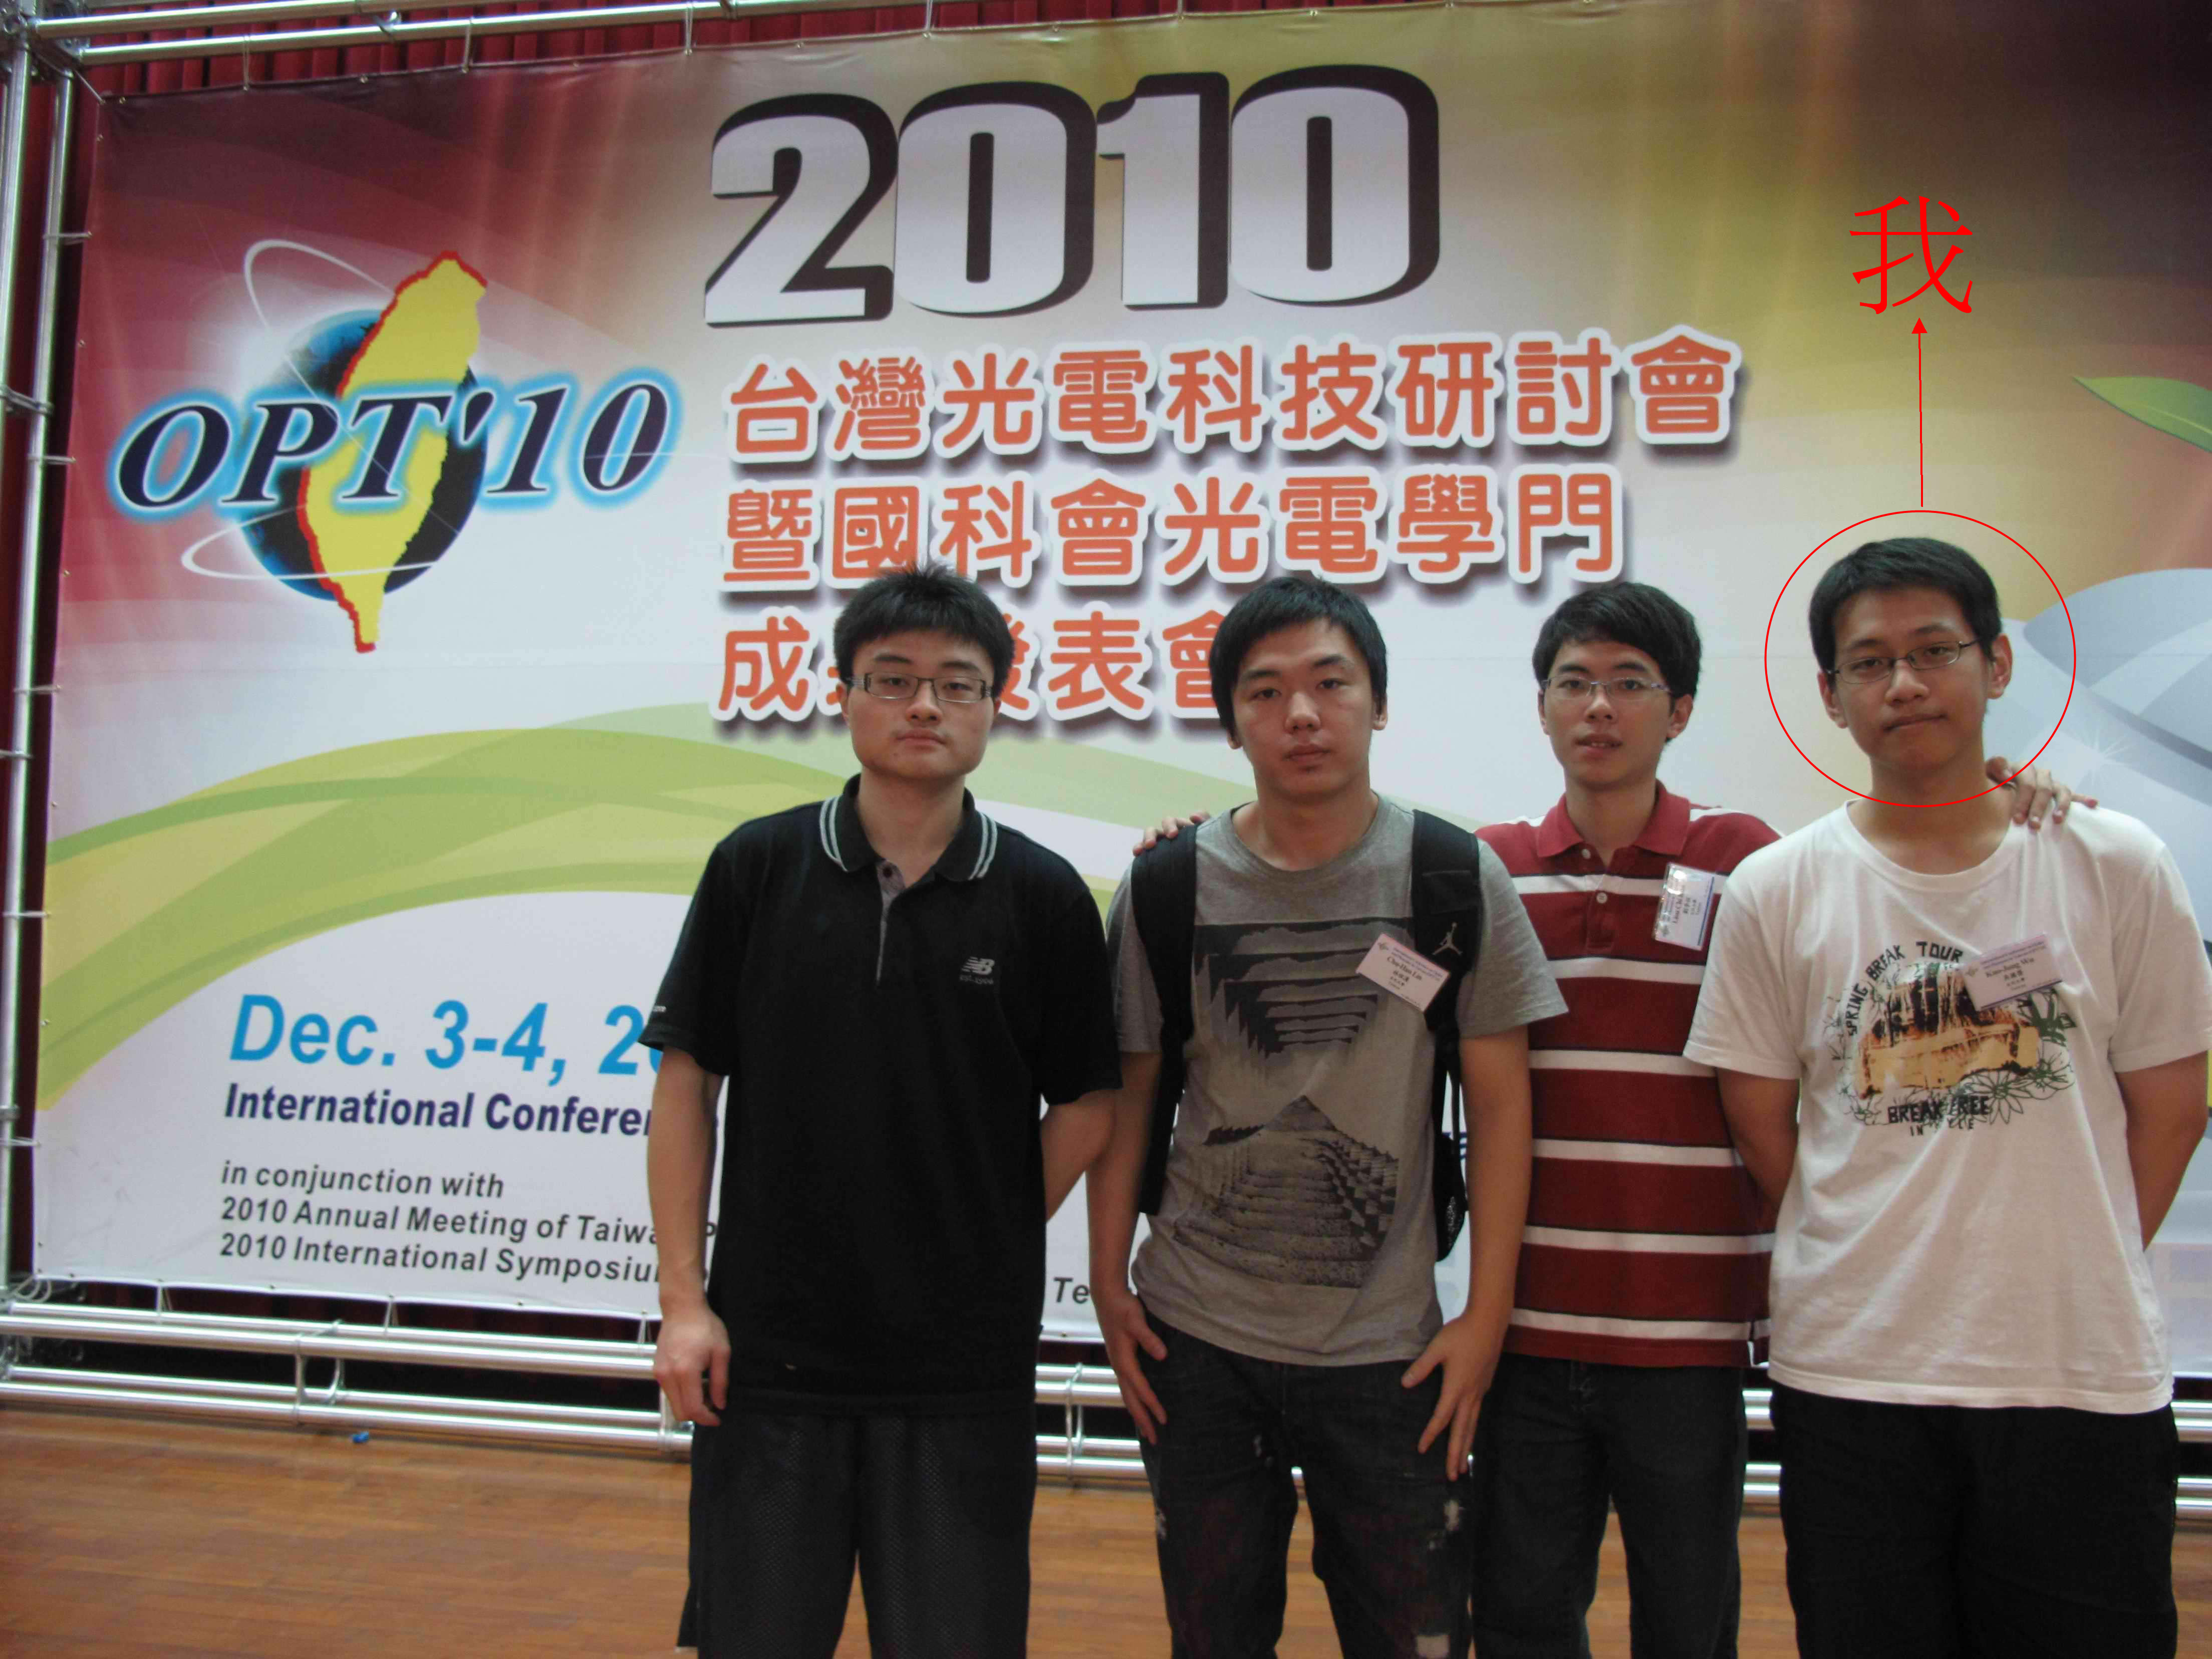
圖1. 聯陽半導體股份有限公司 | 圖2. 2010光電學門研討會(OPT2010)
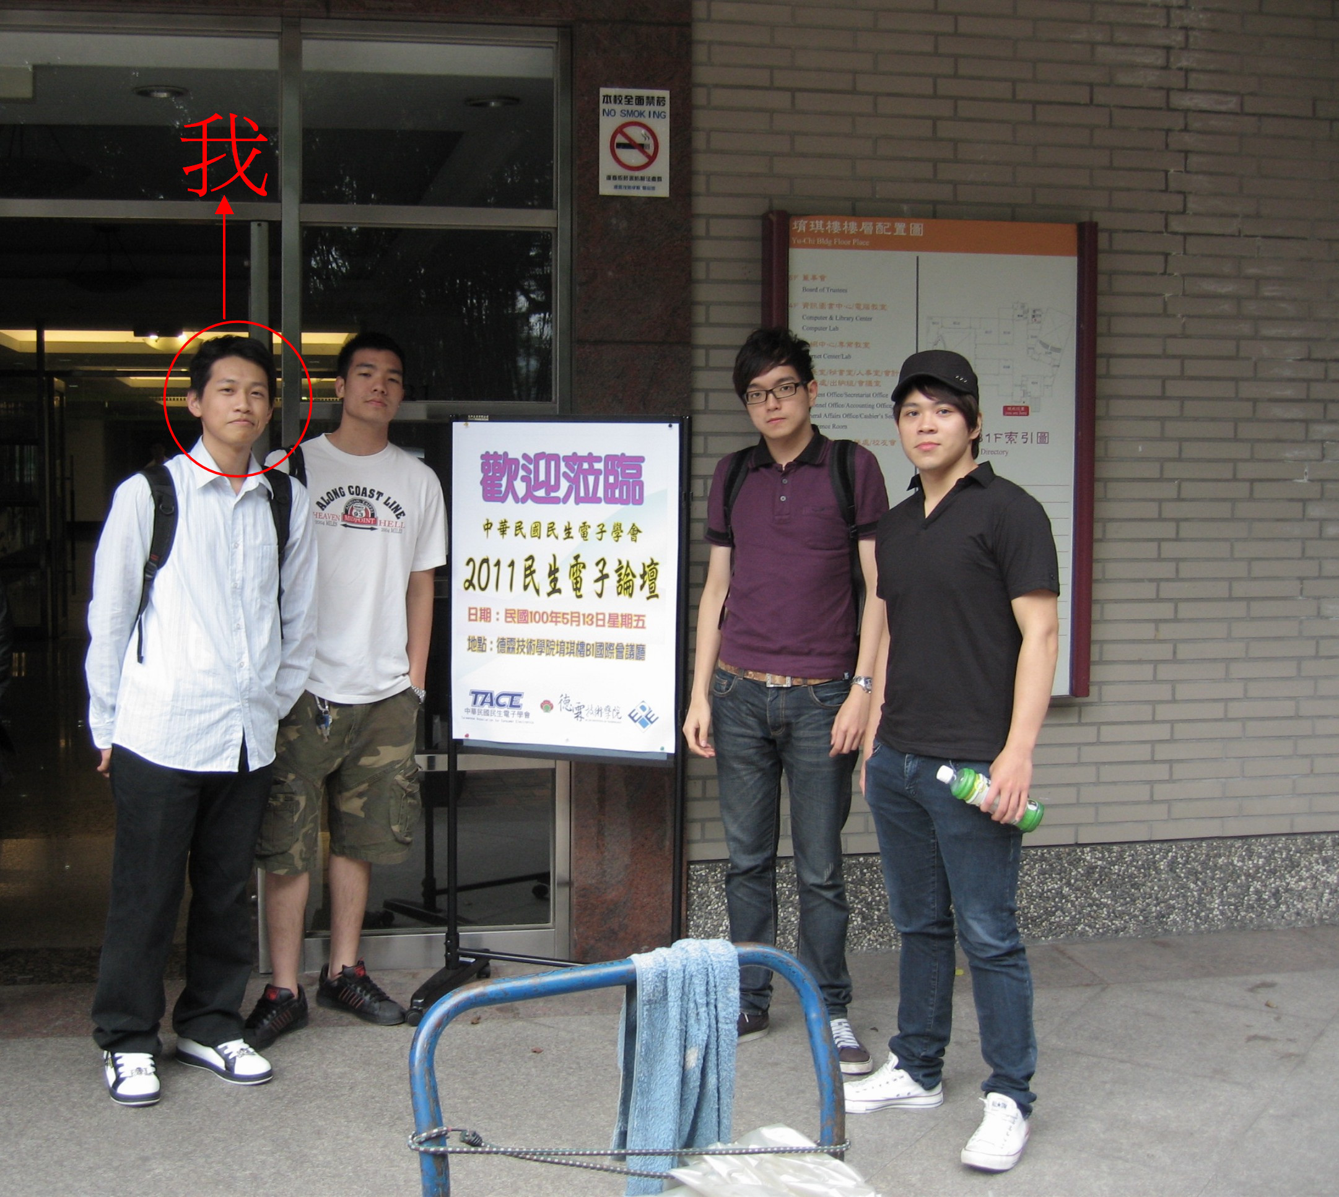
圖3. 2011年民生電子論壇

Autobiography
My name is Guo-Jung Wu, born in a usual family. There are four members in my family. My father is a taxi driver and my mother is a housewife. I have an elder brother who was graduated from the research institute. Now he is a soldier.
As early as my senior-high-school age, I had known that my major interests include computer science and electrical engineering. And then I decided to major in EE department at Chinese Culture University. In my university age, I had served as finance minister of my class. And I was also elected as vice chairman of Taiwanese glove-puppet club. In my research career, I was appointed as two researching group leaders. The first one is to study the optical behaviors of the photonic crystal waveguide and the composite waveguide. The second one is to study the application of Zigbee technology. Besides my own researches on these topics, I also assisted my colleagues in my researching groups to finish their tasks.
Besides studying the classrooms, I have visited ITE Tech. Inc. in 2010. I also attended 2010 Conference of Optics and Photonics Taiwan (OPT2010) held in Tainan and 2011 Consumer Electronics Forum in Xinbei City.
I found that the programming is very important in my research. I learned many tricks for programming and knowledge about optoelectronics during my research period. These experiences make me more interested in optoelectronics, computer science and control system. I would like to study the topics among them in the future.

