Chapter 4 Selected Topics for Circuits and Systems

4-1 Poisson’s and Laplace’s Equations
Poisson’s equation: $∇⋅εE=ρ⇒∇^{2}V=−\frac{ρ}{ε}$
Laplace’s equation: If no charge exists, ρ=0, $∇^{2}V=0$

Eg. The two plates of a parallel-plate capacitor are separated by a distance d and maintained at potentials 0 and V₀. Assume negligible fringing effect at the edges, determine (a) the potential at any point between the plates, (b) the surface charge densities on the plates. [清大電研]
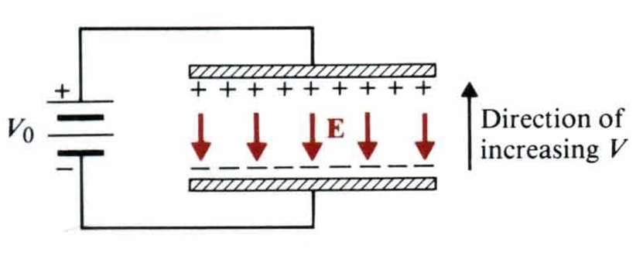
(Sol.) $\frac{d^{2}V}{{\text{dy}}^{2}}=0⇒V=c_{1}y+c_{2},V\left(y=0\right)=0,V\left(y=d\right)=V_{0}⇒V=\frac{V_{0}}{d}y$
$$E=−\hat{y}\frac{\text{dV}}{\text{dy}}=−\hat{y}\frac{V_{0}}{d},E_{n}={\hat{a}}_{n}⋅E=\frac{ρ}{ε}$$
At the lower plate: ${\hat{a}}_{n}=\hat{y},ρ_{\text{sl}}=−\frac{{εV}_{0}}{d}$.
At the upper plate: ${\hat{a}}_{n}=−\hat{y},ρ_{\text{ul}}=\frac{{εV}_{0}}{d}$

Eg. Show that uniqueness of electrostatic solutions.
(Proof) Let V₁ and V₂ satisfy $∇^{2}V_{1}=−\frac{ρ}{ε}$ and $∇^{2}V_{2}=−\frac{ρ}{ε}$. Define V_{d}=V₁-V₂, ▽²V_{d}=0
- On the conducting boundaries, V_{d} =0$⇒$V₁= V₂
- Let f= V_{d}, $A$=▽V_{d}
$∇⋅\left(V_{d}∇V_{d}\right)=∇⋅\left(fA\right)=f∇⋅A+A⋅∇f=V_{d}∇^{2}V_{d}+{\left|∇V_{d}\right|}^{2}$$⇒∯_{s}{{\left(V_{d}∇V_{d}\right)⋅{\hat{a}}_{n}\text{ds}=\iiint_{v^{'}}{\left|∇V_{d}\right|}}^{2}}\text{dv}$
$R→∞,V_{d}=V_{1}−V_{2}∝\frac{1}{R},∇V_{d}∝\frac{1}{R^{2}},\text{ds}∝R^{2}$$⇒∯_{s}{\left(V_{d}∇V_{d}\right)⋅{\hat{a}}_{n}\text{ds}→0},∴\iiint_{v}{{\left|∇V_{d}\right|}^{2}}\text{dv}=0⇒$ V_{d} =0$⇒$V₁= V₂

Image Theorem P(x,y,z) in the y>0 region is $V\left(x,y,z\right)=\frac{Q}{4{\text{πε}}_{0}}\left(\frac{1}{R_{+}}−\frac{1}{R_{−}}\right)$, where R₊ and R₋ are the distances from Q and –Q to the point P, respectively.
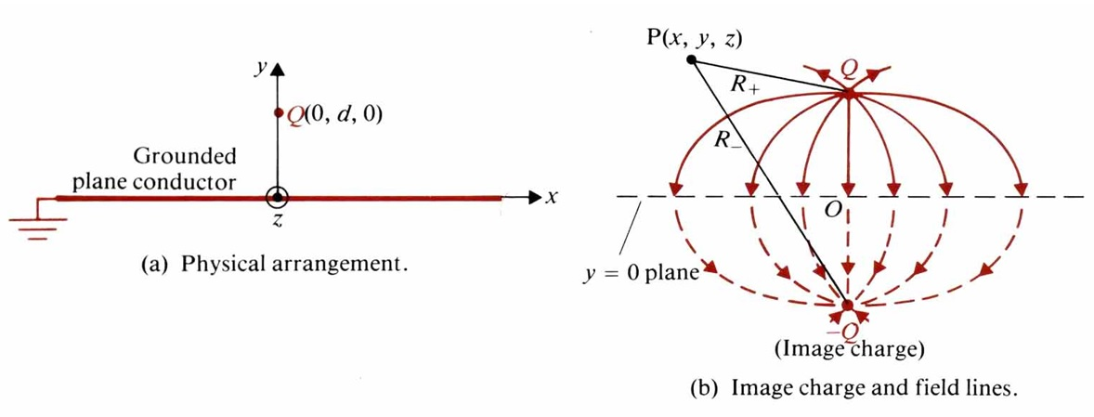
Eg. A line charge density ρ_{l} located at a distance d from the axis of a parallel conducting circular cylinder of radius a. Both are infinitely long. Find the image position of line charge.
(Sol.) Assume $ρ_{i}=−ρ_{l},V=−\int_{r_{0}}^{r}{\text{Edr}}=−\frac{ρ_{l}}{2{\text{πε}}_{0}}\int_{r_{0}}^{r}{\frac{1}{r}\text{dr}}=\frac{ρ_{l}}{2{\text{πε}}_{0}}ℓn\frac{r_{o}}{r}$
$$⇒V_{M}=\frac{ρ_{l}}{2{\text{πε}}_{0}}ℓn\frac{r_{0}}{r}−\frac{ρ_{l}}{2{\text{πε}}_{0}}ℓn\frac{r_{0}}{r_{i}}=\frac{ρ_{l}}{2{\text{πε}}_{0}}ℓn\frac{r_{i}}{r}$$
$\frac{r_{i}}{r}=\frac{d_{i}}{a}=\frac{a}{d}=C⇒$$d_{i}=\frac{a^{2}}{d}$
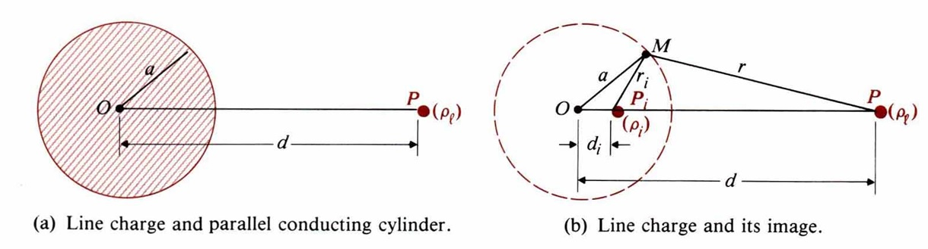

Eg. A point charge Q is placed at a distance d to a conducting sphere. Find its image.
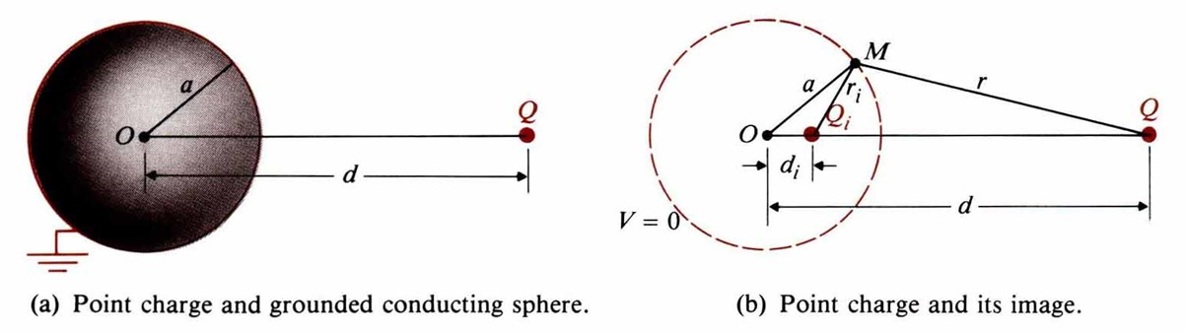
(Sol.) $V_{M}=\frac{1}{4{\text{πε}}_{0}}\left(\frac{Q}{r}+\frac{Q_{i}}{r_{i}}\right)=0$$⇒\frac{r_{i}}{r}=−\frac{Q_{i}}{Q}=\frac{a}{d}⇒Q_{i}=−\frac{a}{d}Q$, $\frac{a−d_{i}}{d−a}=\frac{a}{d}⇒d_{i}=\frac{a^{2}}{d}$
4-2 Boundary-Value Problems in Rectangular Coordinates
$∇^{2}V=\frac{∂^{2}V}{∂x^{2}}+\frac{∂^{2}V}{∂y^{2}}+\frac{∂^{2}V}{∂z^{2}}=0$. Let V(x,y,z)=X(x)Y(y)Z(z), k_{x}²+k_{y}²+k_{z}²=0
→ $\frac{d^{2}X\left(x\right)}{{\text{dx}}^{2}}+k_{x}^{2}X\left(x\right)=0,\frac{d^{2}Y\left(y\right)}{{\text{dy}}^{2}}+k_{y}^{2}Y\left(y\right)=0,\frac{d^{2}Z\left(z\right)}{{\text{dz}}^{2}}+k_{z}^{2}Z\left(z\right)=0$
For X(x), 1. k_{x}²=0, X(x)=A₀x+B₀ is linear.
2. k_{x}²>0, X(x)=A₁sink_{x}x+B₁cosk_{x}x, X(x=a) is finite, X(x=b) is finite
3. k_{x}²<0, X(x)=A₂sinhk_{x}x+B₂coshk_{x}x, X(∞) is finite, X(-∞) is finite
Similar cases exist in Y(y) and Z(z).

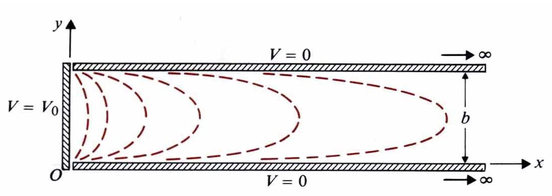
Eg. Two grounded, semi-infinite, parallel-plane electrodes are separated by a distance b. A third electrode perpendicular to and insulated from both is maintained at a constant potential V₀. Determine the potential distribution in the region enclosed by the electrodes. [高考]
(Sol.)
$$V\left(x,y,z\right)=V\left(x,y\right)=X\left(x\right)Y\left(y\right)$$
B.C.: $\begin{aligned}V\left(0,y\right)=V_{0},V\left(x,0\right)=0 \\ V\left(∞,y\right)=0,V\left(x,b\right)=0\end{aligned}$
$\frac{d^{2}X(x)}{d^{2}x}=k_{x}^{2}X(x)⇒X(x)=D_{1}e^{k_{x}x}+D_{2}e^{−k_{x}x}=D_{2}e^{−k_{x}x}$
$\frac{d^{2}Y\left(y\right)}{{\text{dy}}^{2}}=−k_{y}^{2}Y\left(y\right)⇒Y\left(y\right)=A_{1}\text{sin}k_{y}y$
$\begin{aligned}⇒V_{n}\left(x,y\right)=C_{n}e^{−k_{x}x}\text{sin}k_{y}y⇒k_{x}=k_{y}=\frac{nπ}{b},n=1,2,3 \\ ⇒V_{n}\left(x,y\right)=C_{n}e^{−\frac{nπx}{b}}\text{sin}\frac{nπy}{b} \\ V\left(0,y\right)=V_{0}=\sum_{n=1}^{∞}{}C_{n}\text{sin}\frac{nπy}{b} \\ \int{V_{0}\text{sin}\frac{mπy}{b}}\text{dy}=\sum_{n=1}^{∞}{C_{n}}\int{\text{sin}\frac{nπy}{b}}\text{sin}\frac{mπy}{b}\text{dy} \\ \\ \end{aligned}\begin{aligned}\left\{\frac{2{\text{bV}}_{0}}{mπ},m:\text{odd} | \right.\end{aligned}$
$V\left(x,y\right)=\frac{4V_{0}}{π}\sum_{n:\text{odd}}{\frac{1}{n}e^{−\frac{nπx}{b}}}\text{sin}\frac{nπy}{b},n=1,3,5,⋯$ for x>0, 0<y<b.
4-3 Boundary-Value Problems in Cylindrical Coordinates
$$∇^{2}V=\frac{1}{r}\frac{∂}{∂r}\left(r\frac{∂V}{∂r}\right)+\frac{1}{r^{2}}\frac{∂^{2}V}{∂φ^{2}}+\frac{∂^{2}V}{∂z^{2}}=0$$
- Assume $\frac{∂^{2}V}{∂z^{2}}=0$, then V(r,φ)=R(r)Φ(φ),
→ $r^{2}\frac{d^{2}R\left(r\right)}{{\text{dr}}^{2}}+r\frac{\text{dR}\left(r\right)}{\text{dr}}−n^{2}R\left(r\right)=0,\frac{d^{2}Φ\left(φ\right)}{{dφ}^{2}}+n^{2}Φ\left(φ\right)=0$
→R(r)= A_{r}r^{n}+B_{r}r^{-n}, Φ(φ)=A_{φ}sinnφ+ B_{φ}cosnφ
→V_{n}(r,φ)=r^{n}(Asinnφ+Bcosnφ)+ r^{-n}(A’sinnφ+B’cosnφ), n≠0
→V(r,φ)=$\underset{n=1}{\overset{∞}{\sum{V_{n}}}}\left(r,φ\right)$

- Assume n=0, $\frac{d^{2}Φ\left(φ\right)}{{dφ}^{2}}=0⇒$Φ(φ)=A₀φ+B₀, R(r)=C₀lnr+D₀,
In the φ-independent case, V(r)=C₁lnr+D₁
In the φ-dependent case, Φ(φ)=Aφ+B, V(r,φ)=(Clnr+D)(Aφ+B)

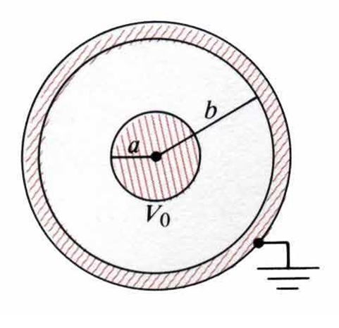
Eg. Consider a very long coaxial cable. The inner conductor has a radius a and is maintained at a potential V₀. The outer conductor has an inner radius b and is grounded. Determine the potential distribution in the space between the conductors. [電信特考]
(Sol.) $V\left(b\right)=0,V\left(a\right)=V_{0}⇒C_{1}ℓn(b)+C_{2}=0,C_{1}ℓn(a)+C_{2}=V_{0}$
$C_{1}=\frac{V_{0}}{\text{ln}\left(b/a\right)},C_{2}=−\frac{V_{0}\text{ln}b}{\text{ln}\left(b/a\right)}$, ∴ $V\left(r\right)=\frac{V_{0}}{\text{ln}\left(b/a\right)}\text{ln}\left(\frac{r}{b}\right)$

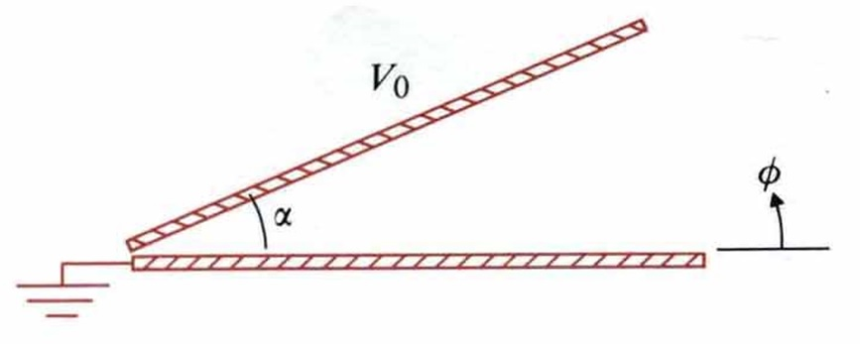
Eg. Two infinite insulated conducting planes maintained at potentials 0 and V₀ form a wedge-shaped configuration. Determine the potential distributions for the regions: $\begin{aligned}\left(a\right)0<φ<α \\ \left(b\right)α<φ<2π\end{aligned}$. [中央光電所、成大電研]
(Sol.)
(a) V(φ)=Aφ+B, $\begin{aligned}\left\{V\left(0\right)=0⇒B_{0}=0 | \right.\end{aligned}$$⇒V\left(φ\right)=\frac{V_{0}}{α}φ,0≤φ≤α$
(b) $\begin{aligned}\left\{V\left(α\right)=V_{0}=A_{1}α+B_{1} | \right.\end{aligned}$$⇒A_{1}=−\frac{V_{0}}{2π−α},B_{1}=\frac{2{πV}_{0}}{2π−α}⇒V\left(φ\right)=\frac{V_{0}}{2π−α}\left(2π−φ\right)$, $α≤φ≤2π$
Eg. An infinitely long, thin, conducting circular tube of radius b is split in two halves. The upper half is kept at a potential V=Vo and the lower half at V=-Vo. Determine the potential distributions both inside and outside the tube.
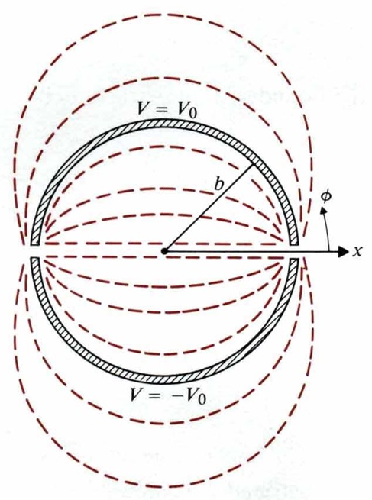
(Sol.) $V\left(b,φ\right)=\begin{aligned}\left\{V_{0},0<φ<π | \right.\end{aligned}$
- Inside the tube: $r<b⇒V_{n}\left(r,φ\right)=A_{n}r^{n}\text{sin}nφ$$⇒V\left(r,φ\right)=\sum_{n=1}^{∞}{}A_{n}r^{n}\text{sin}nφ$
$$r=b⇒\sum_{n=1}^{∞}{}A_{n}b^{n}\text{sin}nφ=\begin{aligned}\left\{V_{0},0<φ<π | \right.\end{aligned}$$
- Outside the tube: $r>b⇒V_{n}\left(r,φ\right)=B_{n}r^{−n}\text{sin}nφ$$⇒V\left(r,φ\right)=\sum_{n=1}^{∞}{}B_{n}r^{−n}\text{sin}nφ$
$$r=b⇒\sum_{n=1}^{∞}{}B_{n}b^{−n}\text{sin}nφ=\begin{aligned}\left\{V_{0},0<φ<π | \right.\end{aligned}$$

Eg. A long, grounded conducting cylinder of radius b is placed along the z-axis in an initially uniform electric field $E=\overset{}{x}E_{0}$. Determine potential distribution V(r,φ) and electric field intensity $E\left(r,φ\right)$ outside the cylinder. Show that the electric field intensity at the surface of the cylinder may be twice as high as that in the distance, which may cause a local breakdown or corona (St. Elmo’s fire.) [中央光電所、高考]
(Sol.) $V\left(r,φ\right)=−E_{0}r\text{cos}φ+\sum_{n=1}^{∞}{B_{n}r^{−n}\text{cos}nφ\left(\text{At}r\text{>>}b,E=\hat{x}E_{0},V=−E_{0}r\text{cos}φ\right)}$
At $r=b:V\left(r,φ\right)=−E_{0}b\text{cos}φ+\sum_{n=1}^{∞}{B_{n}b^{−n}\text{cos}nφ=0}$$⇒B_{1}=E_{0}b^{2},B_{n}=0\text{for}n≠1\text{.}$
Outside the cylinder, $r≥b:V\left(r,φ\right)=−E_{0}r\left(1−\frac{b^{2}}{r^{2}}\right)\text{cos}φ$
4-4 Boundary-Value Problems in Spherical Coordinates
$$∇^{2}V=\frac{1}{R^{2}}\frac{∂}{∂R}\left(R^{2}\frac{∂V}{∂R}\right)+\frac{1}{R^{2}\text{sin}θ}\frac{∂}{∂θ}\left(\text{sin}θ\frac{∂V}{∂θ}\right)+\frac{1}{R^{2}{\text{sin}}^{2}θ}\frac{∂^{2}V}{∂φ^{2}}=0$$
Assume φ-independent: $\frac{∂^{2}}{∂^{2}φ}=0$, V(r,θ)=R(r)Θ(θ)
$r^{2}\frac{d^{2}R\left(r\right)}{{\text{dr}}^{2}}+2r\frac{\text{dR}\left(R\right)}{\text{dr}}−k^{2}R\left(r\right)=0,\frac{d}{dθ}\left[\text{sin}θ\frac{dΘ\left(θ\right)}{dθ}\right]+n\left(n+1\right)Θ\left(θ\right)\text{sin}\left(θ\right)=0$, and
k²=n(n+1)→ R(r)=A_{n}r^{n}+B_{n}r^{-n-1}, Θ(θ)=P_{n}(cosθ)→V(r,θ)=[A_{n}r^{n}+B_{n}r^{-n-1}]P_{n}(cosθ)

Table of Legendre’s Polynomials
n | $$P_{n}\left(\text{cos}θ\right)$$
0 | 1
1 | $$\text{cos}θ$$
2 | $$\frac{1}{2}\left(3{\text{cos}}^{2}θ−1\right)$$
3

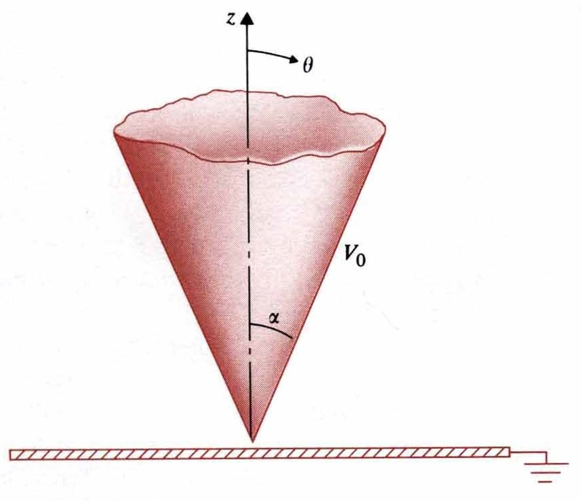
Eg. An infinite conducting cone of half-angle α is maintained at potential V₀ and insulated from a grounded conducting plane. Determine (a) the potential distribution V(θ) in the region α<θ<π/2, (b) the electric field intensity in the region α<θ<π/2, (c) the charge densities on the cone surface and on the grounded plane.
(Sol.)
$$\frac{d}{dθ}\left(\text{sin}θ\frac{\text{dV}}{dθ}\right)=0,\frac{\text{dV}}{dθ}=\frac{C_{1}}{\text{sin}θ}⇒V\left(θ\right)=C_{1}ℓn\left(\text{tan}\frac{θ}{2}\right)+C_{2}$$
（a）$\begin{aligned}V\left(α\right)=C_{1}ℓn\left(\text{tan}\frac{α}{2}\right)+C_{2}=V_{0} \\ V\left(\frac{π}{2}\right)=C_{1}ℓn\left(\text{tan}\frac{π}{4}\right)+C_{2}=0\end{aligned}$$⇒$$\begin{aligned}C_{1}=\frac{V_{0}}{ℓn\left[\text{tan}\left(\frac{α}{2}\right)\right]} \\ C_{2}=0\end{aligned}$$⇒$$V\left(θ\right)=\frac{V_{0}ℓn\left[\text{tan}\left(\frac{θ}{2}\right)\right]}{ℓn\left[\text{tan}\left(\frac{α}{2}\right)\right]}$
（b）$E=−{\hat{a}}_{θ}\frac{\text{dV}}{\text{Rd}θ}=−{\hat{a}}_{θ}\frac{V_{0}}{Rℓn\left[\text{tan}\left(\frac{α}{2}\right)\right]\text{sin}θ}$, （c）$\begin{aligned}θ=α:ρ_{s}=ε_{0}E\left(α\right)=\frac{ε_{0}V_{0}}{Rℓn\left[\text{tan}\left(\frac{α}{2}\right)\right]\text{sin}θ} \\ θ=\frac{π}{2}:ρ_{s}=−ε_{0}E\left(\frac{π}{2}\right)=−\frac{ε_{0}V_{0}}{Rℓn\left[\text{tan}\left(\frac{α}{2}\right)\right]}\end{aligned}$
Eg. An uncharged conducting sphere of radius b is placed in an initially uniform electric field $E=\hat{z}E_{0}$. Determine the potential distribution V(R,θ) and the electric field intensity $E\left(R,θ\right)$ after the introduction of the sphere. [中山電研]
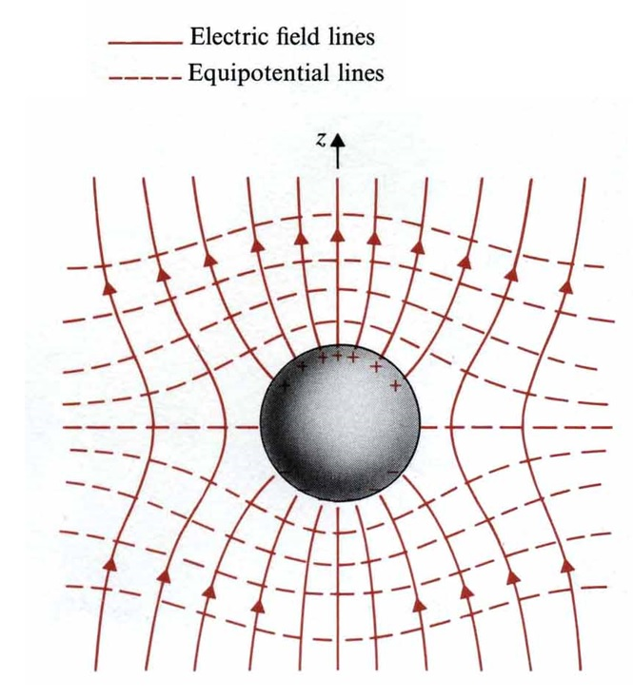
(Sol.) $V\left(b,θ\right)=0$
If R>>b,$V\left(R,θ\right)=−E_{0}z=−E_{0}R\text{cos}θ$
$V\left(R,θ\right)=\sum_{n=0}^{∞}{\left[A_{n}R^{n}+B_{n}R^{−\left(n+1\right)}\right]P_{n}\left(\text{cos}θ\right)}$, $R≥b$
（$\begin{aligned}A_{n}=0,n≠1 \\ A_{1}=−E_{0}\end{aligned}$）
↓
$$=−E_{0}{\text{RP}}_{1}\left(\text{cos}θ\right)+\sum_{n=0}^{∞}{B_{n}R^{−\left(n+1\right)}P_{n}\left(\text{cos}θ\right)},R≥b$$
（sphere is uncharged, $B_{0}=0$）
↓
$=\left(\frac{B_{1}}{R^{2}}−E_{0}R\right)\text{cos}θ+\sum_{n=2}^{∞}{}B_{n}R^{−\left(n+1\right)}P_{n}\left(\text{cos}θ\right),R≥b$
$R=b,0=\left(\frac{B_{1}}{b^{2}}−E_{0}b\right)\text{cos}θ+\sum_{n=2}^{∞}{}B_{n}b^{−\left(n+1\right)}P_{n}\left(\text{cos}θ\right)⇒B_{1}=E_{0}b^{3},B_{n}=0,n≥2$,
∴ $V\left(R,θ\right)=−E_{0}\left[1−{\left(\frac{b}{R}\right)}^{3}\right]R\text{cos}θ,R≥b$
$E\left(R,θ\right)={\hat{a}}_{R}E_{R}+{\hat{a}}_{θ}E_{θ}=−∇V\left(R,θ\right)={\hat{a}}_{R}\left(−\frac{∂V}{∂R}\right)+{\hat{a}}_{θ}\left(−\frac{∂V}{R∂θ}\right)$$={\hat{a}}_{R}E_{0}\left[1+2{\left(\frac{b}{R}\right)}^{3}\right]\text{cos}θ−{\hat{a}}_{θ}E_{0}\left[1−{\left(\frac{b}{R}\right)}^{3}\right]\text{sin}θ,R≥b$
A dipole moment $P=\hat{z}4{\text{πε}}_{0}b^{2}E_{0}$ is at the center of the sphere. Surface charge density is $ρ_{s}\left(θ\right)=ε_{0}E_{R|R=b}=3ε_{0}E_{0}\text{cos}θ$

4-5 Capacitors and Capacitances

Q=CV$⇔$C=Q/V
Eg. A parallel-plane capacitor consists of two parallel conducting plates of area S separate by uniform distance d, the space between the plates is filled with a dielectric of a constant permittivity. Determine the capacitance.
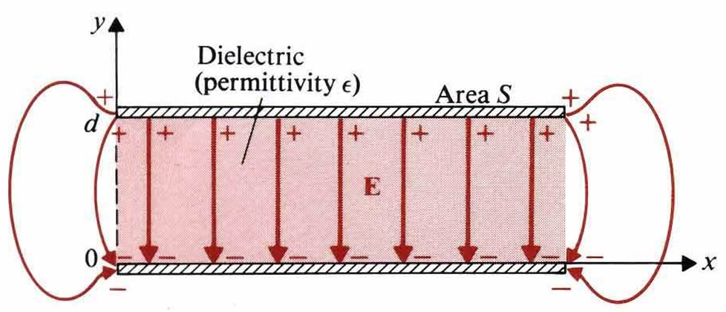
(Sol.) $ρ_{s}=\frac{Q}{S}$, $\overset{→}{E}=−\overset{}{y}\frac{ρ_{s}}{ε}=−\overset{}{y}\frac{Q}{εS}$
$V=−\int{\overset{→}{E}⋅d\overset{→}{l}=\int{\left(−\overset{}{y}\frac{Q}{εS}\right)⋅\left(\overset{}{y}\text{dv}\right)}}=\frac{Q}{ε S}d$
$C=\frac{Q}{V}=ε\frac{S}{d}$. In this problem, $\overset{→}{E}=−\overset{}{y}\frac{V}{d}$

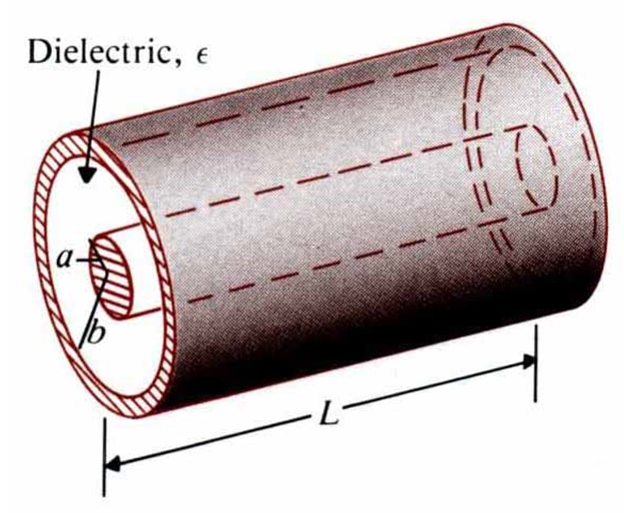
Eg. A cylindrical capacitor consists of an inner conductor of radius a and an outer conductor of radius b is filled with a dielectric of permittivity ε, and the length of the capacitor is L. Determine the capacitance of this capacitor.
(Sol.) $\overset{→}{E}=\overset{}{a_{r}}E_{r}=\frac{Q}{2\text{πε}\text{Lr}}$,
$V_{\text{ab}}=−\int{\overset{→}{E}⋅d\overset{→}{l}}=−\int{\left(\overset{}{a_{r}}\frac{Q}{2\text{πε}\text{Lr}}\right)⋅\left(\overset{}{a}\text{dr}\right)}$$=\frac{Q}{2\text{πε}L}\text{ln}\left(\frac{b}{a}\right)$, $C=\frac{Q}{V_{\text{ab}}}=\frac{2\text{πε}L}{\text{ln}\left(\frac{b}{a}\right)}$
Eg. A cylindrical capacitor of length L consists of coaxial conducting surface of radii r_{i} and r_{o}. Two dielectric media of different dielectric constants ε_{r1} and ε_{r2}, and fill the space between the conducting surface. Determine the capacitance. [台大物理所、高考電機技師]
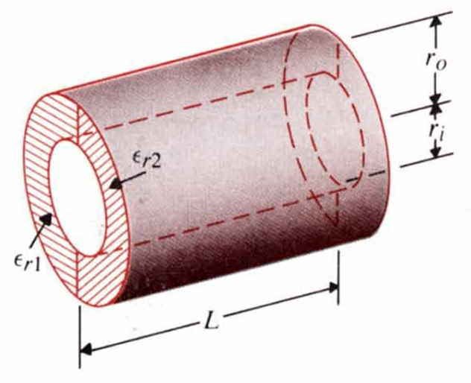
(Sol.) $π\text{rL}\left(ε_{0}ε_{r1}+ε_{0}ε_{r2}\right)E=ρ_{l}L$$⇒E=\frac{ρ_{l}}{{πrε}_{0}\left(ε_{r1}+ε_{r2}\right)}$
$$V=−\int{\text{Edr}}=\frac{ρ_{l}}{{\text{πε}}_{0}\left(ε_{r1}+ε_{r2}\right)}\text{ln}\left(\frac{r_{o}}{r_{i}}\right)$$
$$C=\frac{ρ_{l}L}{V}=\frac{{\text{πε}}_{0}\left(ε_{r1}+ε_{r2}\right)L}{\text{ln}\left(r_{o}/r_{i}\right)}$$

Eg. A spherical capacitor consists of an inner conducting sphere of radius R_{i} and an outer conductor with a spherical wall of radius R_{o}. The space in between them is filled with dielectric of permittivity ε. Determine the capacitance. Assuming the earth to be a large conducting sphere (radius=6.37×10³km) surrounded by air, find the capacitance of the earth and the maximum charge that can exist on the earth before the air breaks down.
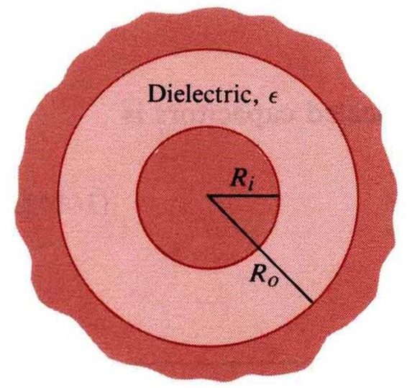
(Sol.) $\overset{→}{E}=\overset{}{a_{r}}E_{r}=\overset{}{a_{r}}\frac{Q}{4\text{πε}R^{2}}$
V=$−\int{\overset{→}{E}⋅\left(\overset{}{a_{r}}\text{dR}\right)}=−\int{\frac{Q}{4\text{πε}R^{2}}\text{dR}}=\frac{Q}{4\text{πε}}\left(\frac{1}{R_{i}}−\frac{1}{R_{o}}\right)$
$C=\frac{Q}{V}=\frac{4\text{πε}}{\frac{1}{R_{i}}−\frac{1}{R_{o}}}$.
For an isolating conductor sphere with $R_{i} , R_{o}→∞ , C=4\text{πε}R_{i}$
$$C=4{\text{πε}}_{0}R=4π×\frac{1}{\text{36}π}×{\text{10}}^{−9}×\left(6\text{.}\text{37}×{\text{10}}^{3}×{\text{10}}^{3}\right)=7\text{.}\text{08}×{\text{10}}^{−4} (F)$$
$$E_{b}=3×{\text{10}}^{6}=\frac{Q_{\text{Max}}}{4{\text{πε}}_{0}R^{2}} ⇒Q_{\text{Max}}=1\text{.}\text{35}×{\text{10}}^{\text{10}} (C)$$
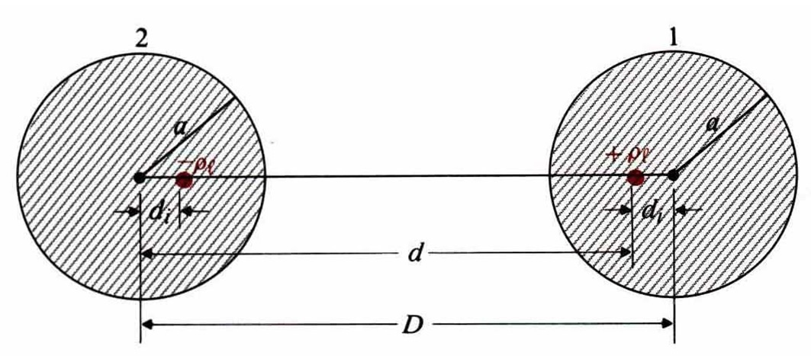
Eg. Determine the capacitance per unit length between two long, parallel, circular conducting wires of radius a. The axes of the wires are separated by a distance D. [台大電研]
(Sol.) $V_{2}=\frac{ρ_{ℓ}}{2\text{πε}}ℓn\frac{a}{d},V_{1}=−\frac{ρ_{ℓ}}{2\text{πε}}ℓn\frac{a}{d}$
$$C=\frac{ρ_{ℓ}}{V_{1}−V_{2}}=\frac{\text{πε}}{ℓn\left(d/a\right)},d=D−d_{i}=D−\frac{a^{2}}{d},d=\frac{1}{2}\left(D+\sqrt{D^{2}−4a^{2}}\right)$$
C=$\frac{\text{πε}}{ℓn\left[\left(D/2a\right)+\sqrt{{\left(D/2a\right)}^{2}−1}\right]}$$=\frac{\text{πε}}{{\text{cosh}}^{−1}\left(D/2a\right)}$ (F/m)

Eg. A straight conducting wire of radius a is parallel to and at height h from the surface of the earth. Assume that the earth is perfectly conducting; determine the capacitance and the force per unit length between the wire and the earth.
(Sol.) D=2h, $C=\frac{{\text{πε}}_{0}}{{\text{cosh}}^{−1}\left(D/2a\right)}=\frac{{\text{πε}}_{0}}{{\text{cosh}}^{−1}\left(h/a\right)}\left(Fm\right)$

4-6 Electrostatic Energy
To remove Q₁ from infinite to a distance R₁₂ from Q₂, the amount of work required is
$$W_{2}=Q_{2}V_{2}=Q_{2}\frac{Q_{1}}{4{\text{πε}}_{0}R_{\text{12}}}=Q_{1}\frac{Q_{2}}{4{\text{πε}}_{0}R_{\text{12}}}=Q_{1}V_{1}=\frac{1}{2}\left(Q_{1}V_{1}+Q_{2}V_{2}\right)$$
$$\begin{aligned}\vec{\text{induction}}\end{aligned}\text{method}→W_{e}=\frac{1}{2}\sum_{k=1}^{N}{Q_{k}V_{k},} \text{where} V_{k}=\frac{1}{4{\text{πε}}_{0}}\sum_{j=1(j≠k)}^{N}{\frac{Q_{j}}{R_{\text{jk}}}}$$

Eg. Find the energy required to assemble a uniform charge of radius b and volume charge density ρ. [清大電研]
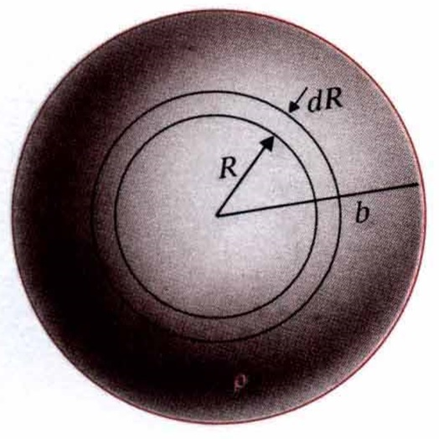
(Sol.) $V_{R}=\frac{Q_{R}}{4{\text{πε}}_{0}R}$ $Q_{R}=ρ\frac{4}{3}{πR}^{3}$
${\text{dQ}}_{R}=ρ4{πR}^{2}\text{dR}$, $\text{dW}=V_{R}{\text{dQ}}_{R}=\frac{4π}{3ε_{0}}ρ^{2}R^{4}\text{dR}$
$$W=\int{\text{dW}}=\frac{4π}{3ε_{0}}ρ^{2}\int{R^{4}\text{dR}}=\frac{4{\text{πρ}}^{2}b^{5}}{\text{15}ε_{0}}$$
$Q=ρ\frac{4π}{3}b^{3}$, $W=\frac{3Q^{2}}{\text{20}{\text{πε}}_{0}b} (J)$
Eg. According to W_{e}=$\frac{1}{2}\iiint{ρ\text{Vdv}}=\frac{1}{2}\iiint{\left(∇⋅\overset{→}{D}\right)\text{Vdv}}$, show that the stored electric energy is $W_{e}=\frac{1}{2}\iiint{\overset{→}{D}⋅\overset{→}{E}\text{dv}}$
(Proof) ∵ $∇⋅\left(V\overset{→}{D}\right)=V∇⋅\overset{→}{D}+\overset{→}{D}⋅∇V$, ∴ $V∇⋅\vec{D}=∇⋅\left(V\overset{→}{D}\right)−\vec{D}⋅∇V$
∴ $W_{e}=\frac{1}{2}\iiint{∇⋅\left(V\overset{→}{D}\right)\text{dv}}−\frac{1}{2}\iiint{\overset{→}{D}⋅∇\text{Vdv}}=\frac{1}{2}∯{V\overset{→}{D}⋅\overset{}{a_{n}}\text{ds}}+\frac{1}{2}\iiint{\overset{→}{D}⋅\overset{→}{E}\text{dv}}$
When$R→∞, S∝R^{2}, V∝\frac{1}{R}, \left|\overset{→}{D}\right|∝\frac{1}{R^{2}}$$⇒\frac{1}{2}∯{V\overset{→}{D}⋅\overset{}{a_{n}}\text{ds}}→0$$⇒W_{e}=\frac{1}{2}\iiint{\overset{→}{D}⋅\overset{→}{E}\text{dv}}$
If$\overset{→}{D}=ε\overset{→}{E}$, then$W_{e}=\frac{1}{2}\iiint{ε{\left|\overset{→}{E}\right|}^{2}\text{dv}}=\frac{1}{2}\iiint{\frac{{\left|\overset{→}{D}\right|}^{2}}{ε}\text{dv}}=\iiint{w_{e}\text{dv}}$
Note: 1. SI unit for energy: Joule(J) and 1 eV =1.6×10⁻¹⁹J.
2. Work (or energy) is a scalar, not a vector.
Electrostatic energy density: w_{e}=$\frac{1}{2}\overset{→}{D}⋅\overset{→}{E}=\frac{1}{2}ε{\left|\overset{→}{E}\right|}^{2}=\frac{{\left|\overset{→}{D}\right|}^{2}}{2ε}$
Eg. A parallel-plate capacitor of area S and separation d is charged by a d-c voltage source V. The permittivity of the dielectric is ε. Find the stored electrostatic energy.
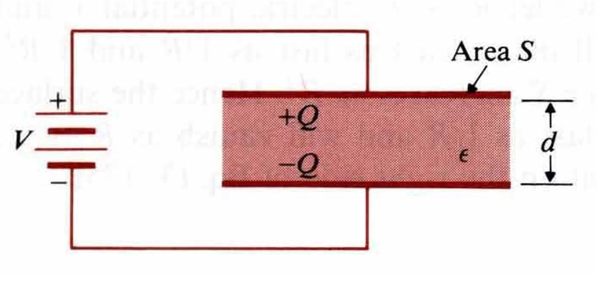
(Sol.) $E=\frac{V}{d}$, $W_{e}=\frac{1}{2}\iiint{ε{\left(\frac{V}{d}\right)}^{2}\text{dv}}=\frac{1}{2}ε{\left(\frac{V}{d}\right)}^{2}\left(\text{Sd}\right)=\frac{1}{2}\left(ε\frac{S}{d}\right)V^{2}$

Eg. Use energy formulas to find the capacitance of a cylindrical capacitance having a length L, an inner conductor of radius a, an outer conductor of inner radius b, and dielectric of permittivity$ε$.
(Sol.) $\overset{→}{E}=\overset{}{a_{r}}\frac{Q}{2\text{πε}\text{Lr}}$, $W_{e}=\frac{1}{2}\int{ε{\left(\frac{Q}{2\text{πε}\text{Lr}}\right)}^{2}\left(L2π\text{rdr}\right)}$$=\frac{Q^{2}}{4\text{πε}L}\int{\frac{\text{dr}}{r}}=\frac{Q^{2}}{4\text{πε}L}\text{ln}\left(\frac{b}{a}\right)$, $\frac{Q^{2}}{2C}=\frac{Q^{2}}{4\text{πε}L}\text{ln}\left(\frac{b}{a}\right)⇒C=\frac{2\text{πε}L}{\text{ln}\left(\frac{b}{a}\right)}$

4-7 Electrostatic Forces and Torques
Electrostatic force and torque due to the fixed charge:
$\text{dW}=\overset{→}{F_{Q}}⋅d\overset{→}{l}$ is mechanic work done by the system, it costs the stored energy.
∵ ${\text{dW}}_{e}=−\text{dW}=−\overset{→}{F_{Q}}⋅d\overset{→}{l}=\left(∇W_{e}\right)⋅d\overset{→}{l}$, ∴ $\overset{→}{F_{Q}}=−∇W_{e} (N)$
${\left(\overset{→}{F_{Q}}\right)}_{l}=−\frac{∂W_{e}}{∂l}=−\frac{∂}{∂l}\left(\frac{Q^{2}}{2C}\right)=\frac{Q^{2}}{2C^{2}}\frac{∂C}{∂l}$, $\text{dW}={\left(T_{Q}\right)}_{z}dφ⇒{\left(T_{Q}\right)}_{z}=−\frac{∂W_{e}}{∂φ}$
Electrostatic force and torque due to the fixed potential:
${\text{dW}}_{s}=\sum_{k}{V_{k}{\text{dQ}}_{k}}$, $\text{dW}=\overset{→}{F_{v}}⋅d\overset{→}{l}$, ${\text{dW}}_{e}=\frac{1}{2}\sum_{k}{V_{k}{\text{dQ}}_{k}}=\frac{1}{2}{\text{dW}}_{s}$
$$\text{dW}+{\text{dW}}_{e}={\text{dW}}_{s} ⇒\text{dW}=\frac{1}{2}{\text{dW}}_{s}={\text{dW}}_{e}=\overset{→}{F_{v}}⋅d\overset{→}{l}=\left(∇W_{e}\right)⋅d\overset{→}{l}$$
∴ $\overset{→}{F_{v}}=∇W_{e}, {\left(T_{v}\right)}_{z}=\frac{∂W_{e}}{∂φ}$, ${\left(\overset{→}{F_{v}}\right)}_{l}=\frac{∂W_{e}}{∂l}=\frac{∂}{∂l}\left(\frac{1}{2}{\text{CV}}^{2}\right)=\frac{V^{2}}{2}\frac{∂C}{∂l}=\frac{Q^{2}}{2C^{2}}\frac{∂C}{∂l}$

Eg. A parallel-plate capacitor of width w, length L, and separation d has a solid dielectric slab of permittivityεin the space between the plates. The capacitor is charged to a voltage V₀ by a battery. Assuming that the dielectric slab is withdrawn to the position shown, determine the force action on the slab. (a) with the switch closed, (b) after the switch is first opened. [台大電研、清大電研]
(Sol.) (a) $W_{e}=\frac{1}{2}{\text{CV}}_{0}^{2},C=\frac{w}{d}\left[εx+ε_{0}\left(L−x\right)\right]⇒F_{x}=∇W_{e}=\hat{x}\frac{V_{0}^{2}}{2}\frac{∂C}{∂x}=\hat{x}\frac{V_{0}^{2}w}{2d}\left(ε−ε_{0}\right)$
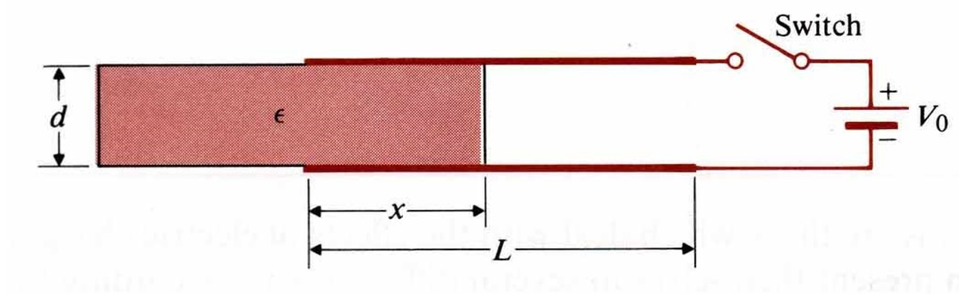
(b)
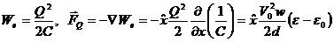

4-8 Resistors and Resistances
Ohm’s law: V=RI
$$V=Eℓ⇒E=\frac{V}{ℓ},I=\iint_{s}{J⋅d\vec{S}}=\text{JS}⇒J=\frac{I}{S}=σ\frac{V}{ℓ}⇒V=\left(\frac{ℓ}{σS}\right)I=\text{RI}$$
∴ $R=\frac{ℓ}{σS}$, $G=\frac{1}{R}=σ\frac{S}{ℓ}$
Power dissipation: $P=\iiint_{v^{'}}{E⋅J\text{dv}=\int{E⋅dℓ\iint_{\text{ss}}{J⋅dS}=−\text{VI}=−I^{2}R}}$

Eg. A d-c voltage of 6V applied to the ends of 1km of a conducting wire of 0.5mm radius results in a current of 1/6A. Find (a) the conductivity of the wire, (b) the electric field intensity of the wire, (c) the power dissipation in the wire, (d) the electron drift velocity, assuming electron mobility in the wire to be $1\text{.}4×{\text{10}}^{−3}\left(m^{2}/V⋅s\right)$.
(Sol.) (a) $R=\frac{ℓ}{σS}=\frac{V}{I}⇒σ=\frac{ℓI}{\text{SV}}=3\text{.}\text{54}×{\text{10}}^{7}\left(S/m\right)$, (b)$E=\frac{V}{ℓ}=6×{\text{10}}^{−3}\left(V/m\right)$, (c) $P=\text{VI}=1$Watt, (d) $v_{e}=μE=8\text{.}4×{\text{10}}^{−6}(m\text{/sec})$

Calculation of resistance:
$$∇^{2}V=0⇒V⇒\vec{E}=−∇V⇒\vec{J}=σ\vec{E}⇒\vec{I}=∯{\vec{J}\text{ds}}⇒R=V/I$$
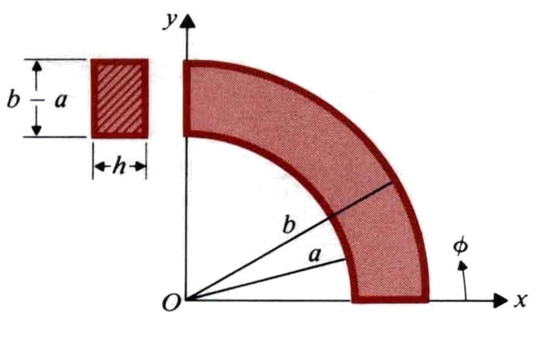
Eg. A conducting material of uniform thickness h and conductivity σ, has the shape of a quarter of a flat circular washer, with inner radius a and outer radius b. Determine the resistance between the end faces. [清大電研]
(Sol.) $∇^{2}V=0$, V=0 at $φ=0$, V=V₀ at $φ=\frac{π}{2}$
$\frac{d^{2}V}{{dφ}^{2}}=0$, V=c₁φ+c₂, $V=\frac{2V_{0}}{π}φ$, $\vec{J}=σ\vec{E}=−σ∇V=−{\hat{a}}_{φ}σ\frac{∂V}{r∂φ}=−{\hat{a}}_{φ}\frac{2{σV}_{0}}{πr}$
$I=\int{\vec{J}⋅d\vec{s}}=\frac{2{σV}_{0}}{π}h\int{\frac{\text{dr}}{r}}=\frac{2σ{\text{hV}}_{0}}{π}\text{ln}\frac{b}{a}$, $R=\frac{V_{0}}{I}=\frac{π}{2σh\text{ln}\left(\frac{b}{a}\right)}$
Eg. A ground connection is made by burying a hemispherical conductor of radius 25mm in the earth with its base up. Assuming the earth conductivity to σ=10⁻⁶ S/m, find the resistance of the conductor to far-away points in the ground. [交大電信所]
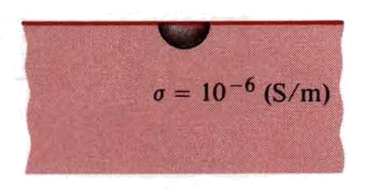
(Sol.) $\vec{J}={\hat{a}}_{R}\frac{I}{2{πR}^{2}}$, $\vec{E}={\hat{a}}_{R}\frac{I}{2\text{πσ}R^{2}}$=>$V_{0}=−\int{\text{EdR}}=\frac{I}{2\text{πσ}b}$
$R=\frac{V_{0}}{I}=\frac{1}{2\text{πσ}b}=\frac{1}{2π({\text{10}}^{−6})(\text{25}×{\text{10}}^{−3})}=6\text{.}\text{36}×{\text{10}}^{6}$.
Relation between R and C: $C=\frac{Q}{V}=\frac{∯{\vec{D}⋅d\vec{s}}}{−\int{\vec{E}⋅d\vec{l}}}=\frac{∯{ε\vec{E⋅d}\vec{s}}}{−\int{\vec{E}⋅d\vec{l}}}$, $R=\frac{V}{I}=\frac{−\int{\vec{E}⋅d\vec{l}}}{∯{\vec{J}}⋅d\vec{s}}=\frac{−\int{\vec{E⋅d\vec{l}}}}{∯{σ\vec{E}⋅d\vec{s}}}$, ∴ RC=$\frac{C}{G}=\frac{ε}{σ}$

Eg. Find the resistance between two concentric spherical surfaces of radii R₁ and R₂ (R₁<R₂) if the space between the surfaces is filled with a homogeneous and isotropic material having a conductivity σ.
(Sol.) $C=\frac{4\text{πε}}{\frac{1}{R1}−\frac{1}{R2}}$, $\text{RC}=\frac{ε}{σ}$ => $R=\frac{1}{C}⋅\frac{ε}{σ}$ => $R=\frac{1}{4\text{πσ}}(\frac{1}{R1}−\frac{1}{R2})$
Eg. Find the leakage resistance per unit length (a) between the inner and outer conductors of a coaxial cable that has an inner conductor of radius a, an outer conductor of inner radius b, and a medium with conductivity σ, and (b) of a parallel-wire transmission line consisting of wires of radius a separated by a distance D in a medium with conductivity σ. [台科大電研]
(Sol.)
(a) $C=\frac{2\text{πε}}{\text{ln}(\frac{b}{a})}$, $R=\frac{ε}{σC}=\frac{1}{2\text{πσ}}\text{ln}\left(\frac{b}{a}\right)$, (b) $C=\frac{\text{πε}}{{\text{cosh}}^{−1}(\frac{D}{2a})}$, $R=\frac{ε}{σC}=\frac{1}{\text{πσ}}{\text{cosh}}^{−1}(\frac{D}{2a})$

4-9 Inductors and Inductances
Mutual flux: $Φ_{\text{12}}=\iint_{S_{2}}{{\vec{B}}_{1}⋅d{\vec{S}}_{2}}=L_{\text{12}}I_{1}$ (Wb)
General mutual inductance: $L_{\text{12}}=\frac{N_{2}Φ_{\text{12}}}{I_{1}}=\frac{Λ_{\text{12}}}{I_{1}}$ (H)
Self-Inductance: $L_{\text{11}}=\frac{Λ_{\text{11}}}{I_{1}}$
Neumaun formula: $L_{\text{12}}=\frac{μ_{0}N_{1}N_{2}}{4π}\oint_{C_{1}}{\oint_{C_{2}}{\frac{dℓ_{1}dℓ_{2}}{R}}}$
L₁₂$=\frac{N_{2}Φ_{\text{12}}}{I_{1}}=\frac{N_{2}}{I_{1}}\iint_{S}{B_{1}⋅dS_{2}}=\frac{N_{2}}{I_{1}}\iint_{S_{2}}{(∇×A_{1})⋅dS_{2}}=\frac{N_{2}}{I_{1}}\oint_{C_{2}}{A_{1}dℓ_{2}}$
∵ $A_{1}=\frac{μ_{0}N_{1}I_{1}}{4π}\oint_{C_{1}}{\frac{dℓ_{1}}{R_{1}}}$, ∴ $L_{\text{12}}=\frac{μ_{0}N_{1}N_{2}}{4π}\oint_{C_{1}}{\oint_{C_{2}}{\frac{dℓ_{1}dℓ_{2}}{R}}}$
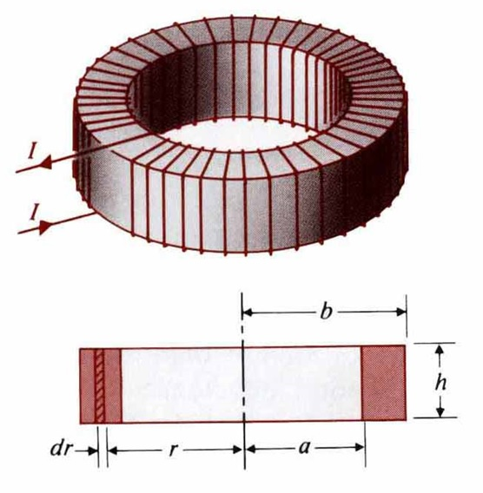
Eg. Assume that N turns of wire are tightly wound on a toroidal frame of a rectangular cross section. Then, assuming the permeability of the medium to be μ₀, find the self-inductance of the toroidal coil. [台大電研]
(Sol.)
$d\vec{l}={\hat{a}}_{φ}\text{rd}φ$, $\oint_{C}{\vec{B}⋅d\vec{l}}=\int{\text{Br}dφ}=2π\text{rB}=μ_{o}\text{NI}⇒B=\frac{μ_{o}\text{NI}}{2πr}$
$⇒Φ=\iint_{S}{\vec{B}⋅d\vec{s}}=\frac{μ_{o}\text{NIh}}{2π}\int{\frac{dr}{r}}=\frac{μ_{o}\text{NIh}}{2π}\text{ln}(\frac{b}{a})$, $L=\frac{NΦ}{I}=\frac{μ_{o}N^{2}h}{2π}\text{ln}(\frac{b}{a})$
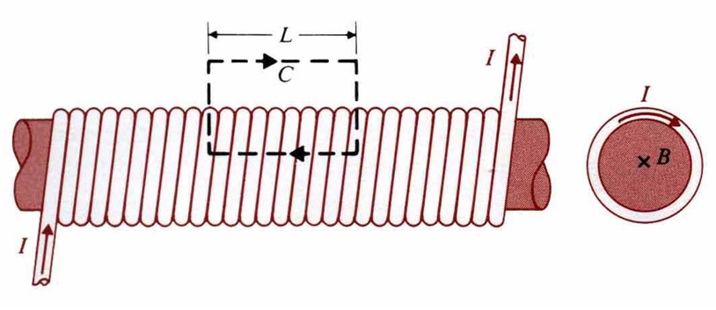
Eg. Find the inductance per unit length of a very long solenoid with air core having n turns per unit length. And S is the cross-sectional area.
(Sol.) $B=μ_{o}\text{nI}$, $Φ=\text{BS}=μ_{o}\text{nSI}$ $'=nΦ=μ_{o}n^{2}\text{SI}$, $L'=μ_{o}n^{2}S$
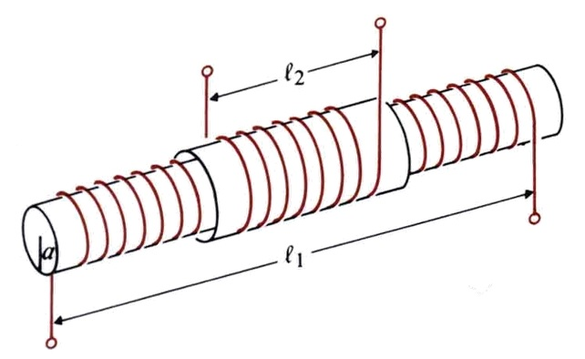
Eg. Two coils of N₁ and N₂ turns are wound concentrically on a straight cylindrical core of radius a and permeability μ. The windings have lengths l₁ and l₂, respectively. Find the mutual inductance between the coils.
(Sol.) $Φ_{\text{12}}=μ(\frac{N_{1}}{ℓ_{1}})({πa}^{2})I_{1}$, $Λ_{\text{12}}=N_{2}Φ_{\text{12}}=\frac{μ}{ℓ_{1}}N_{1}N_{2}{πa}^{2}I_{1}$
=>$L_{\text{12}}=\frac{Λ_{\text{12}}}{I_{1}}=\frac{μ}{ℓ_{1}}N_{1}N_{2}{πa}^{2}$

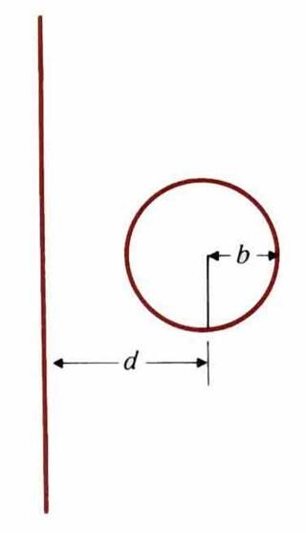
Eg. Determine the mutual inductance between a very long, straight wire and a conducting circular loop. [台大電研、清大物理所]
(Sol.)
B at p is $\frac{μ_{0}I}{2π(d+r\text{cos}θ)}$
$$\begin{aligned}Λ=\frac{μ_{0}I}{2π}\int{\int{\frac{\text{rd}θ\text{dr}}{d+r\text{cos}θ}}}=\frac{μ_{0}I}{2π}\int{\frac{2π\text{rdr}}{\sqrt{d^{2}−r^{2}}}}=μ_{0}I(d−\sqrt{d^{2}−b^{2}}) \\ L=μ_{0}(d−\sqrt{d^{2}−b^{2}})\end{aligned}$$
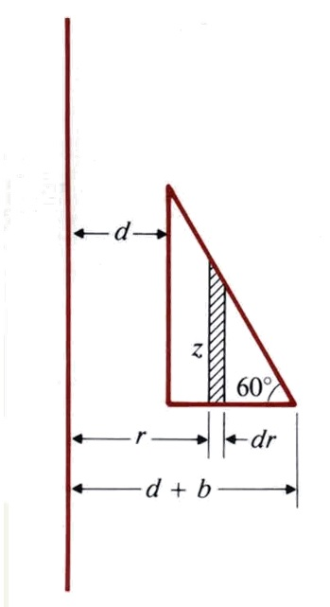
Eg. Determine the mutual inductance between a conducting triangular loop and a very long straight wire.
(Sol.)
, $Λ=Φ=\int{B⋅ds}$, where $dS={\hat{a}}_{φ}\text{zdr}$
z=$\sqrt{3}(d+b−r)$
$$\begin{aligned}Λ=\frac{\sqrt{3}μ_{0}I}{2π}\int{\frac{1}{r}(d+b−r)\text{dr}}=\frac{\sqrt{3}μ_{0}I}{2π}[(d+b)\text{ln}(1+b/d)−b] \\ L=\frac{Λ}{I}=\frac{\sqrt{3}μ_{0}}{2π}[(d+b)\text{ln}(1+b/d)−b]\end{aligned}$$

Eg. Determine the mutual inductance between a very long, straight wire and a conducting equilateral triangular loop. [高考]
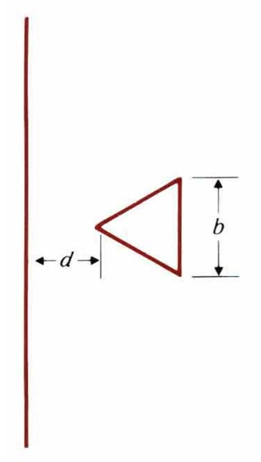
(Sol.)
$$\begin{aligned}B={\hat{a}}_{Φ}\frac{μ_{0}I}{2πr}={\hat{a}}_{Φ}B_{Φ} \\ Λ=\int{B_{Φ}⋅\frac{2}{\sqrt{3}}(r−d)\text{dr}}=\frac{μ_{0}I}{\sqrt{3}π}[\frac{\sqrt{3}}{2}b−d\text{ln}(1+\frac{\sqrt{3}b}{2d})] \\ L=\frac{Λ}{I}=\frac{μ_{0}}{\sqrt{3}π}[\frac{\sqrt{3}}{2}b−d\text{ln}(1+\frac{\sqrt{3}b}{2d})]\end{aligned}$$

Eg. A rectangular loop of width w and height h is situated near a very long wire carrying a current i₁. Assume i₁ to be a rectangular pulse. Find the induced current i₂ in the rectangular loop whose self-inductance is L.
(Sol.)
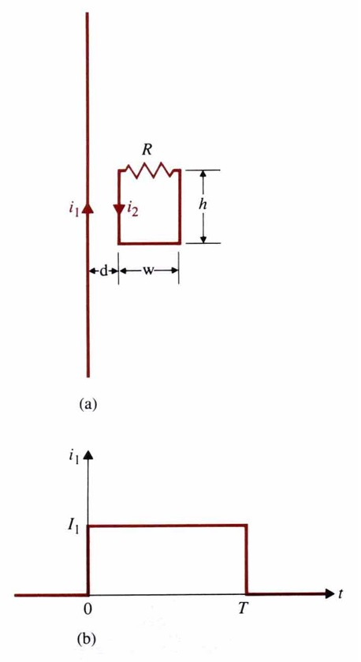
$L_{\text{12}}\frac{{\text{di}}_{1}}{\text{dt}}=L\frac{{\text{di}}_{2}}{\text{dt}}+{\text{Ri}}_{2}$,
where $L_{\text{12}}=\frac{Φ_{\text{12}}}{i_{1}}=\frac{h}{i_{1}}\int{\frac{μ_{0}i_{1}}{2πr}\text{dr}}=\frac{μ_{0}h}{2π}\text{ln}(1+\frac{w}{d})$
t=0, $L\frac{{\text{di}}_{2}}{\text{dt}}+{\text{Ri}}_{2}=L_{\text{12}}I_{1}δ(t)⇒i_{2}=\frac{L_{\text{12}}}{L}I_{1}e^{−(\frac{R}{L})t}$
t=T, $i_{2}=\frac{L_{\text{12}}}{L}I_{1}e^{−\frac{\text{RT}}{L}}$, when –I₁ is applied
t>T, $i_{2}=−\frac{L_{\text{12}}}{L}I_{1}e^{−(\frac{R}{L})(t−T)}$

4-10 Magnetic Energy
W_{m}=$\frac{1}{2}\sum_{j=1}^{N}{\sum_{k=1}^{N}{L_{\text{jk}}}I_{j}I_{k}}=\frac{1}{2}\sum_{k=1}^{N}{I_{k}Φ_{k}}=\frac{1}{2}\iiint_{V'}{A⋅J\text{dv}'}$
Let $V_{1}=L_{1}\frac{{\text{di}}_{1}}{\text{dt}}⇒W_{1}=\int{V_{1}i_{1}\text{dt}}=L_{1}\int{i_{1}{\text{di}}_{1}}=\frac{1}{2}L_{1}I_{1}^{2}=\frac{1}{2}I_{1}Φ_{1}$: Magnetic energy

Similarly, $V_{\text{21}}=L_{\text{21}}\frac{{\text{di}}_{2}}{\text{dt}}⇒W_{\text{21}}=\int{V_{\text{21}}I_{1}\text{dt}}=L_{\text{21}}I_{1}\int{{\text{di}}_{2}}=L_{\text{21}}I_{1}I_{2}$
And $W_{2}=\frac{1}{2}L_{2}I_{2}^{2}$ $⇒W_{m}=\frac{1}{2}LI_{1}^{2}+L_{\text{21}}I_{1}I_{2}+\frac{1}{2}L_{2}I_{2}^{2}=\frac{1}{2}\sum_{j=1}^{2}{\sum_{k=1}^{2}{L_{\text{jk}}}I_{j}I_{k}}$
Generally, $W_{m}=\frac{1}{2}\sum_{j=1}^{N}{\sum_{k=1}^{N}{L_{\text{jk}}}I_{j}I_{k}}=\frac{1}{2}\sum_{k=1}^{N}{I_{k}Φ_{k}}$ when $Φ_{k}=\sum_{j=1}^{N}{L_{\text{jk}}I_{j}}$

∵ $Φ_{k}=\iint_{S_{k}}{B⋅dS_{n}'=\oint_{C_{k}}{A⋅dℓ_{k}}}$
∴ $W_{m}=\frac{1}{2}\sum_{k=1}^{N}{{ΔI}_{k}\oint_{C_{k}}{A⋅dl_{k}}}=\frac{1}{2}\iiint_{V'}{A⋅J\text{dv}'}$ $({ΔI}_{k}{\text{dl}}_{k}'=J(Δ{\hat{a}}_{k}'){\text{dl}}_{k}'=J⋅v_{k}')$
∵ $∇⋅(A×H)=H⋅(∇×A)−A⋅(∇×H)⇒A⋅(∇×H)=H⋅(∇×A)−∇⋅(A×H)$
And $J=∇×H⇒A⋅J=H⋅B−∇⋅(A×H)$
$⇒W_{m}=\frac{1}{2}\iiint_{V'}{H⋅B\text{dv}'−\frac{1}{2}}∯_{S'}{(A×H)⋅a_{n}\text{dS}'}$ as $R→∞⇒\left|A\right|∝\frac{1}{R},$ $\left|H\right|∝\frac{1}{R^{2}}$, $dS∝R^{2}⇒−\frac{1}{2}∯_{S'}{(A×H)⋅{\hat{a}}_{n}\text{dS}'}→0$
∴ $W_{m}=\frac{1}{2}\iiint_{V'}{H⋅B\text{dv}'}=\iiint_{V'}{w_{m}\text{dv}'}$
Magnetic energy density: $\begin{aligned}w_{m}=\frac{1}{2}H⋅B \\ w_{m}=\frac{|B|^{2}}{2μ} \\ w_{m}=\frac{1}{2}μ|H|^{2}\end{aligned}$ and L=$\frac{2W_{m}}{I^{2}}$.

Eg. Determine the inductance per unit length of an air coaxial transmission line that has a solid inner conductor of radius a and a very thin outer conductor of radius b. [台科大電機所]
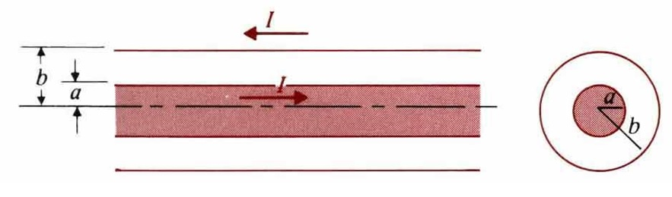
(Sol.)
W_{m1}=$\frac{1}{2μ_{0}}\int{B_{1}^{2}2π\text{rdr}=\frac{μ_{0}I^{2}}{4{πa}^{4}}}\int{r^{3}\text{dr}}=\frac{μ_{0}I^{2}}{\text{16}π}$
W_{m2}=$\frac{1}{2μ_{0}}\int{B_{2}^{2}2π\text{rdr}=\frac{μ_{0}I^{2}}{4π}}\int{\frac{1}{r}\text{dr}}=\frac{μ_{0}I^{2}}{4π}\text{ln}\frac{b}{a}$, $L'=\frac{2}{I^{2}}(W_{m1}+W_{m2})=\frac{μ_{0}}{8π}+\frac{μ_{0}}{2π}\text{ln}\frac{b}{a}$

Eg. Consider two coupled circuits having self-inductance L₁ and L₂, which carry currents I₁ and I₂, respectively. The mutual inductance between the circuits is M.
- Find the ratio I₁/I₂ that makes the stored magnetic energy W_{m} a minimum.
- Show that $M≤\sqrt{L_{1}L_{2}}$. [清大核工所]
(Sol.) $W_{m}=\frac{1}{2}L_{1}I_{1}^{2}+{\text{MI}}_{1}I_{2}+\frac{1}{2}L_{2}I_{2}^{2}$
(a) $W_{m}=\frac{I_{2}^{2}}{2}[L_{1}(\frac{I_{1}}{I_{2}})^{2}+2M(\frac{I_{1}}{I_{2}})+L_{2}]=\frac{I_{2}^{2}}{2}[L_{1}x^{2}+2\text{Mx}+L_{2}],x≡\frac{I_{1}}{I_{2}}$
$\frac{{\text{dW}}_{m}}{\text{dx}}=0=\frac{I_{2}^{2}}{2}(2L_{1}x+2M)⇒x=\frac{I_{1}}{I_{2}}=−\frac{M}{L_{1}}$ for minimum W_{m}
(b) (W_{m})_{min}=$\frac{I_{2}^{2}}{2}(−\frac{M^{2}}{L_{1}}+L_{2})≥0⇒M≤\sqrt{L_{1}L_{2}}$

4-11 Magnetic Forces and Torques

Force due to constant flux linkage:
$F_{φ}⋅dℓ=−{\text{dW}}_{m}=−(∇W_{m})⋅d\vec{ℓ}⇒F_{φ}=−∇W_{m}$ and $(T_{φ})_{z}=−\frac{∂W_{m}}{∂φ}$
Force due to constant current:
$${\text{dW}}_{s}=\sum_{k}{I_{k}'}{dΦ}_{k}=\text{dW}+{\text{dW}}_{m}$$
${\text{dW}}_{m}=\frac{1}{2}\sum_{k}{I_{k}Φ_{k}}=\frac{1}{2}{\text{dW}}_{s}⇒\text{dW}=F_{I}⋅dl={\text{dW}}_{m}=(∇W_{m})⋅dl$$⇒F_{I}=∇W_{m}$
Torque in terms of mutual inductance:
$W_{m}=\frac{1}{2}L_{1}I_{1}^{2}+L_{\text{12}}I_{1}I_{2}+\frac{1}{2}L_{2}I_{2}^{2}$$⇒F_{I}=I_{1}I_{2}(∇L_{\text{12}})$, $T_{I}=I_{1}I_{2}\frac{∂L_{\text{12}}}{∂φ}$
Eg. A current I flows in a long solenoid with n closely wound coil-turns per unit length. The cross-sectional area of its iron core, which has permeability μ, is S. Determine the force acting on the core if it is withdrawn to the position. [高考電機技師]
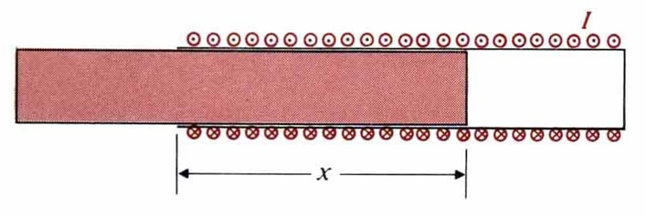
(Sol.)
$$\begin{aligned}W_{m}=\frac{1}{2}\iiint{{μH}^{2}\text{dv}},W_{m}(x+Δx)−W_{m}(x)=(\frac{1}{2}μ_{0}μ_{r}n^{2}I^{2}−\frac{1}{2}μ_{0}n^{2}I^{2})SΔx=\frac{1}{2}μ_{0}(μ_{r}−1)n^{2}I^{2}SΔx \\ ⇒(F_{I})_{x}=\frac{∂W_{m}}{∂x}=\frac{μ_{0}}{2}(μ_{r}−1)n^{2}I^{2}S\end{aligned}$$

Magnetic torque: $T=m×B$ (B=B⊥+B∥, m∥B⊥m×B⊥=0)
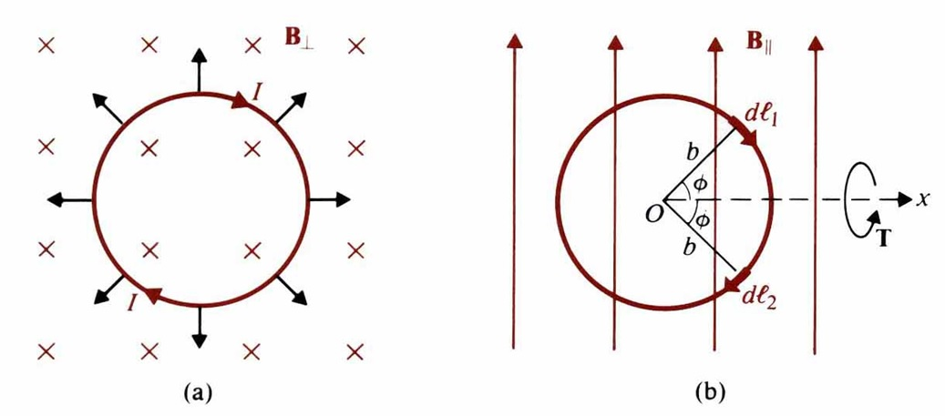
$dT=\hat{x}\text{dF}2b\text{sin}φ=\hat{x}({\text{IdlB}}_{||}\text{sin}φ)2b\text{sin}φ=\hat{x}2{\text{Ib}}^{2}B_{||}{\text{sin}}^{2}φdφ$$\begin{aligned}T=\int{dT=\hat{x}2{\text{Ib}}^{2}B_{\text{//}}}\int{{\text{sin}}^{2}φdφ=\hat{x}I({πb}^{2})B_{\text{//}}}=\hat{x}{\text{mB}}_{\text{//}} \\ ⇒T=m×B\end{aligned}$

Eg. A rectangular loop in the xy-plane with sides b₁ and b₂ carrying a current I has in a uniform magnetic field $B=\hat{x}B_{x}+\hat{y}B_{y}+\hat{z}B_{z}$. Determine the force and torque on the loop.
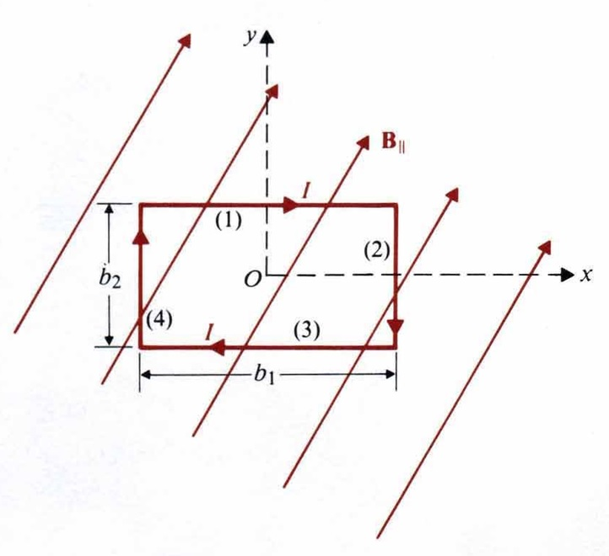
(Sol.) $T=m×B={\text{Ib}}_{1}b_{2}(\hat{x}B_{y}−\hat{y}B_{x})$

