- Find a Hamiltonian cycle in each graph.
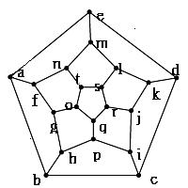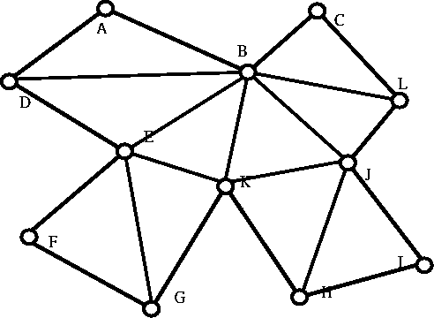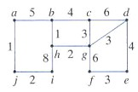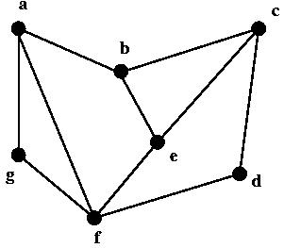
- Find an Euler cycle in each graph.
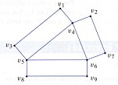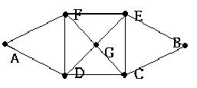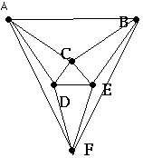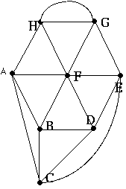
- Let H be the graph shown below where the edges represent the street in a city. A police officer wants to make a trip to patrol each street exactly once. Can such a trip be designed and give your reason? [交大資科所]
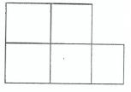
- Determine whether the graphs G₁ and G₂ are isomorphic. [台科大資科所]
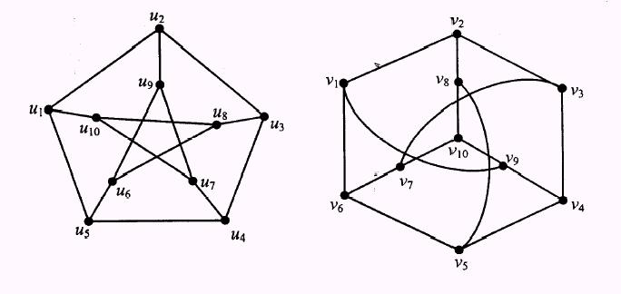
- Find the adjacent matrix of each graph.
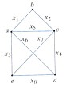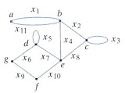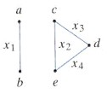
- Find the length of the shortest path from a to z.
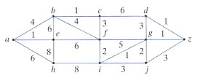
- Determine whether the graphs G₁ and G₂ are isomorphic.
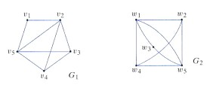
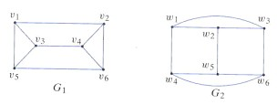
- Determine whether the graphs are planar.
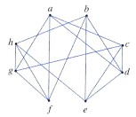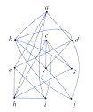
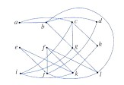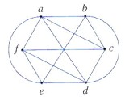
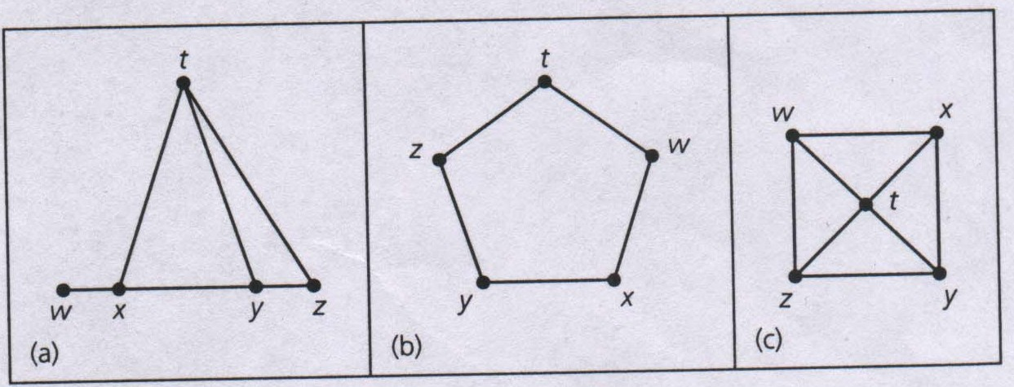
- Show that χ(G)=3 for each graph.

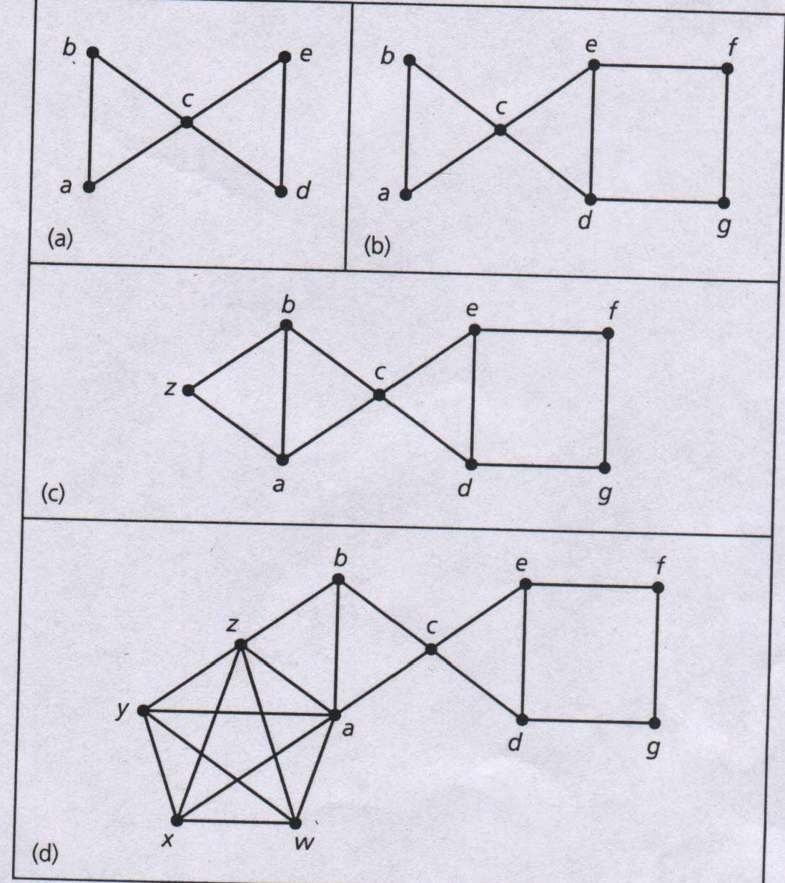
- Show that (a) P(G,λ)=λ(λ-1)²(λ-2)². (b) P(G,λ)=λ(λ-1)(λ-2)²(λ³-4λ²+6λ-3). (c) P(G,λ)=λ(λ-1)(λ-2)³(λ³-4λ²+6λ-3). (d) P(G,λ)=λ(λ-1)(λ-2)⁴(λ³-4λ²+6λ-3).

- Which is a legal chromatic polynomial? (a) x⁴-4x³+6x²-4x+1. (b) x⁴-4x³+6x²-4x. (c) x⁴-4x³-3x²+6x. (d) x⁴-4x³+6x²-3x. (e) 2x⁴-4x³+5x²-3x. [交大資科所]
- An artist is coloring stained glass. Any two adjacent shapes on the glass must have different colors. What is the minimal number of colors the artist needs to paint the glass shown below? [交大轉學考] 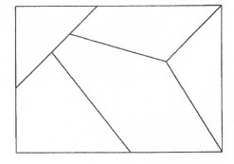
- Color the map properly.
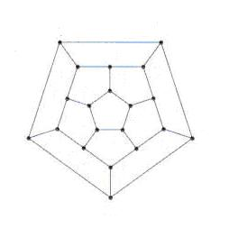
- (a) Draw the transition diagram of the finite-state automaton is defined by the table:
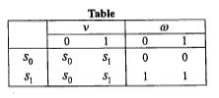
(b) Determine the output for the following input sequences, starting at s₀ in each case: x=111, x=1010, x=00011. (c) Describe in words what machine does. [台科大資工所]

- Draw the transition diagram of the following finite automaton.
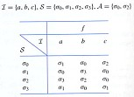
- Draw the transition diagram of the finite automaton by the grammar. 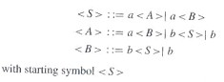.
- Draw the transition diagram of the finite automaton by the grammar.
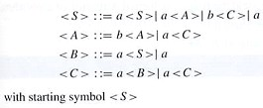
- Draw the transition diagram of the finite automaton by the grammar defined by N={σ,A,B}, T={a,b,c}, P={σ→BAB, σ→ABA, A→AB, B→BA, A→aA, A→ab, B→b}. And show that abbbaabab can be accepted.
- Please construct a grammar for the language L={a^{i}b^{2i}| i1}. [台科大資工所]
- Fill in the missing edge flows.
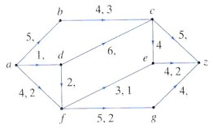
- Find the maximal flow in the network.
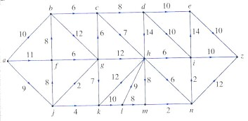
- Find the maximal flow in the network.
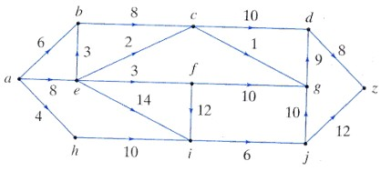
- A is qualified for jobs 2, 4, and 5. B is qualified for jobs 1 and 3. C is qualified for jobs 1, 3, and 5. D is qualified for jobs 3 and 5. Find a maximal matching.
- Represent each expression as a binary tree and write the prefix and postfix form of the expression.
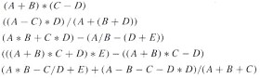
- What is the maximum height of a binary tree with n node? [台大資工所]
- List the order in which the vertices are processed using inorder traversal. [台大資工所]
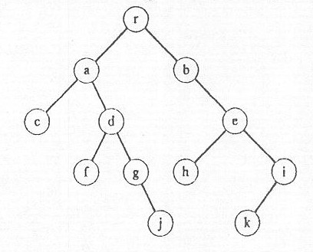
- List the order in which the vertices are processed using preorder, inorder, and postorder traversal.
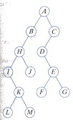
- Find a spanning tree for each graph.
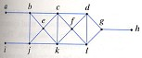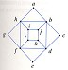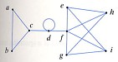
- Find a maximal spanning tree for each graph.

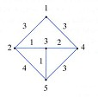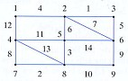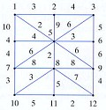
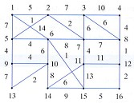
- Consider the graph G whose adjacent matrix is $\left[\begin{matrix}0 & 1 & 1 & 1 \\ 1 & 0 & 1 & 1 \\ 1 & 1 & 0 & 0 \\ 1 & 1 & 0 & 0\end{matrix}\right]$. (a) How many spanning trees has in the graph G. (b) Draw one of its spanning trees. [交大資科所]
- Find a maximal spanning tree of the graph. [交大資工所]
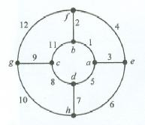
- Transform each general tree into a binary tree.
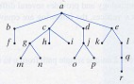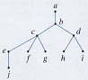
- Find the number of noninteger solutions of x+y+z=15.
- Find the number of positive integer solutions of x+y+z=15.
- How many seven-bit strings contain exactly three 1’s?
- $C_{0}^{n}−C_{1}^{n}+−⋯+(−1)^{n}C_{n}^{n}$=? [台大資工所]
- $\sum_{i=1}^{n}{{\text{iC}}_{i}^{n}}$=? [台大資工所]
- $\sum_{i=0}^{n}{C_{i}^{n}(−1)^{i}2^{i}3^{n−i}}$=? [台大資工所]
- In how many ways can we select a chairman, vice-chairman, secretary, and treasurer from a group of 11 persons?
- How many permutations of the letters ABCDEF contain the letters CDE together in any order?
- In how many ways can 10 persons be seated around a circular table?
- There are 4 A’s and 3 B’s. (a) In how many ways of combinations can we select 2 letters from A’s, and B’s? (b)In how many ways can we select 4 letters from A’s, and B’s?
- In how many ways can we select 5 letters from ENGINE?
- There was a test for AIDS with the property that 90% of those with AIDS reacted positively whereas 3% of those without AIDS react positively. Assume that 2% of patients in a hospital have AIDS. What is the probability that a patient selected at random who reacts positively to this test actually has AIDS?
- Solve a_{r}+3a_{r-1}+2a_{r-2}=f(r), where f(2)=1, f(r)=0 if r≠2, with the boundary condition a₀=a₁=0. [交大資科所]
- Solve $a_{n}=\sqrt{\frac{a_{n−2}}{a_{n−1}}}$, a₀=8, a₁=$\frac{\sqrt{2}}{4}$.
- Obtain integers m and n such that 315m+825n=15.
- What is the remainder of 75³⁸⁴ divided by 97. [台大資工所]
- A natural number n may be written as p₁^{a1}p₂^{a2}…p_{k}^{ak}. Calculate the product of all the divisors of a number n. [交大資科所]
- Prove by induction that n³+2n is divisible by 6 for all integer n>1 and n is an even number. [交大資工所]
- Professor Lee is paid every other week on Monday. Show that in some month he is paid three times.
- An inventory consists of a list of 115 items, each marked “available” or ‘unavailable”. There are 60 available items. Show that there are at least 2 available items in the list exactly 4 items apart.

- True or False: For 2^{n}-1 to be a prime number, the necessary condition is that n is a prime number. [台大資工所]
- p→q is logically equivalent to $¬$q→$¬$p. What is logically equivalent to “Chi-Ling Lin is beautiful, so the boy who likes her is afraid of being rejected by her.”?
- Which of the following is logically equivalent to p→q:
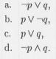 [台大資工所]
- Determine whether the following argument is valid.
Ru-Hwa is more beautiful than nobody
Nobody is more beautiful than Chi-ling Lin
￣￣￣
∴ Ru-Hwa is more beautiful than Chi-ling Lin.
- Determine whether the following argument is valid.
If I study hard, then I get A’s or I become rich.
I don’t get A’s and I don’t become rich.
￣￣￣
∴ I don’t study hard.
- Determine whether the following argument is valid.
I study hard if and only if I become rich.
I become rich.
￣￣￣
∴ I study hard.
- Determine whether the following argument is valid.
If I study hard, then I get A’s.
If I don’t become rich, I don’t get A’s.
￣￣￣
∴ I become rich.

