Chapter 1 Solutions of Equations and Optimization Methods
  - Fixed-Point Iteration Method
Fixed-point theorem Suppose g(x)$∈$C[a,b] and g’(x) exists on [a,b] with |g’(x)|≦k<1, $∀$x$∈$(a,b), and then the sequence can be defined by x_{n}=g(x_{n-1}), x₀$∈$[a,b] converges to the unique fixed point x in [a,b].
(Proof) $|x_{n}−x| = |g(x_{n−1})−g(x)| = |g^{'}(ε)|⋅|x_{n−1}−x|≤k|x_{n−1}−x|$
$|x_{n}−x|≤k|x_{n−1}−x|≤k^{2}|x_{n−2}−x|≤⋯≤k^{n}|x_{0}−x|$
∵ $k<1$, ∴ $|x_{n}−x|→0⇔{\left\{x_{n}\right\}}_{n=0}^{∞}$ converges to x.
Eg. Solve x²-2x-3=0.
(Sol.) 1. Rearrange x²-2x-3=0 into $x=\sqrt{2x+3}$=g₁(x)
$|g_{1}^{'}(x)|=\frac{1}{\sqrt{2x+3}}<1⇒x>−1$
Select $x_{0}=4⇒x_{1}=3\text{.}\text{316}⇒x_{2}=3\text{.}\text{104}$$⇒⋯⇒x_{n}→3$
2. Rearrange x²-2x-3=0 into $x=\frac{3}{x−2}$=g₂(x)
$|g_{2}^{'}(x)|=\left|−\frac{3}{(x−2)^{2}}\right|<1⇒$$\begin{aligned}x>2+\sqrt{3} \\ x<2−\sqrt{3}\end{aligned}$
Select $x_{0}=4⇒x_{1}=1\text{.}5⇒x_{2}=−6$$⇒⋯⇒x_{8}=−1\text{.}\text{003}⇒⋯⇒x_{n}→−1$
3. Rearrange x²-2x-3=0 into $x=\frac{x^{2}−3}{2}$=g₃(x)
$|g_{3}^{'}(x)|=|x|<1⇒−1<x<1$
Select $x_{0}=4⇒x_{1}=6\text{.}5⇒x_{2}=\text{19}\text{.}\text{635}⇒x_{3}=\text{191}\text{.}0$, …, ∴ diverges

A C++ Program (developed by K. –Y. Lee) of solving x²-2x-3=0 is listed as follows.
#include <stdio.h>
#include <math.h>
main()
{
int i,lop; float x;
printf("The initial value of x is\n"); scanf("%f",&x);
printf("The loop number is\n"); scanf("%d",&lop);
for (i=1;i<=lop;i++)
{
x=3/(x-2);
printf("The root is %f \n",x);
}

}
Eg. Solve $\begin{aligned}\left\{3x_{1}−\text{cos}(x_{2}x_{3})−\frac{1}{2}=0 | \right.\left\{x_{1}^{2}−\text{81}(x_{2}+0\text{.}1)^{2}+\text{sin}x_{3}+1\text{.}\text{06}=0 | \right.\end{aligned}$.
(Sol.) $\begin{aligned}\left\{x_{1}=\frac{1}{3}\text{cos}(x_{2}x_{3})+\frac{1}{6} | \right.\left\{x_{2}=\frac{1}{9}\sqrt{x_{1}^{2}+\text{sin}x_{3}+1\text{.}\text{06}}−0\text{.}1 | \right.\end{aligned}$

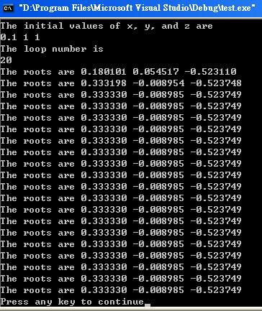
A C++ Program (developed by K. –Y. Lee) of solving the system of equations is listed as follows.
#include <stdio.h>
#include <math.h>
main()
{
int i,lop; float x,y,z;
printf("The initial values of x, y, and z are\n");
scanf("%f %f %f",&x,&y,&z);
printf("The loop number is\n");
scanf("%d",&lop);
for (i=1;i<=lop;i++)
{
x=cos(y*z)/3+1/6; y=sqrt(x*x+sin(z)+1.06)/9-0.1;
z=-exp(-x*y)/20-(10*4*atan(1)-3)/60;
printf("The roots are %f %f %f \n",x,y,z);
}
}
1-2 Newton’s Method
Newton’s method: Solve f(x)=0 by x_{n}=x_{n-1}-f(x_{n-1})/f’(x_{n-1}), then {x_{n}} converges to the root if an appropriate initial value is selected.
Eg. Solve x³+4x²-10=0 on [1,2].
(Sol.) f(x)=x³+4x²-10, f’(x)=3x²+8x, $x_{n}=x_{n−1}−\frac{f(x_{n−1})}{f^{'}(x_{n−1})}$
Choose $x_{0}=1\text{.}5⇒x_{1}=⋯⇒x_{2}=1\text{.}\text{36523001}$

Secant method: Solve f(x)=0 by $x_{n}=x_{n−1}−\frac{f(x_{n−1})(x_{n−1}−x_{n−2})}{f(x_{n−1})−f(x_{n−2})}$.

Newton’s method of solving a system of equations: Solve F(x)=0 by x_{k}=x_{k-1}-J⁻¹(x_{k-1})F(x_{k-1}), where J(x)=$\begin{aligned}\left[∂f_{1}(x)/∂x_{1}⋯∂f_{1}(x)/∂x_{n} | \right]\left[ ⋮ ⋮ | \right] \\ \end{aligned}$, and x=[x₁,x₂,…,x_{n}]^{t}.
Eg. Solve $\begin{aligned}\left\{3x−\text{cos}(\text{yz})−\frac{1}{2}=0 | \right.\left\{x^{2}−\text{81}(y+0\text{.}1)^{2}+\text{sin}(z)+1\text{.}\text{06}=0 | \right.\end{aligned}$.
(Sol.) $J(x,y,z)=\left[\begin{matrix}3 & z\text{sin}(\text{yz}) & y\text{sin}(\text{yz}) \\ 2x & −\text{162}(y+0\text{.}1) & \text{cos}(z) \\ −{\text{ye}}^{−\text{xy}} & −{\text{xe}}^{−\text{xy}} & \text{20}\end{matrix}\right]$ and
$$F(x,y,z)=\begin{aligned}\left[3x−\text{cos}(\text{yz})−\frac{1}{2} | \right]\left[x^{2}−\text{81}(y+0\text{.}1)^{2}+\text{sin}(z)+1\text{.}\text{06} | \right] \\ \end{aligned}$$
$\left[\begin{matrix}x_{k} \\ y_{k} \\ z_{k}\end{matrix}\right]$=$\left[\begin{matrix}x_{k−1} \\ y_{k−1} \\ z_{k−1}\end{matrix}\right]$-${\left[\begin{matrix}3 & z_{k−1}\text{sin}(y_{k−1}z_{k−1}) & y_{k−1}\text{sin}(y_{k−1}z_{k−1}) \\ 2x & −\text{162}(y_{k−1}+0\text{.}1) & \text{cos}(z_{k−1}) \\ −y_{k−1}e^{−x_{k−1}y_{k−1}} & −x_{k−1}e^{−x_{k−1}y_{k−1}} & \text{20}\end{matrix}\right]}^{−1}$$\begin{aligned}\left[3x_{k−1}−\text{cos}(y_{k−1}z_{k−1})−\frac{1}{2} | \right]\left[x_{{k−1}^{2}}−\text{81}(y_{k−1}+0\text{.}1)^{2}+\text{sin}(z_{k−1})+1\text{.}\text{06} | \right] \\ \end{aligned}$
Select $\left[\begin{matrix}x_{0} \\ y_{0} \\ z_{0}\end{matrix}\right]=\left[\begin{matrix}0\text{.}1 \\ 0\text{.}1 \\ −0\text{.}1\end{matrix}\right]⇒⋯⇒\left[\begin{matrix}x_{5} \\ y_{5} \\ z_{5}\end{matrix}\right]=\left[\begin{matrix}0\text{.}\text{33333333} \\ 0 \\ −0\text{.}\text{52359877}\end{matrix}\right]$

1-3 Complex Roots of an Equation
Conventional method of obtaining the complex roots of equations:
Eg. Solve x²+x+1=0.
(Sol.) Set x=a+bi, a, b$∈$R
$x^{2}+x+1=(a^{2}−b^{2}+2\text{abi})+(a+\text{bi})+1$
$=(a^{2}+a−b^{2}+1)+(2\text{ab}+b)i=0$
$⇒\begin{aligned}\left\{a^{2}+a−b^{2}+1=0 | \right.\end{aligned}$ is a system of nonlinear equations.
The system of equations can be solved by the preceding mentioned method.

Eg. Solve (i+1)x²+x=i.
(Sol.) Set x=a+bi, a, b$∈$R
$$(i+1)x^{2}+x=(a^{2}−b^{2}+a−2\text{ab})+i(2\text{ab}+a^{2}−b^{2}+b)=i$$
$⇒\begin{aligned}\left\{a^{2}−b^{2}−2\text{ab}+a=0 | \right.\end{aligned}$

Five-point (SOS) method and nine-point method to obtain the complex roots of f(x)=0:
(a) Shrink: If the central point x_{c}=a+ib such that |f(x_{c})| is the smallest of all grid points, and then shrink the distances between the grid points.
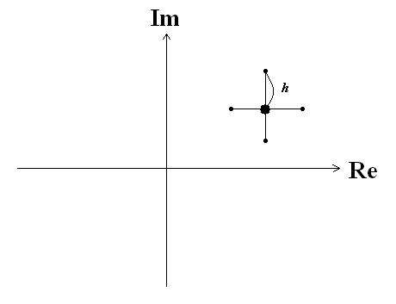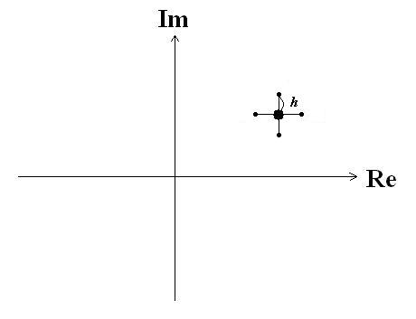
- Shift: If one of the side points x_{s}=c+id such that |f(x_{s})| is the smallest of all grid points, and then let the side point be come the new central point.
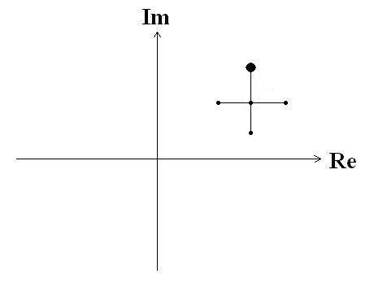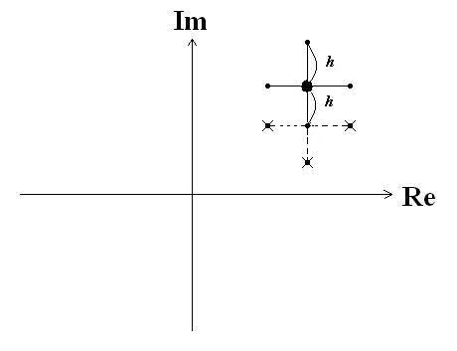
Repeat (a) and (b), the complex roots of f(x) can be found.

Eg. Solve x⁴+i=0 by the 5-point (SOS) method.
A Fortran Program (developed by K. –Y. Lee) is listed as follows.
call fpoint
stop
end

subroutine fpoint
complex xc,x(5)
complex f
common h,x
external f,g
write (*,*) ‘x=?, h=?’
read (*,*) xc,h
x(1)=xc
call patgen
n=0
1 rmin=g(x(1))
do 10 i=2,5
if (g(x(i)).le.rmin) rmin=g(x(i))
10 continue
if (g(x(1)).eq.rmin) then
h=h/2.
call patgen
else if (g(x(2)).eq.rmin) then
x(1)=x(2)
call patgen
else if (g(x(3)).eq.rmin) then
x(1)=x(3)
call patgen
else if (g(x(4)).eq.rmin) then
x(1)=x(4)
call patgen
else
x(1)=x(5)
call patgen
endif
n=n+1
if (h.ge.0.000001) goto 1
write (*,*) x(1),g(x(1)),n
return
end

complex function f(x)
complex x
f=x**4+cmplx(0.,1.)
return
end

function g(x)
external f
complex x,f
g=cabs(f(x))
return
end

subroutine patgen
complex x(5)
common h,x
x(2)=x(1)+cmplx(h,0.)
x(3)=x(1)+cmplx(0.,h)
x(4)=x(1)-cmplx(h,0.)
x(5)=x(1)-cmplx(0.,h)
return
end

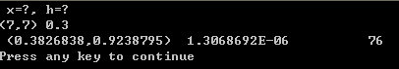

1-4 Optimizations
Optimization: Find the extrema of a function or functions.
It is proved that solving an equation or the system of equations is equivalent to an optimization problem.

Eg. (a) Solve f(x)=0$⇔$Find the minimum of |f(x)|.
(b) Solve $\left\{\begin{matrix}f(x,y)=0 \\ g(x,y)=0\end{matrix}\right.$$⇔$Find the minimum of |f(x,y)|²+|g(x,y)|².
1-5 Simplex Method and Shift-or-Shrink (SOS) Method in Optimizations
Simplex method: Find the local extrema of f(x₁,x₂,…,x_{n}), it needs (n+1) initial guesses.
Consider a 2-dimensional case of maximization. Initial 3 guesses are G, M, and S. Suppose f(G)>f(M)>f(S).
(1) Reflection: Set new1 is the image point of S with respect to the line connecting G and M.
If f(new1)>f(S)$⇒$Expansion. If f(new1)≦ f(S)$⇒$Contraction

(2) Expansion: Extend new1 to new2 by twice distance.
If f(new1)>f(new2)$⇒$M, G, new1$⇒$Reflection
If f(new1)≦f(new2)$⇒$M, G, new2$⇒$Reflection

(3) Contraction: Set new2 is the middle point of S to the line connecting G and M.
If f(new2)>f(S)$⇒$M, G, new2$⇒$Reflection
If f(new2)<f(S)$⇒$Shrink

(4) Shrink: Set new1 is the middle point of S to G and new2 is the middle point of M to G. And use new1, new2, G $⇒$Reflection

Eg. Find the minimum of F(x,y)= x²+y².
(Sol.) Min of F(x,y)= x²+y²$⇔$Max of G(x,y)=-F(x,y)=-x²-y²
There are 2 variables, so we choose arbitrary 3 points: (1,0), (0,1), (1,1)
G(1,1)=-2 is S, G(1,0)=-1, G(0,1)=-1$⇒$
Reflection: reject S, then (0,0) is new1, G(0,0)=0>-2$⇒$
Expansion: $\left(\frac{−1}{2},\frac{−1}{2}\right)$ is new2$⇒G\left(\frac{−1}{2},\frac{−1}{2}\right)=−\frac{1}{2}<0⇒$new2 is rejected
Now, 3 points are (0,0), (0,1), (1,0)$⇒$
Reflection: (0,-1) is new1, G(0,-1)=-1=G(0,1)$⇒$new1 is rejected
Contraction: $\left(0,\frac{1}{2}\right)$ is new2, $G\left(0,\frac{1}{2}\right)=−\frac{1}{4}>−1$
Now, 3 points are (0,0), $\left(0,\frac{1}{2}\right)$, $(1,0)$$⇒$
Reflection: (-1,0) is new1, G(-1,0)=-1=G(1,0)$⇒$new1 is rejected
Contraction: $\left(\frac{1}{2},0\right)$ is new2, $G\left(\frac{1}{2},0\right)=\frac{−1}{4}>−1$
Now, three points become (0,0), (0,1/2), (1/2.0)$⇒⋯$
SOS method (by K. –Y. Lee et al.):
Find the local extrema of f(x₁,x₂,…,x_{n}), it needs (2n+1) initial guesses as follows. Choose a central point x_{c}=(x_{1c},x_{2c},…,x_{nc}), and its neighboring 2n grid point: (x_{1c}±h,x_{2c},…,x_{nc}), (x_{1c},x_{2c}±h,…,x_{nc}), …, (x_{1c},x_{2c},…,x_{nc}±h).
(a) Shift: If one of the side points makes f(x₁,x₂,…,x_{n}) has the extremum of all grid points, then let the side point become the new central point.
(b) Shrink: If the central point x_{c}=(x_{1c},x_{2c},…,x_{nc}) makes f(x₁,x₂,…,x_{n}) has the maximum or minimum of all grid points, then let h become less.
Repeat (a) and (b), the local maximum or minimum of f(x₁,x₂,…,x_{n}) can be found.
Consider a 3-dimensional SOS method in the following figures. Figure (a) shows a central point x_{c}=(x_{1c},x_{2c},x_{3c}) and its neighboring 6 grid point: (x_{1c}±h,x_{2c},x_{3c}), (x_{1c},x_{2c}±h,x_{3c}), and (x_{1c},x_{2c},x_{3c}±h). Figure (b) presents that one of the side points makes f(x₁,x₂,x₃) has the extremum of all grid points, then let the side point become the new central point. Figure (c) describes that the central point x_{c} makes f(x₁,x₂,x₃) has the maximum or minimum of all grid points, then let h become less.
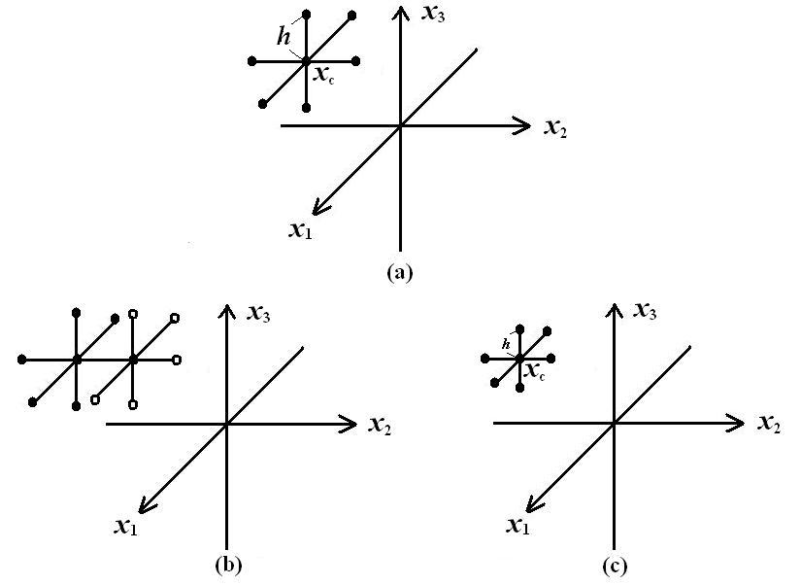
Eg. Find the minima of f(x)=x²-2, F(x,y)=x²+y²-1, and G(x,y,z)=x²+y²+z²+1.
(Sol.) (a) For f(x)=x²-2, we may select x_{c}=1 and h=1, then we have 3 initial guesses: 1, and its neighboring 2 grid point: 0, 2.
f(1)=-1, f(0)=-2, f(2)=2$⇒$x_{c}=0 and h=1, then we have 3 points: 0, -1, 1. (Shift)
f(0)=-2, f(-1)=-1, f(1)=-1$⇒$x_{c}=0 and h=0.5, then we have 3 points: 0, -0.5, 0.5. (Shrink)
f(0)=-2, f(-0.5)=-1.75, f(0.5)=-1.75$⇒$x_{c}=0 and h=0.25, then we have 3 points: 0, -0.25, 0.25. (Shrink)
f(0)=-2, f(-0.25)=-1.9375, f(0.25)=-1.9375$⇒$x_{c}=0 and h=0.125, then we have 3 points: 0, -0.125, 0.125. (Shrink)
$$⋮$$
The 3 points converge to 0 and f(0)=-2 is the minimum.
(b) For F(x,y)=x²+y²-1, we may select x_{c}=(1,0) and h=1, then we have 5 initial guesses: x_{c}=(1,0), and its neighboring 4 grid point: (0,0), (2,0), (1,-1), (1,1).
F(1,0)=0, F(0,0)=-1, F(2,0)=3, F(1,-1)=1, F(1,1)=1$⇒$x_{c}=(0,0) and h=1, then we have 5 points: (0,0), (1,0), (-1,0), (0,-1), (0,1). (Shift)
F(0,0)=-1, F(1,0)=0, F(-1,0)=0, F(0,-1)=0, F(0,1)=0$⇒$x_{c}=(0,0) and h=0.5, then we have 5 points: (0,0), (0.5,0), (-0.5,0), (0,-0.5), (0,0.5). (Shrink)
$$⋮$$
The 5 points converge to (0,0) and F(0,0)=-1 is the minimum.
(c) For G(x,y,z)=x²+y²+z²+1, we may select x_{c}=(1,1,1) and h=1, then we have 7 initial guesses: x_{c}=(1,1,1), and its neighboring 6 grid point: (0,1,1), (2,1,1), (1,0,1), (1,2,1), (1,1,0), (1,1,2).
$$⋮$$
The 7 points converge to (0,0,0) and G(x,y,z)=1 is the minimum.

Eg. Minimize f(x₁, x₂, x₃, …, x_{n})=x₁+x₂+x₃+…+x_{n} by SOS method.
(Sol.) A Fortran Program (developed by K. –Y. Lee) is listed as follows.
dimension gg(0:100),xc(50),y(100,50)
common x(50),h
call ASOS
stop
end

subroutine ASOS
dimension gg(0:100),xc(50),y(100,50)
common x(50),h
external g
write (*,*) 'N=?(N<=50)'
read (*,*) n
do 100 i=1, n
write (*,*) i,' x(i)=',
read (*,*) xc(i)
100 continue
write (*,*) 'h='
read (*,*) h
do 150 j=1,n
x(j)=xc(j)
150 continue
m=1
1 gg(0)=g(n)
rmin=gg(0)
do 300 i=1,2*n
do 350 j=1,n
if ((2*j).eq.(i+1)) then
y(i,j)=x(j)+h
elseif ((2*j).eq.i) then
y(i,j)=x(j)-h
else
y(i,j)=x(j)
endif
350 continue
300 continue
do 400 i=1,2*n
do 450 j=1,n
x(j)=y(i,j)
450 continue
gg(i)=g(n)
if (gg(i).le.rmin) rmin=gg(i)
400 continue
if (gg(0).eq.rmin) then
h=h/2
do 500 j=1,n
x(j)=xc(j)
500 continue
else
do 600 i=1,2*n
if (rmin.eq.gg(i)) then
do 650 j=1,n
xc(j)=y(i,j)
650 continue
endif
600 continue
endif
do 700 j=1,n
x(j)=xc(j)
write (*,*) x(j)
700 continue
m=m+1
write (*,*) h,m,rmin
if (h.ge.0.001) goto 1
return
end

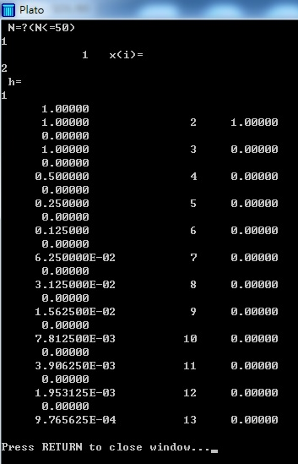
function g(n)
common x(50),h
g=0.
do 1 i=1,n
g=g+x(i)**2
1 continue
return
end

Case 1
Minimize f(x)=x².
Set n=1, choose initial x=x(1)=2 and h=1, we obtain the minimal value is 0 at x=0 after 13 iterations.

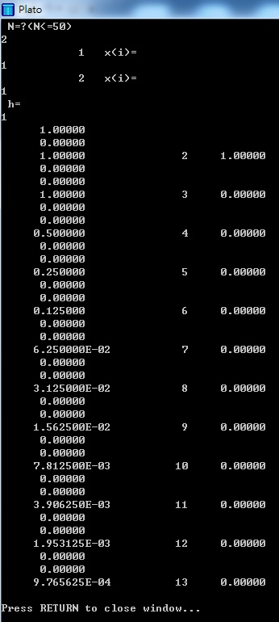
Case 2
Minimize f(x,y)=x²+y².
Set n=2, choose initial x=x(1)=1, y=x(2)=1, and h=1, we obtain the minimal value is 0 at (0,0) after 13 iterations.

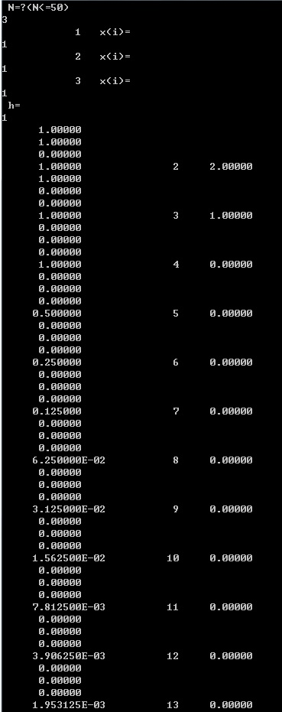
Case 3
Minimize f(x,y,z)=x²+y²+z².
Set n=3, choose initial x=x(1)=1, y=x(2)=1, z=x(3)=1, and h=1, we obtain the minimal value is 0 at (0,0,0) after 14 iterations.
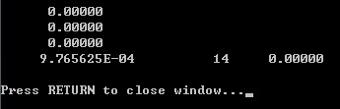
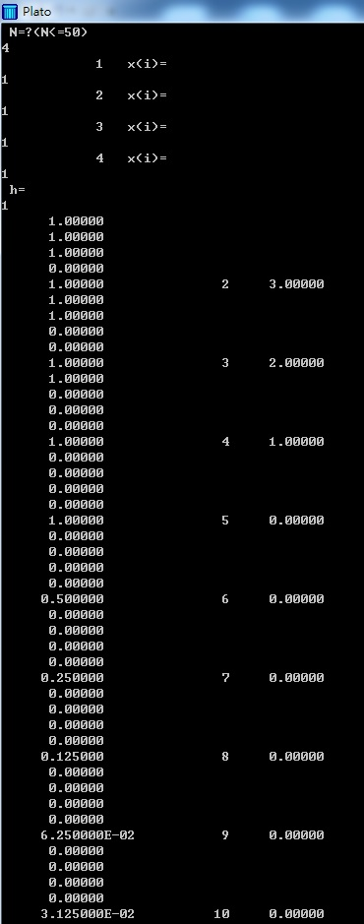
Case 4
Minimize f(x,y,z,w)=x²+y²+z²+w².
Set n=4, choose initial x=x(1)=1, y=x(2)=1, z=x(3)=1, w=x(4)=1, and h=1, we obtain the minimal value is 0 at (0,0,0,0) after 15 iterations.

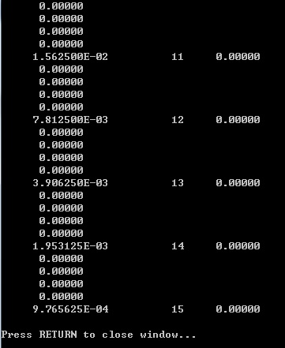
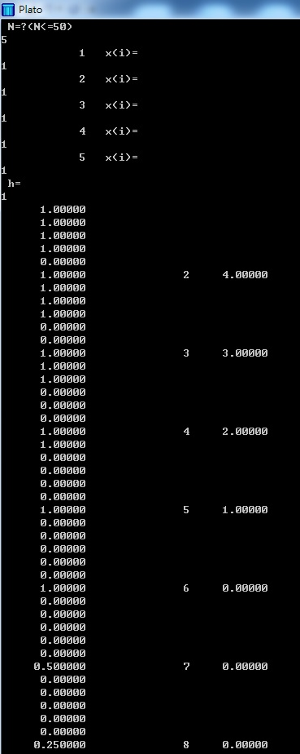
Case 5
Minimize f(x,y,z,w)=x²+y²+z²+w²+v².
Set n=4, choose initial x=x(1)=1, y=x(2)=1, z=x(3)=1, w=x(4)=1, v=x(5)=1,and h=1, we obtain the minimal value is 0 at (0,0,0,0,0) after 16 iterations.

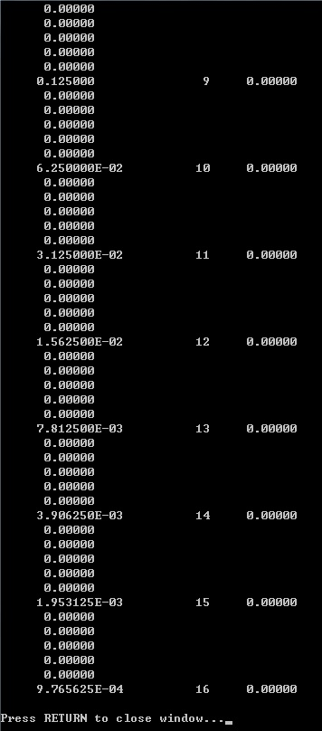

Case 1 Find the maximum of f(c,w,u,v)=-(c-1)²-(w+1)²-(u-2)²-(v+3)² by C/C++ program.
#include<stdio.h>
#include<stdlib.h>
#include<math.h>
float f4(float c, float w, float u, float v)
{
float f4=-pow(c-1,2)-pow(w+1,2)-pow(u-2,2)-pow(v+3,2);
return (f4);
}
void ASOS()
{
int n,m;
float x[50],xc[50],h, rmax, gg[100],y[100][50];
n=4;
for (int i=1; i<= n; i++)
{
printf(" i=%d x[i]=", i);
scanf ("%f", &xc[i]);
}
printf("h=");
scanf ("%f", &h);
for (int j=1; j<=n; j++)
{
x[j]=xc[j];
}
m=0;
while (h>0.001)
{
gg[0]=f4(x[1],x[2],x[3],x[4]) ;
rmax=gg[0];

for ( int i=0; i<=2*n; i++)
{
for (int j=1; j<=n; j++)
{
if (2*j==(i+1))
{ y[i][j]=x[j]+h; }
else if ((2*j)==i)
{ y[i][j]=x[j]-h; }
else
{ y[i][j]=x[j]; }
}
}

for (int i=0; i<=2*n; i++)
{
for (int j=1; j<=n; j++)
{
x[j]=y[i][j];
}
gg[i]=f4(x[1],x[2],x[3],x[4]) ;
if (gg[i]>=rmax)
{ rmax=gg[i]; }
}
if (gg[0]==rmax)
{ h=h/2; }
for (int j; j<=n; j++)
{
x[j]=xc[j];
}
if (gg[0]!=rmax)
{
for (int i=1; i<=2*n; i++)
{
if (rmax==gg[i])
{
for (int j=1; j<=n; j++)
{
xc[j]=y[i][j];
}
}
}
}
for (int j=1; j<=n; j++)
{
x[j]=xc[j];
}
m=m+1;
printf("%f %f %f %f \n", x[1],x[2],x[3],x[4]);
printf("%f %d %f \n", h,m,rmax);
}
}

main ()
{
ASOS();
}

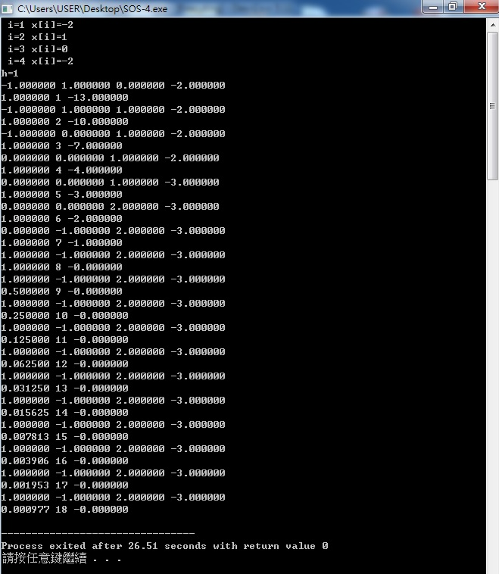
Case 2 Find the maximum of f(c,w,u)=-(c-1)²-(w+1)²-(u-2)² by C/C++ program.
#include<stdio.h>
#include<stdlib.h>
#include<math.h>
float f3(float c, float w, float u)
{
float f3=-pow(c-1,2)-pow(w+1,2)-pow(u-2,2);
return (f3);
}

void ASOS()
{
int n,m;
float x[50],xc[50],h, rmax, gg[100],y[100][50];
n=3;
for (int i=1; i<= n; i++)
{
printf(" i=%d x[i]=", i);
scanf ("%f", &xc[i]);
}
printf("h=");
scanf ("%f", &h);
for (int j=1; j<=n; j++)
{
x[j]=xc[j];
}
m=0;
while (h>0.001)
{
gg[0]=f3(x[1],x[2],x[3]) ;
rmax=gg[0];
for ( int i=0; i<=2*n; i++)
{
for (int j=1; j<=n; j++)
{
if (2*j==(i+1))
{ y[i][j]=x[j]+h; }
else if ((2*j)==i)
{ y[i][j]=x[j]-h; }
else
{ y[i][j]=x[j]; }
}
}

for (int i=0; i<=2*n; i++)
{
for (int j=1; j<=n; j++)
{
x[j]=y[i][j];
}
gg[i]=f3(x[1],x[2],x[3]) ;
if (gg[i]>=rmax)
{ rmax=gg[i]; }
}
if (gg[0]==rmax)
{ h=h/2; }
for (int j; j<=n; j++)
{
x[j]=xc[j];
}
if (gg[0]!=rmax)
{
for (int i=1; i<=2*n; i++)
{
if (rmax==gg[i])
{
for (int j=1; j<=n; j++)
{
xc[j]=y[i][j];
}
}
}
}
for (int j=1; j<=n; j++)
{
x[j]=xc[j];
}
m=m+1;
printf("%f %f %f \n", x[1],x[2],x[3]);
printf("%f %d %f \n", h,m,rmax);
}
}

main ()
{
ASOS();
}
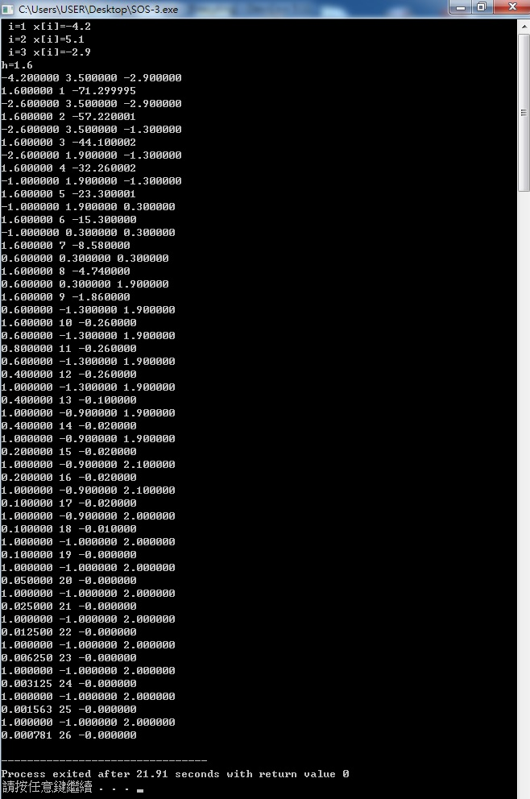

Case 3 Find the maximum of f(c,w)=-(c-1)²-(w+1)² by C/C++ program.
#include<stdio.h>
#include<stdlib.h>
#include<math.h>
float f2(float c, float w)
{
float f2=-pow(c-1,2)-pow(w+1,2);
return (f2);
}

void ASOS()
{
int n,m;
float x[50],xc[50],h, rmax, gg[100],y[100][50];
n=2;
for (int i=1; i<= n; i++)
{
printf(" i=%d x[i]=", i);
scanf ("%f", &xc[i]);
}
printf("h=");
scanf ("%f", &h);

for (int j=1; j<=n; j++)
{
x[j]=xc[j];
}
m=0;
while (h>0.001)
{
gg[0]=f2(x[1],x[2]) ;
rmax=gg[0];
for ( int i=0; i<=2*n; i++)
{
for (int j=1; j<=n; j++)
{
if (2*j==(i+1))
{ y[i][j]=x[j]+h; }
else if ((2*j)==i)
{ y[i][j]=x[j]-h; }
else
{ y[i][j]=x[j]; }
}
}

for (int i=0; i<=2*n; i++)
{
for (int j=1; j<=n; j++)
{
x[j]=y[i][j];
}
gg[i]=f2(x[1],x[2]) ;
if (gg[i]>=rmax)
{ rmax=gg[i]; }
}

if (gg[0]==rmax)
{ h=h/2; }
for (int j; j<=n; j++)
{
x[j]=xc[j];
}
if (gg[0]!=rmax)
{
for (int i=1; i<=2*n; i++)
{
if (rmax==gg[i])
{
for (int j=1; j<=n; j++)
{
xc[j]=y[i][j];
}
}
}
}
for (int j=1; j<=n; j++)
{
x[j]=xc[j];
}
m=m+1;
printf("%f %f \n", x[1],x[2]);
printf("%f %d %f \n", h,m,rmax);
}
}

main ()
{
ASOS();
}

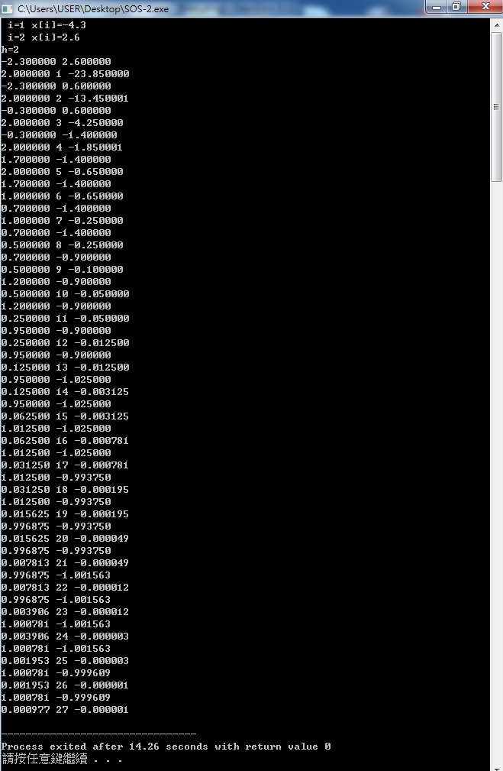
Case 4 Find the maximum of f(c)=-(c-1)² by C/C++ program.
#include<stdio.h>
#include<stdlib.h>
#include<math.h>
float f1(float c)
{
float f1=-pow(c-1,2);
return (f1);
}

void ASOS()
{
int n,m;
float x[50],xc[50],h, rmax, gg[100],y[100][50];
n=1;
for (int i=1; i<= n; i++)
{
printf(" i=%d x[i]=", i);
scanf ("%f", &xc[i]);
}
printf("h=");
scanf ("%f", &h);
for (int j=1; j<=n; j++)
{
x[j]=xc[j];
}
m=0;
while (h>0.001)
{
gg[0]=f1(x[1]) ;
rmax=gg[0];
for ( int i=0; i<=2*n; i++)
{
for (int j=1; j<=n; j++)
{
if (2*j==(i+1))
{ y[i][j]=x[j]+h; }
else if ((2*j)==i)
{ y[i][j]=x[j]-h; }
else
{ y[i][j]=x[j]; }
}
}

for (int i=0; i<=2*n; i++)
{
for (int j=1; j<=n; j++)
{
x[j]=y[i][j];
}

gg[i]=f1(x[1]) ;
if (gg[i]>=rmax)
{ rmax=gg[i]; }
}
if (gg[0]==rmax)
{ h=h/2; }
for (int j; j<=n; j++)
{
x[j]=xc[j];
}
if (gg[0]!=rmax)
{
for (int i=1; i<=2*n; i++)
{
if (rmax==gg[i])
{
for (int j=1; j<=n; j++)
{
xc[j]=y[i][j];
}
}
}
}
for (int j=1; j<=n; j++)
{
x[j]=xc[j];
}
m=m+1;
printf("%f \n", x[1]);
printf("%f %d %f \n", h,m,rmax);
}
}

main ()
{
ASOS();
}

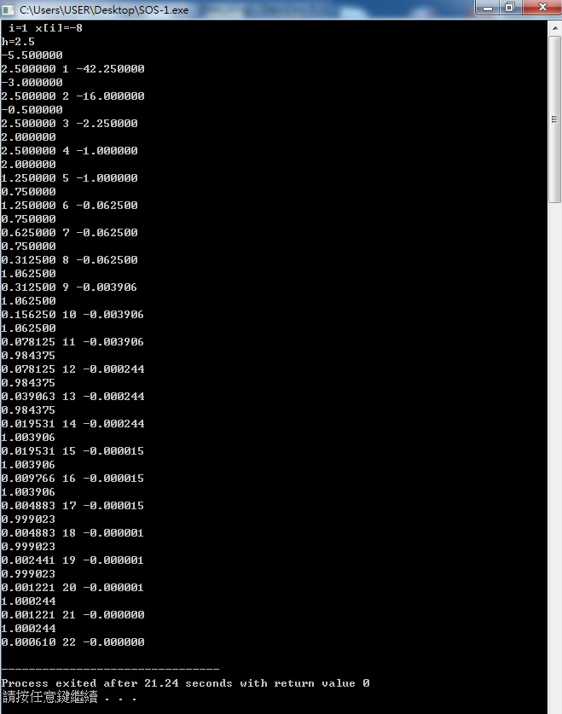
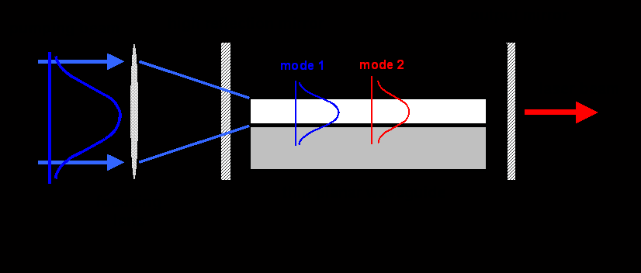
Eg. How can we obtain the optimal direct coupling efficiency between an optical waveguide and a fiber? It is desired to maximize
$$η=\frac{{\left[\iint{ϕ\left(x,y\right)φ\left(x,y\right)\text{dxdy}}\right]}^{2}}{\iint{ϕ^{2}\left(x,y\right)\text{dxdy}⋅\iint{φ^{2}\left(x,y\right)\text{dxdy}}}}$$
Waveguide mode: $ϕ\left(x,y\right)=C_{w}⋅ϕ_{x}\left(x\right)ϕ_{y}\left(y\right)$, where $ϕ_{x}\left(x\right)=\text{exp}\left(−x^{2}a_{1}^{2}\right)$ and $ϕ_{y}\left(y\right)=\text{exp}\left[−{\left(y−b\right)}^{2}a_{i}^{2}\right]$, $i=\left\{\begin{matrix}2, & y≤b \\ 3, & y>b\end{matrix}\right.$.
Fiber mode:$φ\left(x,y\right)=C_{f}⋅\text{exp}\left\{−\left[x^{2}+{\left(y−c\right)}^{2}\right]w^{2}\right\}$
Utilize the formulae: $\int{e^{−t^{2}}\text{dt}=\frac{\sqrt{π}}{2}\text{erf}(A)}$, $\int{e^{−{\text{Bt}}^{2}}\text{dt}=\frac{\sqrt{π}}{2\sqrt{B}}\text{erf}(A\sqrt{B})}$, $\int{e^{−(t−A)^{2}}\text{dt}=\frac{\sqrt{π}}{2}[1−\text{erf}(A)]}$, and $\int{e^{−(t−A)^{2}}\text{dt}=\frac{\sqrt{π}}{2}[1+\text{erf}(A)]}$
$$\int{\int{φ(x,y)ϕ(x,y)\text{dxdy}=C_{f}C_{w}\int{e^{−(\frac{1}{w^{2}}+\frac{1}{a_{1^{2}}})x^{2}}\text{dx}⋅[\int{e^{−\frac{(y−c)^{2}}{w^{2}}−\frac{(y−b)^{2}}{a_{2^{2}}}}\text{dy}+\int{e^{−\frac{(y−c)^{2}}{w^{2}}−\frac{(y−b)^{2}}{a_{3^{2}}}}\text{dy}]}}}}}$$
$\int{e^{−(\frac{1}{w^{2}}+\frac{1}{a_{1^{2}}})x^{2}}\text{dx}=\frac{{\text{wa}}_{1}\sqrt{π}}{\sqrt{w^{2}+a_{1^{2}}}}}$,
$$\int{e^{−\frac{(y−c)^{2}}{w^{2}}−\frac{(y−b)^{2}}{a_{2^{2}}}}\text{dy}=\int{e^{−\frac{[u−(c−b)]^{2}}{w^{2}}−\frac{u^{2}}{a_{2^{2}}}}\text{du}}}=e^{−\frac{(c−b)^{2}}{(a_{2^{2}}+w^{2})}}\int{e^{−\frac{a_{2^{2}}+w^{2}}{w^{2}a_{2^{2}}}⋅[u−\frac{a_{2^{2}}(c−b)}{a_{2^{2}}+w^{2}}]^{2}}\text{du}}$$
$=\frac{a_{2}w\sqrt{π}}{2⋅\sqrt{a_{2}^{2}+w^{2}}}⋅\text{exp}\left[−\frac{{\left(c−b\right)}^{2}}{\left(a_{2}^{2}+w^{2}\right)}\right]⋅\left\{1−\text{erf}\left[\frac{a_{2}\left(c−b\right)}{w⋅\sqrt{a_{2^{2}}+w^{2}}}\right]\right\}$,
Similarly,
$$\int{e^{−\frac{(y−c)^{2}}{w^{2}}−\frac{(y−b)^{2}}{a_{3^{2}}}}\text{dy}=\int{e^{−\frac{[u−(c−b)]^{2}}{w^{2}}−\frac{u^{2}}{a_{3^{2}}}}\text{du}}}=e^{−\frac{(c−b)^{2}}{(a_{3^{2}}+w^{2})}}\int{e^{−\frac{a_{3^{2}}+w^{2}}{w^{2}a_{3^{2}}}⋅[u−\frac{a_{3^{2}}(c−b)}{a_{3^{2}}+w^{2}}]^{2}}\text{du}}$$
$$=\frac{a_{3}w\sqrt{π}}{2⋅\sqrt{a_{3}^{2}+w^{2}}}⋅\text{exp}\left[−\frac{{\left(c−b\right)}^{2}}{\left(a_{3}^{2}+w^{2}\right)}\right]⋅\left\{1+\text{erf}\left[\frac{a_{3}\left(c−b\right)}{w⋅\sqrt{a_{3^{2}}+w^{2}}}\right]\right\}$$
$\int{\int{φ^{2}(x,y)\text{dxdy}=C_{f^{2}}⋅\frac{w^{2}π}{2}}}$, and $\int{\int{ϕ^{2}(x,y)\text{dxdy}=C_{w^{2}}⋅\frac{a_{1}(a_{2}+a_{3})π}{4}}}$,
$⇒$$η=\frac{2a_{1}w^{2}}{\left(a_{2}+a_{3}\right)\left(a_{1}^{2}+w^{2}\right)}⋅{\left(I_{1}+I_{2}\right)}^{2}$, where
$$I_{1}=\frac{a_{2}}{\sqrt{a_{2}^{2}+w^{2}}}⋅\text{exp}\left[−\frac{{\left(c−b\right)}^{2}}{\left(a_{2}^{2}+w^{2}\right)}\right]⋅\left\{1−\text{erf}\left[\frac{a_{2}\left(c−b\right)}{w⋅\sqrt{a_{2^{2}}+w^{2}}}\right]\right\}$$
$$I_{2}=\frac{a_{3}}{\sqrt{a_{3}^{2}+w^{2}}}⋅\text{exp}\left[−\frac{{\left(c−b\right)}^{2}}{\left(a_{3}^{2}+w^{2}\right)}\right]⋅\left\{1+\text{erf}\left[\frac{a_{3}\left(c−b\right)}{w⋅\sqrt{a_{3^{2}}+w^{2}}}\right]\right\}$$
(Sol.)
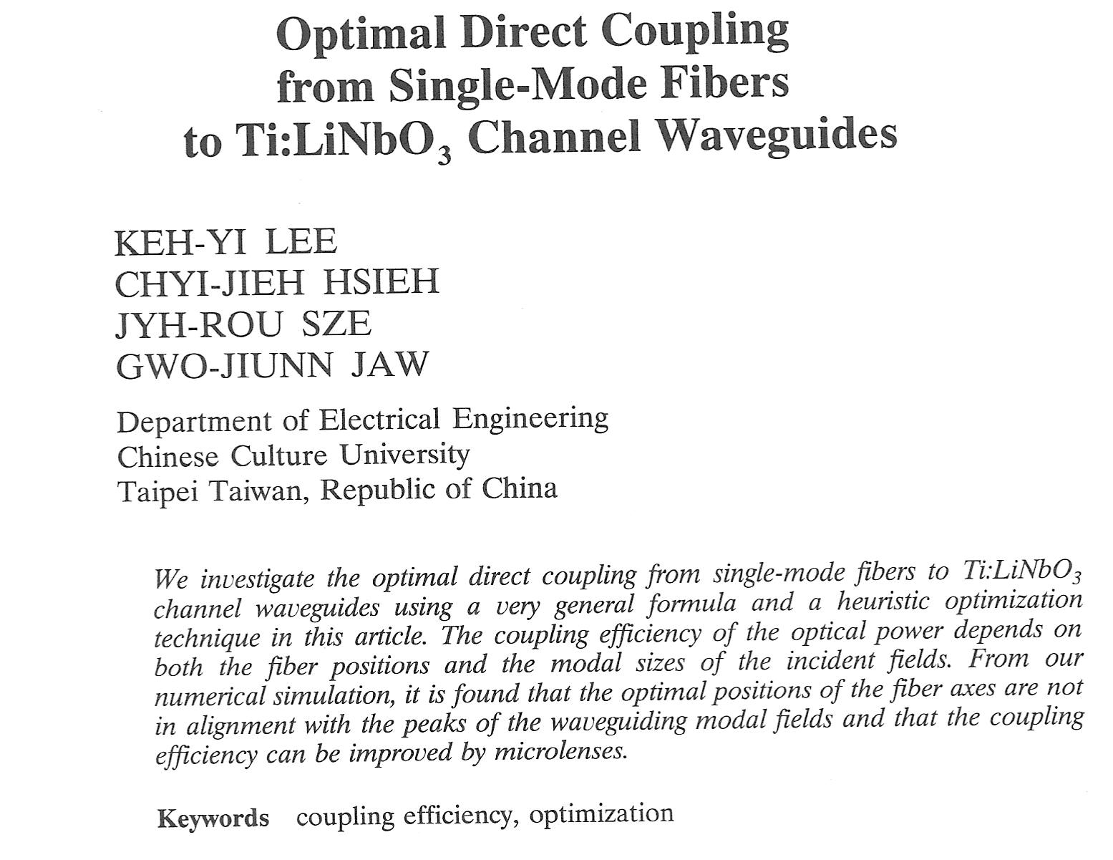
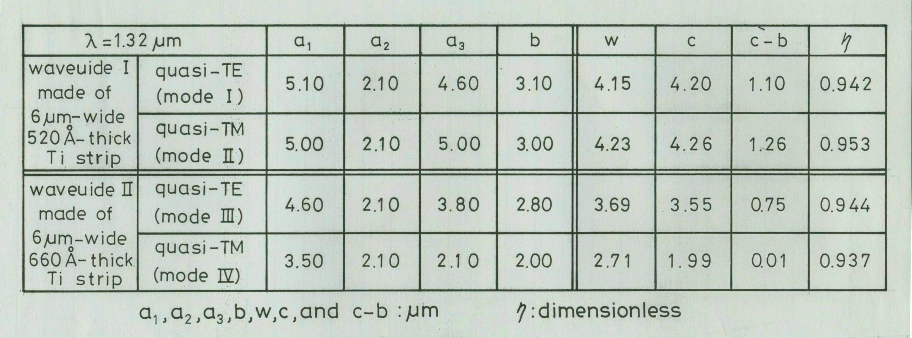
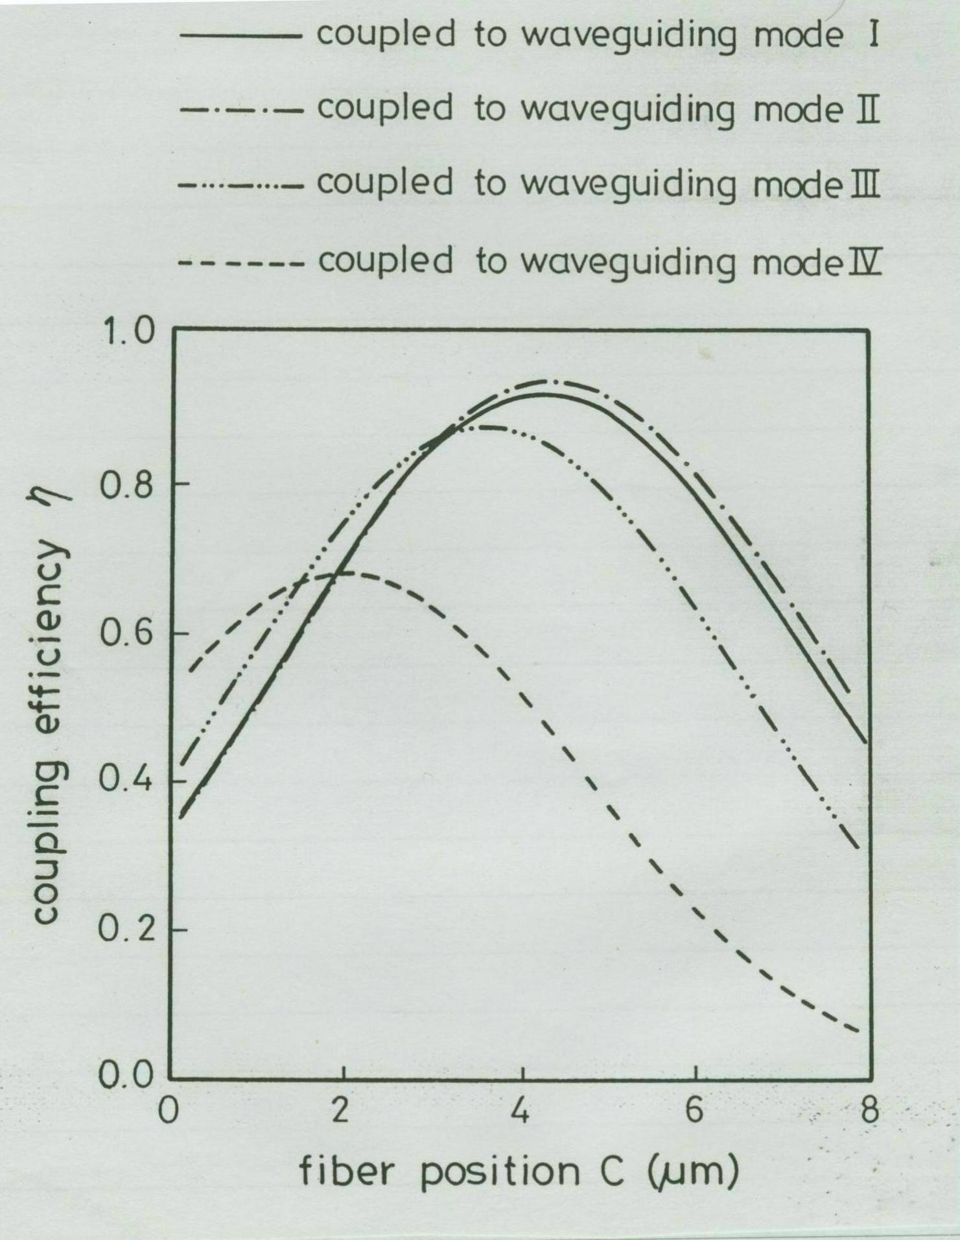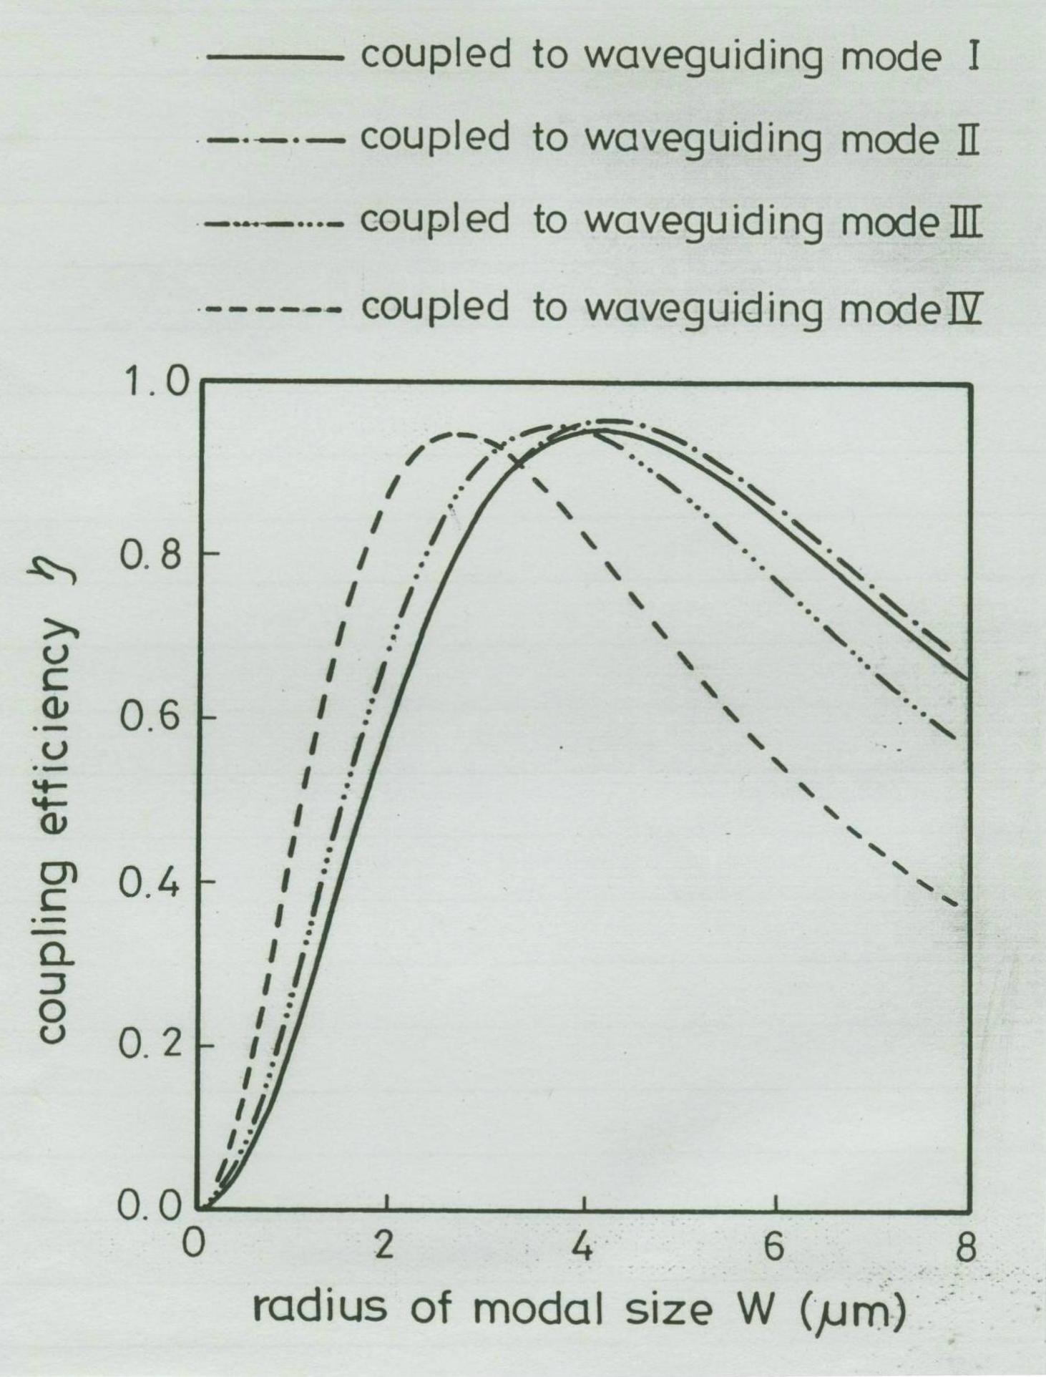
1-6 Steepest Descent Method in Optimizations
Find the minimum of f(x₁,x₂,…,x_{n}): Initial guess is x₀=(x₁⁰,x₂⁰,…,x_{n}⁰), and
$$−∇f(x_{1},⋯,x_{n})=\left(−\frac{∂f(x_{1},⋯,x_{n})}{∂x_{1}},⋯,−\frac{∂f(x_{1},⋯,x_{n})}{∂x_{n}}\right)$$
Recursive formula: $x_{k+1}=x_{k}−α_{k}∇f(x_{k})$
$$⇒(x_{1}^{k+1},⋯,x_{n}^{k+1})=\left(x_{1}^{k}−α_{k}⋅\frac{∂f}{∂x_{1}|_{(x_{1}^{k},⋯,x_{n}^{k})}},⋯,x_{n}^{k}−α_{k}\frac{∂f}{∂x_{n}|{}_{(x_{1}^{k},⋯,x_{n}^{k})}}\right)$$
Solve α_{k} of $\frac{d}{{dα}_{k}}f(x_{k}−α_{k}∇f(x_{k}))=0$
Eg. Find the minimum of f(x,y)= x²+y².
(Sol.) $−∇f(x,y)$=(-2x,-2y),$−α_{k}∇f(x,y)=(−2α_{k}x,−2α_{k}y)$
Initial guess: $(x^{0},y^{0})$=(1,1)
$$\frac{d}{{dα}_{0}}f(1−2α_{0}⋅1,1−2α_{0}⋅1)=\frac{d}{{dα}_{0}}[(1−2α_{0})^{2}+(1−2α_{0})^{2}]=0$$
$⇒α_{0}=\frac{1}{2}$$⇒(x^{1},y^{1})=(x_{0}−2α_{0}⋅x_{0},y_{0}−2α_{0}⋅y_{0})=(0,0)$
$$⋮$$
In fact, (0,0) is the position of the minimum position of f(x,y)=x²+y².

1-7 Optimizations in Constrained Problems
In the previous section, only unconstrained problems are encountered. If there exist some constraints, some new methods are needed to solve them.
1. Lagrange Multiplier Method: Find the extrema of a function with some constraint equations.
2. Penalty Function Method: Find the extrema of a function with some constraint inequalities.

Eg. Find the minimum of f(x)=sin(x), π/2<x<7π/4.
(Sol.) Original problem has infinite local minima
Under the following constraints, only one minimum point by setting $g(x)=\left\{\begin{matrix}\text{sin}(x) & ,\frac{π}{2}<x<\frac{7π}{4} \\ \text{100000} & ,\text{elsewhere}\end{matrix}\right.$
To sum up, imposing some appropriate penalty function outside the constraint ranges, and then we can solve the constraint problem by the previous method as well as the unconstraint ones.

Appendix-Genetic Algorithm(基因演算法)
基因演算法特性
- 最佳化過程只針對適應函數處理
- 透過編碼技術可以直接在空間中找到全域最佳解

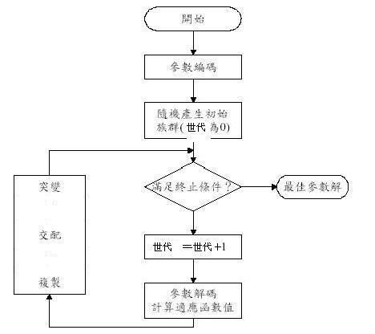

基因演算法專有名詞
- 個體 (individual)
- 世代(generation)
- 族群大小 (population size)
- 交配率 (crossover rate)
- 突變率 (mutation rate)
- 適應函數 (fitness function)

基因演算法主要運算
- 複製
L：個體數目
fi：個體適應值 (i=1,2,…,L)
一個個體被複製到下一代的機率為
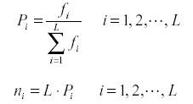
- 交配
有三種主要交配方式：(1)單點交配(one-point crossover) (2)兩點交配(two-point crossover) (3)均勻交配(uniform crossover)

單點交配
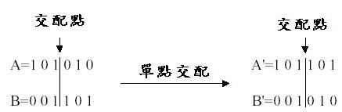
兩點交配
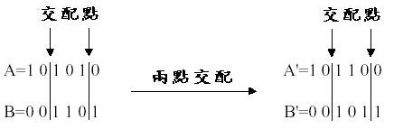
均勻交配
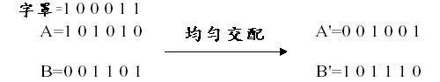
突變
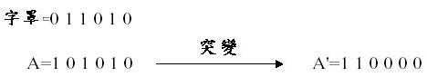
由於突變不會常常發生，可以假設適當的機率函數來設定突變方式。

Eg. Find the maximum of f(x)=-(x-11)² by the genetic algorithm.
編碼方式：以5個bits來表示，例如 0=00000, …, 31=11111
演化機制：輪盤選擇法或四捨五入決定
目標函數：f(x)=-(x-11)²
求極大值：f_{i}(x)=-(x-11)²-min.
(Sol.) 以傳統數學方法可知：當x=11時，f(x)之極大值為0
Genetic Algorithm
The first step
個體編號(假設只猜測四個起始值) | 隨機產生的第一代族群(二進位) | x值 | f(x) | f_{i}(x)=-(x-11)²-min | $${f_{i}}/{\sum{f_{i}}}$$ | $${f_{i}}/{\overline{f}}$$ | 實際值(由輪盤或四捨五入決定)
1 | 01100 | 12 | -1 | 48 | 0.38 | 1.52 | 2
2 | 01111 | 15 | -16 | 33 | 0.26 | 1.05 | 1
3 | 01001 | 9 | -4 | 45 | 0.36 | 1.43 | 1
4 | 10010 | 18 | -49 | 0 | 0 | 0 | 0
總和$\sum{f_{i}}$=126
平均$\overline{f}$=31.5
Max of f(x) = -1
經由演化機制，吾人淘汰x=18(=10010)，而繁殖x=12(=01100)為2個
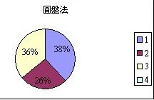
採用單點交配與突變：
經選擇後的個體編號 | 經選擇後的個體 | 交配的配對(隨機產生) | 交配的位置點(隨機產生) | 新產生的個體(二進位) | x值(第二代族群)
1 | 01100 | 4 | 1 | 01001 | 9
2 | 01100 | 3 | 4 | 01101 | 13
3 | 01111 | 2 | 4 | 01110 | 14*→10
4 | 01001 | 1 | 1 | 01100 | 12
假設第二代族群中的x=14*(=01110)發生基因突變成為x=10(=01010)
$⇒$The second step
個體編號 | 第二代族群 | x值 | f(x) | f_{i}(x)=-(x-11)²-min | $${f_{i}}/{\sum{f_{i}}}$$ | $${f_{i}}/{\overline{f}}$$ | 實際值(由輪盤或四捨五入決定)
1 | 01001 | 9 | -4 | 0 | 0 | 0 | 0
2 | 01101 | 13 | -4 | 0 | 0 | 0 | 0
3 | 01010 | 10 | -1 | 3 | 0.5 | 2 | 2*
4 | 01100 | 12 | -1 | 3 | 0.5 | 2 | 1+1*
總和$\sum{f_{i}}$=6
平均$\overline{f}$=1.5
Max of f(x)= 0
經由演化機制，吾人淘汰x=9(=01001)與x=13(=01101)，而繁殖x=10(=01010) 與x=12(=01100)各為2個，但是假設兩個x=10(=01010)均發生突變為x=11(=01011)，而其中一個x=12(=01100)突變為x=8(=01000)

採用單點交配與突變：
經選擇後的個體編號 | 經選擇後的個體 | 交配的配對(隨機產生) | 交配的位置點(隨機產生) | 新產生的個體(二進位) | x值(第三代族群)
1 | 01011 | 3 | 2 | 01100 | 12
2 | 01011 | 4 | 4 | 01010 | 10
3 | 01100 | 1 | 2 | 01011 | 11
4 | 01000 | 2 | 4 | 01001 | 9

$⇒$The third step
個體編號 | 第三代族群 | x值 | f(x) | f_{i}(x)=-(x-11)²-min | $${f_{i}}/{\sum{f_{i}}}$$ | $${f_{i}}/{\overline{f}}$$ | 實際值(由輪盤或四捨五入決定)
1 | 01100 | 12 | -1 | 3 | 0.3 | 1.2 | 1
2 | 01010 | 10 | -1 | 3 | 0.3 | 1.2 | 1
3 | 01011 | 11 | 0 | 4 | 0.4 | 1.6 | 2
4 | 01001 | 9 | -4 | 0 | 0 | 0 | 0
總和$\sum{f_{i}}$=10
平均$\overline{f}$=2.5
Max of f(x)= 0
經由演化機制，吾人淘汰x=9(=01001)，而繁殖x=11(=01011)為2個

採用單點交配與突變：
經選擇後的個體編號 | 經選擇後的個體 | 交配的配對(隨機產生) | 交配的位置點(隨機產生) | 新產生的個體(二進位) | x值(第四代族群)
1 | 01100 | 2 | 4 | 01100 | 12
2 | 01010 | 1 | 4 | 01010 | 10
3 | 01011 | 3 | 3 | 01011 | 11
4 | 01011 | 4 | 3 | 01011 | 11
﹍﹍﹍
吾人將可發現x的四個起始值自第一代族群(12,15,9,18)而至第二代族群(9,13,10,12)，而至第三代族群(12,10,11,9)，而至第四代族群(12,10,11,11)，最後所有族群逐漸收斂至11，而f(x)的極大值則逐漸收斂至0
基因演算法求極小值
#include <stdio.h>
#include <stdlib.h>
#include <time.h>
#include <math.h>
#define POPULATION_SIZE 100
#define MAX_GENERATIONS 1000
#define MUTATION_RATE 0.01
#define imax 4

// Function to calculate the fitness value of an individual
// double calculateFitness(double x, double y, double z, double w) {
double calculateFitness(double x1, double x2, double x3, double x4) {
// return 2 * ((x - 3) * (x - 3)) + ((y + 5.1) * (y + 5.1)) + 4 * ((z - 4.8) * (z - 4.8));
return x4*exp(-x1*x1-x2*x2-x3*x3-x4*x4);
}

// Function to generate a random number between min and max
double getRandomNumber(double min, double max) {
return ((double)rand() / RAND_MAX) * (max - min) + min;
}

// Structure representing an individual in the population
typedef struct {
double x[5];
double fitness;
} Individual;

// Function to initialize an individual with random values
void initializeIndividual(Individual *individual) {
// individual->x = getRandomNumber(-10, 10);
// individual->y = getRandomNumber(-10, 10);
// individual->z = getRandomNumber(-10, 10);
// individual->w = getRandomNumber(-10, 10);
for (int i=1;i<=imax;i++)
{ individual->x[i] = getRandomNumber(-10, 10);
}
individual->fitness = calculateFitness(individual->x[1], individual->x[2], individual->x[3], individual->x[4]);
}

// Function to mutate an individual by adding a small random value
void mutateIndividual(Individual *individual) {
// individual->x += getRandomNumber(-1, 1) * MUTATION_RATE;
// individual->y += getRandomNumber(-1, 1) * MUTATION_RATE;
// individual->z += getRandomNumber(-1, 1) * MUTATION_RATE;
// individual->w += getRandomNumber(-1, 1) * MUTATION_RATE;
for (int i=1;i<=imax;i++)
{ individual->x[i] += getRandomNumber(-1, 1) * MUTATION_RATE;
}
individual->fitness = calculateFitness(individual->x[1], individual->x[2], individual->x[3], individual->x[4]);
}

// Function to perform tournament selection to choose parents for reproduction
Individual selectParent(Individual *population) {
int tournamentSize = 5;
int selected = rand() % POPULATION_SIZE;

for (int i = 0; i < tournamentSize; i++) {
int index = rand() % POPULATION_SIZE;
if (population[index].fitness < population[selected].fitness) {
selected = index;
}
}

return population[selected];
}

// Function to perform crossover between two parents to create offspring
Individual crossover(Individual parent1, Individual parent2) {
Individual offspring;
// offspring.x = (parent1.x + parent2.x) / 2.0;
// offspring.y = (parent1.y + parent2.y) / 2.0;
// offspring.z = (parent1.z + parent2.z) / 2.0;
// offspring.w = (parent1.w + parent2.w) / 2.0;
for (int i=1;i<=imax;i++)
{ offspring.x[i] = (parent1.x[i] + parent2.x[i]) /2.0;
}
offspring.fitness = calculateFitness(offspring.x[1], offspring.x[2], offspring.x[3], offspring.x[4]);
return offspring;
}

int main() {
srand(time(NULL));

Individual population[POPULATION_SIZE];

// Initialize the population
for (int i = 0; i < POPULATION_SIZE; i++) {
initializeIndividual(&population[i]);
}

int generation = 0;

// Evolution loop
while (generation < MAX_GENERATIONS) {
// Create a new population
Individual newPopulation[POPULATION_SIZE];

for (int i = 0; i < POPULATION_SIZE; i++) {
// Select two parents
Individual parent1 = selectParent(population);
Individual parent2 = selectParent(population);

// Perform crossover to create offspring
Individual offspring = crossover(parent1, parent2);

// Mutate the offspring
mutateIndividual(&offspring);

// Add the offspring to the new population
newPopulation[i] = offspring;
}

// Replace the old population with the new population
for (int i = 0; i < POPULATION_SIZE; i++) {
population[i] = newPopulation[i];
}

generation++;
}

// Find the individual with the minimum fitness value
Individual bestIndividual = population[0];
for (int i = 1; i < POPULATION_SIZE; i++) {
if (population[i].fitness < bestIndividual.fitness) {
bestIndividual = population[i];
}
}

// Print the result
printf("Minimum value: %.4f\n", bestIndividual.fitness);
printf("x[1] = %.4f, x[2] = %.4f, x[3] = %.4f, x[4] = %.4f\n", bestIndividual.x[1], bestIndividual.x[2], bestIndividual.x[3], bestIndividual.x[4]);

return 0;
}
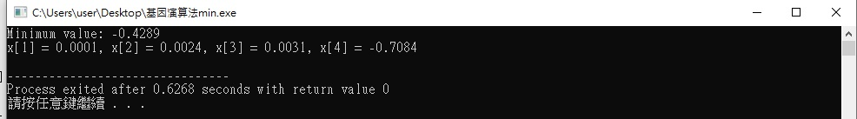

基因演算法求極大值
#include <stdio.h>
#include <stdlib.h>
#include <time.h>
#include <math.h>
#define POPULATION_SIZE 100
#define MAX_GENERATIONS 1000
#define MUTATION_RATE 0.01
#define imax 4

// Function to calculate the fitness value of an individual
// double calculateFitness(double x, double y, double z, double w) {
double calculateFitness(double x1, double x2, double x3, double x4) {
// return 2 * ((x - 3) * (x - 3)) + ((y + 5.1) * (y + 5.1)) + 4 * ((z - 4.8) * (z - 4.8));
return x3*exp(-x1*x1-x2*x2-x3*x3-x4*x4);
}

// Function to generate a random number between min and max
double getRandomNumber(double min, double max) {
return ((double)rand() / RAND_MAX) * (max - min) + min;
}

// Structure representing an individual in the population
typedef struct {
double x[5];
double fitness;
} Individual;

// Function to initialize an individual with random values
void initializeIndividual(Individual *individual) {
// individual->x = getRandomNumber(-10, 10);
// individual->y = getRandomNumber(-10, 10);
// individual->z = getRandomNumber(-10, 10);
// individual->w = getRandomNumber(-10, 10);
for (int i=1;i<=imax;i++)
{ individual->x[i] = getRandomNumber(-10, 10);
}
individual->fitness = calculateFitness(individual->x[1], individual->x[2], individual->x[3], individual->x[4]);
}

// Function to mutate an individual by adding a small random value
void mutateIndividual(Individual *individual) {
// individual->x += getRandomNumber(-1, 1) * MUTATION_RATE;
// individual->y += getRandomNumber(-1, 1) * MUTATION_RATE;
// individual->z += getRandomNumber(-1, 1) * MUTATION_RATE;
// individual->w += getRandomNumber(-1, 1) * MUTATION_RATE;
for (int i=1;i<=imax;i++)
{ individual->x[i] += getRandomNumber(-1, 1) * MUTATION_RATE;
}
individual->fitness = calculateFitness(individual->x[1], individual->x[2], individual->x[3], individual->x[4]);
}

// Function to perform tournament selection to choose parents for reproduction
Individual selectParent(Individual *population) {
int tournamentSize = 5;
int selected = rand() % POPULATION_SIZE;

for (int i = 0; i < tournamentSize; i++) {
int index = rand() % POPULATION_SIZE;
if (population[index].fitness > population[selected].fitness) {
selected = index;
}
}

return population[selected];
}

// Function to perform crossover between two parents to create offspring
Individual crossover(Individual parent1, Individual parent2) {
Individual offspring;
// offspring.x = (parent1.x + parent2.x) / 2.0;
// offspring.y = (parent1.y + parent2.y) / 2.0;
// offspring.z = (parent1.z + parent2.z) / 2.0;
// offspring.w = (parent1.w + parent2.w) / 2.0;
for (int i=1;i<=imax;i++)
{ offspring.x[i] = (parent1.x[i] + parent2.x[i]) /2.0;
}
offspring.fitness = calculateFitness(offspring.x[1], offspring.x[2], offspring.x[3], offspring.x[4]);
return offspring;
}

int main() {
srand(time(NULL));

Individual population[POPULATION_SIZE];

// Initialize the population
for (int i = 0; i < POPULATION_SIZE; i++) {
initializeIndividual(&population[i]);
}

int generation = 0;

// Evolution loop
while (generation < MAX_GENERATIONS) {
// Create a new population
Individual newPopulation[POPULATION_SIZE];

for (int i = 0; i < POPULATION_SIZE; i++) {
// Select two parents
Individual parent1 = selectParent(population);
Individual parent2 = selectParent(population);

// Perform crossover to create offspring
Individual offspring = crossover(parent1, parent2);

// Mutate the offspring
mutateIndividual(&offspring);

// Add the offspring to the new population
newPopulation[i] = offspring;
}

// Replace the old population with the new population
for (int i = 0; i < POPULATION_SIZE; i++) {
population[i] = newPopulation[i];
}

generation++;
}

// Find the individual with the minimum fitness value
Individual bestIndividual = population[0];
for (int i = 1; i < POPULATION_SIZE; i++) {
if (population[i].fitness > bestIndividual.fitness) {
bestIndividual = population[i];
}
}

// Print the result
printf("Maximum value: %.4f\n", bestIndividual.fitness);
printf("x[1] = %.4f, x[2] = %.4f, x[3] = %.4f, x[4] = %.4f\n", bestIndividual.x[1], bestIndividual.x[2], bestIndividual.x[3], bestIndividual.x[4]);

return 0;
}
