Chapter 3 Interpolation, Approximation, and Graphics
3-1 Lagrange Interpolating Polynomials
Given a set of data {(x₀,f(x₀)),(x₁,f(x₁)),(x₂,f(x₂)),…,(x_{n},f(x_{n}))} for x₀<x₁<x₂<…<x_{n}, then there exists a unique polynomial p(x) of degree at most n with the property that f(x_{k})=p(x_{k}), k=0, 1, 2, …, n, and p(x)=$\sum_{k=0}^{n}{f(x_{k})L_{n,k}(x)}$, where
$L_{n,k}(x)=\frac{(x−x_{0})(x−x_{1})⋯(x−x_{k−1})(x−x_{k+1})⋯(x−x_{n})}{(x_{k}−x_{0})(x_{k}−x_{1})⋯(x_{k}−x_{k−1})(x_{k}−x_{k+1})⋯(x_{k}−x_{n})}$$i≠k\underset{n}{}$

Eg. Given x₀=2, x₁=2.5, and x₂=4, find a polynomial to fit f(x)=1/x.
(Sol.) f(x₀)=0.5, f(x₁)=0.4, f(x₂)=0.25
$$L_{2,0}(x)=\frac{(x−2\text{.}5)(x−4)}{(2−2\text{.}5)(2−4)}=x^{2}−6\text{.}5x−\text{10}$$
$$L_{2,1}(x)=\frac{(x−2)(x−4)}{(2\text{.}5−2)(2\text{.}5−4)}=\frac{−4x^{2}+\text{24}x−\text{32}}{3}$$
$$L_{2,2}(x)=\frac{(x−2)(x−2\text{.}5)}{(4−2)(4−2\text{.}5)}=\frac{x^{2}−4\text{.}5x+5}{3}$$
∴ $p(x)=0\text{.}5⋅(x^{2}−6\text{.}5x−\text{10})+0\text{.}4⋅\left(\frac{−4x^{2}+\text{24}x−\text{32}}{3}\right)$$+0\text{.}\text{25}⋅\left(\frac{x^{2}−4\text{.}5x+5}{3}\right)$
=0.05x²-0.425x+1.15

The error in Lagrange polynomial for x in [a,b] is
$\frac{f^{(n+1)}(ξ(x))}{(n+1)!}(x−x_{0})(x−x_{1})⋯(x−x_{n})$, where ξ(x) in (a,b) and f$∈$c^{n+1}[a,b]
$⇒$In case x>x_{n}, or x<x₀, the error is large. But in case x₀<x<x_{n}, the error is small.
3-2 Cubic Spline Interpolation
A very smooth curve for connecting all the given data can be obtained by setting S_{j}(x_{j})=f(x_{j}), S_{j}(x_{j+1})=S_{j+1}(x_{j+1}), S_{j}’(x_{j+1})=S_{j+1}’(x_{j+1}), and S_{j}”(x_{j+1})=S_{j+1}”(x_{j+1}), where j=0, 1, 2, …, n.
Boundary condition 1:S₀”(x₀)=S_{n-1}”(x_{n})=0
Boundary condition 2: S₀’(x₀)=f’(x₀) and S_{n-1}’(x_{n})=f’(x_{n})
Let $S_{j}(x)=a_{j}+b_{j}(x−x_{j})+c_{j}(x−x_{j})^{2}+d_{j}(x−x_{j})^{3}$ and h_{j}=x_{j+1}-x_{j}
$$\begin{aligned}\left.S_{j}(x_{j})=f(x_{j})⇒a_{j}=f(x_{j}) | \right\}\left.S_{j}(x_{j+1})=S_{j+1}(x_{j+1})⇒a_{j+1}=a_{j}+b_{j}h_{j}+c_{j}h_{j}^{2}+d_{j}h_{j}^{3} | \right\}\left.S_{j+1}^{'}(x_{j+1})=S_{j}^{'}(x_{j+1})⇒b_{j+1}=b_{j}+2c_{j}h_{j}+3d_{j}h_{j}^{2} | \right\}\end{aligned}$$
$⇒h_{j−1}c_{j−1}+2(h_{j−1}+h_{j})c_{j}+h_{j}c_{j+1}=\frac{3}{h_{j}}(a_{j+1}−a_{j})−\frac{3}{h_{j−1}}(a_{j}−a_{j−1})$,
j=1, 2, …, n-1$⇒$AC=B, where A is a tri-diagonal matrix.
Input x₀, x₁, x₂, …, x_{n}$⇒$h₀=x₁-x₀, h₁=x₂-x₁, …, h_{n-1}=x_{n}-x_{n-1}$⇒$a₀=f(x₀), a₁=f(x₁), …, a_{n}=f(x_{n})
Solve AC=B$⇒$C=A⁻¹B$⇒$c_{j}=?, j=0, 1, 2, …, n.
$⇒b_{j}=\frac{1}{h_{j}}(a_{j+1}−a_{j})−\frac{h_{j}}{3}(c_{j+1}+2c_{j})$ and $d_{j}=\frac{1}{3h_{j}}(c_{j+1}−c_{j})$
$⇒S_{j}(x)=a_{j}+b_{j}(x−x_{j})+c_{j}(x−x_{j})^{2}+d_{j}(x−x_{j})^{3}$
In case Boundary condition 1 is selected:
$A=\left[\begin{matrix}1 & 0 & 0 & ⋯ & ⋯ & 0 \\ h_{0} & 2(h_{0}+h_{1}) & h_{1} & 0 & ⋱ & ⋮ \\ 0 & h_{1} & 2(h_{1}+h_{2}) & h_{2} & ⋱ & \\ ⋮ & ⋱ & ⋱ & ⋱ & ⋱ & \\ 0 & ⋯ & 0 & ⋱ & ⋱ & 1\end{matrix}\right]$, $B=\left[\begin{matrix}0 \\ \frac{3}{h_{1}}(a_{2}−a_{1})−\frac{3}{h_{0}}(a_{1}−a_{0}) \\ ⋮ \\ \frac{3}{h_{n−1}}(a_{n}−a_{n−1})−\frac{3}{h_{n−2}}(a_{n−1}−a_{n−1}) \\ 0\end{matrix}\right]$

In case Boundary condition 2 is selected:
$A=\left[\begin{matrix}2h_{0} & h_{0} & 0 & ⋯ & 0 \\ h_{0} & 2(h_{0}+h_{1}) & h_{1} & ⋱ & ⋮ \\ 0 & h_{1} & 2(h_{1}+h_{2}) & h_{2} & 0 \\ ⋮ & ⋱ & ⋱ & ⋱ & h_{n−1} \\ 0 & ⋯ & 0 & h_{n−1} & 2h_{n−1}\end{matrix}\right]$, $B=\left[\begin{matrix}\frac{3}{h_{0}}(a_{1}−a_{0})−3f^{'}(a) \\ \frac{3}{h_{1}}(a_{2}−a_{1})−\frac{3}{h_{0}}(a_{1}−a_{0}) \\ ⋮ \\ \frac{3}{h_{n−1}}(a_{n}−a_{n−1})−\frac{3}{h_{n−2}}(a_{n−1}−a_{n−2}) \\ 3f^{'}(b)−\frac{3}{h_{n−1}}(a_{n}−a_{n−1})\end{matrix}\right]$
3-3 The Least-Square Approximation Method
For discrete data {(x₀,y₀),(x₁,y₁),(x₂,y₂),…,(x_{n},y_{n})}, a function y=g(x) is said to fit these data if I=$\sum_{i=0}^{n}{[y_{i}−g(x_{i})]^{2}}$ achieves its minimum.
For a continuous function y=f(x), x$∈$[a,b], another function y=p(x) is said to fit the above function if I=$\int{[f(x)−p(x)]^{2}\text{dx}}$ is minimized.

Eg. Fit the data in the table by y=ax²+bx+c.
i | 0 | 1 | 2 | 3 | 4
x_{i} | 0 | 0.25 | 0.5 | 0.75 | 1
y_{i} | 1 | 1.284 | 1.6487 | 2.117 | 2.7183
(Sol.) $I=\sum_{i=0}^{4}{[y_{i}−{\text{ax}}_{i}^{2}−{\text{bx}}_{i}−c]^{2}}$, $∂I/∂a=0$, $∂I/∂b=0$, $∂I/∂c=0$
$⇒$a=0.8347, b=0.8641, c=1.0052

Eg. Fit y=sin(πx) by y=ax²+bx+c on x$∈$[0,1].
(Sol.) $I=\int{[\text{sin}(πx)−({\text{ax}}^{2}+\text{bx}+c)]^{2}\text{dx}=\int{{\text{sin}}^{2}(πx)\text{dx}+a^{2}\int{x^{4}\text{dx}}}}$
$$+b^{2}\int{x^{2}\text{dx}+c^{2}−2a\int{x^{2}\text{sin}(πx)\text{dx}−2b\int{x\text{sin}(πx)\text{dx}−2c\int{\text{sin}(πx)\text{dx}}}}}$$
$$−2\text{ab}\int{x^{3}\text{dx}−2\text{ac}\int{x^{2}\text{dx}−2\text{bc}\int{\text{xdx}}}}$$
$∂I/∂a=0$, $∂I/∂b=0$, $∂I/∂c=0$$⇒$a=-4.12251, b=4.12251, c=-0.050465

In Matlab language, we can use the following instructions to find a polynomial to fit the discrete data {(x₀,y₀),(x₁,y₁),(x₂,y₂),…,(x_{n},y_{n})}.
>>x=[40,80,120,160,200,240,280,320];
>>y=[19,35,52,69,85.4,101,118.2,133.2];
>>p=polyfit(x,y,2) %求出2次多項式之係數
>>p2=poly2str(p,'x') %用x表示二次多項式

p =
-0.0000 0.4270 1.6286
p2 =
-4.6131e-005 x^2 + 0.42696x + 1.6286
3-4 Rational Function Approximation
Let r(x)=$\frac{p(x)}{q(x)}=\frac{p_{0}+p_{1}x+⋯+p_{n}x^{n}}{q_{0}+q_{1}x+⋯+q_{m}x^{m}}$ be approximate to f(x). If f(x)=$\sum_{i=0}^{∞}{a_{i}x^{i}}$, let
f(x)-r(x)=$f(x)−\frac{p(x)}{q(x)}=\frac{f(x)q(x)−p(x)}{q(x)}=\frac{\sum_{i=0}^{∞}{a_{i}x^{i}}⋅\sum_{i=0}^{m}{q_{i}}x^{i}−\sum_{i=0}^{n}{p_{i}x^{i}}}{q(x)}≈0$
$⇒\left(\sum_{i=0}^{k}{a_{i}q_{k−i}}\right)=p_{k}$, k=0, 1, …, n+m

Eg. Use $\frac{p_{0}+p_{1}x+p_{2}x^{2}+p_{3}x^{3}}{q_{0}+q_{1}x+q_{2}x^{2}}$ to approximate to e^{-x}.
(Sol.) n=3, m=2, k=5, $e^{−x}=1−x+\frac{x^{2}}{2}−\frac{x^{3}}{6}+⋯$
Set q₀=1$⇒\left(1−x+\frac{x^{2}}{2}−\frac{x^{3}}{6}+⋯\right)(1+q_{1}x+q_{2}x^{2})−(p_{0}+p_{1}x+p_{2}x^{2}+p_{3}x^{3})$
$⇒\begin{aligned}\left\{−\frac{1}{\text{120}}+\frac{1}{\text{24}}q_{1}−\frac{1}{6}q_{2}=0 , \frac{1}{2}−q_{1}+q_{2}=p_{2} | \right.\left\{\frac{1}{\text{24}}−\frac{1}{6}q_{1}+\frac{1}{2}q_{2}=0 , −1+q_{1}=p_{1} | \right.\end{aligned}$$⇒r(x)=\frac{1−\frac{3}{5}x+\frac{3}{\text{20}}x^{2}−\frac{1}{\text{60}}x^{3}}{1+\frac{2}{5}x+\frac{1}{\text{20}}x^{2}}$
3-5 Draw Graphs Using Matlab Language

In Matlab language, we can use the following instructions to draw the 2-dimensional curves of x’s and y’s.

>>x=[3,2,1,0,-1,-2,-3];
>>y=[14,4,-2,-4,-2,4,14];
>>plot(x,y)
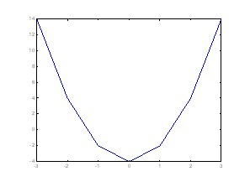

>>x=[0 1 2 3 4 5];
>>y1=[2.3 -0.3 4.5 6.34 1.05 2.09];
>>y2=[0.55 0.98 1.39 2.43 1.08 0.97];
>>plot(x,y1,'o',x,y2,'*');

>>x=[0 1 2 3 4 5];
>>y1=[2.3 -0.3 4.5 6.34 1.05 2.09];
>>y2=[0.55 0.98 1.39 2.43 1.08 0.97];
>>plot(x,y1,'--o',x,y2,'--*');

>>x=[3,2,1,0,-1,-2,-3];
>>y=[2.9,1.9,0.9,-0.1,-1.1,-2.1,-3.1];
>>z=[14,4,-2,-4,-2,4,14];
>>plot3(x,y,z)
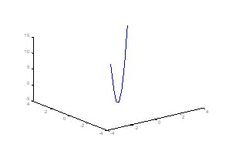
>>x = 0:0.1:2*pi; % x=0, 0.1, 0.2, 0.3, 0.4, …, 2π
>>y1 = sin(x);
>>y2 = exp(-x);
>>plot(x, y1, '--*', x, y2, ':o');
>>xlabel('t = 0 to 2\pi');
>>ylabel('values of sin(t) and e^{-x}')
>>title('Function Plots of sin(t) and e^{-x}');
>>legend('sin(t)','e^{-x}');
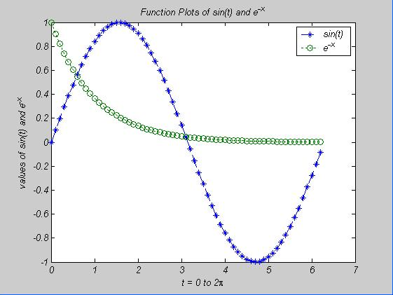

>>x = 0:0.1:2*pi;
>>plot(x, sin(x), x, cos(x));
>>text(pi/4, sin(pi/4),'\leftarrow sin(\pi/4) = 0.707');
>>text(5*pi/4,cos(5*pi/4),'cos(5\pi/4)=-0.707\rightarrow','HorizontalAlignment', 'right');
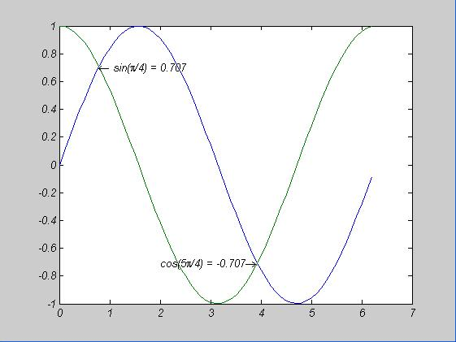

>>x = linspace(0, 2*pi); % 在0到2π間，等分100個點
>>plot(x, sin(x), 'o', x, cos(x), 'x', x, sin(x)+cos(x), '*');
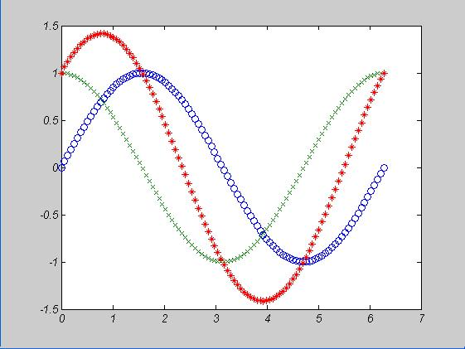

>>x = 0:0.1:4*pi; % x=0, 0.1, 0.2, 0.3, 0.4, …, 4π
>>subplot(2, 2, 1); plot(x, sin(x)); % left-upper
>>subplot(2, 2, 2); plot(x, cos(x)); % right-upper
>>subplot(2, 2, 3); plot(x, sin(x).*exp(-x/5)); % left-down
>>subplot(2, 2, 4); plot(x, x.^2); % right-down
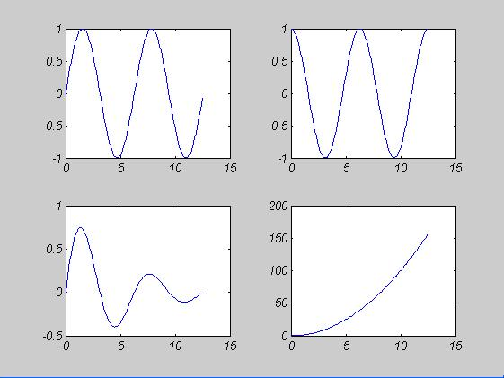

>>x=linspace(0, 2*pi); % 在0到2π間，等分100個點
>>y1=sin(x);
>>y2=exp(-x);
>>plotyy(x, y1, x, y2); % 畫出兩個刻度不同的y軸，分別是y1, y2
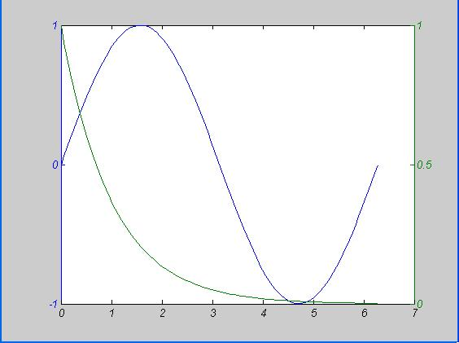

>>theta=linspace(0, 2*pi);
>>r=cos(4*theta);
>>polar(theta,r);
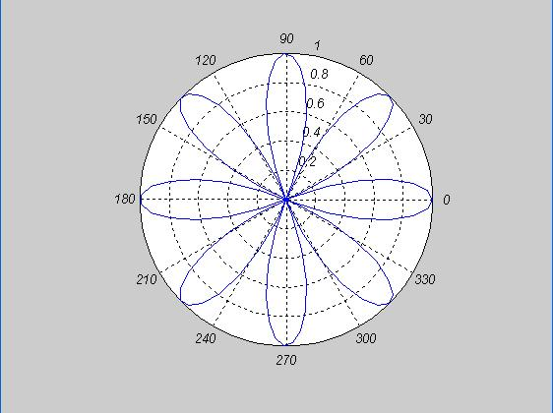
In Matlab language, we can use the following instructions to draw the surfaces of x’s, y’s, and z’s.

>>x=linspace(-2, 2, 25);
y=linspace(-2, 2, 25);
[xx,yy]=meshgrid(x, y);
zz=xx.*exp(-xx.^2-yy.^2); % z=xexp(-x²-y²)
mesh(xx, yy, zz) % draw z=xexp(-x²-y²)
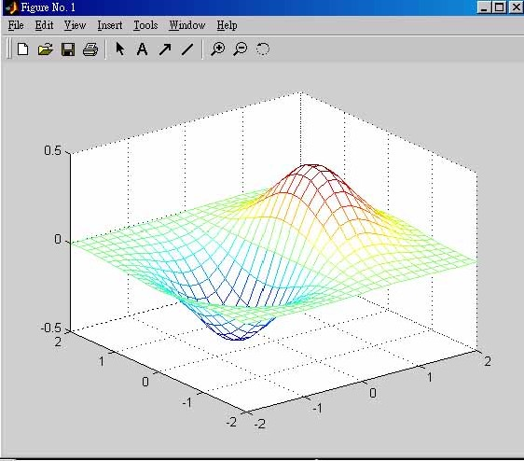
>>surf(xx, yy, zz)
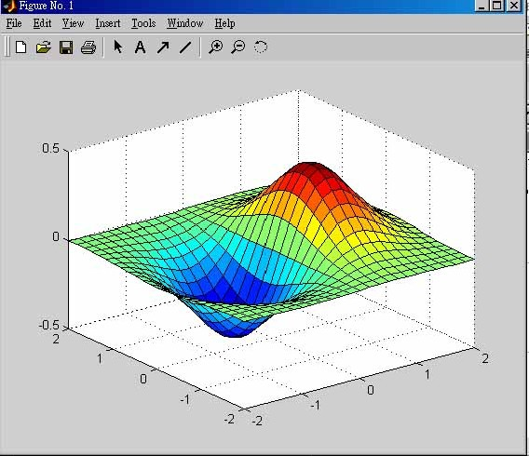
>>contour(xx, yy, zz)
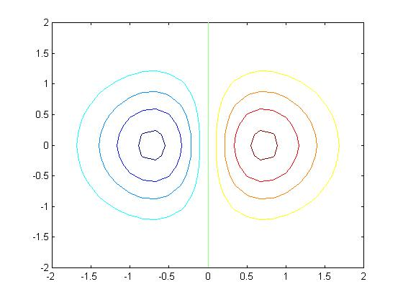
>>x=[1,2,3,4; 1,2,3,4; 1,2,3,4; 1,2,3,4; 1,2,3,4;];
y=[1,1,1,1;2,2,2,2;3,3,3,3;4,4,4,4;5,5,5,5];
z=[0,2,1.5,1; 3,5,6,4; 5,6.5,8,5; 2,3,5,3; 0,1,1,0];
mesh(x,y,z)
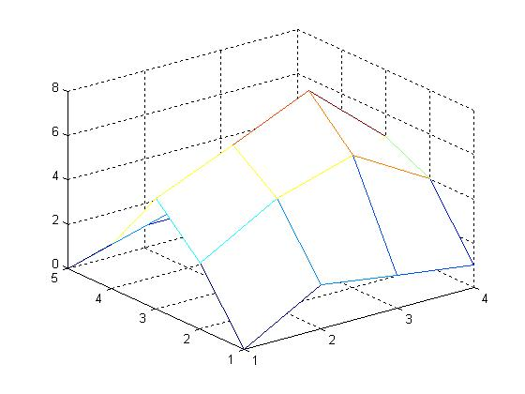

>>z=[0,2,1.5,1; 3,5,6,4; 5,6.5,8,5; 2,3,5,3; 0,1,1,0];
mesh(z);
xlabel('X axis= column index');
ylabel('Y axis= row index');
for i=1:size(z,1)
for j=1:size(z,2)
h=text(j, i, z(i,j)));
end
end
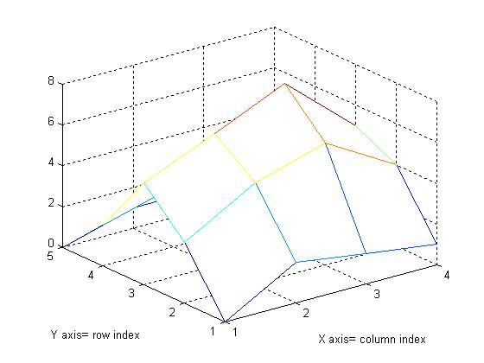
Eg. A MATLAB function of drawing 3D/2D profiles (by Dr. W.- Y. Wu吳維揚博士)
Source program:
%read a file and plot
function draw(F,N)
fid=fopen(F,'r');
A=fscanf(fid,'%e',[N,inf]);
A=A.';
M=size(A,1);
if N==2
plot(A(:,1),A(:,2));
elseif N==3
count=0;
for l=1:M
if A(1)==A(l)
count=count+1;
else
break;
end
end
X=zeros(count,M/count); Y=X; Z=X;
for t=1:M
X(t)=A(t,1);
Y(t)=A(t,2);
Z(t)=A(t,3);
end
figure
mesh(X,Y,Z);
figure
plot3(X,Y,Z);
figure
contour(X,Y,Z);
figure
contour3(X,Y,Z);
else
disp('error input');
end
fclose(fid);
Usages:
1. draw (‘c:\directory\3Dfilename’,3)
2. draw (‘c:\directory\2Dfilename’,2)
>>draw ('D:\matlab\bin\fort.11',3)

>>draw ('D:\matlab\bin\fort.12',2)
Eg. A modified MATLAB function of drawing 3D profiles from distinct view angles (by Dr. G. -D. Chang張高德博士)
Source program:
function drawc(F,N,angle1,angle2)
fid=fopen(F,'r');
A=fscanf(fid,'%e',[N,inf]);
A=A.';
M=size(A,1);
if N==2
plot(A(:,1),A(:,2));
elseif N==3
count=0;
for l=1:M
if A(1)==A(l)
count=count+1;
else
break;
end
end
X=zeros(count,M/count); Y=X; Z=X;
for t=1:M
X(t)=A(t,1);
Y(t)=A(t,2);
Z(t)=A(t,3);
end
figure
mesh(X,Y,Z);
view([angle1,angle2]);
figure
plot3(X,Y,Z);
view([angle1,angle2]);
figure
contour(X,Y,Z);
view([angle1,angle2]);
figure
contour3(X,Y,Z);
view([angle1,angle2]);
else
disp('error input');
end
fclose(fid);
Usage: drawc (‘c:\directory\3Dfilename’,3,angle1,angle2)
>>drawc ('D:\matlab\bin\fort.11',3,30,50)
>>drawc ('D:\matlab\bin\fort.11',3,10,40)
Eg. A MATLAB function of drawing distinct 2D curves (by Dr. G. -D. Chang)
Source program:
function draw2D(F,N)
fid=fopen(F,'r');
A=fscanf(fid,'%e',[N,inf]);
fclose(fid);

%clear;
%N=14;
%A=rand(N,100);
A=A.';
ik=1;
for id=1:2:N
Ax(:,ik)=A(:,id);
Ay(:,ik)=A(:,id+1);
ik=ik+1;
end
h1=plot(Ax,Ay);
set(h1,'linewidth',2);

Usage: draw2D (‘c:\directory\filename having n 2D curves’, 2n)
>>draw2D ('D:\matlab\bin\fort.13',4)
3-6 Image Processing by Matlab Language
Matlab指令名稱：
imread 讀取影像
imshow 顯示影像
imwrite 儲存影像
ginput 滑鼠圖像輸入
round 四捨五入
floor 無條件捨去
ceil 無條件進位
rgb2gray 轉成灰階
eval 執行字串
aviread 讀取AVI檔
aviinfo 讀取AVI訊息
histeq 平均分布
mean 平均值
Eg. Reconstruction of 3D trajectory of flying baseball by two digital video cameras-Version 1. Assume the pixels of the video screen are 480×720. (by B. -H. Chen, 陳柏皓)
(Sol.) clear all;
rgb1=imread('1\1.jpg'); rgb2=imread('1\2.jpg'); rgb3=imread('1\3.jpg');
rgb4=imread('1\4.jpg'); rgb5=imread('1\5.jpg'); rgb6=imread('1\6.jpg');
rgbup=uint8(abs(double(rgb6)-double(rgb5))+abs(double(rgb5)-double(rgb4))+abs(double(rgb4)-double(rgb3))+abs(double(rgb3)-double(rgb2))+abs(double(rgb2)-double(rgb1)));
rgb1=imread('2\1.jpg'); rgb2=imread('2\2.jpg'); rgb3=imread('2\3.jpg');
rgb4=imread('2\4.jpg'); rgb5=imread('2\5.jpg'); rgb6=imread('2\6.jpg');
rgb7=imread('2\7.jpg'); rgb8=imread('2\8.jpg'); rgb9=imread('2\9.jpg');
rgbleft=uint8(abs(double(rgb9)-double(rgb8))+abs(double(rgb8)-double(rgb7))+abs(double(rgb7)-double(rgb6))+abs(double(rgb6)-double(rgb5))+abs(double(rgb5)-double(rgb4))+abs(double(rgb4)-double(rgb3))+abs(double(rgb3)-double(rgb2))+abs(double(rgb2)-double(rgb1)));
n1=1; n2=1; n3=1; x1(1)=0; y1(1)=0; x2(1)=0; y2(1)=0;
for j=1:720,
k1=0; k2=0; sum1=0; sum2=0;
for i=1:480,
if rgbup(i,j,1)>=80 & rgbup(i,j,2)>=80 & rgbup(i,j,3)>=80,
sum1=sum1+(481-i); k1=k1+1;
end
if rgbleft(i,j,1)>=80 & rgbleft(i,j,2)>=80 & rgbleft(i,j,3)>=80,
sum2=sum2+(481-i); k2=k2+1;
end
if k1~=0 && sum1~=0 && i==480,
x1(n1)=sum1/k1; y1(n1)=j; n1=n1+1;
end
if k2~=0 && sum2~=0 && i==480,
x2(n2)=sum2/k2; y2(n2)=j; n2=n2+1;
end
if k1~=0 && sum1~=0 && k2~=0 && sum2~=0 && i==480,
x(n3)=j; y(n3)=x1(n1-1); z(n3)=x2(n2-1); n3=n3+1;
end
end
end

subplot(3,2,1); image(rgbup);
subplot(3,2,2); image(rgbleft);
subplot(3,2,3); plot(y1,x1); axis([0,720,0,480]);
subplot(3,2,4); plot(y2,x2); axis([0,720,0,480]);
subplot(3,2,5); plot(480-y,z); axis([0,480,0,480]);
subplot(3,2,6); plot3(x,y,z); axis([0,720,0,480,0,480]);
Results:
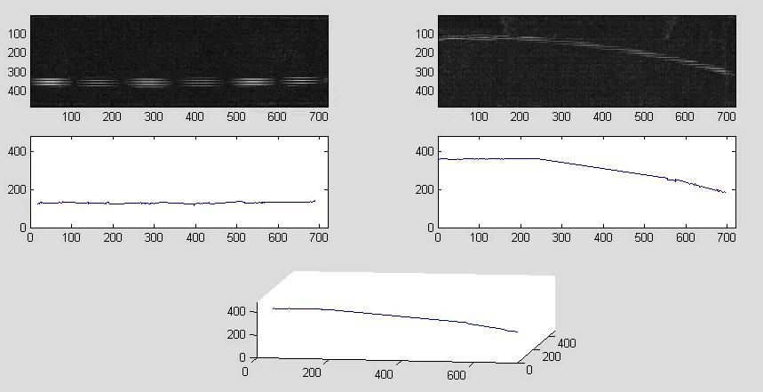

Modified results (The range of judging strike is depicted):
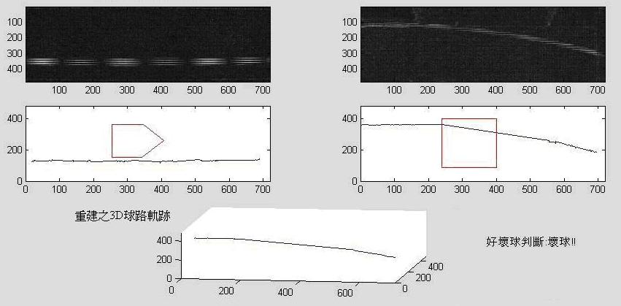
∴The flying ball is not a strike. It is a ball!

Matlab 支援原始的AVI檔案
安裝DVSD codec可讓Matlab支援DVSD格式的AVI.
Eg. Reconstructions of 3D trajectory of pitched baseball by two digital video cameras-Version 2. (AutoReadVideo.m by B. -H. Chen)
(Sol.)
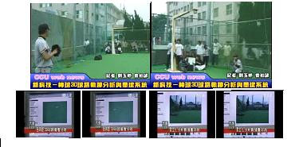
(2005-5-4)
clc;
clear all;
close all;
%------------filter setting---------------
%blim=[70,70]; % Range:0~255
read_type='v'; % v -> video or p -> picture
filtercontrol=[9,9];% 0,1,3
filterline=[1,300];
afilterline=[1,1];
%inferi=[1,1];
%inferf=[2,3];
sample=[0.7,0.7326];
contrast_select=[9,9]; % 0 -> Increase the contrast , others -> close this function (only picture type)
predict_num=10; % predict number , predict the in/out trajectory
distance=[300,300];
%-------------------------------
%Find the picture number
if read_type=='p',
filetype='jpg';
filetarget={'1\','2\'};
path1=dir(char(filetarget(1)));
path2=dir(char(filetarget(2)));
files_count=[0 0];
for j=1:2,
for i=1:length(eval(['path' int2str(j)])),
if findstr(getfield(eval(['path' int2str(j) '(i)']),'name'),filetype),
files_count(j)=files_count(j)+1;
end
end
end
filenumber=files_count;
end
%--------------------------------
for timec=1:2,
% Control filter:控制讀取範圍
clear find;
if filtercontrol(timec)==0,
i0=1;
i1=(481-filterline(timec));
elseif filtercontrol(timec)==1,
i0=(481-filterline(timec));
i1=480;
elseif filtercontrol(timec)==3,
i0=(481-afilterline(timec));
i1=(481-filterline(timec));
else
i0=1;
i1=480;
end
im_cal=0;im_past=0;
if read_type=='v',
% get Up or left/right:利用色差
f_string=sprintf('%d.avi',timec);
VideoInfo = aviinfo(f_string);
I_frame_stop=VideoInfo.NumFrames;
for ix=1:1:I_frame_stop
Video=aviread(f_string,ix);
if ix>1,
im_cal=im_cal+abs(double(Video.cdata)-double(im_past));
im_past=Video.cdata;
else
im_past=Video.cdata;
end
end
else
for i=1:filenumber(timec),
rgb(:,:,:,i)=imread([filetarget{timec} int2str(i) '.' filetype]);
if contrast_select(timec)==0,
rgb(:,:,1,i)=histeq(rgb(:,:,1,i));%histeq() 強化對比
rgb(:,:,2,i)=histeq(rgb(:,:,2,i));
rgb(:,:,3,i)=histeq(rgb(:,:,3,i));
end
if i>=2,
im_cal=im_cal+abs(double(rgb(:,:,:,i))-double(rgb(:,:,:,i-1)));
end
end
end
eval(sprintf('rgbo%d=uint8(im_cal);',timec));
%轉成灰階
im=rgb2gray(eval(sprintf('rgbo%d',timec)));
%im=mean(eval(sprintf('rgbo%d',timec)),3)
%im=rgb2ycbcr(eval(sprintf('rgbo%d',timec)));
im=im(:,:,1);
blim=uint8(double(max(max(im)))*sample(timec));
n=1;lk=0;y=0;x=0;o=1;t=2;lnc=0;
%取得有色差位置
for j=1:720,
k=0;
sum=0;
for i=i0:i1,
if im(i,j)>blim,
sum=sum+(481-i);
k=k+1;
end
if k~=0 && sum~=0 && i==i1,
if lk==0,
lk=k;
elseif k>lk && o==1 ,
o=0;
no=n;
elseif k<lk && o==0 ,
o=1;
nc=no+n;
if mod(nc,2)~=0,
nc=nc-1;
end
nc=nc/2;
if nc~=lnc,
find(1,t)=y(nc);
find(2,t)=x(nc);
t=t+1;
fprintf('x=%.0f y=%.0f\n',y(nc),x(nc));
end
lnc=nc;
end
x(n)=sum/k;
y(n)=j;
n=n+1;
lk=k;
end
end
end
find(1,1)=1;
%前端點預測
temp=(find(2,3:(3+predict_num))-find(2,2:(2+predict_num)))./(find(1,3:(3+predict_num))-find(1,2:(2+predict_num)));
find(2,1)=find(2,2)-mean(temp)*(find(1,2)-find(1,1));
%find(2,1)=find(2,1+inferi(timec))-(find(2,2+inferi(timec))-find(2,1+inferi(timec)))/(find(1,2+inferi(timec))-find(1,1+inferi(timec)))*(find(1,1+inferi(timec))-find(1,1));
if find(2,t-1)<=480,
find(1,t)=720;
%後端點預測
temp=(find(2,(t-predict_num):(t-1))-find(2,(t-predict_num-1):(t-2)))./(find(1,(t-predict_num):(t-1))-find(1,(t-predict_num-1):(t-2)));
find(2,t)=find(2,t-1)+mean(temp)*(find(1,t)-find(1,t-1));
%find(2,t)=find(2,t-inferf(timec))+(find(2,t-inferf(timec))-find(2,t-inferf(timec)-1))/(find(1,t-inferf(timec))-find(1,t-inferf(timec)-1))*(find(1,t)-find(1,t-inferf(timec)));
end
eval(sprintf('apic%d=find;',timec));
end
%比較兩張影像最大數值
t=1;
tc1=1;
tc2=1;
if max(apic1(1,:))<max(apic2(1,:)),
comp=max(apic1(1,:));
else
comp=max(apic2(1,:));
end
%重建影像
for i=1:comp;
if i==1,
d3(1,i)=i;d3(2,i)=apic1(2,1);d3(3,i)=apic2(2,1);
elseif i==max(apic1(1,:)) && max(apic1(1,:))~=720,
d3(1,i)=i;d3(2,i)=max(apic1(2,:));d3(3,i)=d3(3,i-1);
elseif i==720,
d3(1,i)=i;d3(2,i)=apic1(2,length(apic1));d3(3,i)=apic2(2,length(apic2));
else
d3(1,i)=i;
while i~=0,
if i>=apic1(1,tc1) && i<apic1(1,tc1+1),
break;
else
tc1=tc1+1;
end
end
A=apic1(1,tc1+1)-apic1(1,tc1);
B=apic1(2,tc1+1)-apic1(2,tc1);
if A==0,
d3(2,i)=apic1(2,tc1);
else
d3(2,i)=B/A*(i-apic1(1,tc1))+apic1(2,tc1);
end
while i~=0,
if i>=apic2(1,tc2) && i<apic2(1,tc2+1),
break;
else
tc2=tc2+1;
end
end
A=apic2(1,tc2+1)-apic2(1,tc2);
B=apic2(2,tc2+1)-apic2(2,tc2);
if A==0,
d3(3,i)=apic2(2,tc2);
else
d3(3,i)=B/A*(i-apic2(1,tc2))+apic2(2,tc2);
end
end
end
%繪圖
figure(1);
subplot(2,2,1); image(rgbo1); subplot(2,2,2); image(rgbo2);
subplot(2,2,3); plot(apic1(1,:),apic1(2,:)); axis([0, 720,0,480]);
subplot(2,2,4); plot(apic2(1,:),apic2(2,:)); axis([0, 720,0,480]);
figure(2);
plot3(d3(1,:),d3(2,:),d3(3,:),'o');
grid;
view(8,30);
axis([0, 720,0, 720,0,480]);
%hgsave(figure(1),'fig1');
%hgsave(figure(2),'fig2');
%figure,image(rgbo1);
%figure,
%plot(apic1(1,:),apic1(2,:));
%axis([0, 720,0,480]);
%figure,image(rgbo2);
%figure,
%plot(apic2(1,:),apic2(2,:));
%axis([0, 720,0,480]);

2005-5-4 Experimental Results: (當時攝影方式為球路從右至左飛行)
文化大學棒球隊投手林永坤：
直球：進壘位置偏中，球路直 滑球：進壘時略往外角轉彎
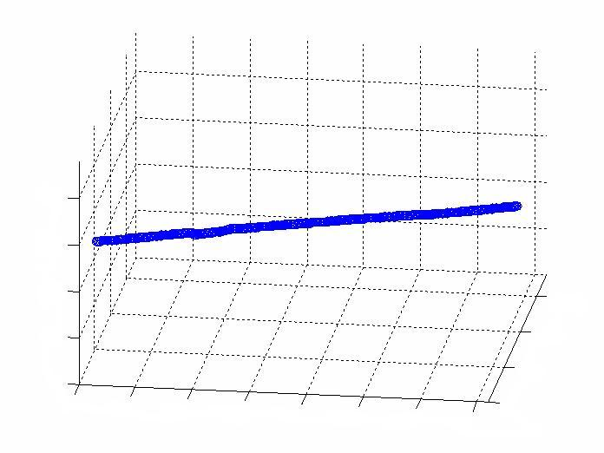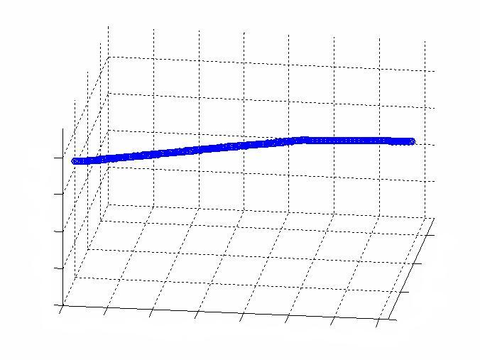

文化大學棒球隊投手黃義哲(2005年世界盃國手)：
直球：進壘位置偏高但略有尾勁 滑球：進壘位置較低，球路明顯往外角偏移
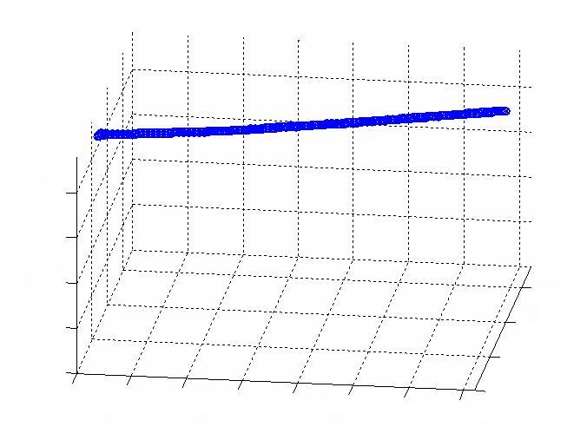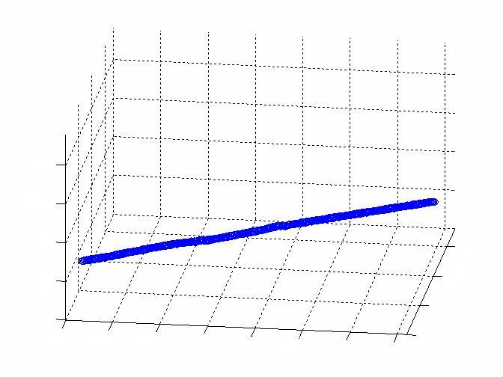

Eg. Reconstruction of 3D trajectory of flying baseball by two digital video cameras-Version 3. (AutoReadVideo1.m by B. -H. Chen)
(Sol.)
clc;
clear all;
close all;
warning off MATLAB:mir_warning_variable_used_as_function
%----------------------------------------------------------------
sample=[0.5,0.5];
predict_num=4; % predict number , predict the in/out trajectory
distance=[300,300];
%----------------------------------------------------------------
for timec=1:2,
clear find;
im_cal=0;im_past=0;
% get Up or left/right:利用色差
f_string=sprintf('%d.avi',timec);
fprintf('\nVideo %d \n',timec);
VideoInfo = aviinfo(f_string);
I_frame_stop=VideoInfo.NumFrames;
I_Width=VideoInfo.Width;
I_Height=VideoInfo.Height;
for ix=1:1:I_frame_stop
Video=aviread(f_string,ix);
if ix>1,
im_diff=abs(double(Video.cdata)-double(im_past));
if max(max(max(im_diff)))<20,
continue;
end
im_cal=im_cal+im_diff;
im_past=Video.cdata;
else
im_past=Video.cdata;
end
end
eval(sprintf('rgbo%d=uint8(im_cal);',timec));
% 轉成灰階
im=rgb2gray(eval(sprintf('rgbo%d',timec)));
im=im(:,:,1);
blim=uint8(double(max(max(im)))*sample(timec));
n=1;lk=0;y=0;x=0;o=1;t=2;lnc=0;
%取得有色差位置
for j=1:I_Width,
k=0;
sum=0;
for i=1:I_Height,
if double(im(i,j))>double(blim),
sum=sum+(I_Height+1-i);
k=k+1;
end
if k~=0 && sum~=0 && i==I_Height,
if lk==0,
lk=k;
elseif k>lk && o==1 ,
o=0;
no=n;
elseif k<lk && o==0 ,
o=1;
nc=no+n;
if mod(nc,2)~=0,
nc=nc-1;
end
nc=nc/2;
if nc~=lnc,
find(1,t)=y(nc);
find(2,t)=x(nc);
t=t+1;
fprintf('x=%.0f y=%.0f\n',y(nc),x(nc));
end
lnc=nc;
end
x(n)=sum/k;
y(n)=j;
n=n+1;
lk=k;
end
end
end
find(1,1)=1;
%前端點預測
temp=(find(2,3:(3+predict_num))-find(2,2:(2+predict_num)))./(find(1,3:(3+predict_num))-find(1,2:(2+predict_num)));
find(2,1)=find(2,2)-mean(temp)*(find(1,2)-find(1,1));
%find(2,1)=find(2,1+inferi(timec))-(find(2,2+inferi(timec))-find(2,1+inferi(timec)))/(find(1,2+inferi(timec))-find(1,1+inferi(timec)))*(find(1,1+inferi(timec))-find(1,1));
if find(2,t-1)<=I_Height,
find(1,t)=I_Width;
%後端點預測
temp=(find(2,(t-predict_num):(t-1))-find(2,(t-predict_num-1):(t-2)))./(find(1,(t-predict_num):(t-1))-find(1,(t-predict_num-1):(t-2)));
find(2,t)=find(2,t-1)+mean(temp)*(find(1,t)-find(1,t-1));
%find(2,t)=find(2,t-inferf(timec))+(find(2,t-inferf(timec))-find(2,t-inferf(timec)-1))/(find(1,t-inferf(timec))-find(1,t-inferf(timec)-1))*(find(1,t)-find(1,t-inferf(timec)));
end
eval(sprintf('apic%d=find;',timec));
end
%比較兩張影像最大數值
t=1;
tc1=1;
tc2=1;
if max(apic1(1,:))<max(apic2(1,:)),
comp=max(apic1(1,:));
else
comp=max(apic2(1,:));
end
%重建影像
for i=1:comp;
if i==1,
d3(1,i)=i;d3(2,i)=apic1(2,1);d3(3,i)=apic2(2,1);
elseif i==max(apic1(1,:)) && max(apic1(1,:))~=720,
d3(1,i)=i;d3(2,i)=max(apic1(2,:));d3(3,i)=d3(3,i-1);
elseif i==720,
d3(1,i)=i;d3(2,i)=apic1(2,length(apic1));d3(3,i)=apic2(2,length(apic2));
else
d3(1,i)=i;
while i~=0,
if i>=apic1(1,tc1) && i<apic1(1,tc1+1),
break;
else
tc1=tc1+1;
end
end
A=apic1(1,tc1+1)-apic1(1,tc1);
B=apic1(2,tc1+1)-apic1(2,tc1);
if A==0,
d3(2,i)=apic1(2,tc1);
else
d3(2,i)=B/A*(i-apic1(1,tc1))+apic1(2,tc1);
end
while i~=0,
if i>=apic2(1,tc2) && i<apic2(1,tc2+1),
break;
else
tc2=tc2+1;
end
end
A=apic2(1,tc2+1)-apic2(1,tc2);
B=apic2(2,tc2+1)-apic2(2,tc2);
if A==0,
d3(3,i)=apic2(2,tc2);
else
d3(3,i)=B/A*(i-apic2(1,tc2))+apic2(2,tc2);
end
end
end
%繪圖
figure(1);
subplot(2,2,1);
image(rgbo1);
subplot(2,2,2);
image(rgbo2);
subplot(2,2,3);
plot(apic1(1,:),apic1(2,:));
axis([0, I_Width,0,I_Height]);
subplot(2,2,4);
plot(apic2(1,:),apic2(2,:));
axis([0, I_Width,0,I_Height]);
figure(2);
plot3(d3(1,:),d3(2,:),d3(3,:),'o');
grid;
view(8,30);
axis([0, I_Width,0, I_Width,0,I_Height]);
%hgsave(figure(1),'fig1');
%hgsave(figure(2),'fig2');
%figure,image(rgbo1);
%figure,
%plot(apic1(1,:),apic1(2,:));
%axis([0, 720,0,480]);
%figure,image(rgbo2);
%figure,
%plot(apic2(1,:),apic2(2,:));
%axis([0, 720,0,480]);

2007-12-26 Experimental Results: (當時攝影方式為球路從左至右飛行)
文化大學棒球隊投手曾琮萱：測試當天除了指叉球會下墜以外，其餘球路都差不多近似直球，表示他對大部份變化球的球路控制不佳

直球 指叉球
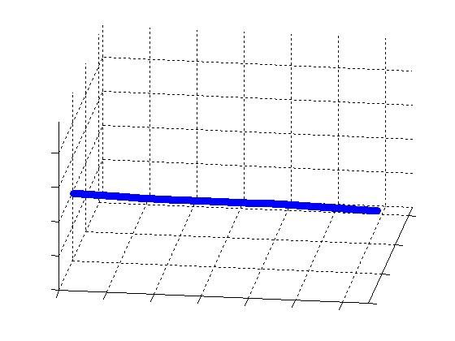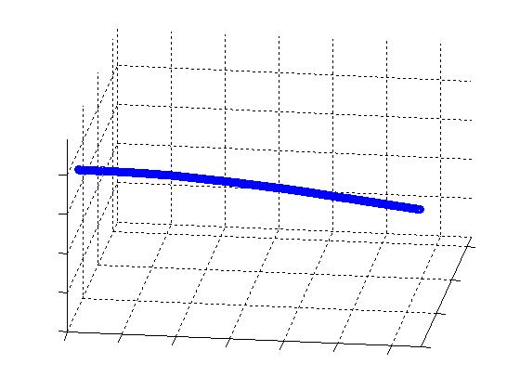 滑球 變速球
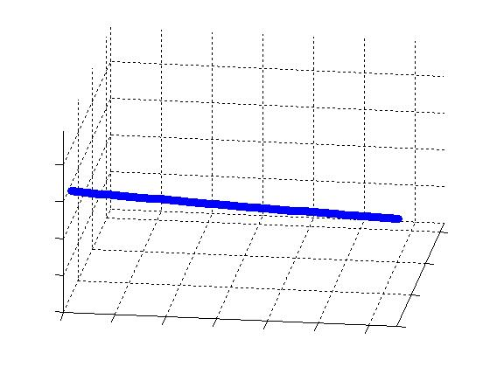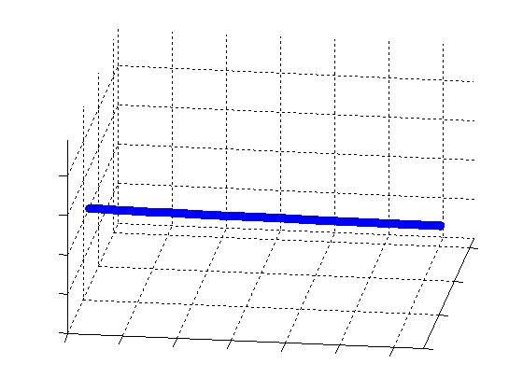

文化大學棒球隊投手廖文楊：測試當天第一個(左)滑球之球路會往右打者外角轉彎，第二個(右)則類似直球無變化，表示他對滑球的球路控制尚不穩定。而其曲球軌跡則類似滑球
滑球一 滑球二
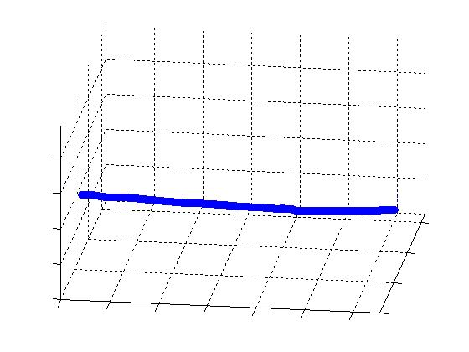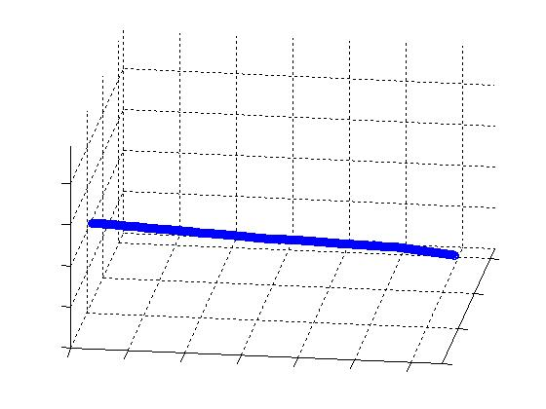
直球 曲球
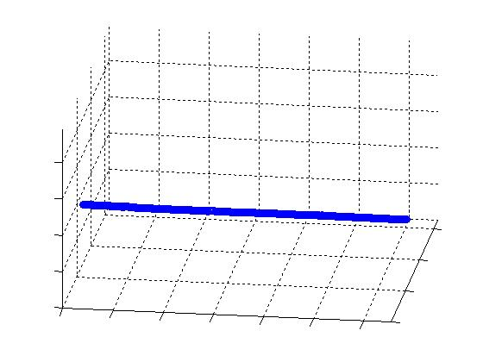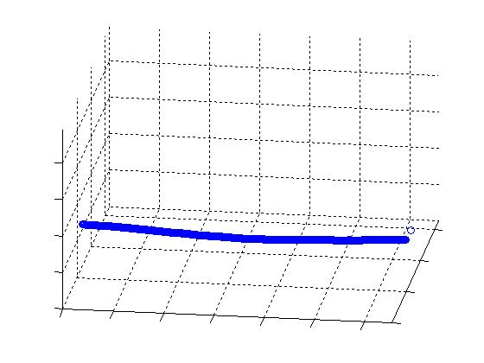
文化大學棒球隊投手王溢正：直球會往右打者外角轉彎，類似滑球，有尾勁
直球
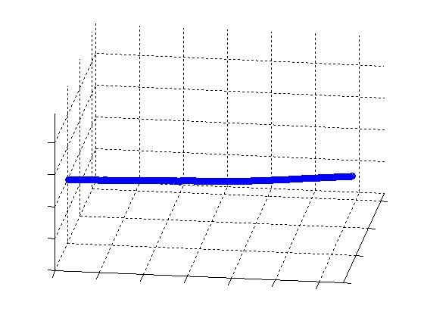

文化大學棒球隊投手許文錚：測試當天第一個(左)變速球之球路類似直球無太多變化，第二個(右)則會下墜，表示他對變速球的球路控制尚不穩定。而其指叉球軌跡則類似直球無變化

變速球一 變速球二
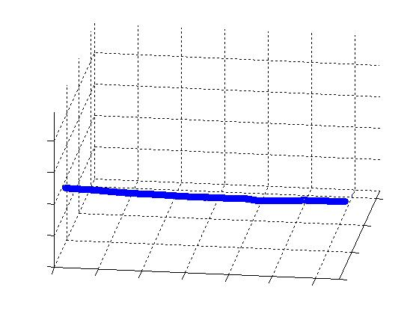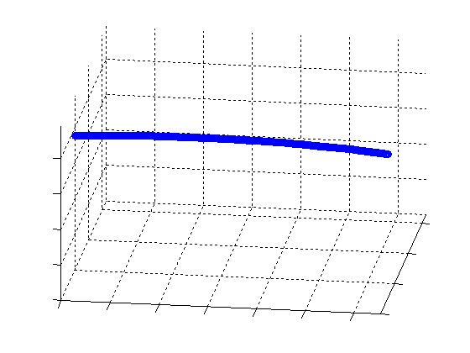
指叉球
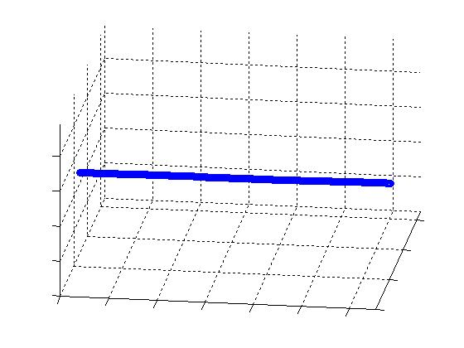
Eg. 利用滑鼠點選而取得座標的範例，可用來改寫成判斷好壞球區之範圍
% Example: Graphical input from mouse.
clear all;
im=imread('DingDangFly','jpg');
imshow(im);
while 1,
[x,y,button]=ginput(1);
if button~=1, break;
end
fprintf('\nx=%d y=%d %d',round(x),round(y));
end
close all;

Experiment 1: Download GraphIn.m and DingDangFly.jpg
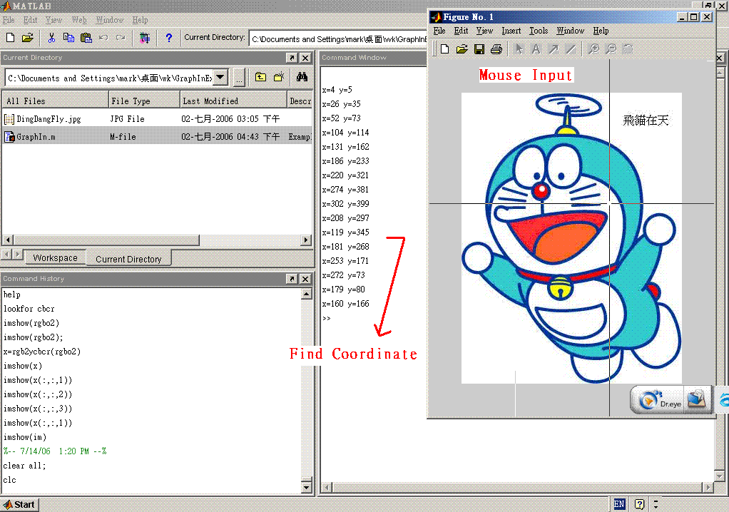
Eg. Reconstruction of 3D trajectory of flying baseball by two digital video cameras-Version 4. (AutoReadVideo3.m by黃建維)
clc;
clear all;
close all;
warning off MATLAB:mir_warning_variable_used_as_function
%----------------------------------------------------------------
sample=[0.5,0.5];
predict_num=4; % predict number , predict the in/out trajectory
distance=[300,300];
%----------------------------------------------------------------
for timec=1:2,
clear find;
im_cal=0;im_past=0;
% get Up or left/right:利用色差
f_string=sprintf('%d.avi',timec);
fprintf('\nVideo %d \n',timec);
VideoInfo = aviinfo(f_string);
I_frame_stop=VideoInfo.NumFrames;
I_Width=VideoInfo.Width;
I_Height=VideoInfo.Height;
for ix=1:1:I_frame_stop
Video=aviread(f_string,ix);
if ix>1,
im_diff=abs(double(Video.cdata)-double(im_past));
if max(max(max(im_diff)))<20,
continue;
end
im_cal=im_cal+im_diff;
im_past=Video.cdata;
else
im_past=Video.cdata;
end
end
eval(sprintf('rgbo%d=uint8(im_cal);',timec));
% 轉成灰階
im=rgb2gray(eval(sprintf('rgbo%d',timec)));
im=im(:,:,1);
blim=uint8(double(max(max(im)))*sample(timec));
n=1;lk=0;y=0;x=0;o=1;t=2;lnc=0;
%取得有色差位置
for j=1:I_Width,
k=0;
sum=0;
for i=1:I_Height,
if double(im(i,j))>double(blim),
sum=sum+(I_Height+1-i);
k=k+1;
end
if k~=0 && sum~=0 && i==I_Height,
if lk==0,
lk=k;
elseif k>lk && o==1 ,
o=0;
no=n;
elseif k<lk && o==0 ,
o=1;
nc=no+n;
if mod(nc,2)~=0,
nc=nc-1;
end
nc=nc/2;
if nc~=lnc,
find(1,t)=y(nc);
find(2,t)=x(nc);
t=t+1;
%fprintf('x=%.0f y=%.0f\n',y(nc),x(nc));
end
lnc=nc;
end
x(n)=sum/k;
y(n)=j;
n=n+1;
lk=k;
end
end
end
find(1,1)=1;
%前端點預測
temp=(find(2,3:(3+predict_num))-find(2,2:(2+predict_num)))./(find(1,3:(3+predict_num))-find(1,2:(2+predict_num)));
find(2,1)=find(2,2)-mean(temp)*(find(1,2)-find(1,1));
%find(2,1)=find(2,1+inferi(timec))-(find(2,2+inferi(timec))-find(2,1+inferi(timec)))/(find(1,2+inferi(timec))-find(1,1+inferi(timec)))*(find(1,1+inferi(timec))-find(1,1));
if find(2,t-1)<=I_Height,
find(1,t)=I_Width;
%後端點預測
temp=(find(2,(t-predict_num):(t-1))-find(2,(t-predict_num-1):(t-2)))./(find(1,(t-predict_num):(t-1))-find(1,(t-predict_num-1):(t-2)));
find(2,t)=find(2,t-1)+mean(temp)*(find(1,t)-find(1,t-1));
%find(2,t)=find(2,t-inferf(timec))+(find(2,t-inferf(timec))-find(2,t-inferf(timec)-1))/(find(1,t-inferf(timec))-find(1,t-inferf(timec)-1))*(find(1,t)-find(1,t-inferf(timec)));
end
eval(sprintf('apic%d=find;',timec));
end
%比較兩張影像最大數值
t=1;
tc1=1;
tc2=1;
if max(apic1(1,:))<max(apic2(1,:)),
comp=max(apic1(1,:));
else
comp=max(apic2(1,:));
end
%重建影像
for i=1:comp;
if i==1,
d3(1,i)=i;d3(2,i)=apic1(2,1);d3(3,i)=apic2(2,1);
elseif i==max(apic1(1,:)) && max(apic1(1,:))~=720,
d3(1,i)=i;d3(2,i)=max(apic1(2,:));d3(3,i)=d3(3,i-1);
elseif i==720,
d3(1,i)=i;d3(2,i)=apic1(2,length(apic1));d3(3,i)=apic2(2,length(apic2));
else
d3(1,i)=i;
while i~=0,
if i>=apic1(1,tc1) && i<apic1(1,tc1+1),
break;
else
tc1=tc1+1;
end
end
A=apic1(1,tc1+1)-apic1(1,tc1);
B=apic1(2,tc1+1)-apic1(2,tc1);
if A==0,
d3(2,i)=apic1(2,tc1);
else
d3(2,i)=B/A*(i-apic1(1,tc1))+apic1(2,tc1);
end
while i~=0,
if i>=apic2(1,tc2) && i<apic2(1,tc2+1),
break;
else
tc2=tc2+1;
end
end
A=apic2(1,tc2+1)-apic2(1,tc2);
B=apic2(2,tc2+1)-apic2(2,tc2);
if A==0,
d3(3,i)=apic2(2,tc2);
else
d3(3,i)=B/A*(i-apic2(1,tc2))+apic2(2,tc2);
end
end
end

%繪圖
figure(1);
subplot(2,2,1);
image(rgbo1);
set( gca, 'XTick', [], 'YTick', [] );
subplot(2,2,2);
image(rgbo2);
set( gca, 'XTick', [], 'YTick', [] );
subplot(2,2,3);
plot(apic1(1,:),apic1(2,:));
axis([0, I_Width,0,I_Height]);
set( gca, 'XTick', [], 'YTick', [] );
subplot(2,2,4);
plot(apic2(1,:),apic2(2,:));
axis([0, I_Width,0,I_Height]);
set( gca, 'XTick', [], 'YTick', [] );
%--------------------------------------------------------------------
figure(2);
plot(apic1(1,:),apic1(2,:),'-');
axis([0, I_Width,0,I_Height]);
set( gca, 'XTick', [], 'YTick', [] );
hold on;
sum=0;
while sum<1
sum=sum+1;
[x,y,button]=ginput(4);
if button~=1, break;
end
fprintf('\nx=%d x=%d x=%d x=%d y=%d y=%d y=%d y=%d \n',round(x),round(y));
end
p3=round(x);
p4=round(y);
xll=(p3(1,1)+p3(2,1))/2;
xrr=(p3(3,1)+p3(4,1))/2;
yuu=(p4(1,1)+p4(4,1))/2;
yff=(p4(2,1)+p4(3,1))/2;
XDD=xll:1:xrr;
xboxx=round(xrr-xll);
yxdd=interp1(apic1(1,:),apic1(2,:),XDD);
yggg=yxdd(1,1);
yccc=yxdd(1,xboxx);
if yggg>=yff&&yggg<=yuu&&yccc>=yff&&yccc<=yuu
title(('""""""""""""""""""""""""passing the region"""""""""""""""""""""""""'))
else
title(('""""""""""""""""""""not passing the region """"""""""""""""""""""""""""'))
end
%fill(p3,p4,'y')
p33=[xll xll xrr xrr];
p44=[yuu yff yff yuu];
fill(p33,p44,'y')
%---------------------------------------------------------------------
%--------------------------------------------------------------------
figure(3);
plot(apic2(1,:),apic2(2,:),'-');
axis([0, I_Width,0,I_Height]);
set( gca, 'XTick', [], 'YTick', [] );
hold on;
sum=0;
while sum<1
sum=sum+1;
[x,y,button]=ginput(4);
if button~=1, break;
end
fprintf('\nx=%d x=%d x=%d x=%d y=%d y=%d y=%d y=%d \n',round(x),round(y));
end
p1=round(x);
p2=round(y);
xl=(p1(1,1)+p1(2,1))/2;
xr=(p1(3,1)+p1(4,1))/2;
yu=(p2(1,1)+p2(4,1))/2;
yf=(p2(2,1)+p2(3,1))/2;
XD=xl:1:xr;
xbox=round(xr-xl);
yxd=interp1(apic2(1,:),apic2(2,:),XD);
ygg=yxd(1,1);
ycc=yxd(1,xbox);
if ygg>=yf&&ygg<=yu&&ycc>=yf&&ycc<=yu
title(('""""""""""""""""""""""""passing the region"""""""""""""""""""""""""'))
else
title(('""""""""""""""""""""not passing the region """"""""""""""""""""""""""""'))
end
%fill(p1,p2,'y')
p11=[xl xl xr xr];
p22=[yu yf yf yu];
fill(p11,p22,'y')
%--------------------------------------------------------------------------
%---------------------------------------------------------------------
figure(4);
plot3(d3(1,:),d3(2,:),d3(3,:),'o');
set( gca, 'XTick', [], 'YTick', [] ,'ZTick',[]);
grid;
view(8,30);
axis([0, I_Width,0, I_Width,0,I_Height]);
rotate3d on
if yggg>=yff&&yggg<=yuu&&yccc>=yff&&yccc<=yuu&&ygg>=yf&&ygg<=yu&&ycc>=yf&&ycc<=yu
title(('"""""""""""""""""""""""" Strike !! """""""""""""""""""""""""'))
else
title(('"""""""""""""""""""""""" Ball !............ """"""""""""""""""""""""""""'))
end
%figure(5);
%plot3(d3(1,:),d3(3,:),d3(2,:),'o');
%grid;
%view(8,30);
%axis([0, I_Width,0, I_Width,0,I_Height]);

%hold on
%plot3(p3,p4,p1,'r');
%plot3(bb,b,b,'r');
%rotate3d on
%if yl>=150&&yl<=300&&yj>=150&&yj<=300
% title(('wuts a nice strike !!!'))
%else
% title(('"""""""""""""""""""""""""""""ball !! """"""""""""""""""""""""" '))
%end
%set( gca, 'XTick', [], 'YTick', [] );
%set(get(gca,'color'),'color','g')
%figure(4);
%plot(apic2(1,:),apic2(2,:));
%axis([0, I_Width,0,I_Height]);

%hgsave(figure(3),'fig3');
%hgsave(figure(4),'fig4');
%splinetool(apic2(1,:),apic2(2,:));
%splinetool(apic1(1,:),apic1(2,:));
%figure,image(rgbo1);
%figure,
%plot(apic1(1,:),apic1(2,:));
%axis([0, 720,0,480]);
%figure,image(rgbo2);
%figure,
%plot(apic2(1,:),apic2(2,:));
%axis([0, 720,0,480]);

Eg. A MATLAB program of transforming an AVI file into several bmp files (by張高德博士)
Source program:

clear;
f_string=sprintf('d:\\kitty1.avi');
VideoInfo = aviinfo(f_string);
I_frame_stop=VideoInfo.NumFrames;

for ix=1:1:I_frame_stop
Video=aviread(f_string,ix);
image_string=sprintf('d:\\%d.bmp',ix);
imwrite(Video.cdata,image_string,'bmp');
disp(ix);
end
Experiment 2: Download AutoReadVideo.m (by 陳柏皓), AutoReadVideo3.m (by 黃建維), AutoReadVideo4.m and StrikeRegion.m (by 余信宏), down.jpg, up.jpg, dvdemocodecv2.1.exe, 1.avi, and 2.avi
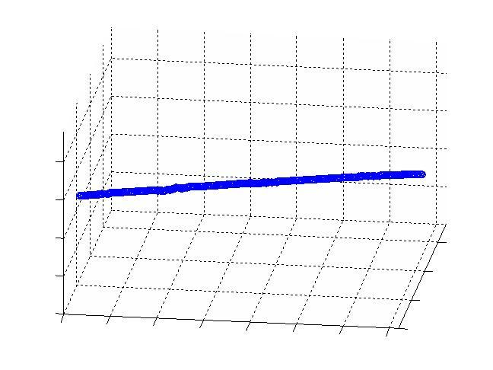
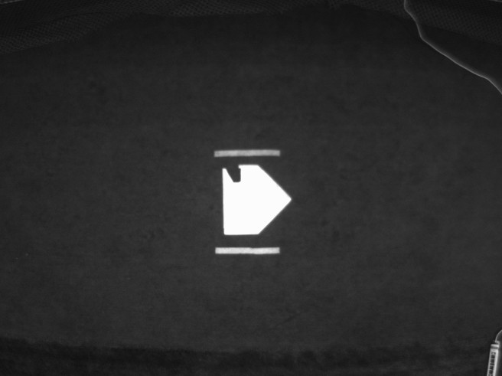
down.jpg


up.jpg

