Chapter 5 Numerical Differentiation and Integration
5-1 Numerical Differentiation
2-point formulae: $f^{'}(x_{0})≈\frac{f(x_{0}+h)−f(x_{0})}{h}+O(h)$$\frac{f(x_{0})−f(x_{0}−h)}{h}+O(h)$
3-point formulae: $f^{'}(x_{0})≈\frac{1}{2h}[f(x_{0}+h)−f(x_{0}−h)]−\frac{h^{2}}{6}f^{(3)}(ξ_{0})$
$\frac{1}{2h}[−3f(x_{0})+4f(x_{0}+h)−f(x_{0}+2h)]+\frac{h^{3}}{3}f^{(3)}(ξ_{1})$
$\frac{1}{2h}[f(x_{0}−2h)−4f(x_{0}−h)+3f(x_{0})]+\frac{h^{3}}{3}f^{(3)}(ξ_{2})$
$$f^{''}(x_{0})≈\frac{1}{h^{2}}[f(x_{0}−h)−2f(x_{0})+f(x_{0}+h)]−\frac{h^{2}}{\text{24}}[f^{(4)}(ξ_{1})+f^{(4)}(ξ_{−1})]$$
$$\frac{1}{h^{2}}[−f(x_{0}+3h)+4f(x_{0}+2h)−5f(x_{0}+h)+2f(x_{0})]+O(h^{2})$$
$$\frac{1}{\text{12}h^{2}}[−f(x_{0}+2h)+\text{16}f(x_{0}+h)−\text{30}f(x_{0})+\text{16}f(x_{0}−h)$$
$−f(x_{0}−2h)]+O(h^{4})$
$$f^{'''}(x_{0})≈\frac{1}{h^{3}}[f(x_{0}+3h)−3f(x_{0}+2h)+3f(x_{0}+h)−f(x_{0})]+O(h)$$
$$\frac{1}{2h^{3}}[f(x_{0}+2h)−2f(x_{0}+h)+2f(x_{0}−h)−f(x_{0}−2h)]+O(h^{2})$$

Eg. Find f’(2.0) for f(x)=xe^{x} by numerical differentiation methods.
(Sol.) f(x)=xe^{x}, f’(x)=(x+1)e^{x} $⇒$exact f’(2.0)=22.167168
For $f^{'}(x_{0})≈\frac{1}{2h}[f(x_{0}+h)−f(x_{0}−h)]$
Choose h=0.1, $f^{'}(2\text{.}0)≈\frac{1}{0\text{.}2}[f(2\text{.}1)−f(1\text{.}9)]=\text{22}\text{.}\text{28790}$
h=0.2, $f^{'}(2\text{.}0)≈\frac{1}{0\text{.}4}[f(2\text{.}2)−f(1\text{.}8)]=\text{22}\text{.}\text{414163}$
For $f^{'}(x_{0})≈\frac{1}{2h}[−3f(x_{0})+4f(x_{0}+h)−f(x_{0}+2h)]$
Choose h=0.1, $f^{'}(2\text{.}0)≈\frac{1}{0\text{.}2}[−3f(2\text{.}0)+4f(2\text{.}1)−f(2\text{.}2)]$=22.03231

Eg. Find f”(2.0) for f(x)=xe^{x} by $f^{''}(x_{0})≈\frac{1}{h^{2}}[f(x_{0}−h)−2f(x_{0})+f(x_{0}+h)]$.
(Sol.) Choose h=0.1, $f^{''}(2\text{.}0)≈\frac{1}{0\text{.}\text{01}}[f(1\text{.}9)−2f(2\text{.}0)+f(2\text{.}1)]$=29.5932
5-2 Numerical Integration by Trapezoidal & Simpson’s Rules
Composite trapezoidal integration method: h=(b-a)/n
$$\int{f(x)\text{dx}≈\frac{h}{2}\left[f(a)+f(b)+2\sum_{i=1}^{n−1}{f(a+\text{ih})}\right]−\frac{(b−a)h^{2}}{\text{12}}f^{''}(μ)}$$
Eg. Use trapezoidal integration method to calculate .
C/C++ program:
#include<stdio.h>
#include<stdlib.h>
#include<math.h>

float f1(float x)
{
return pow(x,2);
}

void SingleIntegral()
{
int m=10000;
float x,xl=0.0, xu=1.0;
float hx, aint, s, output;

hx=(xu-xl)/m;
aint=(f1(xl)+ f1(xu))*hx;
for (int j=1; j<=m-1; j++)
{
x=xl+j*hx;
s=f1(x);
aint=aint+s*hx;
}
output=aint;
printf(" output=%f ", output);
}

main ()
{
SingleIntegral();
}

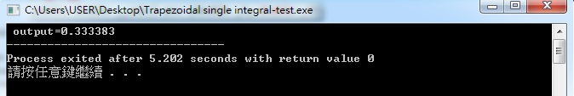

Eg. Compute single integral .
C/C++ program:
#include<stdio.h>
#include<stdlib.h>
#include<math.h>

float f1(float x)
{ return 1+x+pow(x,2); }

void SingleIntegral()
{
int m=10000;
float x,xl=0.0, xu=1.0; float hx, aint, s, output;
hx=(xu-xl)/m;
aint=(f1(xl)+ f1(xu))*hx;
for (int j=1; j<=m-1; j++)
{
x=xl+j*hx; s=f1(x); aint=aint+s*hx;
}
output=aint; printf(" output=%f ", output);
}

main ()
{ SingleIntegral(); }

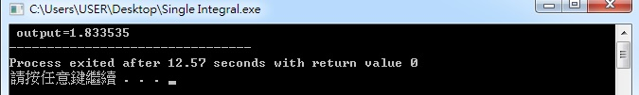
Eg. Compute double integral $\int{\int{\text{xydxdy}}}$ by the trapezoidal rule.
Fortran program:
real f
write (*,*) 'xl=, xu=, yl=, yu=, m=, n='
read (*,*) xl, xu, yl, yu, m,n
hx=(xu-xl)/m
hy=(yu-yl)/n
aint=(f(xl,yl)+ f(xl,yu)+ f(xu,yl)+ f(xu,yu))*hy
do 5 j=1,m-1
x=xl+j*hx
s=(f(x,yl)+f(x,yu))/2
do 10 jj=1,n-1
y=yl+jj*hy
s=s+f(x,y)
10 continue
aint=aint+s*hy
5 continue
aint=aint*hx
output=aint
write (*,*) output
stop
end

real function f(x,y)
f=x*y
return
end
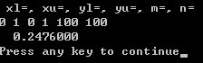
C/C++ program:
#include<stdio.h>
#include<stdlib.h>
#include<math.h>

float f2(float x, float y)
{
Return x*y;
}

void DoubleIntegral()
{
int m=1000,n=1000;
float x,y,xl=0.0, xu=1.0, yl=0.0, yu=1.0;
float hx, hy, aint, s, output;

hx=(xu-xl)/m;
hy=(yu-yl)/n;
aint=(f2(xl,yl)+ f2(xl,yu)+ f2(xu,yl)+ f2(xu,yu))*hy;
for (int j=1; j<=m-1; j++)
{
x=xl+j*hx;
s=(f2(x,yl)+f2(x,yu))/2;
for ( int i=1; i<=n-1; i++)

{
y=yl+i*hy;
s=s+f2(x,y);
}
aint=aint+s*hy;
}
aint=aint*hx;
output=aint;
printf(" output=%f ", output);
}

main ()
{
DoubleIntegral();
}
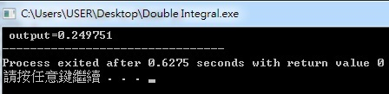
Eg. Use trapezoidal integration method to calculate .
#include<stdio.h>
#include<stdlib.h>
#include<math.h>

float f2(float x, float y)
{
return exp(y/x) ;
}

float yl(float x)
{
return pow(x,3) ;
}

float yu(float x)
{
return pow(x,2) ;
}

void DoubleIntegral()
{
int m=2000,n=2000;
float x,y,xl=0.1, xu=0.5;
float hx, hy, hyl, hyu, aint, s, output;
hx=(xu-xl)/m; hyl=(yu(xl)-yl(xl))/n; hyu=(yu(xu)-yl(xu))/n;
aint=(f2(xl,yl(xl))+f2(xl,yu(xl)))*hyl/2.+ (f2(xu,yl(xu))+f2(xu,yu(xu)))*hyu/2.;
for (int j=1; j<=m-1; j++)
{
x=xl+j*hx; hy=(yu(x)-yl(x))/n;
s=(f2(x,yl(x))+f2(x,yu(x)))/2;
for ( int i=1; i<=n-1; i++)
{
y=yl(x)+i*hy;
s=s+f2(x,y);
}
aint=aint+s*hy;
}
aint=aint*hx;
output=aint;
printf(" output=%f ", output);
}

main ()
{
DoubleIntegral();
}


Composite Simpson’s 1/3 integration method: h=(b-a)/2m
$\int{f(x)\text{dx}≈\frac{h}{3}\left[f(a)+2\sum_{i=1}^{m−1}{f(a+2\text{ih})+4\sum_{i=1}^{m}{f(a+(2i−1)h)+f(b)}}\right]}$$−\frac{(b−a)}{\text{180}}h^{4}f^{(4)}(μ)$
Eg. Use composite Simpson’s 1/3 algorithm to calculate $\int{\text{sin}\text{xdx}}$ with m=10.
(Sol.) h=$\frac{π−0}{2×\text{10}}=\frac{π}{\text{20}}$, $\frac{h}{3}=\frac{π}{\text{60}}$, f(0)=f(π)=0
$\int{\text{sin}\text{xdx}≈\frac{π}{\text{60}}\left[2\sum_{j=1}^{9}{\text{sin}\left(0+\frac{2jπ}{\text{20}}\right)+4\sum_{j=1}^{\text{10}}{\text{sin}\left[0+\frac{(2j−1)π}{\text{20}}\right]+f(0)+f(π)}}\right]}$=2.000006

Eg. Use composite Simpson’s 1/3 rule to calculate .
C/C++ program

#include<stdio.h>
#include<stdlib.h>
#include<math.h>

float f(float x)
{
return pow(x,2);
}

void SingleIntegral()
{
float x,y,xl=0.0, xu=1.0;
float hx, aj1, aj2, aj3, aint, output;
int m=1000;
hx=(xu-xl)/2./m;
aj1=0.; aj2=0.; aj3=0.;
for (int i=0; i<=2*m; i++)
{ x=xl+i*hx;
if (i==0) aj1= aj1+f(x);
if (i==2*m) aj1= aj1+f(x);
if (i%2==0) aj2= aj2+f(x);
if (i%2==1) aj3= aj3+f(x);
}
aint=(aj1+2*aj2+4*aj3)*hx/3.;
output=aint;
printf(" output=%f ", output);
}

main ()
{
SingleIntegral();
}

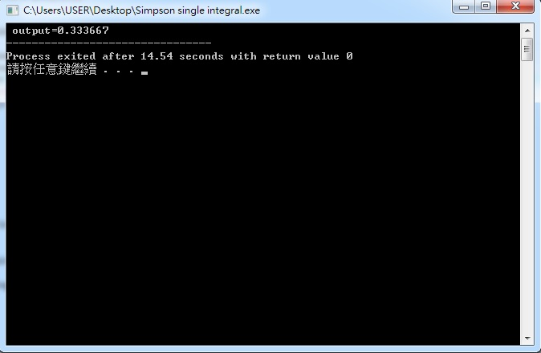

Eg. Use composite Simpson’s 1/3 rule to calculate $\int{\int{\text{xydxdy}}}$.
C/C++ program:
#include<stdio.h>
#include<stdlib.h>
#include<math.h>

float f2(float x, float y)
{ return x*y; }

void DoubleIntegral()
{
float x,y,xl=0.0, xu=1.0, yl=0.0, yu=1.0;
float hx, hy, ak1, ak2, ak3, aj1, aj2, aj3, a1, aint, output;
int m=200, n=200;
hx=(xu-xl)/2./m; hy=(yu-yl)/2./n;
aj1=0.; aj2=0. ; aj3=0.;
for (int i=0; i<=2*n; i++)
{ x=xl+i*hx;
ak1=f2(x,yl)+f2(x,yu);
ak2=0.; ak3=0.;
for (int j=1; j<=2*m-1; j++)
{ y=yl+j*hy;
if (j%2==0) ak2= ak2+f2(x,y);
if (j%2==1) ak3= ak3+f2(x,y);
}
a1=(ak1+2*ak2+4*ak3)*hy/3. ;
if (i==0) aj1= aj1+a1;
if (i==2*n) aj1= aj1+a1;
if (i%2==0) aj2= aj2+a1;
if (i%2==1) aj3= aj3+a1;
}
aint=(aj1+2*aj2+4*aj3)*hx/3.;
output=aint;
printf(" output=%f ", output);
}

main ()
{
DoubleIntegral();
}
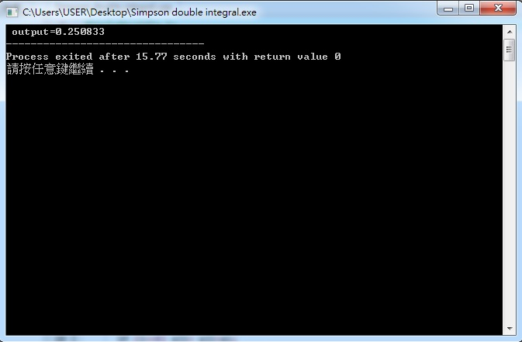

Eg. Use composite Simpson’s 1/3 rule to calculate $\int{\int{e^{y/x}}\text{dydx}}$.
(Sol.) $I=\int{\int{f(x,y)\text{dydx}}}$ Now, a=0.1, b=0.5, y_{l}(x)=x³, y_{u}(x)=x²
We can write a Fortran Program to approximate it.
external f,yl,yu
write (*,*) 'xl=, xu=, m=, n='
read (*,*) a,b,m,n
h=(b-a)/2./n
aj1=0.
aj2=0.
aj3=0.
do 1 i=0, 2*n
x=a+i*h
hy=(yu(x)-yl(x))/2./m
ak1=f(x,yl(x))+f(x,yu(x))
ak2=0.
ak3=0.
do 2 j=1, 2*m-1
y=yl(x)+j*hy
jr=mod(j,2)
if (jr.eq.0) ak2= ak2+f(x,y)
if (jr.eq.1) ak3= ak3+f(x,y)
2 continue
a1=(ak1+2*ak2+4*ak3)*hy/3.
ir=mod(i,2)
if ((i.eq.0).or.(i.eq.(2*n))) aj1= aj1+a1
if (ir.eq.0) aj2= aj2+a1
if (ir.eq.1) aj3= aj3+a1
1 continue
dint=(aj1+2*aj2+4*aj3)*h/3.
output=dint
write (*,*) output
stop
end

function f(x,y)
f=exp(y/x)
return
end

function yl(x)
yl=x**3
return
end

function yu(x)
yu=x**2
return
end
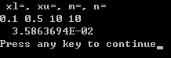

C/C++ program
#include<stdio.h>
#include<stdlib.h>
#include<math.h>

float f2(float x, float y)
{
return exp(y/x) ;
}

float yl(float x)
{
return pow(x,3) ;
}

float yu(float x)
{
return pow(x,2) ;
}

void DoubleIntegral()
{
float x,y,xl=0.1, xu=0.5;
float hx, hy, ak1, ak2, ak3, aj1, aj2, aj3, a1, aint, output;
int m=10, n=10;
hx=(xu-xl)/2./m;
aj1=0.; aj2=0. ; aj3=0.;
for (int i=0; i<=2*n; i++)
{x=xl+i*hx; hy=(yu(x)-yl(x))/2./n;
ak1=f2(x,yl(x))+f2(x,yu(x));
ak2=0.;
ak3=0.;
for (int j=1; j<=2*m-1; j++)
{ y=yl(x)+j*hy;
if (j%2==0) ak2= ak2+f2(x,y);
if (j%2==1) ak3= ak3+f2(x,y);
}
a1=(ak1+2*ak2+4*ak3)*hy/3. ;
if (i==0) aj1= aj1+a1;
if (i==2*n) aj1= aj1+a1;
if (i%2==0) aj2= aj2+a1;
if (i%2==1) aj3= aj3+a1;
}
aint=(aj1+2*aj2+4*aj3)*hx/3.;
output=aint;
printf(" output=%f ", output);
}

main ()
{
DoubleIntegral();
}

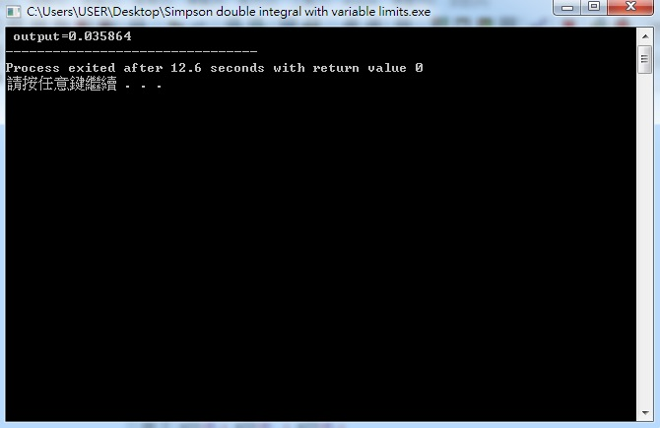

In Matlab language, we can use the following instructions to execute the numerical integral of a function:

>>S = 'sqrt(x)';
>>numeric(int(S,0.5,0.6)) % Calculate $\int{\sqrt{x}\text{dx}}$
ans=
0.0741

5-3 Romberg Integration and Gaussian Quadrature method
Romberg integration method:
1. Define R_{1,1}=$\frac{h_{1}}{2}[f(a)+f(b)]=\frac{b−a}{2}[f(a)+f(b)]$, h₁=b-a
$R_{2,1}=\frac{h_{2}}{2}[f(a)+2f(a+h_{2})+f(b)]$$=\frac{(b−a)}{4}\left[f(a)+f(b)+2f\left(a+\frac{b−a}{2}\right)\right]$
$=\frac{1}{2}\left[R_{1,1}+h_{1}f\left(a+\frac{1}{2}h_{1}\right)\right]$, $h_{2}=\frac{b−a}{2}$
$⋮$
R_{k,1}=$\frac{1}{2}\left[R_{k−1,1}+h_{k−1}⋅\sum_{i=1}^{2^{k−2}}{f\left(a+\left(i−\frac{1}{2}\right)h_{k−1}\right)}\right]$, k=2, 3, …, n
$⇒\int{f(x)\text{dx}=\frac{4R_{k,1}−R_{k−1,1}}{3}}+O(h_{k}^{4})$, $h_{k}=\frac{b−a}{2^{k−1}}$
2. Define R_{k,2}=$\frac{4R_{k,1}−R_{k−1,1}}{3}$, k=2, 3, …, n
3. R_{i,j}=$\frac{4^{j−1}R_{i,j−1}−R_{i−1,j−1}}{4^{j−1}−1}$, $\begin{aligned}i=2,3,4,⋯,n \\ j=2,3,⋯,i \\ (2≤j≤i≤n)\end{aligned}$$⇒\int{f(x)\text{dx}=R_{n,n}}$.
Eg. Use Romberg algorithm to calculate $\int{\text{sin}\text{xdx}}$ with n=6.
(Sol.) $R_{1,1}=\frac{π}{2}[\text{sin}0+\text{sin}π]=0$, $R_{2,1}=\frac{1}{2}\left[R_{1,1}+π\text{sin}\frac{π}{2}\right]=1\text{.}\text{57079633}$
$R_{3,1}=\frac{1}{2}\left[R_{2,1}+\frac{π}{2}\left(\text{sin}\frac{π}{4}+\text{sin}\frac{3π}{4}\right)\right]=1\text{.}\text{89611890}$
$R_{4,1}=\frac{1}{2}\left[R_{3,1}+\frac{π}{4}\left(\text{sin}\frac{π}{8}+\text{sin}\frac{3π}{8}+\text{sin}\frac{5π}{8}+\text{sin}\frac{7π}{8}\right)\right]=1\text{.}\text{9742160}$
$R_{5,1}=1\text{.}\text{99357034}$, $R_{6,1}=1\text{.}\text{99839336}$
$R_{\text{ij}}=\frac{4^{j−1}R_{i,j−1}−R_{i−1,j−1}}{4^{j−1}−1}$, $i=2,3,⋯,6$ and $j=2,⋯,i$
0
1.57079633 2.09439511
1.89611890 2.00455976 1.99857073
1.97423160 2.0026917 1.99998313 2.00000555
1.99357034 2.00001659 1.99999975 2.00000001 1.99999999
1.99839336 2.00000103 2.0000000 2.00000000 2.00000000 2.00000000
$$⇒\int{\text{sin}\text{xdx}≈R_{6,6}=2}$$
Gaussian Quadrature method:
Set t=(2x-a-b)/(b-a)$⇒\int{f(x)\text{dx}=\int{f\left(\frac{(b−a)t+b+a}{2}\right)\frac{b−a}{2}\text{dt}}}$$\int{g(t)\text{dt}}$=$\sum_{i=0}^{n−1}{c_{i}g(x_{i})}$,
where c_{i}=$\underset{n−1}{\int_{j≠i}{}}\text{dx}$, and x₀, x₁, x₂, …, x_{n-1} are the zeros of the n^{th}-order Legendre’s polynomial.
Eg. Compute $\int{e^{−x^{2}}\text{dx}}$.
(Sol.) $\int{e^{−x^{2}}}\text{dx}=\frac{1}{4}\int{e^{−\frac{(t+5)^{2}}{\text{16}}}}\text{dt}$
Table for the Gaussian Quadrature method:
As n=2, x₀=0.5773502692, x₁=-x₀, and c₀=1, c₁=1
$\int{e^{−x^{2}}}\text{dx}≈\frac{1}{4}[1⋅e^{−\frac{(x_{0}+5)^{2}}{\text{16}}}+1⋅e^{−\frac{(x_{1}+5)^{2}}{\text{16}}}]=0\text{.}\text{1094003}$

As n=3, x₀=0.7745966692, x₁=0, x₂=-x₀ and c₀=0.55555555556, c₁=0.8888888889, c₂=c₀
$\int{e^{−x^{2}}}\text{dx}≈\frac{1}{4}[c_{0}e^{−\frac{(x_{0}+5)^{2}}{\text{16}}}+c_{1}e^{−\frac{(x_{1}+5)^{2}}{\text{16}}}+c_{2}e^{−\frac{(x_{2}+5)^{2}}{\text{16}}}]=0\text{.}\text{1093642}$
$\int{e^{−x^{2}}}\text{dx}≈R_{4,4}=0\text{.}\text{1093643}$ is obtained by the Romberg method.
5-4 Hwa’s Integral Method (華羅庚積分法)
For computing an n-dimensional multiple integral, it needs n nested loops for most methods. And then more CPU time consumes. But Hwa’s method needs only one loop.
Eg. Hwa’s method to compute a double integral $\int{\int{\text{xydxdy}}}$.
external QUADR,F
write (*,*) 'xl=, xu=, yl=, yu=, m='
read (*,*) a,b,c,d,m
output=QUADR(F,a,b,c,d,m)
write (*,*) output
stop
end

Function F(x,y)
F=x*y
return
end

FUNCTION QUADR(F,X1,X2,Y1,Y2,M)
EXTERNAL F
INTEGER FIBON(20)
DATA FIBON/13,21,34,55,89,144,233,377,610,987,1597,2584,4181,6765,10946,17711,28657,46368,75025,121393/
NH=FIBON(M-1)
N=FIBON(M)
XINT=X2-X1
YINT=Y2-Y1
KK=0
QUADR =0.
DO 10 K=1,N
X=(XINT*K)/N+X1
KK=KK+NH
IF (KK.GE.N) KK=KK-N
Y=(YINT*KK)/N+Y1
10 QUADR=QUADR+F(X,Y)
QUADR=QUADR*XINT*YINT/N
RETURN
END
For xl=0, xu=1, yl=0, yu=1, m=10, QUADR0.2496822. And the exact value of the integral is about 0.25.
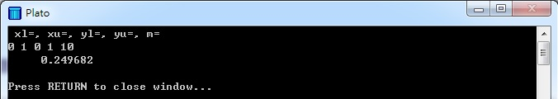Eg. Hwa’s method to compute a quadruple integral $\int{\int{\int{\int{\text{wxyzdwdxdydz}}}}}$.
external QUADPR,F
write (*,*) 'wl=, wu=, xl=, xu=, yl=, yu=, zl=, zu=, m='
read (*,*) a,b,c,d,e,ff,g,h,m
output=QUADPR(F,a,b,c,d,e,ff,g,h,m)
write (*,*) output
stop
end

function F(w,x,y,z)
F=w*x*y*z
return
end

FUNCTION QUADPR(F,W1,W2,X1,X2,Y1,Y2,Z1,Z2,M)
EXTERNAL F
INTEGER FN(24),F2(24),F3(24),F4(24)
INTEGER H2,H3,H4
DATA FN/60,118,180,286,440,562,732,932,1142,1354,2129,3001,4001,5003,6007,8191,10007,20039,28117,39029,57091,82001,100063,147312/
DATA F2/8,18,8,16,21,53,248,116,150,492,766,174,113,792,1351,2488,1206,19668,17549,30699,52590,57270,92313,136641/
DATA F3/18,40,46,94,136,89,294,288,187,550,1281,266,766,1889,5080,5939,3421,17407,1900,34367,48787,58903,24700,116072/
DATA F4/22,52,74,138,216,221,324,314,274,658,1906,1269,2537,191,3086,7859,2842,14600,24455,605,38790,17672,95582,76424/
N=FN(M)
H2=F2(M)
H3=F3(M)
H4=F4(M)
WINT=W2-W1
XINT=X2-X1
YINT=Y2-Y1
ZINT=Z2-Z1
K2=0.
K3=0.
K4=0.
QUADR=0.
DO 10 K=1,N
W=(WINT*K)/N+W1
K2=K2+H2
IF (K2.GE. N) K2=K2-N
X=(XINT*K2)/N+X1
K3=K3+H3
IF (K3.GE.N) K3=K3-N
Y=(YINT*K3)/N+Y1
K4=K4+H4
IF (K4.GE.N) K4=K4-N
Z=(ZINT*K4)/N+Z1
10 QUADPR=QUADPR+F(W,X,Y,Z)
QUADPR=QUADPR*WINT*XINT*YINT*ZINT/N
RETURN
END
For wl=0, wu=1, xl=0, xu=1, yl=0, yu=1, zl=0, zu=1, m=10, QUADPR0.0615789. And the exact value of the integral is about 0.0625.
