Chapter 8 Partial Differential Equations
8-1 Elliptic Partial Differential Equations
Solve $\frac{∂^{2}u(x,y)}{∂x^{2}}+\frac{∂^{2}u(x,y)}{∂y^{2}}=f(x,y)$, $∀$(x,y)$∈$R; u(x,y)=g(x,y), $∀$(x,y)$∈$S, where R={(x,y): a≦x≦b, c≦y≦d}, and S is the boundary of R.
Set x_{i}=a+ih, y_{j}=c+jk, h=(b-a)/n, k=(d-c)/m, i=0, 1, 2, …, n, and j=0, 1, 2, …, m.

Central difference method:
$\frac{u(x_{i+1},y_{j})−2u(x_{i},y_{j})+u(x_{i−1},y_{j})}{h^{2}}+\frac{u(x_{i},y_{j+1})−2u(x_{i},y_{j})+u(x_{i},y_{j−1})}{k^{2}}$$=f(x_{i},y_{j})$
and u(x₀,y_{j})=g(x₀,y_{j}), u(x_{n},y_{j})=g(x_{n},y_{j}), j=0, 1, 2, …, m-1; u(x_{i},y₀)=g(x_{i},y₀), u(x_{i},y_{m})=g(x_{i},y_{m}), i=0, 1, 2, …, n-1
$⇒2\left[{\left(\frac{h}{k}\right)}^{2}+1\right]u_{\text{ij}}−(u_{i+1,j}+u_{i−1,j})−{\left(\frac{h}{k}\right)}^{2}(u_{i,j+1}+u_{i,j−1})=−h^{2}f_{\text{ij}}$ and u_{0j}=g_{0j}, u_{nj}=g_{nj}, u_{i0}=g_{i0}, u_{im}=g_{im}.

Eg. Solve $\frac{∂^{2}u}{∂x^{2}}+\frac{∂^{2}u}{∂y^{2}}=0$, 0≦x≦0.5, 0≦y≦0.5 with u(0,y)=u(x,0)=0, u(x,1/2)=200x, u(1/2,y)=200y. (Exact solution: u(x,y)=400xy)
(Sol.) We set n=m=4, and then
$h=k=\frac{\frac{1}{2}}{4}=\frac{1}{8}$, $u_{\text{ij}}=u(x_{i},y_{j})$, $\begin{aligned}x_{i}=\text{ih} \\ y_{j}=\text{jk}\end{aligned}$$⇒\frac{u_{i+1,j}−2u_{i,j}+u_{i−1,j}}{h^{2}}+\frac{u_{i,j+1}−2u_{i,j}+u_{i,j−1}}{k^{2}}=0$
$$⇒2\left[{\left(\frac{h}{k}\right)}^{2}+1\right]u_{\text{ij}}−(u_{i+1,j}+u_{i−1,j})−{\left(\frac{h}{k}\right)}^{2}(u_{i,j+1}+u_{i,j−1})=0$$
$⇒\begin{aligned}\left\{4u_{\text{13}}−u_{\text{23}}−u_{\text{12}}=u_{\text{14}}=\text{200}×\frac{1}{8}=\text{25} | \right.\left\{4u_{\text{23}}−u_{\text{33}}−u_{\text{13}}−u_{\text{22}}=u_{\text{24}}=\text{200}×\frac{2}{8}=\text{50} | \right.\left\{4u_{\text{33}}−u_{\text{23}}−u_{\text{32}}=u_{\text{43}}+u_{\text{34}}=\text{200}×\frac{3}{8}+\text{200}×\frac{3}{8}=\text{150} | \right.\left\{4u_{\text{12}}−u_{\text{22}}−u_{\text{13}}−u_{\text{11}}=u_{\text{02}}=0 | \right.\left\{4u_{\text{22}}−u_{\text{32}}−u_{\text{12}}−u_{\text{23}}−u_{\text{21}}=0 | \right.\left\{4u_{\text{32}}−u_{\text{22}}−u_{\text{33}}−u_{\text{31}}=u_{\text{42}}=\text{200}×\frac{2}{8}=\text{50} | \right.\left\{4u_{\text{11}}−u_{\text{21}}−u_{\text{12}}=u_{\text{01}}+u_{\text{10}}=0 | \right.\left\{4u_{\text{21}}−u_{\text{31}}−u_{\text{11}}−u_{\text{22}}=u_{\text{20}}=0 | \right.\end{aligned}$$⇒\left[\begin{matrix}4 & −1 & 0 & −1 & 0 & 0 & 0 & 0 & 0 \\ −1 & 4 & −1 & 0 & −1 & 0 & 0 & 0 & 0 \\ 0 & −1 & 4 & 0 & 0 & −1 & 0 & 0 & 0 \\ −1 & 0 & 0 & 4 & −1 & 0 & −1 & 0 & 0 \\ 0 & −1 & 0 & −1 & 4 & −1 & 0 & −1 & 0 \\ 0 & 0 & −1 & 0 & −1 & 4 & 0 & 0 & −1 \\ 0 & 0 & 0 & −1 & 0 & 0 & 4 & −1 & 0 \\ 0 & 0 & 0 & 0 & −1 & 0 & −1 & 4 & −1 \\ 0 & 0 & 0 & 0 & 0 & −1 & 0 & −1 & 4\end{matrix}\right] \left[\begin{matrix}u_{\text{13}} \\ u_{\text{23}} \\ u_{\text{33}} \\ u_{\text{12}} \\ u_{\text{22}} \\ u_{\text{32}} \\ u_{\text{11}} \\ u_{\text{21}} \\ u_{\text{31}}\end{matrix}\right]=\left[\begin{matrix}\text{25} \\ \text{50} \\ \text{150} \\ 0 \\ 0 \\ \text{50} \\ 0 \\ 0 \\ \text{25}\end{matrix}\right]$
$⇒$u₁₃=18.75, u₂₃=37.5, …, u₂₁=12.5, u₃₁=18.75
In MATLAB language, we can use the following program to solve the partial differential equation:
>>A=[4,-1,0,-1,0,0,0,0,0;-1,4,-1,0,-1,0,0,0,0;0,-1,4,0,0,-1,0,0,0;-1,0,0,4,-1,0,-1,0,0;
0,-1,0,-1,4,-1,0,-1,0;0,0,-1,0,-1,4,0,0,-1;0,0,0,-1,0,0,4,-1,0;0,0,0,0,-1,0,-1,4,-1;
0,0,0,0,0,-1,0,-1,4];
>>B=[25;50;150;0;0;50;0;0;25];
>>rref([A,B])

ans =
Columns 1 through 7

1.0000 0 0 0 0 0 0
0 1.0000 0 0 0 0 0
0 0 1.0000 0 0 0 0
0 0 0 1.0000 0 0 0
0 0 0 0 1.0000 0 0
0 0 0 0 0 1.0000 0
0 0 0 0 0 0 1.0000
0 0 0 0 0 0 0
0 0 0 0 0 0 0

Columns 8 through 10

0 0 18.7500
0 0 37.5000
0 0 56.2500
0 0 12.5000
0 0 25.0000
0 0 37.5000
0 0 6.2500
1.0000 0 12.5000
0 1.0000 18.7500
8-2 Parabolic Partial Differential Equations
Solve $\frac{∂u(x,t)}{∂t}=α^{2}⋅\frac{∂^{2}u(x,t)}{∂x^{2}}$, 0≦x≦l, t>0, with u(0,t)=u(l,t)=0, u(x,0)=f(x).
Set h=l/m, x_{i}=ih, t_{j}=jk, i=0, 1, 2, …, m, and j=0, 1, 2, …
Forward difference method: $\frac{u_{i,j+1}−u_{\text{ij}}}{k}−α^{2}⋅\frac{u_{i+1,j}−2u_{\text{ij}}+u_{i−1,j}}{h^{2}}=0$
Set $λ=\frac{α^{2}k}{h^{2}}$$⇒u_{i,j+1}=(1−2λ)u_{\text{ij}}+λ(u_{i+1,j}+u_{i−1,j})$ and u_{0j}=u_{mj}=0, u_{i0}=f(x_{i})
$⇒\left[\begin{matrix}u_{1,j+1} \\ u_{2,j+1} \\ ⋮ \\ ⋮ \\ u_{m−1,j+1}\end{matrix}\right]=\left[\begin{matrix}(1−2λ) & λ & 0 & ⋯ & 0 \\ λ & (1−2λ) & λ & ⋱ & ⋮ \\ 0 & λ & (1−2λ) & ⋱ & 0 \\ ⋮ & ⋱ & ⋱ & ⋱ & λ \\ 0 & ⋯ & 0 & λ & (1−2λ)\end{matrix}\right] \left[\begin{matrix}u_{1j} \\ u_{2j} \\ ⋮ \\ ⋮ \\ u_{m−1,j}\end{matrix}\right]$
We have
$\left[\begin{matrix}u_{\text{11}} \\ u_{\text{21}} \\ ⋮ \\ ⋮ \\ u_{m−1,1}\end{matrix}\right]=\left[\begin{matrix}(1−2λ) & λ & 0 & ⋯ & 0 \\ λ & (1−2λ) & λ & ⋱ & ⋮ \\ 0 & λ & (1−2λ) & ⋱ & 0 \\ ⋮ & ⋱ & ⋱ & ⋱ & λ \\ 0 & ⋯ & 0 & λ & (1−2λ)\end{matrix}\right] \left[\begin{matrix}f(x_{1}) \\ f(x_{2}) \\ ⋮ \\ ⋮ \\ f(x_{m−1})\end{matrix}\right]$,
$\left[\begin{matrix}u_{\text{12}} \\ u_{\text{22}} \\ ⋮ \\ ⋮ \\ u_{m−1,2}\end{matrix}\right]=\left[\begin{matrix}(1−2λ) & λ & 0 & ⋯ & 0 \\ λ & (1−2λ) & λ & ⋱ & ⋮ \\ 0 & λ & (1−2λ) & ⋱ & 0 \\ ⋮ & ⋱ & ⋱ & ⋱ & λ \\ 0 & ⋯ & 0 & λ & (1−2λ)\end{matrix}\right] \left[\begin{matrix}u_{\text{11}} \\ u_{\text{21}} \\ ⋮ \\ ⋮ \\ u_{m−1,1}\end{matrix}\right]$,
$\left[\begin{matrix}u_{\text{13}} \\ u_{\text{23}} \\ ⋮ \\ ⋮ \\ u_{m−1,3}\end{matrix}\right]=\left[\begin{matrix}(1−2λ) & λ & 0 & ⋯ & 0 \\ λ & (1−2λ) & λ & ⋱ & ⋮ \\ 0 & λ & (1−2λ) & ⋱ & 0 \\ ⋮ & ⋱ & ⋱ & ⋱ & λ \\ 0 & ⋯ & 0 & λ & (1−2λ)\end{matrix}\right] \left[\begin{matrix}u_{\text{12}} \\ u_{\text{22}} \\ ⋮ \\ ⋮ \\ u_{m−1,2}\end{matrix}\right]$,$\left[\begin{matrix}u_{\text{14}} \\ u_{\text{24}} \\ ⋮ \\ ⋮ \\ u_{m−1,4}\end{matrix}\right]=\left[\begin{matrix}(1−2λ) & λ & 0 & ⋯ & 0 \\ λ & (1−2λ) & λ & ⋱ & ⋮ \\ 0 & λ & (1−2λ) & ⋱ & 0 \\ ⋮ & ⋱ & ⋱ & ⋱ & λ \\ 0 & ⋯ & 0 & λ & (1−2λ)\end{matrix}\right] \left[\begin{matrix}u_{\text{13}} \\ u_{\text{23}} \\ ⋮ \\ ⋮ \\ u_{m−1,3}\end{matrix}\right]$, ….
Backward difference method: $\frac{u_{\text{ij}}−u_{i,j−1}}{k}−α^{2}⋅\frac{u_{i+1,j}−2u_{\text{ij}}+u_{i−1,j}}{h^{2}}=0$
$⇒u_{i,j−1}=(1+2λ)u_{\text{ij}}−λ(u_{i+1,j}+u_{i−1,j})$
$\left[\begin{matrix}(1+2λ) & −λ & 0 & ⋯ & 0 \\ −λ & (1+2λ) & −λ & ⋱ & ⋮ \\ 0 & ⋱ & ⋱ & ⋱ & 0 \\ ⋮ & ⋱ & ⋱ & ⋱ & −λ \\ 0 & ⋯ & 0 & −λ & (1+2λ)\end{matrix}\right] \left[\begin{matrix}u_{1j} \\ u_{2j} \\ ⋮ \\ ⋮ \\ u_{m−1,j}\end{matrix}\right]=\left[\begin{matrix}u_{1,j−1} \\ u_{2,j−1} \\ ⋮ \\ ⋮ \\ u_{m−1,j−1}\end{matrix}\right]$, where u_{i0}=f(x_{i}).

We solve
$\left[\begin{matrix}(1+2λ) & −λ & 0 & ⋯ & 0 \\ −λ & (1+2λ) & −λ & ⋱ & ⋮ \\ 0 & ⋱ & ⋱ & ⋱ & 0 \\ ⋮ & ⋱ & ⋱ & ⋱ & −λ \\ 0 & ⋯ & 0 & −λ & (1+2λ)\end{matrix}\right] \left[\begin{matrix}u_{\text{11}} \\ u_{\text{21}} \\ ⋮ \\ ⋮ \\ u_{m−1,1}\end{matrix}\right]=\left[\begin{matrix}f(x_{1}) \\ f(x_{2}) \\ ⋮ \\ ⋮ \\ f(x_{m−1})\end{matrix}\right]$$⇒$$\left[\begin{matrix}u_{\text{11}} \\ u_{\text{21}} \\ ⋮ \\ ⋮ \\ u_{m−1,1}\end{matrix}\right]$=?

and then we solve
$\left[\begin{matrix}(1+2λ) & −λ & 0 & ⋯ & 0 \\ −λ & (1+2λ) & −λ & ⋱ & ⋮ \\ 0 & ⋱ & ⋱ & ⋱ & 0 \\ ⋮ & ⋱ & ⋱ & ⋱ & −λ \\ 0 & ⋯ & 0 & −λ & (1+2λ)\end{matrix}\right] \left[\begin{matrix}u_{\text{12}} \\ u_{\text{22}} \\ ⋮ \\ ⋮ \\ u_{m−1,2}\end{matrix}\right]=\left[\begin{matrix}u_{\text{11}} \\ u_{\text{21}} \\ ⋮ \\ ⋮ \\ u_{m−1,1}\end{matrix}\right]$$⇒$$\left[\begin{matrix}u_{\text{12}} \\ u_{\text{22}} \\ ⋮ \\ ⋮ \\ u_{m−1,2}\end{matrix}\right]$=?

and then we solve
$\left[\begin{matrix}(1+2λ) & −λ & 0 & ⋯ & 0 \\ −λ & (1+2λ) & −λ & ⋱ & ⋮ \\ 0 & ⋱ & ⋱ & ⋱ & 0 \\ ⋮ & ⋱ & ⋱ & ⋱ & −λ \\ 0 & ⋯ & 0 & −λ & (1+2λ)\end{matrix}\right] \left[\begin{matrix}u_{\text{13}} \\ u_{\text{23}} \\ ⋮ \\ ⋮ \\ u_{m−1,3}\end{matrix}\right]=\left[\begin{matrix}u_{\text{12}} \\ u_{\text{22}} \\ ⋮ \\ ⋮ \\ u_{m−1,2}\end{matrix}\right]$$⇒$$\left[\begin{matrix}u_{\text{13}} \\ u_{\text{23}} \\ ⋮ \\ ⋮ \\ u_{m−1,3}\end{matrix}\right]$=?

and then we solve
$\left[\begin{matrix}(1+2λ) & −λ & 0 & ⋯ & 0 \\ −λ & (1+2λ) & −λ & ⋱ & ⋮ \\ 0 & ⋱ & ⋱ & ⋱ & 0 \\ ⋮ & ⋱ & ⋱ & ⋱ & −λ \\ 0 & ⋯ & 0 & −λ & (1+2λ)\end{matrix}\right] \left[\begin{matrix}u_{\text{14}} \\ u_{\text{24}} \\ ⋮ \\ ⋮ \\ u_{m−1,4}\end{matrix}\right]=\left[\begin{matrix}u_{\text{13}} \\ u_{\text{23}} \\ ⋮ \\ ⋮ \\ u_{m−1,3}\end{matrix}\right]$$⇒$$\left[\begin{matrix}u_{\text{14}} \\ u_{\text{24}} \\ ⋮ \\ ⋮ \\ u_{m−1,4}\end{matrix}\right]$=?
, ….
Eg. Solve $\frac{∂u(x,t)}{∂t}−\frac{∂^{2}u(x,t)}{∂x^{2}}=0$, 0≦x≦1, t>0 with u(0,t)=u(1,t)=0, and u(x,0)=sin(πx).
(Sol.) Use the Backward-difference method, and choose m=10, h=0.1, k=0.01$⇒$λ=1, 1+2λ=3, x_{i}=0.1i, t_{j}=0.01j, and then we have
$\left[\begin{matrix}3 & −1 & 0 & ⋯ & 0 \\ −1 & 3 & −1 & ⋱ & ⋮ \\ 0 & ⋱ & ⋱ & ⋱ & 0 \\ ⋮ & ⋱ & ⋱ & ⋱ & −1 \\ 0 & ⋯ & 0 & −1 & 3\end{matrix}\right] \left[\begin{matrix}u_{\text{11}} \\ u_{\text{21}} \\ ⋮ \\ ⋮ \\ u_{\text{91}}\end{matrix}\right]$=$\left[\begin{matrix}u_{\text{10}} \\ u_{\text{20}} \\ ⋮ \\ ⋮ \\ u_{\text{90}}\end{matrix}\right]$=$\left[\begin{matrix}\text{sin}({πx}_{1}) \\ \text{sin}({πx}_{2}) \\ ⋮ \\ ⋮ \\ \text{sin}({πx}_{9})\end{matrix}\right]$
$⇒$$\left[\begin{matrix}u_{\text{11}} \\ u_{\text{21}} \\ ⋮ \\ ⋮ \\ u_{\text{91}}\end{matrix}\right]$=${\left[\begin{matrix}3 & −1 & 0 & ⋯ & 0 \\ −1 & 3 & −1 & ⋱ & ⋮ \\ 0 & ⋱ & ⋱ & ⋱ & 0 \\ ⋮ & ⋱ & ⋱ & ⋱ & −1 \\ 0 & ⋯ & 0 & −1 & 3\end{matrix}\right]}^{−1}$$\left[\begin{matrix}\text{sin}({πx}_{1}) \\ \text{sin}({πx}_{2}) \\ ⋮ \\ ⋮ \\ \text{sin}({πx}_{9})\end{matrix}\right]$, and
$\left[\begin{matrix}3 & −1 & 0 & ⋯ & 0 \\ −1 & 3 & −1 & ⋱ & ⋮ \\ 0 & ⋱ & ⋱ & ⋱ & 0 \\ ⋮ & ⋱ & ⋱ & ⋱ & −1 \\ 0 & ⋯ & 0 & −1 & 3\end{matrix}\right] \left[\begin{matrix}u_{\text{12}} \\ u_{\text{22}} \\ ⋮ \\ ⋮ \\ u_{\text{92}}\end{matrix}\right]=\left[\begin{matrix}u_{\text{11}} \\ u_{\text{21}} \\ ⋮ \\ ⋮ \\ u_{\text{91}}\end{matrix}\right]$$⇒$$\left[\begin{matrix}u_{\text{12}} \\ u_{\text{22}} \\ ⋮ \\ ⋮ \\ u_{\text{92}}\end{matrix}\right]$=${\left[\begin{matrix}3 & −1 & 0 & ⋯ & 0 \\ −1 & 3 & −1 & ⋱ & ⋮ \\ 0 & ⋱ & ⋱ & ⋱ & 0 \\ ⋮ & ⋱ & ⋱ & ⋱ & −1 \\ 0 & ⋯ & 0 & −1 & 3\end{matrix}\right]}^{−1}\left[\begin{matrix}u_{\text{11}} \\ u_{\text{21}} \\ ⋮ \\ ⋮ \\ u_{\text{91}}\end{matrix}\right]$,
$\left[\begin{matrix}3 & −1 & 0 & ⋯ & 0 \\ −1 & 3 & −1 & ⋱ & ⋮ \\ 0 & ⋱ & ⋱ & ⋱ & 0 \\ ⋮ & ⋱ & ⋱ & ⋱ & −1 \\ 0 & ⋯ & 0 & −1 & 3\end{matrix}\right] \left[\begin{matrix}u_{\text{13}} \\ u_{\text{23}} \\ ⋮ \\ ⋮ \\ u_{\text{93}}\end{matrix}\right]=\left[\begin{matrix}u_{\text{12}} \\ u_{\text{22}} \\ ⋮ \\ ⋮ \\ u_{\text{92}}\end{matrix}\right]$$⇒$$\left[\begin{matrix}u_{\text{13}} \\ u_{\text{23}} \\ ⋮ \\ ⋮ \\ u_{\text{93}}\end{matrix}\right]$=${\left[\begin{matrix}3 & −1 & 0 & ⋯ & 0 \\ −1 & 3 & −1 & ⋱ & ⋮ \\ 0 & ⋱ & ⋱ & ⋱ & 0 \\ ⋮ & ⋱ & ⋱ & ⋱ & −1 \\ 0 & ⋯ & 0 & −1 & 3\end{matrix}\right]}^{−1}\left[\begin{matrix}u_{\text{12}} \\ u_{\text{22}} \\ ⋮ \\ ⋮ \\ u_{\text{92}}\end{matrix}\right]$,
$\left[\begin{matrix}3 & −1 & 0 & ⋯ & 0 \\ −1 & 3 & −1 & ⋱ & ⋮ \\ 0 & ⋱ & ⋱ & ⋱ & 0 \\ ⋮ & ⋱ & ⋱ & ⋱ & −1 \\ 0 & ⋯ & 0 & −1 & 3\end{matrix}\right] \left[\begin{matrix}u_{\text{14}} \\ u_{\text{24}} \\ ⋮ \\ ⋮ \\ u_{\text{94}}\end{matrix}\right]=\left[\begin{matrix}u_{\text{13}} \\ u_{\text{23}} \\ ⋮ \\ ⋮ \\ u_{\text{93}}\end{matrix}\right]$$⇒$$\left[\begin{matrix}u_{\text{14}} \\ u_{\text{24}} \\ ⋮ \\ ⋮ \\ u_{\text{94}}\end{matrix}\right]$=${\left[\begin{matrix}3 & −1 & 0 & ⋯ & 0 \\ −1 & 3 & −1 & ⋱ & ⋮ \\ 0 & ⋱ & ⋱ & ⋱ & 0 \\ ⋮ & ⋱ & ⋱ & ⋱ & −1 \\ 0 & ⋯ & 0 & −1 & 3\end{matrix}\right]}^{−1}\left[\begin{matrix}u_{\text{13}} \\ u_{\text{23}} \\ ⋮ \\ ⋮ \\ u_{\text{93}}\end{matrix}\right]$,
…
In Matlab language, we can use the following program to solve the partial differential equation:
>> A=[3,-1,0,0,0,0,0,0,0;-1,3,-1,0,0,0,0,0,0;0,-1,3,-1,0,0,0,0,0;0,0,-1,3,-1,0,0,0,0;
0,0,0,-1,3,-1,0,0,0;0,0,0,0,-1,3,-1,0,0;0,0,0,0,0,-1,3,-1,0;0,0,0,0,0,0,-1,3,-1;
0,0,0,0,0,0,0,-1,3];
>>pi=3.1415926;
>>B=[sin(0.1*pi);sin(0.2*pi);sin(0.3*pi);sin(0.4*pi);sin(0.5*pi);sin(0.6*pi);sin(0.7*pi);sin(0.8*pi);sin(0.9*pi)];
>>for i=1:5
C=inv(A)*B
B=C;
end
C =
0.1765
0.3356
0.4620
0.5431
0.5710
0.5431
0.4620
0.3356
0.1765

C =
0.1607
0.3057
0.4208
0.4947
0.5201
0.4947
0.4208
0.3057
0.1607

C =
0.1464
0.2785
0.3833
0.4506
0.4737
0.4506
0.3833
0.2785
0.1464

C =
0.1333
0.2536
0.3491
0.4104
0.4315
0.4104
0.3491
0.2536
0.1333

C =
0.1215
0.2310
0.3180
0.3738
0.3930
0.3738
0.3180
0.2310
0.1215
Richardson’s method: $\frac{u_{i,j+1}−u_{i,j−1}}{2k}−α^{2}\frac{u_{i+1,j}−2u_{\text{ij}}+u_{i−1,j}}{h^{2}}=0$.
Note: Forward difference method is conditional stable. Richardson’s method has a serious stability problem.
Crank-Nicholson method: Au^{(j+1)}=Bu^{(j)}
$\left[\begin{matrix}(1+λ) & −\frac{λ}{2} & 0 & ⋯ & 0 \\ −\frac{λ}{2} & (1+λ) & −\frac{λ}{2} & ⋱ & ⋮ \\ 0 & ⋱ & ⋱ & ⋱ & 0 \\ ⋮ & ⋱ & ⋱ & ⋱ & −\frac{λ}{2} \\ 0 & ⋯ & 0 & −\frac{λ}{2} & (1+λ)\end{matrix}\right]$$\left[\begin{matrix}u_{1,j+1} \\ u_{2,j+1} \\ ⋮ \\ \begin{aligned}⋮ \\ ⋮\end{aligned} \\ u_{m−1,j+1}\end{matrix}\right]=\left[\begin{matrix}(1−λ) & \frac{λ}{2} & 0 & ⋯ & 0 \\ \frac{λ}{2} & (1−λ) & \frac{λ}{2} & ⋱ & ⋮ \\ 0 & ⋱ & ⋱ & ⋱ & 0 \\ ⋮ & ⋱ & ⋱ & ⋱ & \frac{λ}{2} \\ 0 & ⋯ & 0 & \frac{λ}{2} & (1−λ)\end{matrix}\right] \left[\begin{matrix}u_{1j} \\ u_{2j} \\ ⋮ \\ ⋮ \\ u_{m−1,j}\end{matrix}\right]$, where u_{i0}=f(x_{i}).
We solve
$\left[\begin{matrix}(1+λ) & −\frac{λ}{2} & 0 & ⋯ & 0 \\ −\frac{λ}{2} & (1+λ) & −\frac{λ}{2} & ⋱ & ⋮ \\ 0 & ⋱ & ⋱ & ⋱ & 0 \\ ⋮ & ⋱ & ⋱ & ⋱ & −\frac{λ}{2} \\ 0 & ⋯ & 0 & −\frac{λ}{2} & (1+λ)\end{matrix}\right]$$\left[\begin{matrix}u_{\text{11}} \\ u_{\text{21}} \\ ⋮ \\ \begin{aligned}⋮ \\ ⋮\end{aligned} \\ u_{m−1,1}\end{matrix}\right]=\left[\begin{matrix}(1−λ) & \frac{λ}{2} & 0 & ⋯ & 0 \\ \frac{λ}{2} & (1−λ) & \frac{λ}{2} & ⋱ & ⋮ \\ 0 & ⋱ & ⋱ & ⋱ & 0 \\ ⋮ & ⋱ & ⋱ & ⋱ & \frac{λ}{2} \\ 0 & ⋯ & 0 & \frac{λ}{2} & (1−λ)\end{matrix}\right] \left[\begin{matrix}f(x_{1}) \\ f(x_{2}) \\ ⋮ \\ ⋮ \\ f(x_{m−1})\end{matrix}\right]$,
and then we solve
$\left[\begin{matrix}(1+λ) & −\frac{λ}{2} & 0 & ⋯ & 0 \\ −\frac{λ}{2} & (1+λ) & −\frac{λ}{2} & ⋱ & ⋮ \\ 0 & ⋱ & ⋱ & ⋱ & 0 \\ ⋮ & ⋱ & ⋱ & ⋱ & −\frac{λ}{2} \\ 0 & ⋯ & 0 & −\frac{λ}{2} & (1+λ)\end{matrix}\right]$$\left[\begin{matrix}u_{\text{12}} \\ u_{\text{22}} \\ ⋮ \\ \begin{aligned}⋮ \\ ⋮\end{aligned} \\ u_{m−1,2}\end{matrix}\right]=\left[\begin{matrix}(1−λ) & \frac{λ}{2} & 0 & ⋯ & 0 \\ \frac{λ}{2} & (1−λ) & \frac{λ}{2} & ⋱ & ⋮ \\ 0 & ⋱ & ⋱ & ⋱ & 0 \\ ⋮ & ⋱ & ⋱ & ⋱ & \frac{λ}{2} \\ 0 & ⋯ & 0 & \frac{λ}{2} & (1−λ)\end{matrix}\right] \left[\begin{matrix}u_{\text{11}} \\ u_{\text{21}} \\ ⋮ \\ ⋮ \\ u_{m−1,1}\end{matrix}\right]$,
and then we solve
$\left[\begin{matrix}(1+λ) & −\frac{λ}{2} & 0 & ⋯ & 0 \\ −\frac{λ}{2} & (1+λ) & −\frac{λ}{2} & ⋱ & ⋮ \\ 0 & ⋱ & ⋱ & ⋱ & 0 \\ ⋮ & ⋱ & ⋱ & ⋱ & −\frac{λ}{2} \\ 0 & ⋯ & 0 & −\frac{λ}{2} & (1+λ)\end{matrix}\right]$$\left[\begin{matrix}u_{\text{13}} \\ u_{\text{23}} \\ ⋮ \\ \begin{aligned}⋮ \\ ⋮\end{aligned} \\ u_{m−1,3}\end{matrix}\right]=\left[\begin{matrix}(1−λ) & \frac{λ}{2} & 0 & ⋯ & 0 \\ \frac{λ}{2} & (1−λ) & \frac{λ}{2} & ⋱ & ⋮ \\ 0 & ⋱ & ⋱ & ⋱ & 0 \\ ⋮ & ⋱ & ⋱ & ⋱ & \frac{λ}{2} \\ 0 & ⋯ & 0 & \frac{λ}{2} & (1−λ)\end{matrix}\right] \left[\begin{matrix}u_{\text{12}} \\ u_{\text{22}} \\ ⋮ \\ ⋮ \\ u_{m−1,2}\end{matrix}\right]$,
and then we solve
$\left[\begin{matrix}(1+λ) & −\frac{λ}{2} & 0 & ⋯ & 0 \\ −\frac{λ}{2} & (1+λ) & −\frac{λ}{2} & ⋱ & ⋮ \\ 0 & ⋱ & ⋱ & ⋱ & 0 \\ ⋮ & ⋱ & ⋱ & ⋱ & −\frac{λ}{2} \\ 0 & ⋯ & 0 & −\frac{λ}{2} & (1+λ)\end{matrix}\right]$$\left[\begin{matrix}u_{\text{14}} \\ u_{\text{24}} \\ ⋮ \\ \begin{aligned}⋮ \\ ⋮\end{aligned} \\ u_{m−1,4}\end{matrix}\right]=\left[\begin{matrix}(1−λ) & \frac{λ}{2} & 0 & ⋯ & 0 \\ \frac{λ}{2} & (1−λ) & \frac{λ}{2} & ⋱ & ⋮ \\ 0 & ⋱ & ⋱ & ⋱ & 0 \\ ⋮ & ⋱ & ⋱ & ⋱ & \frac{λ}{2} \\ 0 & ⋯ & 0 & \frac{λ}{2} & (1−λ)\end{matrix}\right] \left[\begin{matrix}u_{\text{13}} \\ u_{\text{23}} \\ ⋮ \\ ⋮ \\ u_{m−1,3}\end{matrix}\right]$,
…
8-3 Hyperbolic Partial Differential Equations
Solve $\frac{∂^{2}u(x,t)}{∂t^{2}}−α^{2}\frac{∂^{2}u(x,t)}{∂x^{2}}=0$, 0≦x≦l, t>0 with u(0,t)=u(l,t)=0, u(x,0)=f(x), $\frac{∂u}{∂ t}(x,0)$=g(x).
Central difference method: Set h=l/m, x_{i}=ih, t_{j}=jk, and λ=αk/h
$⇒\frac{u_{i,j+1}−2u_{\text{ij}}+u_{i,j−1}}{k^{2}}−α^{2}⋅\frac{u_{i+1,j}−2u_{\text{ij}}+u_{i−1,j}}{h^{2}}=0$$⇒u_{i,j+1}=2(1−λ^{2})u_{\text{ij}}+λ^{2}(u_{i+1,j}+u_{i−1,j})−u_{i,j−1}$, u_{i0}=f(x_{i}), u_{0j}=u_{mj}=0, and u_{i1}=u_{i0}+kg(x_{i})$(1−λ^{2})u_{i0}+\frac{λ^{2}}{2}[f(x_{i+1})+f(x_{i−1})]+\text{kg}(x_{i})$
$$⇒\left[\begin{matrix}u_{1,j+1} \\ u_{2,j+1} \\ ⋮ \\ ⋮ \\ u_{m−1,j+1}\end{matrix}\right]=\left[\begin{matrix}2(1−λ^{2}) & λ^{2} & 0 & ⋯ & 0 \\ λ^{2} & 2(1−λ^{2}) & λ^{2} & ⋱ & ⋮ \\ 0 & ⋱ & ⋱ & ⋱ & 0 \\ ⋮ & ⋱ & ⋱ & ⋱ & λ^{2} \\ 0 & ⋯ & 0 & λ^{2} & 2(1−λ^{2})\end{matrix}\right] \left[\begin{matrix}u_{1j} \\ u_{2j} \\ ⋮ \\ ⋮ \\ u_{m−1,j}\end{matrix}\right]−\left[\begin{matrix}u_{1,j−1} \\ u_{2,j−1} \\ ⋮ \\ ⋮ \\ u_{m−1,j−1}\end{matrix}\right]$$
We have
$\left[\begin{matrix}u_{\text{12}} \\ u_{\text{22}} \\ ⋮ \\ ⋮ \\ u_{m−1,2}\end{matrix}\right]=\left[\begin{matrix}2(1−λ^{2}) & λ^{2} & 0 & ⋯ & 0 \\ λ^{2} & 2(1−λ^{2}) & λ^{2} & ⋱ & ⋮ \\ 0 & ⋱ & ⋱ & ⋱ & 0 \\ ⋮ & ⋱ & ⋱ & ⋱ & λ^{2} \\ 0 & ⋯ & 0 & λ^{2} & 2(1−λ^{2})\end{matrix}\right] \left[\begin{matrix}u_{\text{11}} \\ u_{\text{21}} \\ ⋮ \\ ⋮ \\ u_{m−1,1}\end{matrix}\right]−\left[\begin{matrix}f(x_{1}) \\ f(x_{2}) \\ ⋮ \\ ⋮ \\ f(x_{m−1})\end{matrix}\right]$,
$\left[\begin{matrix}u_{\text{13}} \\ u_{\text{23}} \\ ⋮ \\ ⋮ \\ u_{m−1,3}\end{matrix}\right]=\left[\begin{matrix}2(1−λ^{2}) & λ^{2} & 0 & ⋯ & 0 \\ λ^{2} & 2(1−λ^{2}) & λ^{2} & ⋱ & ⋮ \\ 0 & ⋱ & ⋱ & ⋱ & 0 \\ ⋮ & ⋱ & ⋱ & ⋱ & λ^{2} \\ 0 & ⋯ & 0 & λ^{2} & 2(1−λ^{2})\end{matrix}\right] \left[\begin{matrix}u_{\text{12}} \\ u_{\text{22}} \\ ⋮ \\ ⋮ \\ u_{m−1,2}\end{matrix}\right]−\left[\begin{matrix}u_{\text{11}} \\ u_{\text{21}} \\ ⋮ \\ ⋮ \\ u_{m−1,1}\end{matrix}\right]$,
$\left[\begin{matrix}u_{\text{14}} \\ u_{\text{24}} \\ ⋮ \\ ⋮ \\ u_{m−1,4}\end{matrix}\right]=\left[\begin{matrix}2(1−λ^{2}) & λ^{2} & 0 & ⋯ & 0 \\ λ^{2} & 2(1−λ^{2}) & λ^{2} & ⋱ & ⋮ \\ 0 & ⋱ & ⋱ & ⋱ & 0 \\ ⋮ & ⋱ & ⋱ & ⋱ & λ^{2} \\ 0 & ⋯ & 0 & λ^{2} & 2(1−λ^{2})\end{matrix}\right] \left[\begin{matrix}u_{\text{13}} \\ u_{\text{23}} \\ ⋮ \\ ⋮ \\ u_{m−1,3}\end{matrix}\right]−\left[\begin{matrix}u_{\text{12}} \\ u_{\text{22}} \\ ⋮ \\ ⋮ \\ u_{m−1,2}\end{matrix}\right]$, …
Eg. Solve $\frac{∂^{2}u(x,t)}{∂ t^{2}}−4\frac{∂^{2}u(x,t)}{∂x^{2}}=0$, 0≦x≦1, t>0 with u(0,t)=u(1,t)=0, u(x,0)=sin(πx), and $\frac{∂u(x,0)}{∂ t}=0$.
(Sol.) Set m=10, h=0.1, k=0.05$⇒$λ=1, λ²=1, 2(1-λ²)=0, x_{i}=0.1i, t_{j}=0.05j
$⇒$u_{i0}=f(x_{i})=sin(πx_{i}), u_{0j}=u_{mj}=0,
$u_{i1}≈\frac{1}{2}[f(x_{i+1})+f(x_{i−1})]+0\text{.}\text{05}g(x_{i})$$=\frac{1}{2}[\text{sin}({πx}_{i+1})+\text{sin}({πx}_{i−1})]$,
and then we have $\left[\begin{matrix}u_{\text{10}} \\ u_{\text{20}} \\ ⋮ \\ ⋮ \\ u_{\text{90}}\end{matrix}\right]=\left[\begin{matrix}\text{sin}({πx}_{1}) \\ \text{sin}({πx}_{2}) \\ ⋮ \\ ⋮ \\ \text{sin}({πx}_{9})\end{matrix}\right]$, $\left[\begin{matrix}u_{\text{11}} \\ u_{\text{21}} \\ ⋮ \\ ⋮ \\ u_{\text{91}}\end{matrix}\right]=\left[\begin{matrix}\frac{1}{2}[\text{sin}({πx}_{2})+\text{sin}({πx}_{0})] \\ \frac{1}{2}[\text{sin}({πx}_{3})+\text{sin}({πx}_{1})] \\ ⋮ \\ ⋮ \\ \frac{1}{2}[\text{sin}({πx}_{\text{10}})+\text{sin}({πx}_{8})]\end{matrix}\right]$,
$\left[\begin{matrix}u_{\text{12}} \\ u_{\text{22}} \\ ⋮ \\ ⋮ \\ u_{\text{92}}\end{matrix}\right]=\left[\begin{matrix}0 & 1 & 0 & ⋯ & 0 \\ 1 & 0 & 1 & ⋱ & ⋮ \\ 0 & ⋱ & ⋱ & ⋱ & 0 \\ ⋮ & ⋱ & ⋱ & ⋱ & 1 \\ 0 & ⋯ & 0 & 1 & 0\end{matrix}\right]$$\left[\begin{matrix}\frac{1}{2}[\text{sin}({πx}_{2})+\text{sin}({πx}_{0})] \\ \frac{1}{2}[\text{sin}({πx}_{3})+\text{sin}({πx}_{1})] \\ ⋮ \\ ⋮ \\ \frac{1}{2}[\text{sin}({πx}_{\text{10}})+\text{sin}({πx}_{8})]\end{matrix}\right]$-$\left[\begin{matrix}\text{sin}({πx}_{1}) \\ \text{sin}({πx}_{2}) \\ ⋮ \\ ⋮ \\ \text{sin}({πx}_{9})\end{matrix}\right]$
$⇒$$\left[\begin{matrix}u_{\text{13}} \\ u_{\text{23}} \\ ⋮ \\ ⋮ \\ u_{\text{93}}\end{matrix}\right]=\left[\begin{matrix}0 & 1 & 0 & ⋯ & 0 \\ 1 & 0 & 1 & ⋱ & ⋮ \\ 0 & ⋱ & ⋱ & ⋱ & 0 \\ ⋮ & ⋱ & ⋱ & ⋱ & 1 \\ 0 & ⋯ & 0 & 1 & 0\end{matrix}\right] \left[\begin{matrix}u_{\text{12}} \\ u_{\text{22}} \\ ⋮ \\ ⋮ \\ u_{\text{92}}\end{matrix}\right]$-$\left[\begin{matrix}\frac{1}{2}[\text{sin}({πx}_{2})+\text{sin}({πx}_{0})] \\ \frac{1}{2}[\text{sin}({πx}_{3})+\text{sin}({πx}_{1})] \\ ⋮ \\ ⋮ \\ \frac{1}{2}[\text{sin}({πx}_{\text{10}})+\text{sin}({πx}_{8})]\end{matrix}\right]$
$⇒$$\left[\begin{matrix}u_{\text{14}} \\ u_{\text{24}} \\ ⋮ \\ ⋮ \\ u_{\text{94}}\end{matrix}\right]=\left[\begin{matrix}0 & 1 & 0 & ⋯ & 0 \\ 1 & 0 & 1 & ⋱ & ⋮ \\ 0 & ⋱ & ⋱ & ⋱ & 0 \\ ⋮ & ⋱ & ⋱ & ⋱ & 1 \\ 0 & ⋯ & 0 & 1 & 0\end{matrix}\right] \left[\begin{matrix}u_{\text{13}} \\ u_{\text{23}} \\ ⋮ \\ ⋮ \\ u_{\text{93}}\end{matrix}\right]−\left[\begin{matrix}u_{\text{12}} \\ u_{\text{22}} \\ ⋮ \\ ⋮ \\ u_{\text{92}}\end{matrix}\right]$
$⇒$$\left[\begin{matrix}u_{\text{15}} \\ u_{\text{25}} \\ ⋮ \\ ⋮ \\ u_{\text{95}}\end{matrix}\right]=\left[\begin{matrix}0 & 1 & 0 & ⋯ & 0 \\ 1 & 0 & 1 & ⋱ & ⋮ \\ 0 & ⋱ & ⋱ & ⋱ & 0 \\ ⋮ & ⋱ & ⋱ & ⋱ & 1 \\ 0 & ⋯ & 0 & 1 & 0\end{matrix}\right] \left[\begin{matrix}u_{\text{14}} \\ u_{\text{24}} \\ ⋮ \\ ⋮ \\ u_{\text{94}}\end{matrix}\right]−\left[\begin{matrix}u_{\text{13}} \\ u_{\text{23}} \\ ⋮ \\ ⋮ \\ u_{\text{93}}\end{matrix}\right]$$⇒$…
In Matlab language, we can use the following program to solve the partial differential equation:
>>A=[0,1,0,0,0,0,0,0,0;1,0,1,0,0,0,0,0,0;0,1,0,1,0,0,0,0,0;0,0,1,0,1,0,0,0,0;
0,0,0,1,0,1,0,0,0;0,0,0,0,1,0,1,0,0;0,0,0,0,0,1,0,1,0;0,0,0,0,0,0,1,0,1;
0,0,0,0,0,0,0,1,0];
>>pi=3.1415926;
>>B=[sin(0.1*pi);sin(0.2*pi);sin(0.3*pi);sin(0.4*pi);sin(0.5*pi);sin(0.6*pi);sin(0.7*pi);sin(0.8*pi);sin(0.9*pi)];
>>C=[(0+sin(0.2*pi))/2;(sin(0.1*pi)+sin(0.3*pi))/2;(sin(0.2*pi)+sin(0.4*pi))/2;(sin(0.3*pi)+sin(0.5*pi))/2;(sin(0.4*pi)+sin(0.6*pi))/2;(sin(0.5*pi)+sin(0.7*pi))/2;(sin(0.6*pi)+sin(0.8*pi))/2;(sin(0.7*pi)+sin(0.9*pi))/2;(sin(0.8*pi)+sin(pi))/2];
>>for i=2:5
D=A*C-B
B=C;
C=D;
end
D =
0.2500
0.4755
0.6545
0.7694
0.8090
0.7694
0.6545
0.4755
0.2500

D =
0.1816
0.3455
0.4755
0.5590
0.5878
0.5590
0.4755
0.3455
0.1816

D =
0.0955
0.1816
0.2500
0.2939
0.3090
0.2939
0.2500
0.1816
0.0955

D =
1.0e-007 *

0.0828
0.1575
0.2168
0.2548
0.2679
-0.2548
-0.2168
-0.1575
-0.0828
8-4 Finite-Difference Time-Domain (FDTD) Method of Solving Maxwell’s Equations
3D Full-vector FDTD method (by Kane S. Yee, 1966):
Maxwell’s equations in the source-free region: $∇×\vec{H}=ε\frac{∂\vec{E}}{∂t}$, $∇×\vec{E}=μ\frac{∂\vec{H}}{∂t}$
$⇒$$ε\frac{∂E_{x}}{∂t}=\frac{∂H_{z}}{∂y}−\frac{∂H_{y}}{∂z}$, $ε\frac{∂E_{y}}{∂t}=\frac{∂H_{x}}{∂z}−\frac{∂H_{z}}{∂x}$, $ε\frac{∂E_{z}}{∂t}=\frac{∂H_{y}}{∂x}−\frac{∂H_{x}}{∂y}$,
$μ\frac{∂H_{x}}{∂t}=\frac{∂E_{y}}{∂z}−\frac{∂E_{z}}{∂y}$, $μ\frac{∂H_{y}}{∂t}=\frac{∂E_{z}}{∂x}−\frac{∂E_{x}}{∂z}$, $μ\frac{∂H_{z}}{∂t}=\frac{∂E_{x}}{∂y}−\frac{∂E_{y}}{∂x}$

(Yee’s cell)
Define the following notations: E(i△x,j△y,k△z,l△t)≡E(i,j,k,l)≡E^{l}(i,j,k) and H(i△x,j△y,k△z,l△t)≡H(i,j,k,l)≡H^{l}(i,j,k). According to Yee’s cell, we have
E_{x}≡E_{x}(i+1/2,j,k,l)≡E_{x}^{l}(i+1/2,j,k),
E_{y}≡E_{y}(i,j+1/2,k,l)≡E_{y}^{l}(i,j+1/2,k),
E_{z}≡E_{z}(i,j,k+1/2,l)≡E_{z}^{l}(i,j,k+1/2),
H_{x}≡H_{x}(i,j+1/2,k+1/2,l-1/2)≡H_{x}^{l-1/2}(i,j+1/2,k+1/2),
H_{y}≡H_{y}(i+1/2,j,k+1/2,l-1/2)≡H_{y}^{l-1/2}(i+1/2,j,k+1/2),
H_{z}≡H_{z}(i+1/2,j+1/2,k,l-1/2)≡H_{z} ^{l-1/2}(i+1/2,j+1/2,k),

$\frac{∂E_{x}}{∂t}≈\frac{E_{x}(i+\frac{1}{2},j,k,l+1)−E_{x}(i+\frac{1}{2},j,k,l)}{Δt}$,
$\frac{∂E_{y}}{∂t}≈\frac{E_{y}(i,j+\frac{1}{2},k,l+1)−E_{y}(i,j+\frac{1}{2},k,l)}{Δt}$,
$\frac{∂E_{z}}{∂t}≈\frac{E_{z}(i,j,k+\frac{1}{2},l+1)−E_{z}(i,j,k+\frac{1}{2},l)}{Δt}$,
$\frac{∂E_{x}}{∂y}≈\frac{E_{x}(i+\frac{1}{2},j,k,l)−E_{x}(i+\frac{1}{2},j−1,k,l)}{Δy}$,
$\frac{∂E_{x}}{∂z}≈\frac{E_{x}(i+\frac{1}{2},j,k,l)−E_{x}(i+\frac{1}{2},j,k−1,l)}{Δz}$,
$\frac{∂E_{y}}{∂x}≈\frac{E_{y}(i,j+\frac{1}{2},k,l)−E_{y}(i−1,j+\frac{1}{2},k,l)}{Δx}$,
$\frac{∂E_{y}}{∂z}≈\frac{E_{y}(i,j+\frac{1}{2},k,l)−E_{y}(i,j+\frac{1}{2},k−1,l)}{Δz}$,
$\frac{∂E_{z}}{∂x}≈\frac{E_{z}(i,j,k+\frac{1}{2},l)−E_{z}(i−1,j,k+\frac{1}{2},l)}{Δx}$,
$\frac{∂E_{z}}{∂y}≈\frac{E_{z}(i,j,k+\frac{1}{2},l)−E_{z}(i,j−1,k+\frac{1}{2},l)}{Δy}$,
But
$\frac{∂H_{x}}{∂t}≈\frac{H_{x}(i,j+\frac{1}{2},k+\frac{1}{2},l+\frac{1}{2})−H_{x}(i,j+\frac{1}{2},k+\frac{1}{2},l−\frac{1}{2})}{Δt}$,
$\frac{∂H_{y}}{∂t}≈\frac{H_{y}(i+\frac{1}{2},j,k+\frac{1}{2},l+\frac{1}{2})−H_{y}(i+\frac{1}{2},j,k+\frac{1}{2},l−\frac{1}{2})}{Δt}$,
$\frac{∂H_{z}}{∂t}≈\frac{H_{z}(i+\frac{1}{2},j+\frac{1}{2},k,l+\frac{1}{2})−H_{z}(i+\frac{1}{2},j+\frac{1}{2},k,l−\frac{1}{2})}{Δt}$,
$\frac{∂H_{x}}{∂y}≈\frac{H_{x}(i,j+\frac{1}{2},k+\frac{1}{2},l−\frac{1}{2})−H_{x}(i,j−\frac{1}{2},k+\frac{1}{2},l−\frac{1}{2})}{Δy}$,
$\frac{∂H_{x}}{∂z}≈\frac{H_{x}(i,j+\frac{1}{2},k+\frac{1}{2},l−\frac{1}{2})−H_{x}(i,j+\frac{1}{2},k−\frac{1}{2},l−\frac{1}{2})}{Δz}$,
$\frac{∂H_{y}}{∂x}≈\frac{H_{y}(i+\frac{1}{2},j,k+\frac{1}{2},l−\frac{1}{2})−H_{y}(i−\frac{1}{2},j,k+\frac{1}{2},l−\frac{1}{2})}{Δx}$,
$\frac{∂H_{y}}{∂z}≈\frac{H_{y}(i+\frac{1}{2},j,k+\frac{1}{2},l−\frac{1}{2})−H_{y}(i+\frac{1}{2},j,k−\frac{1}{2},l−\frac{1}{2})}{Δz}$,
$\frac{∂H_{z}}{∂x}≈\frac{H_{z}(i+\frac{1}{2},j+\frac{1}{2},k,l−\frac{1}{2})−H_{z}(i−\frac{1}{2},j+\frac{1}{2},k,l−\frac{1}{2})}{Δx}$,
$$\frac{∂H_{z}}{∂y}≈\frac{H_{z}(i+\frac{1}{2},j+\frac{1}{2},k,l−\frac{1}{2})−H_{z}(i+\frac{1}{2},j−\frac{1}{2},k,l−\frac{1}{2})}{Δy}$$
$⇒$$\begin{aligned}E_{x}^{l+1}(i+\frac{1}{2},j,k)=E_{x}^{l}(i+\frac{1}{2},j,k)+C(i+\frac{1}{2},j,k)⋅\left[\frac{H_{z}^{l−\frac{1}{2}}(i+\frac{1}{2},j+\frac{1}{2},k)−H_{z}^{l−\frac{1}{2}}(i+\frac{1}{2},j−\frac{1}{2},k)}{Δy}−\frac{H_{y}^{l−\frac{1}{2}}(i+\frac{1}{2},j,k+\frac{1}{2})−H_{y}^{l−\frac{1}{2}}(i+\frac{1}{2},j,k−\frac{1}{2})}{Δz}\right]\end{aligned}$,
$\begin{aligned}E_{y}^{l+1}(i,j+\frac{1}{2},k)=E_{y}^{l}(i,j+\frac{1}{2},k)+C(i,j+\frac{1}{2},k)⋅\left[\frac{H_{x}^{l−\frac{1}{2}}(i,j+\frac{1}{2},k+\frac{1}{2})−H_{x}^{l+\frac{1}{2}}(i,j+\frac{1}{2},k−\frac{1}{2})}{Δz}−\frac{H_{z}^{l−\frac{1}{2}}(i+\frac{1}{2},j+\frac{1}{2},k)−H_{z}^{l−\frac{1}{2}}(i−\frac{1}{2},j+\frac{1}{2},k)}{Δx}\right]\end{aligned}$,
$\begin{aligned}E_{z}^{l+1}(i,j,k+\frac{1}{2})=E_{z}^{l}(i,j,k+\frac{1}{2})+C(i,j,k+\frac{1}{2})⋅\left[\frac{H_{y}^{l−\frac{1}{2}}(i+\frac{1}{2},j,k+\frac{1}{2})−H_{y}^{l−\frac{1}{2}}(i−\frac{1}{2},j,k+\frac{1}{2})}{Δx}−\frac{H_{x}^{l−\frac{1}{2}}(i,j+\frac{1}{2},k+\frac{1}{2})−H_{x}^{l−\frac{1}{2}}(i,j−\frac{1}{2},k+\frac{1}{2})}{Δy}\right]\end{aligned}$,
$\begin{aligned}H_{x}^{l+\frac{1}{2}}(i,j+\frac{1}{2},k+\frac{1}{2})=H_{x}^{l−\frac{1}{2}}(i,j+\frac{1}{2},k+\frac{1}{2})+D(i,j+\frac{1}{2},k+\frac{1}{2})⋅\left[−\frac{E_{z}^{l}(i,j+1,k+\frac{1}{2})−E_{z}^{l}(i,j,k+\frac{1}{2})}{Δy}+\frac{E_{y}^{l}(i,j+\frac{1}{2},k+1)−E_{y}^{l}(i,j+\frac{1}{2},k)}{Δz}\right]\end{aligned}$,
$\begin{aligned}H_{y}^{l+\frac{1}{2}}(i+\frac{1}{2},j,k+\frac{1}{2})=H_{y}^{l−\frac{1}{2}}(i+\frac{1}{2},j,k+\frac{1}{2})+D(i+\frac{1}{2},j,k+\frac{1}{2})⋅\left[\frac{E_{z}^{l}(i+1,j,k+\frac{1}{2})−E_{z}^{l}(i,j,k+\frac{1}{2})}{Δx}−\frac{E_{x}^{l}(i+\frac{1}{2},j,k+1)−E_{x}^{l}(i+\frac{1}{2},j,k)}{Δz}\right]\end{aligned}$,
$\begin{aligned}H_{z}^{l+\frac{1}{2}}(i+\frac{1}{2},j+\frac{1}{2},k)=H_{z}^{l−\frac{1}{2}}(i+\frac{1}{2},j+\frac{1}{2},k)+D(i+\frac{1}{2},j+\frac{1}{2},k)⋅\left[\frac{E_{x}^{l}(i+\frac{1}{2},j+1,k)−E_{x}^{l}(i+\frac{1}{2},j,k)}{Δy}−\frac{E_{y}^{l}(i+1,j+\frac{1}{2},k)−E_{y}^{l}(i,j+\frac{1}{2},k)}{Δx}\right]\end{aligned}$,
where $C(i,j,k)=\frac{Δt}{ε(i,j,k)}$, $D(i,j,k)=\frac{Δt}{μ(i,j,k)}$, and the electromagnetic power distribution ${\left|\vec{E}\right|}^{2}=(E_{x^{2}}+E_{y^{2}}+E_{z^{2}})$.
Stability criterion: $Δt≤\frac{1}{v_{\text{max}}\sqrt{\frac{1}{{Δx}^{2}}+\frac{1}{{Δy}^{2}}+\frac{1}{{Δz}^{2}}}}$, where v_{max} is the maximal velocity of EM wave propagating.

3D Scalar FDTD method (by Dr. Wei-Ping Huang, 1991):
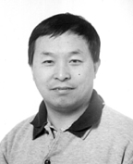
Dr. Wei-Ping Huang was born in Beijing. He graduated from MIT and got his PhD degree. Now he is a professor in the ECE Department at the University of Waterloo, Canada. His research group is one of the leading groups internationally in photonics and computer aided design. Dr. Huang is creating new design tools to help develop the highly-efficient photonics systems required for large-scale broadband communication.

Consider a wave equation: $∇^{2}Ψ+\frac{n^{2}}{c^{2}}\frac{∂^{2}Ψ}{∂t^{2}}=\frac{∂^{2}Ψ}{∂x^{2}}+\frac{∂^{2}Ψ}{∂y^{2}}+\frac{∂^{2}Ψ}{∂z^{2}}+\frac{n^{2}}{c^{2}}\frac{∂^{2}Ψ}{∂t^{2}}=0$, where Ψ(x,y,z,t) is the scalar field (approximation) and n(x,y,z) is the refractive index. Using Ψ(i△x,j△y,k△z,l△t)≡Ψ(i,j,k,l)≡Ψ^{l}(i,j,k), where 0≦i≦I, 0≦j≦J, and 0≦k≦K.
Let $\frac{∂^{2}Ψ}{∂x^{2}}=\frac{Ψ^{l}(i+1,j,k)−2Ψ^{l}(i,j,k)+Ψ^{l}(i−1,j,k)}{{Δx}^{2}}$,
$\frac{∂^{2}Ψ}{∂y^{2}}=\frac{Ψ^{l}(i,j+1,k)−2Ψ^{l}(i,j,k)+Ψ^{l}(i,j−1,k)}{{Δy}^{2}}$,
$\frac{∂^{2}Ψ}{∂z^{2}}=\frac{Ψ^{l}(i,j,k+1)−2Ψ^{l}(i,j,k)+Ψ^{l}(i,j,k−1)}{{Δz}^{2}}$,
and $\frac{∂^{2}Ψ}{∂t^{2}}=\frac{Ψ^{l+1}(i,j,k)−2Ψ^{l}(i,j,k)^{l}+Ψ^{l−1}(i,j,k)}{{Δt}^{2}}$
$⇒$$Ψ^{l+1}(i,j,k)=2⋅[1−\frac{δ_{x^{2}}+δ_{y^{2}}+δ_{z^{2}}}{n^{2}(i,j,k)}]⋅Ψ^{l}(i,j,k)−Ψ^{l−1}(i,j,k)$
$+\frac{δ_{x^{2}}}{n^{2}(i,j,k)}⋅[Ψ^{l}(i+1,j,k)+Ψ^{l}(i−1,j,k)]$$+\frac{δ_{y^{2}}}{n^{2}(i,j,k)}⋅[Ψ^{l}(i,j+1,k)+Ψ^{l}(i,j−1,k)]$
$$+\frac{δ_{z^{2}}}{n^{2}(i,j,k)}⋅[Ψ^{l}(i,j,k+1)+Ψ^{l}(i,j,k−1)]$$
where $δ_{x}=\frac{cΔt}{Δx}$, $δ_{y}=\frac{cΔt}{Δy}$, $δ_{z}=\frac{cΔt}{Δz}$.
The electromagnetic power distribution |Ψ|².

The 3D scalar FDTD method may be incorporated with the Mur’s absorbing boundary conditions.

Mur’s First-Order Absorbing Boundary Conditions:
At x=0, $Ψ^{l+1}(0,j,k)=Ψ^{l}(1,j,k)+\frac{cΔt−Δx}{cΔt+Δx}⋅[Ψ^{l+1}(1,j,k)−Ψ^{l}(0,j,k)]$
x=I△x, $Ψ^{l+1}(I,j,k)=Ψ^{l}(I−1,j,k)+\frac{cΔt−Δx}{cΔt+Δx}⋅[Ψ^{l+1}(I−1,j,k)−Ψ^{l}(I,j,k)]$
y=0, $Ψ^{l+1}(i,0,k)=Ψ^{l}(i,1,k)+\frac{cΔt−Δy}{cΔt+Δy}⋅[Ψ^{l+1}(i,1,k)−Ψ^{l}(i,0,k)]$
y=J△y, $Ψ^{l+1}(i,J,k)=Ψ^{l}(i,J−1,k)+\frac{cΔt−Δy}{cΔt+Δy}⋅[Ψ^{l+1}(i,J−1,k)−Ψ^{l}(i,J,k)]$
z=0, $Ψ^{l+1}(i,j,0)=Ψ^{l}(i,j,0)+\frac{cΔt−Δz}{cΔt+Δz}⋅[Ψ^{l+1}(i,j,1)−Ψ^{l}(i,j,0)]$
z=K△z, $Ψ^{l+1}(i,j,K)=Ψ^{l}(i,j,K−1)+\frac{cΔt−Δz}{cΔt+Δz}⋅[Ψ^{l+1}(i,j,K−1)−Ψ^{l}(i,j,K)]$

3D Semi-vectorial FDTD method (also by Dr. Wei-Ping Huang):
$$E_{x^{l+1}}(i,j,k)=2⋅\left\{1−\frac{[2−\frac{T(i+1,j,k)+T(i−1,j,k)}{2}]⋅δ_{x^{2}}+δ_{y^{2}}+δ_{z^{2}}}{n^{2}(i,j,k)}\right\}⋅E_{x^{l}}(i,j,k)−E_{x^{l−1}}(i,j,k)$$
$$+\frac{δ_{x^{2}}}{n^{2}(i,j,k)}⋅[T(i+1,j,k)⋅E_{x^{l}}(i+1,j,k)+T(i−1,j,k)⋅E_{x^{l}}(i−1,j,k)]$$
$+\frac{δ_{y^{2}}}{n^{2}(i,j,k)}⋅[E_{x^{l}}(i,j+1,k)+E_{x^{l}}(i,j−1,k)]$$+\frac{δ_{z^{2}}}{n^{2}(i,j,k)}⋅[E_{x^{l}}(i,j,k+1)+E_{x^{l}}(i,j,k−1)]$

$$E_{y^{l+1}}(i,j,k)=2⋅\left\{1−\frac{δ_{x^{2}}+[2−\frac{T(i,j+1,k)+T(i,j−1,k)}{2}]⋅δ_{y^{2}}+δ_{z^{2}}}{n^{2}(i,j,k)}\right\}⋅E_{y^{l}}(i,j,k)−E_{y^{l−1}}(i,j,k)$$
$+\frac{δ_{x^{2}}}{n^{2}(i,j,k)}⋅[E_{y^{l}}(i+1,j,k)+E_{y^{l}}(i−1,j,k)]$$+\frac{δ_{z^{2}}}{n^{2}(i,j,k)}⋅[E_{y^{l}}(i,j,k+1)+E_{y^{l}}(i,j,k−1)]$
$$+\frac{δ_{y^{2}}}{n^{2}(i,j,k)}⋅[T(i,j+1,k)⋅E_{y^{l}}(i,j+1,k)+T(i,j−1,k)⋅E_{y^{l}}(i,j−1,k)]$$

where $T(i±1,j,k)=\frac{2n^{2}(i±1,j,k)}{n^{2}(i±1,j,k)+n^{2}(i,j,k)}$ and $T(i,j±1,k)=\frac{2n^{2}(i,j±1,k)}{n^{2}(i,j±1,k)+n^{2}(i,j,k)}$.

The 3D Semi-vectorial FDTD method may be incorporated with the perfectly matched layer (PML) boundary conditions.

Perfectly matched layer (PML) boundary conditions:
In the x-direction:
$Ψ^{l+1}\left(i,j,k\right)=−Ψ^{l−1}\left(i,j,k\right)+2\left[1−\frac{δ_{y^{2}}+δ_{z^{2}}}{n^{2}\left(i,j,k\right)}\right]Ψ^{l}\left(i,j,k\right)$$+\frac{δ_{x^{2}}}{n^{2}\left(i,j,k\right)}\left[D_{{2x}^{l+\frac{1}{2}}}\left(i,j,k\right)−D_{{2x}^{l−\frac{1}{2}}}\left(i,j,k\right)\right]$$+\frac{δ_{y^{2}}}{n^{2}\left(i,j,k\right)}\left[Ψ^{l}\left(i,j+1,k\right)+Ψ^{l}\left(i,j−1,k\right)\right]$$+\frac{δ_{z^{2}}}{n^{2}\left(i,j,k\right)}\left[Ψ^{l}\left(i,j,k+1\right)+Ψ^{l}\left(i,j,k−1\right)\right]$, where $δ_{x}=\frac{cΔt}{Δx}$, $δ_{y}=\frac{cΔt}{Δy}$, $δ_{z}=\frac{cΔt}{Δz}$
$$D_{{1x}^{l+1}}\left(i+1,j,k\right)=\frac{a_{x}−\frac{σ_{x}⋅Δt}{ε_{0}n^{2}\left(i+1,j,k\right)}}{a_{x}+\frac{σ_{x}⋅Δt}{ε_{0}n^{2}\left(i+1,j,k\right)}}⋅D_{{1x}^{l−1}}\left(i+1,j,k\right)$$
$$+\frac{1}{a_{x}+\frac{σ_{x}⋅Δt}{ε_{0}n^{2}\left(i+1,j,k\right)}}⋅\left[Ψ^{l}\left(i+1,j,k\right)−Ψ^{l}\left(i,j,k\right)\right]$$

$$D_{{2x}^{l+1}}\left(i,j,k\right)=\frac{a_{x}−\frac{σ_{x}⋅Δt}{ε_{0}n^{2}\left(i+1,j,k\right)}}{a_{x}+\frac{σ_{x}⋅Δt}{ε_{0}n^{2}\left(i+1,j,k\right)}}⋅D_{{2x}^{l−1}}\left(i,j,k\right)$$
$$+\frac{1}{a_{x}+\frac{σ_{x}⋅Δt}{ε_{0}n^{2}\left(i+1,j,k\right)}}⋅[D_{{1x}^{l+1}}\left(i+1,j,k\right)−D_{{1x}^{l+1}}\left(i−1,j,k\right)$$
$−D_{{1x}^{l−1}}\left(i+1,j,k\right)+D_{{1x}^{l−1}}\left(i−1,j,k\right)]$,
$$σ_{x}\left(x\right)={\left(\frac{x}{d}\right)}^{m}σ_{x\text{max}}=−{\left(\frac{x}{d}\right)}^{m}\frac{n_{x^{2}}ε_{0}c\left(m+1\right)\text{ln}\left(R_{0}\right)}{2d}$$
$d=n_{x}Δx$: thickness of PML, m: order, $R_{0}$: reflection from PML at normal incidence
$n_{x}=8$, $R_{0}={\text{10}}^{−2}$, m=4
In the y-direction:
$$Ψ^{l+1}\left(i,j,k\right)=−Ψ^{l−1}\left(i,j,k\right)+2\left[1−\frac{δ_{x^{2}}+δ_{z^{2}}}{n^{2}\left(i,j,k\right)}\right]Ψ^{l}\left(i,j,k\right)$$
$+\frac{δ_{x^{2}}}{n^{2}\left(i,j,k\right)}\left[Ψ^{l}\left(i+1,j,k\right)+Ψ^{l}\left(i−1,j,k\right)\right]$$+\frac{δ_{y^{2}}}{n^{2}\left(i,j,k\right)}\left[D_{{2y}^{l+\frac{1}{2}}}\left(i,j,k\right)−D_{{2y}^{l−\frac{1}{2}}}\left(i,j,k\right)\right]$$+\frac{δ_{z^{2}}}{n^{2}\left(i,j,k\right)}\left[Ψ^{l}\left(i,j,k+1\right)+Ψ^{l}\left(i,j,k−1\right)\right]$,
where $δ_{x}=\frac{cΔt}{Δx}$, $δ_{y}=\frac{cΔt}{Δy}$, $δ_{z}=\frac{cΔt}{Δz}$
$$D_{{1y}^{l+1}}\left(i,j+1,k\right)=\frac{a_{y}−\frac{σ_{y}⋅Δt}{ε_{0}n^{2}\left(i,j+1,k\right)}}{a_{y}+\frac{σ_{y}⋅Δt}{ε_{0}n^{2}\left(i,j+1,k\right)}}⋅D_{{1y}^{l−1}}\left(i,j+1,k\right)$$
$$+\frac{1}{a_{y}+\frac{σ_{y}⋅Δt}{ε_{0}n^{2}\left(i,j+1,k\right)}}⋅\left[Ψ^{l}\left(i,j+1,k\right)−Ψ^{l}\left(i,j,k\right)\right]$$
$$D_{{2y}^{l+1}}\left(i,j,k\right)=\frac{a_{y}−\frac{σ_{y}⋅Δt}{ε_{0}n^{2}\left(i,j+1,k\right)}}{a_{y}+\frac{σ_{y}⋅Δt}{ε_{0}n^{2}\left(i,j+1,k\right)}}⋅D_{{2y}^{l−1}}\left(i,j,k\right)$$
$$+\frac{1}{a_{y}+\frac{σ_{y}⋅Δt}{ε_{0}n^{2}\left(i,j+1,k\right)}}⋅[D_{{1y}^{l+1}}\left(i,j+1,k\right)−D_{{1y}^{l+1}}\left(i,j−1,k\right)$$
$−D_{{1y}^{l−1}}\left(i,j+1,k\right)+D_{{1y}^{l−1}}\left(i,j−1,k\right)]$,
$$σ_{y}\left(y\right)={\left(\frac{y}{d}\right)}^{m}σ_{y\text{max}}=−{\left(\frac{y}{d}\right)}^{m}\frac{n_{y^{2}}ε_{0}c\left(m+1\right)\text{ln}\left(R_{0}\right)}{2d}$$
$d=n_{y}Δy$: thickness of PML, m: order
$R_{0}$: reflection from PML at normal incidence
$n_{y}=8$, $R_{0}={\text{10}}^{−2}$, m=4
In the z-direction:
$$Ψ^{l+1}\left(i,j,k\right)=−Ψ^{l−1}\left(i,j,k\right)+2\left[1−\frac{δ_{x^{2}}+δ_{y^{2}}}{n^{2}\left(i,j,k\right)}\right]Ψ^{l}\left(i,j,k\right)$$
$+\frac{δ_{x^{2}}}{n^{2}\left(i,j,k\right)}\left[Ψ^{l}\left(i+1,j,k\right)+Ψ^{l}\left(i−1,j,k\right)\right]$$+\frac{δ_{y^{2}}}{n^{2}\left(i,j,k\right)}\left[Ψ^{l}\left(i,j+1,k\right)+Ψ^{l}\left(i,j−1,k\right)\right]$$+\frac{δ_{z^{2}}}{n^{2}\left(i,j,k\right)}\left[D_{{2z}^{l+\frac{1}{2}}}\left(i,j,k\right)−D_{{2z}^{l−\frac{1}{2}}}\left(i,j,k\right)\right]$,
where $δ_{x}=\frac{cΔt}{Δx}$, $δ_{y}=\frac{cΔt}{Δy}$, $δ_{z}=\frac{cΔt}{Δz}$
$$D_{{1z}^{l+1}}\left(i,j,k+1\right)=\frac{a_{z}−\frac{σ_{z}⋅Δt}{ε_{0}n^{2}\left(i,j,k+1\right)}}{a_{z}+\frac{σ_{z}⋅Δt}{ε_{0}n^{2}\left(i,j,k+1\right)}}⋅D_{{1z}^{l−1}}\left(i,j,k+1\right)$$
$+\frac{1}{a_{z}+\frac{σ_{z}⋅Δt}{ε_{0}n^{2}\left(i,j,k+1\right)}}⋅\left[Ψ^{l}\left(i,j,k+1\right)−Ψ^{l}\left(i,j,k\right)\right]$
$$σ_{z}\left(z\right)={\left(\frac{z}{d}\right)}^{m}σ_{z\text{max}}=−{\left(\frac{z}{d}\right)}^{m}\frac{n_{z^{2}}ε_{0}c\left(m+1\right)\text{ln}\left(R_{0}\right)}{2d}$$
$$+\frac{1}{a_{z}+\frac{σ_{z}⋅Δt}{2ε_{0}n^{2}\left(i,j,k+1\right)}}⋅[D_{{1z}^{l+1}}\left(i,j,k+1\right)−D_{{1z}^{l+1}}\left(i,j,k−1\right)$$
$$−D_{{1z}^{l−1}}\left(i,j,k+1\right)+D_{{1z}^{l−1}}\left(i,j,k−1\right)]$$

$$σ_{z}\left(z\right)={\left(\frac{z}{d}\right)}^{m}σ_{z\text{max}}=−{\left(\frac{z}{d}\right)}^{m}\frac{n_{z^{2}}ε_{0}c\left(m+1\right)\text{ln}\left(R_{0}\right)}{2d}$$
$d=n_{z}Δz$: thickness of PML, m: order
$R_{0}$: reflection from PML at normal incidence
$n_{z}=8$, $R_{0}={\text{10}}^{−2}$, m=4

Eg. Use FDTD method to simulate the characteristics of photonic crystal T-junction waveguide. (by Y. -J. Lin, 林宇仁)
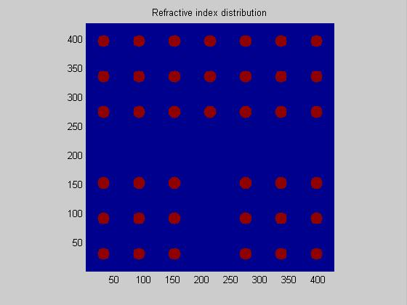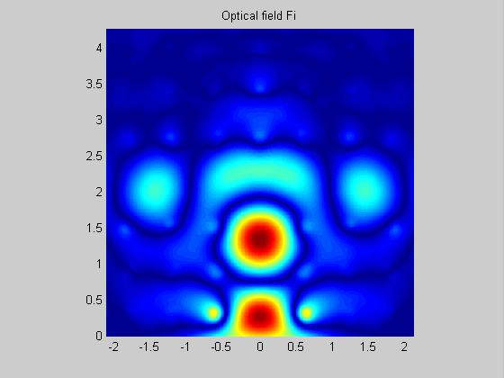
Eg. Use FDTD method to simulate the characteristics of photonic crystal Y-junction waveguide.
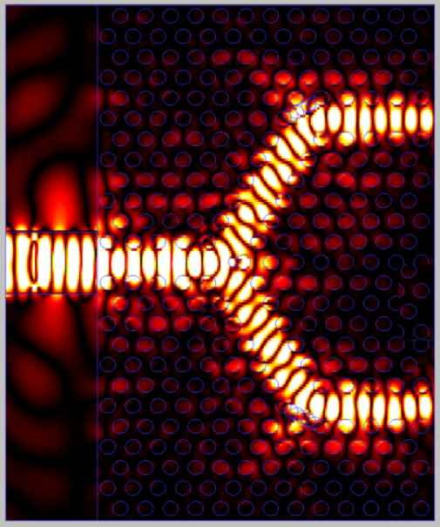

Eg. Use FDTD method to simulate the characteristics of LED.
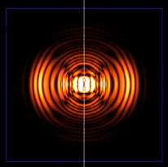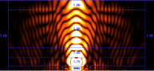
8-5 Finite-difference Beam Propagation Method (FDBPM)
Consider that a light wave propagates along z-directional optical waveguide and set $\vec{E}=xE'_{x}+yE'_{y}+zE'_{z}$ in a source-free region.

E-formulation (by Dr. Wei-Ping Huang):
$∇×∇×\vec{E}−n^{2}k^{2}\vec{E}=∇(∇⋅\vec{E})−∇^{2}\vec{E}−n^{2}k^{2}\vec{E}=0$$⇒$$∇^{2}\vec{E}+n^{2}k^{2}\vec{E}=∇(∇⋅\vec{E})$
$⇒$$∇^{2}(xE'_{x}+yE'_{y}+zE'_{z})+n^{2}k^{2}(xE'_{x}+yE'_{y}+zE'_{z})=∇(\frac{∂E'_{x}}{∂x}+\frac{∂E'_{y}}{∂y}+\frac{∂E'_{z}}{∂z})$
∵ No source, ∴$∇⋅(ε\vec{E})=∇⋅(n^{2}\vec{E})=0$$⇒$$\frac{∂(n^{2}E'_{x})}{∂x}+\frac{∂(n^{2}E'_{y})}{∂y}+\frac{∂n^{2}}{∂z}E'_{z}+n^{2}\frac{∂E'_{z}}{∂z}=0$

If the refractive index profile varies slowly along the z-axis, $∂n^{2}/∂z$ may be neglected. $⇒$$\frac{∂E'_{z}}{∂z}≈−\frac{1}{n^{2}}[\frac{∂(n^{2}E'_{x})}{∂x}+\frac{∂(n^{2}E'_{y})}{∂y}]$
$$\begin{aligned}∇^{2}(xE'_{x}+yE'_{y}+zE'_{z})+n^{2}k^{2}(xE'_{x}+yE'_{y}+zE'_{z}) \\ (x\frac{∂}{∂x}+y\frac{∂}{∂y}+z\frac{∂}{∂z})(\frac{∂E'_{x}}{∂x}+\frac{∂E'_{y}}{∂y}−\frac{1}{n^{2}}[\frac{∂(n^{2}E'_{x})}{∂x}+\frac{∂(n^{2}E'_{y})}{∂y}])\end{aligned}$$
$⇒$$∇^{2}E'_{x}+n^{2}k^{2}E'_{x}=\frac{∂}{∂x}$,
and $∇^{2}E'_{y}+n^{2}k^{2}E'_{y}=\frac{∂}{∂y}$.

Assume that $E'_{x}=E_{x}e^{−{\text{jn}}_{0}\text{kz}}$ and $E'_{y}=E_{y}e^{−{\text{jn}}_{0}\text{kz}}$, where k is the vacuum wave number and n₀=β/k is the effective refractive index. With the assumption that the guided lightwave has a slow-varying envelop and is paraxially propagating; i.e., $\left|\frac{∂^{2}E_{x}}{∂z^{2}}\right|\text{<<}2n_{0}k\left|\frac{∂E_{x}}{∂z}\right|$, $\left|\frac{∂^{2}E_{y}}{∂z^{2}}\right|\text{<<}2n_{0}k\left|\frac{∂E_{y}}{∂z}\right|$$⇒$$\left|\frac{∂^{2}E_{x}}{∂z^{2}}\right|$ and $\left|\frac{∂^{2}E_{y}}{∂z^{2}}\right|$ are neglected.

And then we have the following coupled equations
$$2{\text{jn}}_{0}k⋅\frac{∂E_{x}(x,y,z)}{∂z}=\frac{∂}{∂x}\left\{\frac{1}{n^{2}(x,y,z)}⋅\frac{∂}{∂x}[n^{2}(x,y,z)E_{x}(x,y,z)]\right\}+\frac{∂^{2}E_{x}(x,y,z)}{∂y^{2}}$$
$+[n^{2}(x,y,z)−n_{0^{2}}]k^{2}E_{x}(x,y,z)$$+\frac{∂}{∂x}\left\{\frac{1}{n^{2}(x,y,z)}⋅\frac{∂}{∂y}[n^{2}(x,y,z)E_{y}(x,y,z)]\right\}−\frac{∂^{2}E_{y}(x,y,z)}{∂x∂y}$
and
$$2{\text{jn}}_{0}k⋅\frac{∂E_{y}(x,y,z)}{∂z}=\frac{∂^{2}E_{y}(x,y,z)}{∂x^{2}}+\frac{∂}{∂y}\left\{\frac{1}{n^{2}(x,y,z)}⋅\frac{∂}{∂y}[n^{2}(x,y,z)E_{y}(x,y,z)]\right\}$$
$+[n^{2}(x,y,z)−n_{0^{2}}]k^{2}E_{y}(x,y,z)$$+\frac{∂}{∂y}\left\{\frac{1}{n^{2}(x,y,z)}⋅\frac{∂}{∂x}[n^{2}(x,y,z)E_{x}(x,y,z)]\right\}−\frac{∂^{2}E_{x}(x,y,z)}{∂y∂x}$
These coupled equations are the basic formulas of the full-vector BPM. If we neglect the terms of A_{xy} and A_{yx}, then the equations are reduced to the formulas of the semi-vector BPM. In case the transverse variation of the refractive index is very small, and that is, $\frac{1}{n^{2}}\frac{∂}{∂x}(n^{2}E_{x})≈\frac{∂E_{x}}{∂x}$ and $\frac{1}{n^{2}}\frac{∂}{∂y}(n^{2}E_{y})≈\frac{∂E_{y}}{∂y}$.
The formulas of the semi-vector BPM can be simplified into the following Fresnel equation, which is the formula of the scalar BPM.

3D Full-vector BPM involving the Runge-Kutta algorithm (by Y. -J. Lin):
The transverse components of the optical field fulfill the following coupled equations
$$2{\text{jn}}_{0}k⋅\frac{∂E_{x}(x,y,z)}{∂z}=\frac{∂}{∂x}\left\{\frac{1}{n^{2}(x,y,z)}⋅\frac{∂}{∂x}[n^{2}(x,y,z)E_{x}(x,y,z)]\right\}+\frac{∂^{2}E_{x}(x,y,z)}{∂y^{2}}$$
$+[n^{2}(x,y,z)−n_{0^{2}}]k^{2}E_{x}(x,y,z)$$+\frac{∂}{∂x}\left\{\frac{1}{n^{2}(x,y,z)}⋅\frac{∂}{∂y}[n^{2}(x,y,z)E_{y}(x,y,z)]\right\}−\frac{∂^{2}E_{y}(x,y,z)}{∂x∂y}$
and
$$2{\text{jn}}_{0}k⋅\frac{∂E_{y}(x,y,z)}{∂z}=\frac{∂^{2}E_{y}(x,y,z)}{∂x^{2}}+\frac{∂}{∂y}\left\{\frac{1}{n^{2}(x,y,z)}⋅\frac{∂}{∂y}[n^{2}(x,y,z)E_{y}(x,y,z)]\right\}$$
$+[n^{2}(x,y,z)−n_{0^{2}}]k^{2}E_{y}(x,y,z)$$+\frac{∂}{∂y}\left\{\frac{1}{n^{2}(x,y,z)}⋅\frac{∂}{∂x}[n^{2}(x,y,z)E_{x}(x,y,z)]\right\}−\frac{∂^{2}E_{x}(x,y,z)}{∂y∂x}$

According to the Runge-Kutta method, the transverse components of the propagating field are expressed by

$\left\{\begin{matrix}\overset{}{E_{x}}(m,n,l+1)=\begin{aligned}\left\{\overset{}{E_{x}}(m,n,l)+\frac{K_{1}(m,n,l)+2K_{2}(m,n,l)+2K_{3}(m,n,l)+K_{4}(m,n,l)}{6} | \right\}\end{aligned}\left\{\right\} \\ \overset{}{E_{y}}(m,n,l+1)=\begin{aligned}\left\{\overset{}{E_{y}}(m,n,l)+\frac{J_{1}(m,n,l)+2J_{2}(m,n,l)+2J_{3}(m,n,l)+J_{4}(m,n,l)}{6} | \right\}\end{aligned}\left\{\right\}\end{matrix}\right.$,
where
$K_{1}\left(m,n,l\right)=\frac{Δz}{2{\text{jn}}_{0}k}⋅$+$\frac{−b}{{Δx}^{2}}\left[\overset{}{E_{x}}\left(m,n,l\right)\right]$+$\frac{c}{{Δx}^{2}}\left[\overset{}{E_{x}}\left(m−1,n,l\right)\right]$
+$\frac{1}{{Δy}^{2}}\left[\overset{}{E_{x}}\left(m,n+1,l\right)\right]$+$\frac{−2}{{Δy}^{2}}\left[\overset{}{E_{x}}\left(m,n,l\right)\right]$+$\frac{1}{{Δy}^{2}}\left[\overset{}{E_{x}}\left(m,n−1,l\right)\right]$
$$+\left[n^{2}\left(m,n,l\right)−n_{0^{2}}\right]⋅k^{2}⋅\left[\overset{}{E_{x}}\left(m,n,l\right)\right]$$
$$K_{2}\left(m,n,l\right)=\frac{Δz}{2{\text{jn}}_{0}k}⋅$$
+$\frac{−b}{{Δx}^{2}}\left[\overset{}{E_{x}}\left(m,n,l\right)+\frac{K_{1}\left(m,n,l\right)}{2}\right]$+$\frac{c}{{Δx}^{2}}\left[\overset{}{E_{x}}\left(m−1,n,l\right)+\frac{K_{1}\left(m−1,n,l\right)}{2}\right]$
+$\frac{1}{{Δy}^{2}}\left[\overset{}{E_{x}}\left(m,n+1,l\right)+\frac{K_{1}\left(m,n+1,l\right)}{2}\right]$+$\frac{−2}{{Δy}^{2}}\left[\overset{}{E_{x}}\left(m,n,l\right)+\frac{K_{1}\left(m,n,l\right)}{2}\right]$
+$\frac{1}{{Δy}^{2}}\left[\overset{}{E_{x}}\left(m,n−1,l\right)+\frac{K_{1}\left(m,n−1,l\right)}{2}\right]$$+\left[n^{2}\left(m,n,l\right)−n_{0^{2}}\right]⋅k^{2}⋅\left[\overset{}{E_{x}}\left(m,n,l\right)+\frac{K_{1}\left(m,n,l\right)}{2}\right]$
$$K_{3}\left(m,n,l\right)=\frac{Δz}{2{\text{jn}}_{0}k}⋅$$
+$\frac{−b}{{Δx}^{2}}$+$\frac{c}{{Δx}^{2}}$
+$\frac{1}{{Δy}^{2}}\left[\overset{}{E_{x}}\left(m,n+1,l\right)+\frac{K_{2}\left(m,n+1,l\right)}{2}\right]$+$\frac{−2}{{Δy}^{2}}\left[\overset{}{E_{x}}\left(m,n,l\right)+\frac{K_{2}\left(m,n,l\right)}{2}\right]$
+$\frac{1}{{Δy}^{2}}\left[\overset{}{E_{x}}\left(m,n−1,l\right)+\frac{K_{2}\left(m,n−1,l\right)}{2}\right]$
$$+\left[n^{2}\left(m,n,l\right)−n_{0^{2}}\right]⋅k^{2}⋅\left[\overset{}{E_{x}}\left(m,n,l\right)+\frac{K_{2}\left(m,n,l\right)}{2}\right]$$
$$K_{4}\left(m,n,l\right)=\frac{Δz}{2{\text{jn}}_{0}k}⋅$$
+$\frac{−b}{{Δx}^{2}}\left[\overset{}{E_{x}}\left(m,n,l\right)+K_{3}\left(m,n,l\right)\right]$+$\frac{c}{{Δx}^{2}}\left[\overset{}{E_{x}}\left(m−1,n,l\right)+K_{3}\left(m−1,n,l\right)\right]$
+$\frac{1}{{Δy}^{2}}\left[\overset{}{E_{x}}\left(m,n+1,l\right)+K_{3}\left(m,n+1,l\right)\right]$+$\frac{−2}{{Δy}^{2}}\left[\overset{}{E_{x}}\left(m,n,l\right)+K_{3}\left(m,n,l\right)\right]$
+$\frac{1}{{Δy}^{2}}\left[\overset{}{E_{x}}\left(m,n−1,l\right)+K_{3}\left(m,n−1,l\right)\right]$
$$+\left[n^{2}\left(m,n,l\right)−n_{0^{2}}\right]⋅k^{2}⋅\left[\overset{}{E_{x}}\left(m,n,l\right)+K_{3}\left(m,n,l\right)\right]$$
$O_{1}\left(m,n,l\right)=\frac{Δz}{8{\text{jn}}_{0}kΔxΔy}$$\overset{}{E_{y}}\left(m+1,n+1,l\right)⋅\left[\frac{n^{2}\left(m+1,n+1,l\right)}{n^{2}\left(m+1,n,l\right)}−1\right]$
+$\overset{}{E_{y}}\left(m,n+1,l\right)⋅\left[−2\frac{n^{2}\left(m,n+1,l\right)}{n^{2}\left(m,n,l\right)}+2\right]$+$\overset{}{E_{y}}\left(m−1,n+1,l\right)⋅\left[\frac{n^{2}\left(m−1,n+1,l\right)}{n^{2}\left(m−1,n,l\right)}−1\right]$
+$\overset{}{E_{y}}\left(m+1,n−1,l\right)⋅\left[\frac{n^{2}\left(m+1,n−1,l\right)}{n^{2}\left(m+1,n,l\right)}−1\right]$+$\overset{}{E_{y}}\left(m,n−1,l\right)⋅\left[−2\frac{n^{2}\left(m,n−1,l\right)}{n^{2}\left(m,n,l\right)}+2\right]$
+$\overset{}{E_{y}}\left(m−1,n−1,l\right)⋅\left[\frac{n^{2}\left(m−1,n−1,l\right)}{n^{2}\left(m−1,n,l\right)}−1\right]$-$2E_{y}(m+1,n,l)$+$4E_{y}(m,n,l)$-$2E_{y}(m−1,n,l)$
$O_{2}\left(m,n,l\right)=\frac{Δz}{8{\text{jn}}_{0}kΔxΔy}$$\left[\overset{}{E_{y}}\left(m+1,n+1,l\right)+\frac{O_{1}\left(m+1,n+1,l\right)}{2}\right]⋅\left[\frac{n^{2}\left(m+1,n+1,l\right)}{n^{2}\left(m+1,n,l\right)}−1\right]$
+$\left[\overset{}{E_{y}}\left(m,n+1,l\right)+\frac{O_{1}\left(m,n+1,l\right)}{2}\right]⋅\left[−2\frac{n^{2}\left(m,n+1,l\right)}{n^{2}\left(m,n,l\right)}+2\right]$
+$\left[\overset{}{E_{y}}\left(m−1,n+1,l\right)+\frac{O_{1}\left(m−1,n+1,l\right)}{2}\right]⋅\left[\frac{n^{2}\left(m−1,n+1,l\right)}{n^{2}\left(m−1,n,l\right)}−1\right]$
+$\left[\overset{}{E_{y}}\left(m+1,n−1,l\right)+\frac{O_{1}\left(m+1,n−1,l\right)}{2}\right]⋅\left[\frac{n^{2}\left(m+1,n−1,l\right)}{n^{2}\left(m+1,n,l\right)}−1\right]$
+$\left[\overset{}{E_{y}}\left(m,n−1,l\right)+\frac{O_{1}\left(m,n−1,l\right)}{2}\right]⋅\left[−2\frac{n^{2}\left(m,n−1,l\right)}{n^{2}\left(m,n,l\right)}+2\right]$
+$\left[\overset{}{E_{y}}\left(m−1,n−1,l\right)+\frac{O_{1}\left(m−1,n−1,l\right)}{2}\right]⋅\left[\frac{n^{2}\left(m−1,n−1,l\right)}{n^{2}\left(m−1,n,l\right)}−1\right]$
-$2⋅[E_{y}(m+1,n,l)+O_{1}(m+1,n,l)/2]$+$4⋅[E_{y}(m,n,l)+O_{1}(m,n,l)/2]$
-$2⋅[E_{y}(m−1,n,l)+O_{1}(m−1,n,l)/2]$
$O_{3}\left(m,n,l\right)=\frac{Δz}{8{\text{jn}}_{0}kΔxΔy}$$\left[\overset{}{E_{y}}\left(m+1,n+1,l\right)+\frac{O_{2}\left(m+1,n+1,l\right)}{2}\right]⋅\left[\frac{n^{2}\left(m+1,n+1,l\right)}{n^{2}\left(m+1,n,l\right)}−1\right]$
+$\left[\overset{}{E_{y}}\left(m,n+1,l\right)+\frac{O_{2}\left(m,n+1,l\right)}{2}\right]⋅\left[−2\frac{n^{2}\left(m,n+1,l\right)}{n^{2}\left(m,n,l\right)}+2\right]$
+$\left[\overset{}{E_{y}}\left(m−1,n+1,l\right)+\frac{O_{2}\left(m−1,n+1,l\right)}{2}\right]⋅\left[\frac{n^{2}\left(m−1,n+1,l\right)}{n^{2}\left(m−1,n,l\right)}−1\right]$
+$\left[\overset{}{E_{y}}\left(m+1,n−1,l\right)+\frac{O_{2}\left(m+1,n−1,l\right)}{2}\right]⋅\left[\frac{n^{2}\left(m+1,n−1,l\right)}{n^{2}\left(m+1,n,l\right)}−1\right]$
+$\left[\overset{}{E_{y}}\left(m,n−1,l\right)+\frac{O_{2}\left(m,n−1,l\right)}{2}\right]⋅\left[−2\frac{n^{2}\left(m,n−1,l\right)}{n^{2}\left(m,n,l\right)}+2\right]$
+$\left[\overset{}{E_{y}}\left(m−1,n−1,l\right)+\frac{O_{2}\left(m−1,n−1,l\right)}{2}\right]⋅\left[\frac{n^{2}\left(m−1,n−1,l\right)}{n^{2}\left(m−1,n,l\right)}−1\right]$
-$2⋅[E_{y}(m+1,n,l)+O_{2}(m+1,n,l)/2]$+$4⋅[E_{y}(m,n,l)+O_{2}(m,n,l)/2]$
-$2⋅[E_{y}(m−1,n,l)+O_{2}(m−1,n,l)/2]$
$O_{4}\left(m,n,l\right)=\frac{Δz}{8{\text{jn}}_{0}kΔxΔy}$$\left[\overset{}{E_{y}}\left(m+1,n+1,l\right)+O_{3}\left(m+1,n+1,l\right)\right]⋅\left[\frac{n^{2}\left(m+1,n+1,l\right)}{n^{2}\left(m+1,n,l\right)}−1\right]$
+$\left[\overset{}{E_{y}}\left(m,n+1,l\right)+O_{3}\left(m,n+1,l\right)\right]⋅\left[−2\frac{n^{2}\left(m,n+1,l\right)}{n^{2}\left(m,n,l\right)}+2\right]$
+$\left[\overset{}{E_{y}}\left(m−1,n+1,l\right)+O_{3}\left(m−1,n+1,l\right)\right]⋅\left[\frac{n^{2}\left(m−1,n+1,l\right)}{n^{2}\left(m−1,n,l\right)}−1\right]$
+$\left[\overset{}{E_{y}}\left(m+1,n−1,l\right)+O_{3}\left(m+1,n−1,l\right)\right]⋅\left[\frac{n^{2}\left(m+1,n−1,l\right)}{n^{2}\left(m+1,n,l\right)}−1\right]$
+$\left[\overset{}{E_{y}}\left(m,n−1,l\right)+O_{3}\left(m,n−1,l\right)\right]⋅\left[−2\frac{n^{2}\left(m,n−1,l\right)}{n^{2}\left(m,n,l\right)}+2\right]$
+$\left[\overset{}{E_{y}}\left(m−1,n−1,l\right)+O_{3}\left(m−1,n−1,l\right)\right]⋅\left[\frac{n^{2}\left(m−1,n−1,l\right)}{n^{2}\left(m−1,n,l\right)}−1\right]$
-$2⋅[E_{y}(m+1,n,l)+O_{3}(m+1,n,l)]$+$4⋅[E_{y}(m,n,l)+O_{3}(m,n,l)]$
-$2⋅[E_{y}(m−1,n,l)+O_{3}(m−1,n,l)]$
$J_{1}\left(m,n,l\right)=\frac{Δz}{2{\text{jn}}_{0}k}⋅$+$\frac{−2}{{Δx}^{2}}\left[\overset{}{E_{y}}\left(m,n,l\right)\right]$
+$\frac{1}{{Δx}^{2}}\left[\overset{}{E_{y}}\left(m−1,n,l\right)\right]$+$\frac{d}{{Δy}^{2}}\left[\overset{}{E_{y}}\left(m,n+1,l\right)\right]$+$\frac{−e}{{Δy}^{2}}\left[\overset{}{E_{y}}\left(m,n,l\right)\right]$+$\frac{f}{{Δy}^{2}}\left[\overset{}{E_{y}}\left(m,n−1,l\right)\right]$
$$+\left[n^{2}\left(m,n,l\right)−n_{0^{2}}\right]⋅k^{2}⋅\left[\overset{}{E_{y}}\left(m,n,l\right)\right]$$
$$J_{2}\left(m,n,l\right)=\frac{Δz}{2{\text{jn}}_{0}k}⋅$$
+$\frac{−2}{{Δx}^{2}}\left[\overset{}{E_{y}}\left(m,n,l\right)+\frac{J_{1}\left(m,n,l\right)}{2}\right]$+$\frac{1}{{Δx}^{2}}\left[\overset{}{E_{y}}\left(m−1,n,l\right)+\frac{J_{1}\left(m−1,n,l\right)}{2}\right]$
+$\frac{d}{{Δy}^{2}}\left[\overset{}{E_{y}}\left(m,n+1,l\right)+\frac{J_{1}\left(m,n+1,l\right)}{2}\right]$+$\frac{−e}{{Δy}^{2}}\left[\overset{}{E_{y}}\left(m,n,l\right)+\frac{J_{1}\left(m,n,l\right)}{2}\right]$
+$\frac{f}{{Δy}^{2}}\left[\overset{}{E_{y}}\left(m,n−1,l\right)+\frac{J_{1}\left(m,n−1,l\right)}{2}\right]$
$$+\left[n^{2}\left(m,n,l\right)−n_{0^{2}}\right]⋅k^{2}⋅\left[\overset{}{E_{y}}\left(m,n,l\right)+\frac{J_{1}\left(m,n,l\right)}{2}\right]$$
$$J_{3}\left(m,n,l\right)=\frac{Δz}{2{\text{jn}}_{0}k}⋅$$
+$\frac{−2}{{Δx}^{2}}\left[\overset{}{E_{y}}\left(m,n,l\right)+\frac{J_{2}\left(m,n,l\right)}{2}\right]$+$\frac{1}{{Δx}^{2}}\left[\overset{}{E_{y}}\left(m−1,n,l\right)+\frac{J_{2}\left(m−1,n,l\right)}{2}\right]$
+$\frac{d}{{Δy}^{2}}\left[\overset{}{E_{y}}\left(m,n+1,l\right)+\frac{J_{2}\left(m,n+1,l\right)}{2}\right]$+$\frac{−e}{{Δy}^{2}}\left[\overset{}{E_{y}}\left(m,n,l\right)+\frac{J_{2}\left(m,n,l\right)}{2}\right]$
+$\frac{f}{{Δy}^{2}}\left[\overset{}{E_{y}}\left(m,n−1,l\right)+\frac{J_{2}\left(m,n−1,l\right)}{2}\right]$$+\left[n^{2}\left(m,n,l\right)−n_{0^{2}}\right]⋅k^{2}⋅\left[\overset{}{E_{y}}\left(m,n,l\right)+\frac{J_{2}\left(m,n,l\right)}{2}\right]$
$$J_{4}\left(m,n,l\right)=\frac{Δz}{2{\text{jn}}_{0}k}⋅$$
+$\frac{−2}{{Δx}^{2}}\left[\overset{}{E_{y}}\left(m,n,l\right)+J_{3}\left(m,n,l\right)\right]$+$\frac{1}{{Δx}^{2}}\left[\overset{}{E_{y}}\left(m−1,n,l\right)+J_{3}\left(m−1,n,l\right)\right]$
+$\frac{d}{{Δy}^{2}}\left[\overset{}{E_{y}}\left(m,n+1,l\right)+J_{3}\left(m,n+1,l\right)\right]$+$\frac{−e}{{Δy}^{2}}\left[\overset{}{E_{y}}\left(m,n,l\right)+J_{3}\left(m,n,l\right)\right]$
+$\frac{f}{{Δy}^{2}}\left[\overset{}{E_{y}}\left(m,n−1,l\right)+J_{3}\left(m,n−1,l\right)\right]$
$$+\left[n^{2}\left(m,n,l\right)−n_{0^{2}}\right]⋅k^{2}⋅\left[\overset{}{E_{y}}\left(m,n,l\right)+J_{3}\left(m,n,l\right)\right]$$
$P_{1}\left(m,n,l\right)=\frac{Δz}{8{\text{jn}}_{0}kΔxΔy}$$\overset{}{E_{x}}\left(m+1,n+1,l\right)⋅\left[\frac{n^{2}\left(m+1,n+1,l\right)}{n^{2}\left(m,n+1,l\right)}−1\right]$
+$\overset{}{E_{x}}\left(m+1,n,l\right)⋅\left[−2\frac{n^{2}\left(m+1,n,l\right)}{n^{2}\left(m,n,l\right)}+2\right]$+$\overset{}{E_{x}}\left(m+1,n−1,l\right)⋅\left[\frac{n^{2}\left(m+1,n−1,l\right)}{n^{2}\left(m,n−1,l\right)}−1\right]$
+$\overset{}{E_{x}}\left(m−1,n+1,l\right)⋅\left[\frac{n^{2}\left(m−1,n+1,l\right)}{n^{2}\left(m,n+1,l\right)}−1\right]$+$\overset{}{E_{x}}\left(m−1,n,l\right)⋅\left[−2\frac{n^{2}\left(m−1,n,l\right)}{n^{2}\left(m,n,l\right)}+2\right]$
+$\overset{}{E_{x}}\left(m−1,n−1,l\right)⋅\left[\frac{n^{2}\left(m−1,n−1,l\right)}{n^{2}\left(m,n−1,l\right)}−1\right]$-$2E_{x}(m,n+1,l)$+$4E_{x}(m,n,l)$
-$2E_{x}(m,n−1,l)$
$P_{2}\left(m,n,l\right)=\frac{Δz}{8{\text{jn}}_{0}kΔxΔy}$$\left[\overset{}{E_{x}}\left(m+1,n+1,l\right)+\frac{P_{1}\left(m+1,n+1,l\right)}{2}\right]⋅\left[\frac{n^{2}\left(m+1,n+1,l\right)}{n^{2}\left(m,n+1,l\right)}−1\right]$
+$\left[\overset{}{E_{x}}\left(m+1,n,l\right)+\frac{P_{1}\left(m+1,n,l\right)}{2}\right]⋅\left[−2\frac{n^{2}\left(m+1,n,l\right)}{n^{2}\left(m,n,l\right)}+2\right]$
+$\left[\overset{}{E_{x}}\left(m+1,n−1,l\right)+\frac{P_{1}\left(m+1,n−1,l\right)}{2}\right]⋅\left[\frac{n^{2}\left(m+1,n−1,l\right)}{n^{2}\left(m1,n−1,l\right)}−1\right]$
+$\left[\overset{}{E_{x}}\left(m−1,n+1,l\right)+\frac{P_{1}\left(m−1,n+1,l\right)}{2}\right]⋅\left[\frac{n^{2}\left(m−1,n+1,l\right)}{n^{2}\left(m,n+1,l\right)}−1\right]$
+$\left[\overset{}{E_{x}}\left(m−1,n,l\right)+\frac{P_{1}\left(m−1,n,l\right)}{2}\right]⋅\left[−2\frac{n^{2}\left(m−1,n,l\right)}{n^{2}\left(m,n,l\right)}+2\right]$
+$\left[\overset{}{E_{x}}\left(m−1,n−1,l\right)+\frac{P_{1}\left(m−1,n−1,l\right)}{2}\right]⋅\left[\frac{n^{2}\left(m−1,n−1,l\right)}{n^{2}\left(m,n−1,l\right)}−1\right]$
-$2⋅[E_{x}(m,n+1,l)+P_{1}(m,n+1,l)/2]$+$4⋅[E_{x}(m,n,l)+P_{1}(m,n,l)/2]$
-$2⋅[E_{x}(m,n−1,l)+P_{1}(m,n−1,l)/2]$
$P_{3}\left(m,n,l\right)=\frac{Δz}{8{\text{jn}}_{0}kΔxΔy}$$\left[\overset{}{E_{x}}\left(m+1,n+1,l\right)+\frac{P_{2}\left(m+1,n+1,l\right)}{2}\right]⋅\left[\frac{n^{2}\left(m+1,n+1,l\right)}{n^{2}\left(m,n+1,l\right)}−1\right]$
+$\left[\overset{}{E_{x}}\left(m+1,n,l\right)+\frac{P_{2}\left(m+1,n,l\right)}{2}\right]⋅\left[−2\frac{n^{2}\left(m+1,n,l\right)}{n^{2}\left(m,n,l\right)}+2\right]$
+$\left[\overset{}{E_{x}}\left(m+1,n−1,l\right)+\frac{P_{2}\left(m+1,n−1,l\right)}{2}\right]⋅\left[\frac{n^{2}\left(m+1,n−1,l\right)}{n^{2}\left(m1,n−1,l\right)}−1\right]$
+$\left[\overset{}{E_{x}}\left(m−1,n+1,l\right)+\frac{P_{2}\left(m−1,n+1,l\right)}{2}\right]⋅\left[\frac{n^{2}\left(m−1,n+1,l\right)}{n^{2}\left(m,n+1,l\right)}−1\right]$
+$\left[\overset{}{E_{x}}\left(m−1,n,l\right)+\frac{P_{2}\left(m−1,n,l\right)}{2}\right]⋅\left[−2\frac{n^{2}\left(m−1,n,l\right)}{n^{2}\left(m,n,l\right)}+2\right]$
+$\left[\overset{}{E_{x}}\left(m−1,n−1,l\right)+\frac{P_{2}\left(m−1,n−1,l\right)}{2}\right]⋅\left[\frac{n^{2}\left(m−1,n−1,l\right)}{n^{2}\left(m,n−1,l\right)}−1\right]$
-$2⋅[E_{x}(m,n+1,l)+P_{2}(m,n+1,l)/2]$+$4⋅[E_{x}(m,n,l)+P_{2}(m,n,l)/2]$
-$2⋅[E_{x}(m,n−1,l)+P_{2}(m,n−1,l)/2]$
$P_{4}\left(m,n,l\right)=\frac{Δz}{8{\text{jn}}_{0}kΔxΔy}$$\left[\overset{}{E_{x}}\left(m+1,n+1,l\right)+P_{3}\left(m+1,n+1,l\right)\right]⋅\left[\frac{n^{2}\left(m+1,n+1,l\right)}{n^{2}\left(m,n+1,l\right)}−1\right]$
+$\left[\overset{}{E_{x}}\left(m+1,n,l\right)+P_{3}\left(m+1,n,l\right)\right]⋅\left[−2\frac{n^{2}\left(m+1,n,l\right)}{n^{2}\left(m,n,l\right)}+2\right]$
+$\left[\overset{}{E_{x}}\left(m+1,n−1,l\right)+P_{3}\left(m+1,n−1,l\right)\right]⋅\left[\frac{n^{2}\left(m+1,n−1,l\right)}{n^{2}\left(m,n−1,l\right)}−1\right]$
+$\left[\overset{}{E_{x}}\left(m−1,n+1,l\right)+P_{3}\left(m−1,n+1,l\right)\right]⋅\left[\frac{n^{2}\left(m−1,n+1,l\right)}{n^{2}\left(m,n+1,l\right)}−1\right]$
+$\left[\overset{}{E_{x}}\left(m−1,n,l\right)+P_{3}\left(m−1,n,l\right)\right]⋅\left[−2\frac{n^{2}\left(m−1,n,l\right)}{n^{2}\left(m,n,l\right)}+2\right]$
+$\left[\overset{}{E_{x}}\left(m−1,n−1,l\right)+P_{3}\left(m−1,n−1,l\right)\right]⋅\left[\frac{n^{2}\left(m−1,n−1,l\right)}{n^{2}\left(m,n−1,l\right)}−1\right]$
-$2⋅[E_{x}(m,n+1,l)+P_{3}(m,n+1,l)]$+$4⋅[E_{x}(m,n,l)+P_{3}(m,n,l)]$
-$2⋅[E_{x}(m,n−1,l)+P_{3}(m,n−1,l)]$
$a=\frac{1}{2}+\frac{n^{2}\left(m+1,n,l\right)}{2n^{2}\left(m,n,l\right)}$, $b=1+\frac{n^{2}\left(m,n,l\right)}{2}⋅\left[\frac{1}{n^{2}\left(m+1,n,l\right)}+\frac{1}{n^{2}\left(m−1,n,l\right)}\right]$,
$c=\frac{1}{2}+\frac{n^{2}\left(m−1,n,l\right)}{2n^{2}\left(m,n,l\right)}$, $d=\frac{1}{2}+\frac{n^{2}(m,n+1,l)}{2n^{2}(m,n,l)}$,
$e=1+\frac{n^{2}\left(m,n,l\right)}{2}⋅\left[\frac{1}{n^{2}\left(m,n+1,l\right)}+\frac{1}{n^{2}\left(m,n−1,l\right)}\right]$, $f=\frac{1}{2}+\frac{n^{2}\left(m,n−1,l\right)}{2n^{2}\left(m,n,l\right)}$
Power distribution${\left|\vec{E}\right|}^{2}=(E_{x^{2}}+E_{y^{2}})$
3D Semi-vector BPM involving the Runge-Kutta algorithm (by K. -Y. Lee):
The transverse components of the optical field E_{x}(x,y,z) and E_{y}(x,y,z) fulfill
$$2{\text{jn}}_{0}k⋅\frac{∂E_{x}(x,y,z)}{∂z}=\frac{∂}{∂x}\left\{\frac{1}{n^{2}(x,y,z)}⋅\frac{∂}{∂x}[n^{2}(x,y,z)E_{x}(x,y,z)]\right\}+\frac{∂^{2}E_{x}(x,y,z)}{∂y^{2}}$$
$$+[n^{2}(x,y,z)−n_{0^{2}}]k^{2}E_{x}(x,y,z)$$
and
$$2{\text{jn}}_{0}k⋅\frac{∂E_{y}(x,y,z)}{∂z}=\frac{∂^{2}E_{y}(x,y,z)}{∂x^{2}}+\frac{∂}{∂y}\left\{\frac{1}{n^{2}(x,y,z)}⋅\frac{∂}{∂y}[n^{2}(x,y,z)E_{y}(x,y,z)]\right\}$$
$$+[n^{2}(x,y,z)−n_{0^{2}}]k^{2}E_{y}(x,y,z)$$
The Runge-Kutta algorithm can be directly to obtain the propagating field components as
$$E_{x}(m,i,l+1)=E_{x}(m,i,l)+\frac{K_{1}(m,i,l)+2K_{2}(m,i,l)+2K_{3}(m,i,l)+K_{4}(m,i,l)}{6}$$
and
$E_{y}(m,i,l+1)=E_{y}(m,i,l)+\frac{J_{1}(m,i,l)+2J_{2}(m,i,l)+2J_{3}(m,i,l)+J_{4}(m,i,l)}{6}$,
where
$$K_{1}(m,i,l)=\frac{Δz}{2{\text{jn}}_{0}k}⋅$$
$+\frac{E_{x}(m,i+1,l)−2E_{x}(m,i,l)+E_{x}(m,i−1,l)}{{Δy}^{2}}$$+[n^{2}(m,i,l)−n_{0^{2}}]⋅k^{2}⋅E_{x}(m,i,l)$
$$K_{2}(m,i,l)=\frac{Δz}{2{\text{jn}}_{0}k}⋅$$
$$+\frac{E_{x}(m,i+1,l)+\frac{K_{1}(m,i+1,l)}{2}−2[E_{x}(m,i,l)+\frac{K_{1}(m,i,l)}{2}]+E_{x}(m,i−1,l)+\frac{K_{1}(m,i−1,l)}{2}}{{Δy}^{2}}$$
$$+[n^{2}(m,i,l)−n_{0^{2}}]⋅k^{2}⋅[E_{x}(m,i,l)+\frac{K_{1}(m,i,l)}{2}]$$
$$K_{3}(m,i,l)=\frac{Δz}{2{\text{jn}}_{0}k}⋅$$
$$+\frac{E_{x}(m,i+1,l)+\frac{K_{2}(m,i+1,l)}{2}−2[E_{x}(m,i,l)+\frac{K_{2}(m,i,l)}{2}]+E_{x}(m,i−1,l)+\frac{K_{2}(m,i−1,l)}{2}}{{Δy}^{2}}$$
$$+[n^{2}(m,i,l)−n_{0^{2}}]⋅k^{2}⋅[E_{x}(m,i,l)+\frac{K_{2}(m,i,l)}{2}]$$
$$K_{4}(m,i,l)=\frac{Δz}{2{\text{jn}}_{0}k}⋅$$
$$+\frac{E_{x}(m,i+1,l)+K_{3}(m,i+1,l)−2[E_{x}(m,i,l)+K_{3}(m,i,l)]+E_{x}(m,i−1,l)+K_{3}(m,i−1,l)}{{Δy}^{2}}$$
$$+[n^{2}(m,i,l)−n_{0^{2}}]⋅k^{2}⋅[E_{x}(m,i,l)+K_{3}(m,i,l)]$$
$$J_{1}(m,i,l)=\frac{Δz}{2{\text{jn}}_{0}k}⋅$$

$+\frac{{\text{dE}}_{y}(m,i+1,l)−{\text{eE}}_{y}(m,i,l)+{\text{fE}}_{y}(m,i−1,l)}{{Δy}^{2}}$$+[n^{2}(m,i,l)−n_{0^{2}}]⋅k^{2}⋅E_{y}(m,i,l)$,
$$J_{2}(m,i,l)=\frac{Δz}{2{\text{jn}}_{0}k}⋅$$
$$+\frac{d[E_{y}(m,i+1,l)+\frac{J_{1}(m,i+1,l)}{2}]−e[E_{y}(m,i,l)+\frac{J_{1}(m,i,l)}{2}]+f[E_{y}(m,i−1,l)+\frac{J_{1}(m,i−1,l)}{2}]}{{Δy}^{2}}$$
$$+[n^{2}(m,i,l)−n_{0^{2}}]⋅k^{2}⋅[E_{y}(m,i,l)+\frac{J_{1}(m,i,l)}{2}]$$
$$J_{3}(m,i,l)=\frac{Δz}{2{\text{jn}}_{0}k}⋅$$
$$+\frac{d[E_{y}(m,i+1,l)+\frac{J_{2}(m,i+1,l)}{2}]−e[E_{y}(m,i,l)+\frac{J_{2}(m,i,l)}{2}]+f[E_{y}(m,i−1,l)+\frac{J_{2}(m,i−1,l)}{2}]}{{Δy}^{2}}$$
$$+[n^{2}(m,i,l)−n_{0^{2}}]⋅k^{2}⋅[E_{y}(m,i,l)+\frac{J_{2}(m,i,l)}{2}]$$
$$J_{4}(m,i,l)=\frac{Δz}{2{\text{jn}}_{0}k}⋅$$
$$+\frac{d[E_{y}(m,i+1,l)+J_{3}(m,i+1,l)]−e[E_{y}(m,i,l)+J_{3}(m,i,l)]+f[E_{y}(m,i−1,l)+J_{3}(m,i−1,l)]}{{Δy}^{2}}$$
$$+[n^{2}(m,i,l)−n_{0^{2}}]⋅k^{2}⋅[E_{y}(m,i,l)+J_{3}(m,i,l)]$$
$a=\frac{1}{2}+\frac{n^{2}(m+1,i,l)}{2n^{2}(m,i,l)}$, $b=1+\frac{n^{2}(m,i,l)}{2}⋅[\frac{1}{n^{2}(m+1,i,l)}+\frac{1}{n^{2}(m−1,i,l)}]$, $c=\frac{1}{2}+\frac{n^{2}(m−1,i,l)}{2n^{2}(m,i,l)}$,
$d=\frac{1}{2}+\frac{n^{2}(m,i+1,l)}{2n^{2}(m,i,l)}$, $e=1+\frac{n^{2}(m,i,l)}{2}⋅[\frac{1}{n^{2}(m,i+1,l)}+\frac{1}{n^{2}(m,i−1,l)}]$, $f=\frac{1}{2}+\frac{n^{2}(m,i−1,l)}{2n^{2}(m,i,l)}$

Note that coefficients b and e approach 2, but a, c, d, and f approach 1 as the transverse variations of the refractive index profiles are very small. In this case, the above semivectorial formulae for two types of polarizations are reduced into the same scalar expressions.
Power distribution${\left|\vec{E}\right|}^{2}=E_{x^{2}}$ or $E_{y^{2}}$

3D Scalar BPM involving the Runge-Kutta algorithm (by K. -Y. Lee):
The scalar optical field φ(x,y,z) can be described by the following Fresnel equation
$2{\text{jn}}_{0}k⋅\frac{∂φ(x,y,z)}{∂z}=\frac{∂^{2}φ(x,y,z)}{∂x^{2}}+\frac{∂^{2}φ(x,y,z)}{∂y^{2}}+[n^{2}(x,y,z)−n_{0^{2}}]k^{2}φ(x,y,z)$,
Utilizing the finite difference scheme and the Runge-Kutta method, the propagating optical field at $(x=mΔx,y=iΔy,z=(l+1)Δz)$ is expressed by
$φ(m,i,l+1)=φ(m,i,l)+\frac{K_{1}(m,i,l)+2K_{2}(m,i,l)+2K_{3}(m,i,l)+K_{4}(m,i,l)}{6}$,
where
$$K_{1}(m,i,l)=\frac{Δz}{2{\text{jn}}_{0}k}⋅$$
$+\frac{φ(m,i+1,l)−2φ(m,i,l)+φ(m,i−1,l)}{{Δy}^{2}}$$+[n^{2}(m,i,l)−n_{0^{2}}]⋅k^{2}⋅φ(m,i,l)$
$$K_{2}(m,i,l)=\frac{Δz}{2{\text{jn}}_{0}k}⋅$$
$$+\frac{φ(m,i+1,l)+\frac{K_{1}(m,i+1,l)}{2}−2φ(m,i,l)−K_{1}(m,i,l)+φ(m,i−1,l)+\frac{K_{1}(m,i−1,l)}{2}}{{Δy}^{2}}$$
$$+[n^{2}(m,i,l)−n_{0^{2}}]⋅k^{2}⋅[φ(m,i,l)+\frac{K_{1}(m,i,l)}{2}]$$
$K_{3}(m,i,l)=\frac{Δz}{2{\text{jn}}_{0}k}⋅$$+\frac{φ(m,i+1,l)+\frac{K_{2}(m,i+1,l)}{2}−2φ(m,i,l)−K_{2}(m,i,l)+φ(m,i−1,l)+\frac{K_{2}(m,i−1,l)}{2}}{{Δy}^{2}}$
$$+[n^{2}(m,i,l)−n_{0^{2}}]⋅k^{2}⋅[φ(m,i,l)+\frac{K_{2}(m,i,l)}{2}]$$
and
$$K_{4}(m,i,l)=\frac{Δz}{2{\text{jn}}_{0}k}⋅$$
$$+\frac{φ(m,i+1,l)+K_{3}(m,i+1,l)−2φ(m,i,l)−2K_{3}(m,i,l)+φ(m,i−1,l)+K_{3}(m,i−1,l)}{{Δy}^{2}}$$
$$+[n^{2}(m,i,l)−n_{0^{2}}]⋅k^{2}⋅[φ(m,i,l)+K_{3}(m,i,l)]$$

On the other hand, the transparent boundary condition (TBC) is implemented in the computer programming for reducing extra numerical errors due to undesired wave reflections at the edges of computational windows.

Transparent Boundary Conditions (TBC):
Define $α_{+x}$, $α_{−x}$, $β_{+x}$, $β_{−x}$, $α_{+y}$, $α_{−y}$, $β_{+y}$, and $β_{−y}$ as
$α_{±x}+{jβ}_{±x}≡\text{ln}[\frac{φ(±M∓1,i,l)}{φ(±M∓2,i,l)}]$ and $α_{±y}+{jβ}_{±y}≡\text{ln}[\frac{φ(m,±I∓1,l)}{φ(m,±I∓2,l)}]$
TBC shows that
$$φ(±M,i,l)=\left\{\begin{matrix}\frac{φ(±M∓1,i,l)^{2}}{φ(±M∓2,i,l)} & ,α_{±x}<0 \\ φ(±M∓1,i,l)⋅\text{exp}({jβ}_{±x}) & ,α_{±x}≥0\end{matrix}\right.$$
and
$$φ(m,±I,l)=\left\{\begin{matrix}\frac{φ(m,±I∓1,l)^{2}}{φ(m,±I∓2,l)} & ,α_{±y}<0 \\ φ(m,±I∓1,l)⋅\text{exp}({jβ}_{±y}) & ,α_{±y}≥0\end{matrix}\right.$$
Similarly, the values $K_{1}(±M,i,l)$, $K_{2}(±M,i,l)$, $K_{3}(±M,i,l)$, $K_{4}(±M,i,l)$, $K_{1}(m,±I,l)$, $K_{2}(m,±I,l)$, $K_{3}(m,±I,l)$, and $K_{4}(m,±I,l)$ at the edges of the computation windows are obtained by the same rules.
Power distribution${\left|φ\right|}^{2}$
Eg. A laser beam passes an MMI waveguide device. (by K. Huang, 黃建智)
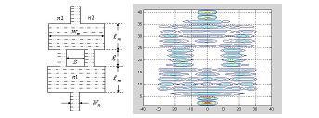

Eg. Simulation of the fundamental mode of a single-mode ridge waveguide.
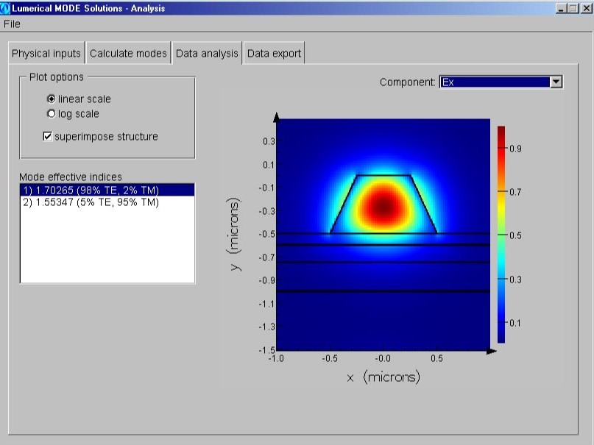

Eg. Simulation of a 10°-Y-junction 3D waveguide. (by K. –Y. Lee)
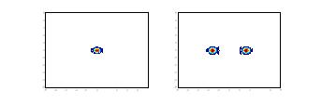
Input mode Output light spots
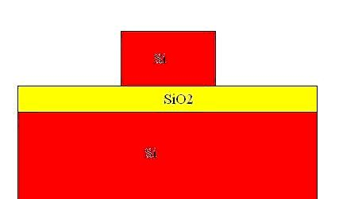
Eg. For an n×1 MMI optical combiner and a 1×n MMI optical splitter, the BPM simulation shows that L_{n×1}/L_{1×n}n-1, where L_{n×1} is the wide section length of the n×1 MMI optical combiner and L_{1×n} is the wide section length of the 1×n MMI optical splitter, respectively. Consider a SOI waveguide of n_{core}=3.45, $n_{\text{SiO}2}$=1.5, λ=1.55μm. The thickness of oxide is 2μm. The input single-mode waveguide has a 5μm×5μm cross section.
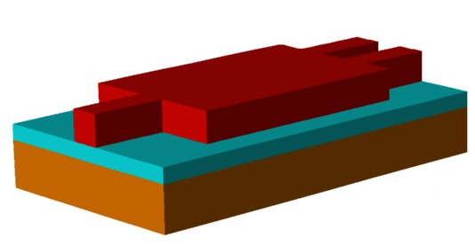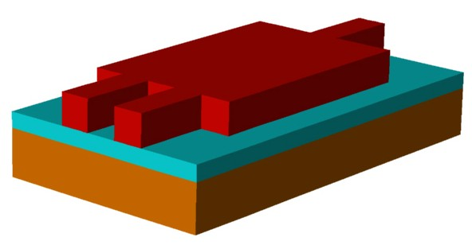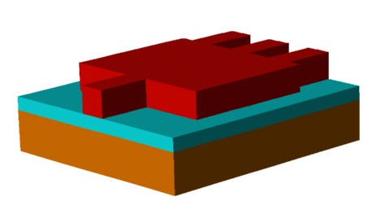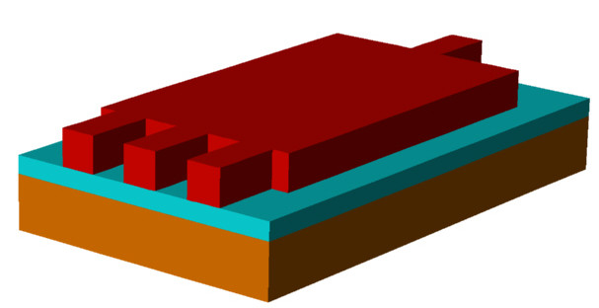
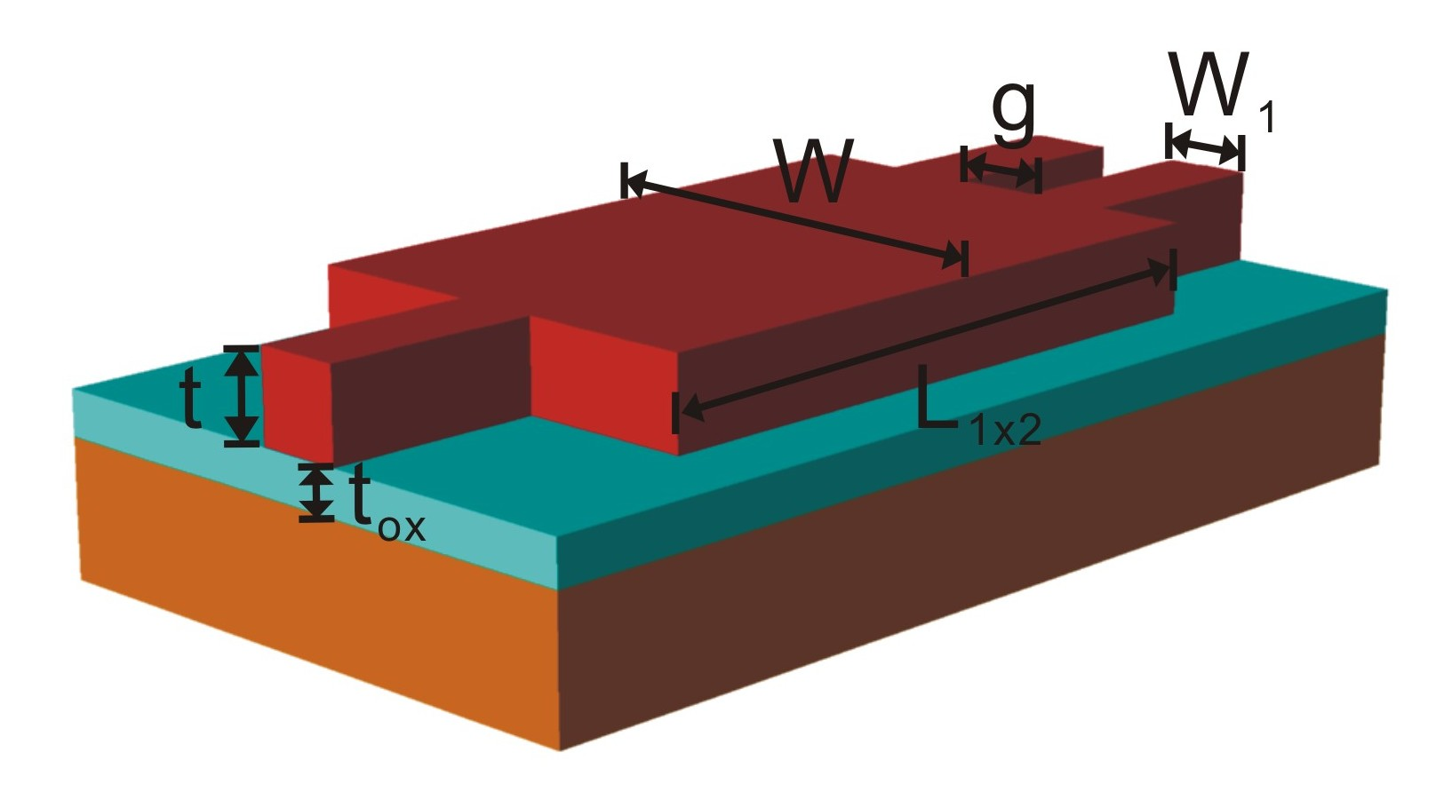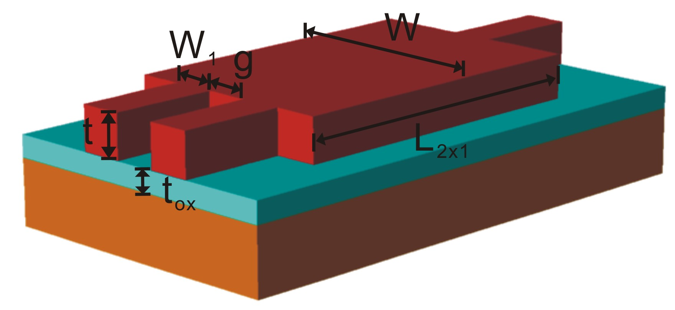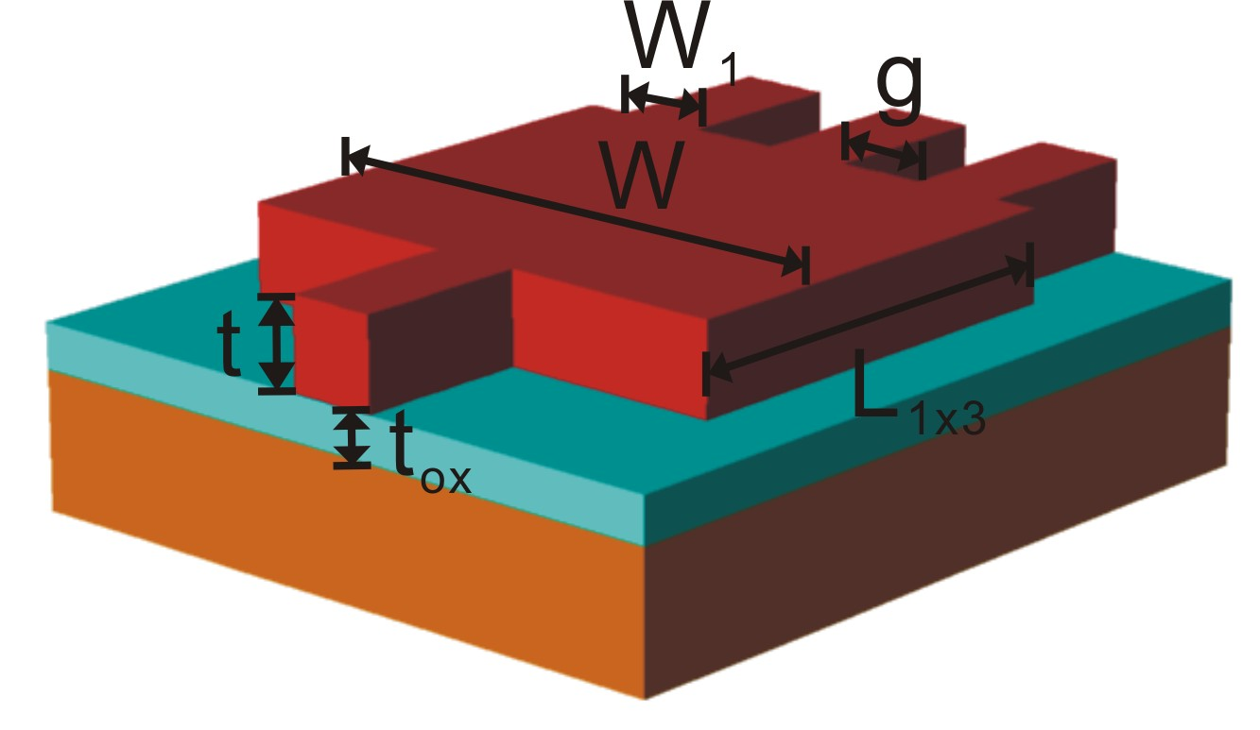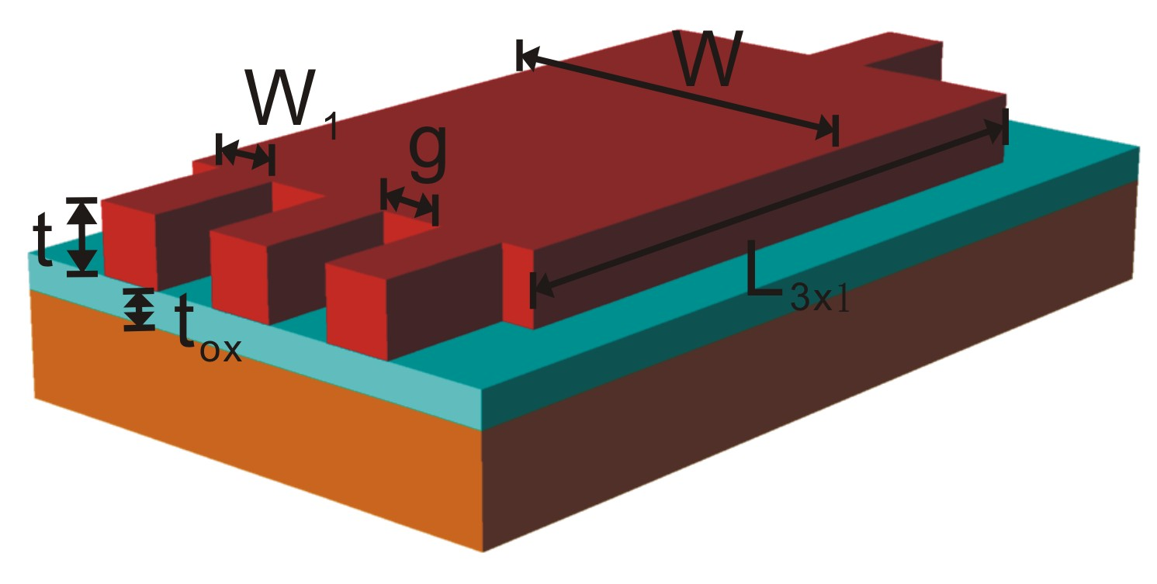
1×2 MMI splitter 2×1 MMI combiner 1×3 MMI splitter 3×1 MMI combiner 3D BPM simulation (by J. –R. Sze et al.):
n | 2 | 3 | 4 | 5
W | 40μm | 40μm | 40μm | 40μm
g | 15μm | 8.333μm | 5μm | 3μm
L_{n×1} | 1772μm | 2380μm | 2684μm | 2846μm
L_{1×n} | 1805μm | 1197μm | 893μm | 731μm
L_{n×1}/L_{1×n} | 0.98≒1 | 1.98≒2 | 3.005≒3 | 3.89≒4
