Chapter 9 Integral Equations
9-1 Classification of Integral Equations
Fredholm equation: $α(x)y(x)=F(x)+λ\int{K(x,t)y(t)\text{dt}}$
The 1st kind: α=0$⇒−F(x)=G(x)=λ\int{K(x,t)y(t)\text{dt}}$
The 2nd kind: α=1$⇒y(x)=F(x)+λ\int{K(x,t)y(t)\text{dt}}$
Voterra equation: $α(x)y(x)=F(x)+λ\int{K(x,t)y(t)\text{dt}}$
The 1st kind: α=0$⇒−F(x)=G(x)=λ\int{K(x,t)y(t)\text{dt}}$
The 2nd kind: α=1$⇒y(x)=F(x)+λ\int{K(x,t)y(t)\text{dt}}$
Eg. Solve Hallen’s equation: $−i\sqrt{\frac{ε_{0}}{μ_{0}}}\frac{V}{2}\text{sin}(k|z|)+C\text{cos}(k|z|)$$=\int{I(z^{'})K(z−z^{'},a)\text{dz}}'$, where K(z-z’,a)=$\frac{e^{−\text{ik}\sqrt{(z−z^{'})^{2}+a^{2}}}}{4π\sqrt{(z−z^{'})^{2}+a^{2}}}$, k=2π/λ and C must be satisfied by I(l)=0. This is an example of the first kind of the Fredholm equation.
(Sol.) 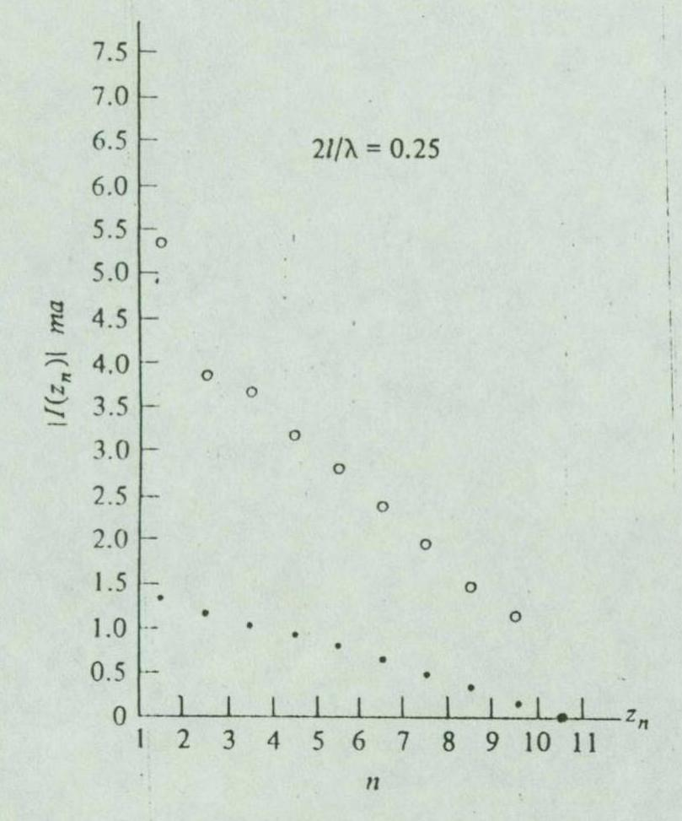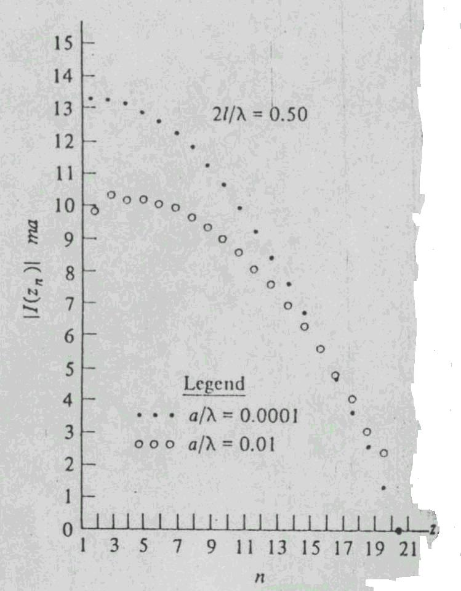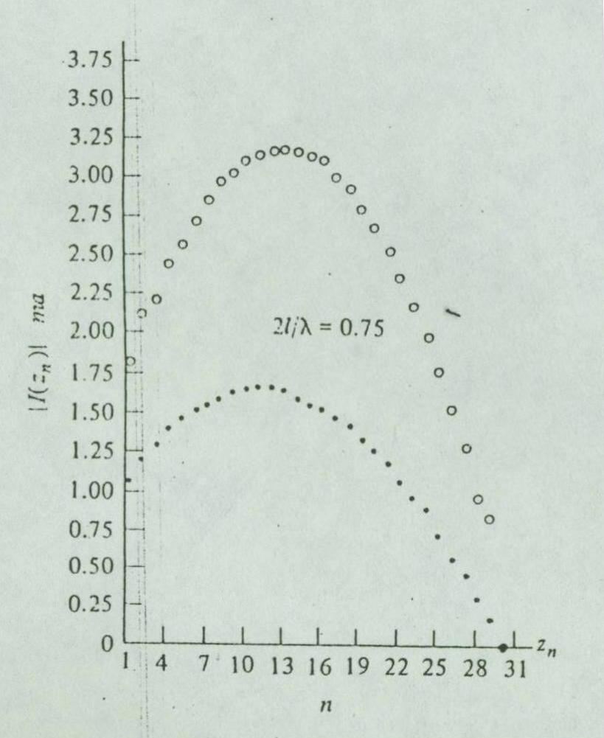
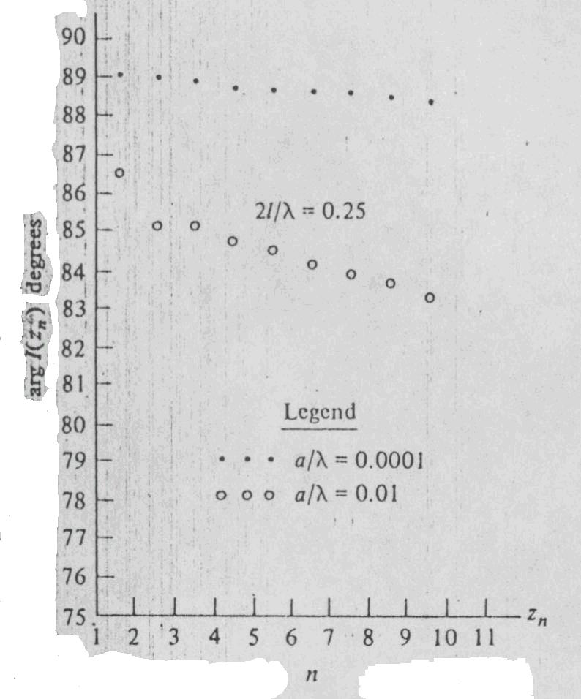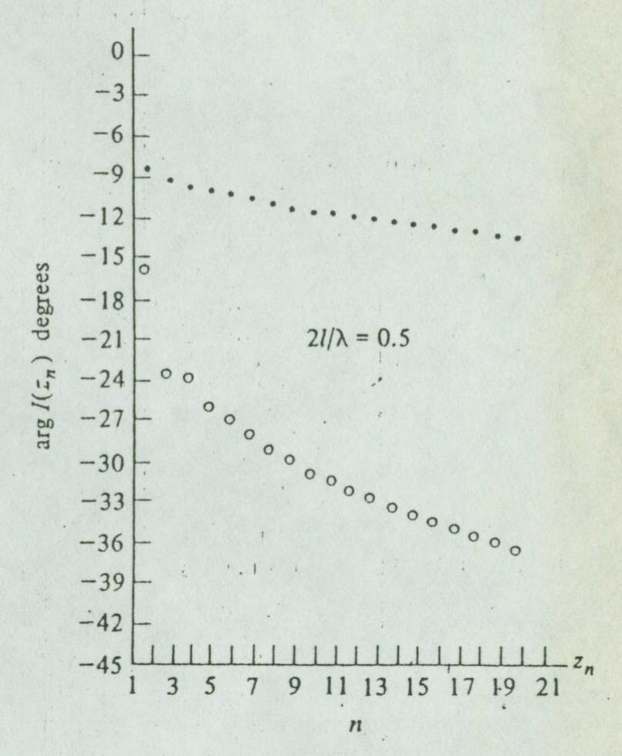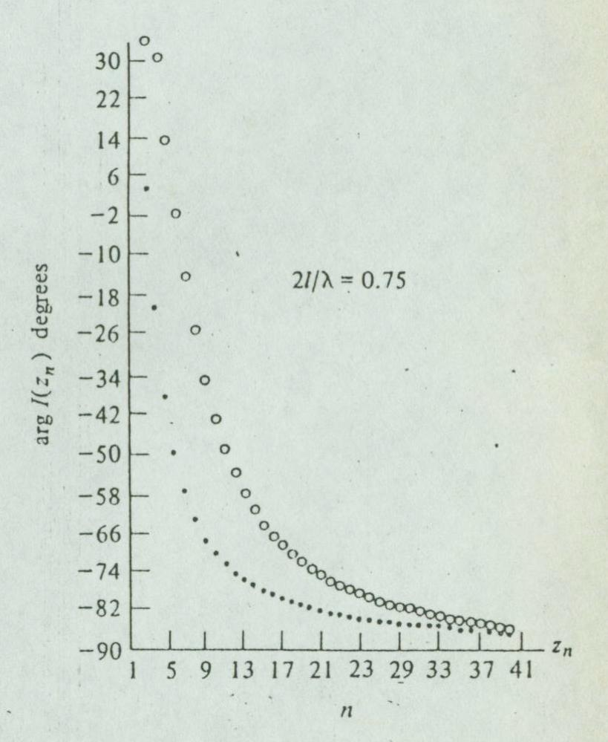
It is shown that the resonant length of the dipole antenna is about 1/4 of wavelength.
Eg. f(x)=e^{-x}-$\frac{1}{2}+\frac{e^{−(x+1)}}{2}+\frac{1}{2}\int{(x+1)e^{−\text{xy}}f(y)\text{dy}}$ is the second kind of the Fredholm equation, which has a solution f(x)=e^{-x}.
Some examples of solving integral equations:
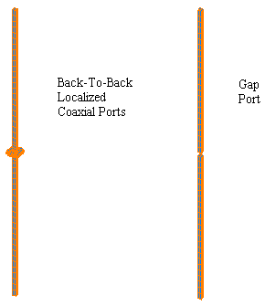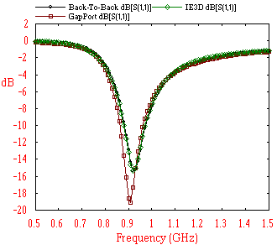
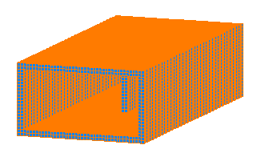
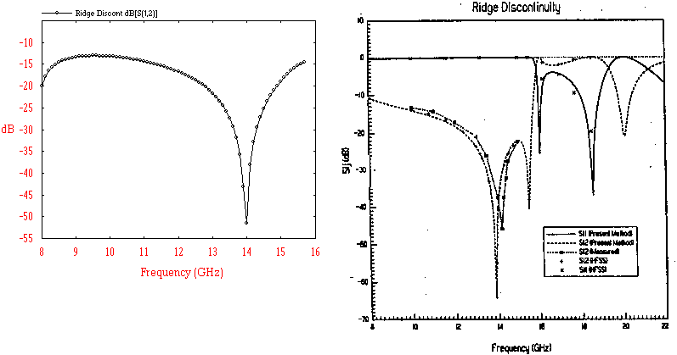
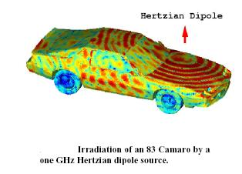
Relations between differential and integral equations:
Eg. $\frac{d^{2}y}{{\text{dx}}^{2}}+A(x)\frac{\text{dy}}{\text{dx}}+B(x)y=f(x)$ with y(a)=C, y’(a)=D.
Dummy variables: x=t, dx=dt, and then we have $\frac{d^{2}y}{{\text{dt}}^{2}}+A(t)\frac{\text{dy}}{\text{dt}}+B(t)y=f(t)$
$\int{\frac{d^{2}y}{{\text{dt}}^{2}}⋅\text{dt}=\int{f(t)\text{dt}−\int{A(t)\frac{\text{dy}}{\text{dt}}⋅\text{dt}−\int{B(t)y(t)⋅\text{dt}}}}}$
$=\int{f(t)\text{dt}−A(x)y(x)}\begin{aligned}|x \\ |a\end{aligned}+\int{y(t)A^{'}(t)\text{dt}}$$−\int{y(t)B(t)\text{dt}}$
$⇒y^{'}(x)−D=−A(x)y(x)−\int{[B(t)−A^{'}(t)]y(t)\text{dt}+\int{f(t)\text{dt}}}$+A(a)C
Dummy variables: x=s, dx=ds
$⇒\int{y^{'}(s)\text{ds}=[A(a)C+D](x−a)−\int{A(s)y(s)\text{ds}}}$
$−\int{\int{[B(t)−A^{'}(t)]y(t)\text{dtds}+\int{\int{f(t)\text{dtds}}}}}$
$⇒y(x)=C+[A(a)C+D](x−a)−\int{\int{[B(t)−A^{'}(t)]y(t)\text{dsdt}}}$$+\int{\int{f(t)\text{dsdt}−\int{A(t)y(t)\text{dt}}}}$
$=C+[A(a)C+D](x−a)−\int{\left\{A(t)+(x−t)[B(t)−A^{'}(t)]\right\}}y(t)\text{dt}$$+\int{(x−t)f(t)\text{dt}}$
$⇒y(x)=C+[A(a)C+D](x−a)+\int{(x−t)f(t)\text{dt}}$$−\int{\left\{A(t)+(x−t)[B(t)−A^{'}(t)]\right\}y(t)\text{dt}}$is the 2nd kind of Volterra equation.

Eg. Transform $\frac{d^{2}y}{{\text{dx}}^{2}}+λy=f(x)$ with y(0)=1, y’(0)=0 into an integral equation.
(Sol.) A(x)=0, B(x)=λ, C=1, D=0
$$⇒y(x)=1+\int{(x−t)f(t)\text{dt}−\int{(x−t)λy(t)\text{dt}}}$$
$$⇒y(x)=1−\int{(t−x)f(t)\text{dt}+λ\int{(t−x)y(t)\text{dt}}}$$

9-2 Moment Method
Solve a Fredholm equation F(x)=α(x)y(x)-$λ\int{K(x,t)y(t)\text{dt}}$.
Let y(x)=$\sum_{n=1}^{∞}{c_{n}f_{n}(x)≈\sum_{n=1}^{N}{c_{n}f_{n}(x)}}$
$⇒F(x)≈\sum_{n=1}^{N}{c_{n}α(x)f_{n}(x)−λ\int{K(x,t)⋅\sum_{n=1}^{N}{c_{n}f_{n}(t)\text{dt}}}}$$=\sum_{n=1}^{N}{c_{n}[α(x)f_{n}(x)}−λ\int{K(x,t)f_{n}(t)\text{dt}]}$
Choose distinct x₁, x₂, …, x_{N}
F(x₁)=$\sum_{n=1}^{N}{c_{n}A_{n}(x_{1})=c_{1}A_{1}(x_{1})+c_{2}A_{2}(x_{1})+⋯+c_{N}A_{N}(x_{1})}$
F(x₂)=$\sum_{n=1}^{N}{c_{n}A_{n}(x_{2})=c_{1}A_{1}(x_{2})+c_{2}A_{2}(x_{2})+⋯+c_{N}A_{N}(x_{2})}$
$$⋮ ⋮ ⋮ ⋮ ⋮$$
F(x_{N})=$\sum_{n=1}^{N}{c_{n}A_{n}(x_{N})=c_{1}A_{1}(x_{N})+c_{2}A_{2}(x_{N})+⋯+c_{N}A_{N}(x_{N})}$
Or, $\left[\begin{matrix}F(x_{1}) \\ F(x_{2}) \\ ⋮ \\ F(x_{N})\end{matrix}\right]=\left[\begin{matrix}A_{1}(x_{1}) & A_{2}(x_{1}) & ⋯ & A_{N}(x_{1}) \\ A_{1}(x_{2}) & A_{2}(x_{2}) & ⋯ & A_{N}(x_{2}) \\ ⋮ & ⋮ & & ⋮ \\ A_{1}(x_{N}) & A_{2}(x_{N}) & ⋯ & A_{N}(x_{N})\end{matrix}\right] \left[\begin{matrix}c_{1} \\ c_{2} \\ ⋮ \\ c_{N}\end{matrix}\right]⇒\left[\begin{matrix}c_{1} \\ c_{2} \\ ⋮ \\ c_{N}\end{matrix}\right]=?$
where $A_{n}(x_{m})=α(x_{m})f_{n}(x_{m})−λ\int{K(x_{m},t)f_{n}(t)\text{dt}}$, $1≤n$, $m≤N$.
Solve a Volterra equation F(x)=α(x)y(x)-$λ\int{K(x,t)y(t)\text{dt}}$.
Let y(x)=$\sum_{n=1}^{∞}{c_{n}f_{n}(x)≈\sum_{n=1}^{N}{c_{n}f_{n}(x)}}$
$⇒F(x_{i})≈\sum_{n=1}^{N}{c_{n}α(x_{i})f_{n}(x_{i})−λ\int{K(x_{i},t)⋅\sum_{n=1}^{N}{c_{n}f_{n}(t)\text{dt}}}}$$=\sum_{n=1}^{N}{c_{n}⋅[α(x_{i})f_{n}(x_{i})−λ\int{K(x_{i},t)f_{n}(t)\text{dt}]}}$
Or, $\left[\begin{matrix}F(x_{1}) \\ F(x_{2}) \\ ⋮ \\ F(x_{N})\end{matrix}\right]=\left[\begin{matrix}B_{1}(x_{1}) & B_{2}(x_{1}) & ⋯ & B_{N}(x_{1}) \\ B_{1}(x_{2}) & B_{2}(x_{2}) & ⋯ & B_{N}(x_{2}) \\ ⋮ & ⋮ & & ⋮ \\ B_{1}(x_{N}) & B_{2}(x_{N}) & ⋯ & B_{N}(x_{N})\end{matrix}\right] \left[\begin{matrix}c_{1} \\ c_{2} \\ ⋮ \\ c_{N}\end{matrix}\right]⇒\left[\begin{matrix}c_{1} \\ c_{2} \\ ⋮ \\ c_{N}\end{matrix}\right]=?$
where $B_{n}(x_{m})=α(x_{m})f_{n}(x_{m})−λ\int{K(x_{m},t)f_{n}(t)\text{dt}}$, $1≤n$, $m≤N$.
Eg. Let y(x)=$\sum_{n=1}^{N}{c_{n}f_{n}(x)=\sum_{n=1}^{N}{c_{n}x^{n−1}}}$ and solve y(x)=$\int{K(x,t)y(t)\text{dt}−x}$, where $K(x,t)=\begin{aligned}\left\{x(1−t), x<t | \right.\end{aligned}$.

